Numeracy Tasks

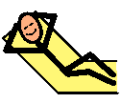

Play Dough

Relaxation at Home

Play
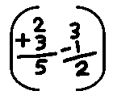

Numeracy Task

Play
Play is so important. Why not get out into the garden and get some fresh air or enjoy playing with your favourite toy or game.
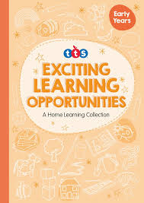
Play Dough
Check out pages 8 –11 in your “Exciting Learning Opportunities” booklet and choose a one of the activities to complete using the play dough you made yesterday!
Numeracy Task
Look inside your pack. You will have one of the following workbooks: “Counting 0 to 5”, “Workbook 1” or “Adding 0 to10”. Please complete the first 2 pages of either workbook.
Relaxation at Home
Time for a little bit of chill. Close the curtains, dim the lights and tune in for some sensory quiet time at home.
https://www.youtube.com/watch?v=xir91dOrO64&t=196s

