Numeracy Tasks

Laptop or iPad

Number Songs

Play Dough

Play

Study Ladder
Inside the front cover of your School Closure Jotter you will find a note of your Study Ladder login details. Please log in and have a go at the task that has been assigned to you.
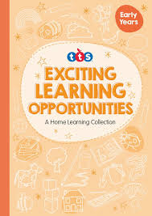
Play Dough
Making your own playdough at home is very fun and can provide limitless learning opportunities. On Page 6 of your ‘Exciting Learning Opportunities’ booklet you will find a very simple recipe for making playdough at home. Give it a try and let me know what you can make with your new homemade play dough! Once made, we usually keep ours inside a bag or container in the fridge.
Number Songs
Sing your favourite number songs with your family members! One of my personal favourites is “Five Little Monkeys”. Please use this link to take you to a YouTube video https://www.youtube.com/watch?v=sfFwo7iQsDw

