Date: W/C 23rd March 2020 | Theme for this week: Spring and Planting ‘Jasper’s Beanstalk’ https://www.youtube.com/watch?v=A4OIrJWXfjs Story  https://www.youtube.com/watch?v=D0FCByNUgoc Song
Curriculum Area | Science  I am learning to grow plants and to name different parts. I can talk about how they grow and how I will look after them.  SCN 0-03a | Numeracy  I am aware of how routines and events in my world link with times and seasons  MNU 0-10a | Literacy  I enjoy exploring and choosing stories and other texts to watch, read or listen to, and can share my likes and dislikes.  LIT 0-01b / LIT 0-11b
Monday | If you can source a pot and some seeds help your child to plant the seeds and record when they planted them and watch over the days and weeks to come what is happening. https://www.bbc.co.uk/cbeebies/grownups/how-does-your-garden-grow  You could show a time lapse video of a plant growing.  https://www.youtube.com/watch?v=jyRw597JBVg | Read or listen to ‘Jasper’s Beanstalk’ and help your child to think about the days of the week and what Jasper did on each day.  https://www.youtube.com/watch?v=36n93jvjkDs  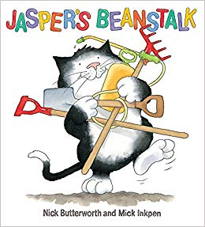 | Word Boost for this week and next week will be ‘The Gigantic Turnip’, which you will find in the pack provided for you.  Day 1 – Read the story or watch on Youtube:  https://www.youtube.com/watch?v=CFmdYSjT-qA  