To access Microsoft Teams on a laptop:
- Go to https://glow.rmunify.com/ or type in glow login into google.
- Type in your glow login details (all children have been given these).
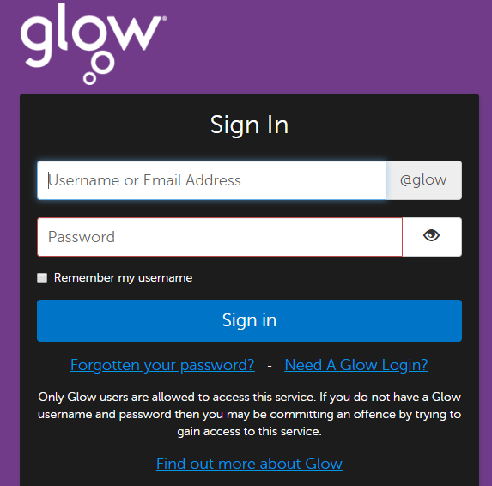
- Click the ‘Mail’ tile
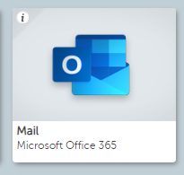
- Click the square in the top left corner.
- Click the Teams icon.
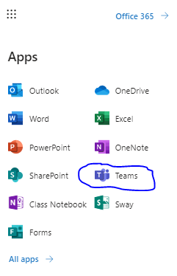
- Click your class team.
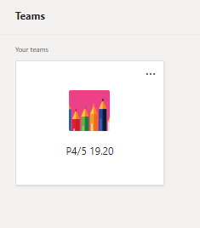
- In teams you will be able to read and reply to posts from teachers explaining tasks etc., in assignments you will find tasks that your teachers have assigned specifically for you. All you need to do is type in your response and it will save automatically.
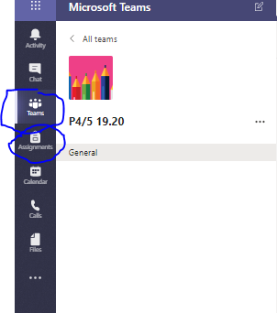
To access Teams on an iPad/tablet:
- Download the Microsoft Teams app from the app store.
- Click sign in.
- Write in your full login @glow.sch.uk
- Access posts and assignments.
To access and share via your OneDrive:
If you are given a task not in your assignments you may need to complete it on Word/PowerPoint and share it with your teacher.
- Go to https://glow.rmunify.com/ or type in glow login into google.
- Type in your glow login details (all children have been given these).
- Click the ‘OneDrive’ tile (you may have to scroll down).
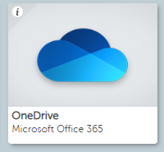
- To create a new file click ‘New’ (your files save automatically – just give it a name).
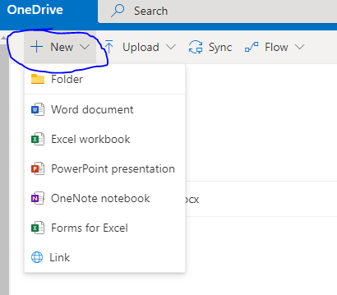

- To upload a file from your computer click ‘Upload’.
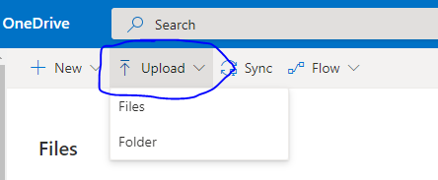
- Once you are ready to share your finished work, click the left hand side of the file name and a tick will appear
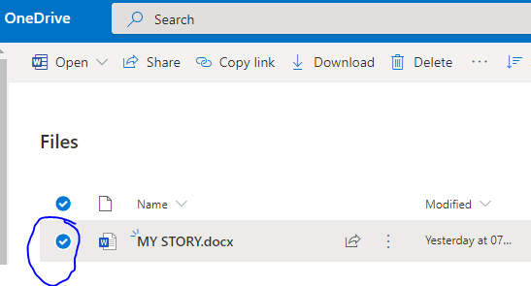
- Next, click share and type in your teacher’s name (you may have to type in their full name).
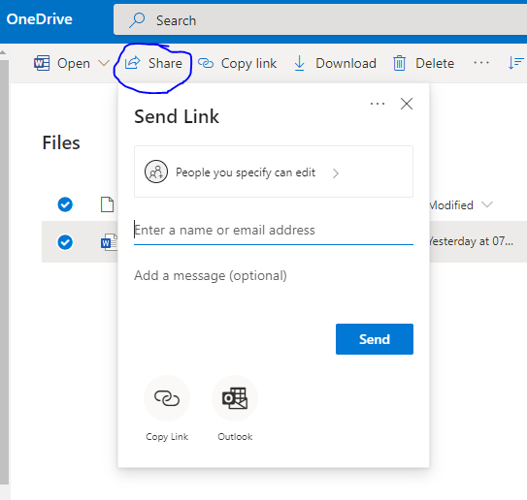
- Then click send and your work will be sent directly sent to your teacher.

