SCHOOL LOGO.wmfSCHOOL LOGO.wmf**Blackburn Primary School**

**Hopefield Nursery Class**

**Newsletter**

**November 2019**

**Head Teacher’s Comments**

We have had a very busy start to the session as 2019 is a very significant year for the school. Blackburn Primary School opened 60 years ago and the children have been involved in a whole school project learning about Blackburn and comparing the changes to the school and the town over the past 60 years. We have also been learning about historical events, pop culture, fashion and industry in the last 60 years to name a few and we are looking forward to our celebration on Thursday where the children are very excited to meet with you and demonstrate their learning. We are looking forward to seeing you there and in time honoured tradition there will be Birthday cake! Please remember numbers are tight and guests are invited by invitation only. Any questions contact Mrs McCarney.

**Children in Need**

Children in Need is on Friday the 15th of November and this year we are inviting the children to dress up in spots and or as Pudsey Bear. Throughout the day the children will be enjoying many fun activities and our A2 class will be baking cakes for sale on the day. We will also organise a raffle for the children and there will be a prize for the best dressed person. The children can bring a £1 to dress up and raffle tickets and cakes will also cost a £1. Please support this good cause with the same generosity that you have given in previous years.

**Book Week: Week beginning the 18th of November**

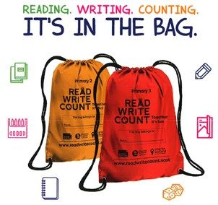

To continue our work on developing a reading culture, throughout Scottish book week the children will be engaging in many engaging reading activities and we have invited several authors such as Anna Docherty, Gary Erskine and John Fardell to entertain the children and share their love of books. We will also be visiting our local library and will distribute our Book Bug bags for our Primary 1 pupils and the Read, Write, Count Bags for Primary 2 and Primary 3. These bags are provided by the Scottish Book Trust for all P1 to P3 pupils and are an excellent resource for your children to help them to develop a love of reading. Please take the time to enjoy these resources with your child and engage in the many activities that are provided to help them on their reading journey.

**The Cost of the School Day:**

**Blackburn Family Larder and Dress down Friday**

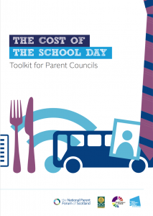

Mrs McCarney and Mrs Valente have been undertaking some work on reducing the cost of the school day for our families. They have created an information leaflet on the many ways in which we reduce costs for our families and ensure equity for all. Mrs McCarney has led the setting up of our Family Larder (food bank) which is situated at the entrance of the school. The location is to allow you access to the food without having to ask or tell anyone. We hope you will use it when you need it. The idea of the larder is that in times of need you take from it and when you maybe have a wee bit extra you can replenish items (it does not need to be like for like).

The initiative is not about an IOU debt it’s more about a how can we help you solution. We are going to introduce dress down on the first Friday of the month, however we ask that the children bring something to add to the food bank instead of a £1. We plan to start dress down again in the New Year therefore our first dress down day will be Friday the 10th of January 2020.

**2020 Primary 1 Enrolment**

If your child will be 5 years old on or before 28th February 2021, you are invited to enrol your child at Blackburn Primary School. Enrolment forms will **no longer** be distributed from Pupil Placement to pupils at Hopefield Nursery Class or at Blackburn Primary School and you need to apply online at [pupilplacement@westlothian.gov.uk](mailto:pupilplacement@westlothian.gov.uk) However if you are not able to access the internet please contact nursery staff on 01506 630944 or the school office on 01506 653481 and we will be delighted to help you with your application.

**Scottish National Standardised Assessment (SNSA)**

West Lothian Council will continue to undertake national standardised assessments which are now in their third year of roll out. These assessments will provide an additional source of nationally consistent evidence for teachers to use when assessing children’s progress. Ongoing and informal assessment is, and will continue to be a central part of everyday learning and teaching. Our teachers at Blackburn Primary remain best placed to know how the children in their class are progressing and their professional judgement will continue to be the most important way of assessing your child’s progress at school.

Further information can also be found on the Scottish Government’s website: [**http://www.gov.scot/Topics/Education/Schools/NationalImprovementFramework/NatonalImprovementFramework**](http://www.gov.scot/Topics/Education/Schools/NationalImprovementFramework/NatonalImprovementFramework)

**School Improvement Planning and Pupil Equity Funding Planning (PEF) Session 2019/2020**

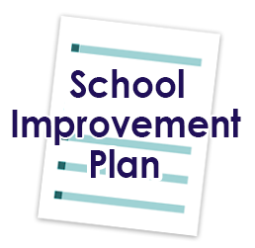To increase attainment in literacy and numeracy, improve the health and wellbeing of our children, close the poverty attainment gap between our most and least disadvantaged children and develop the young workforce this session our main priorities are:

* To continue to develop a reading culture and develop a writing culture
* To engage with Pivotal training for teachers to support the management of behaviour in the school and the development of our Behaviour Policy
* To work with the organisation Hidden Giants to improve creativity in classroom practice and provide more opportunities for pupil voice
* To have a Teacher in the Nursery to provide and oversee targeted intervention for individual pupils
* To continue with our Family Link Worker to provide support financially and emotionally for our families
* To have a PEF Pupil Support Worker to provide 5 minute box programmes and Scotland Reads Initiative (paired reading) for targeted pupils

**Validated Self Evaluation (VSE) Wednesday the 4th of December 2019**

The school and nursery will be involved in a short inspection type model known as a Validated Self-Evaluation. This will involve a group of Head Teachers and our Quality Improvement Officer visiting the school and taking part in classroom observations and discussions with pupils, partners and parents. The purpose of a VSE is to ensure that the school and nursery have completed the actions from our HMIe Inspection and to make sure we are grading ourselves against the Quality Indicators from How Good is Our School 4 and How Good is our Early Learning and Childcare? If you are willing to join a focus group to talk about the ongoing work in the school please inform the office and we will contact you nearer the time.



New Arrivals!

We have some lovely news to share. We are delighted to inform you that our Blackburn family is growing as Mr Riding and his wife are expecting a baby in February and Mrs Lund and her husband are expecting a baby at Easter! Congratulations to both families we are thrilled for them.

**Hopefield Nursery**

It has been extremely busy with all the new children and the returning children moving into Pre-school. They have been a great help to the new children supporting them and showing them the ropes… where the toilet is and the garden, how to collect a plate and choose their own snack. In fact, the children have been choosing the snack that they would like for the cold winter months ahead. We may even be making our very own bread.

**Autumn** has involved releasing our butterflies, collecting leaves and talking about the changes in our environment; it is getting colder and darker, the leaves are changing colour and they are falling off the trees.

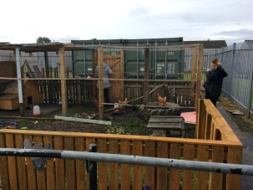**Babies** everywhere – there were some families with babies who came to visit us and we were learning how to take care of babies, what they like to eat and drink and how to look after them.

**Our chickens** are thriving and providing us with eggs for the Big Breakfast that Bonnie organises and we have even sold some to parents who want fresh, fresh eggs. This was run in conjunction with the McMillan Coffee Morning which was a huge success, raising £115.00 which could not have been achieved without the support of our wonderful Hopefield Nursery parents.

**Maths Week – The Three Little Pigs**

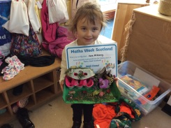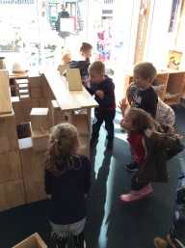

Involved a challenge with parent participation and together the children created a house that the wolf could not blow down. They measured out the sticks and bricks that they needed to make a strong building and thought about the size and shape … Well done to all the families who participated.

**Halloween**

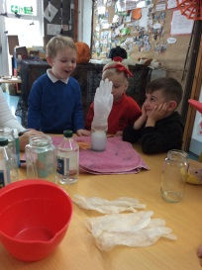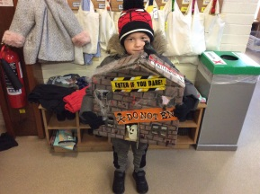There was an exciting party and the children dressed up and had scary food; spooky sausages, owl blood juice, creepy crisps and listened to ‘The Room on the Broom’ and even acted the story out with puppets. The children were involved with science and mixing of ingredients to create ghostly hands that moved and grew very large!

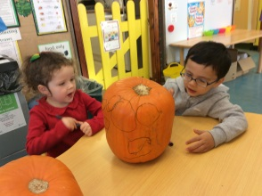

**Term Dates Blackburn Primary School & Hopefield Nursery Class - Session 2019/2020**

Thursday the 7th of November Blackburn Primary School’s 60th Birthday

Friday the 8th of November Children’s parties celebrating the school’s 60th Birthday

Thursday the 14th of November P5/6/7 to Risk Factory

Friday the 15th of November Children in Need

Monday the 18th of November Scottish Book Week at Blackburn Primary School

Friday the 29th of November Blackburn’s School Fayre: Christmas, Cake, Coffee and Craft

11.00 am – 12.30 pm

Tuesday the 3rd of December P4/5 Handball Festival

Wednesday the 4th of December Blackburn Primary School and Hopefield Nursery VSE (Validated Self Evaluation)

Monday the 9thof December Nursery Christmas sing a long 1.45 pm for pm pupils and full day Monday pupils at Blackburn Primary School (nursery parents are welcome to attend)

Tuesday the 10th of December Nursery Christmas sing a long 9.30 am for am pupils and full day Tuesday pupils at Blackburn Primary School (nursery parents are welcome to attend)

Tuesday the 10th of December Christmas School Nativity ‘Everyone Loves a Baby’ P1 – P3 - 1.15 pm

Wednesday the 11th of December 10.00 am – 12.00 pm Whole School to Cinderella Pantomime

Howden Park Centre “Oh yes they are…”

Thursday the 12th of December Christmas lunch: Children to donate £1 and wear Christmas jumper/tee- shirt/bobbly hat for Save the Children

Tuesday the 17th of December Nursery party (All children) 11.00 am – 12.30 pm at Blackburn Primary School. A special visitor has been invited and we are hopeful that he will be able to attend our party at around 12.00 pm

Tuesday the 17th of December 1.30 pm Primary 1 and A1 Christmas party. A special visitor has been invited and we are hopeful that he will be able to attend our party at around 2.30 pm and hope that he will not be too tired after the nursery party

Wednesday the 18th of December Primary 2/3 Christmas party

Thursday the 19th of December P4/5, P5/6/7 and A2 Christmas Party

Thursday the 19th of December 8.55 am Breakfast for our taxi drivers and escorts of ASD pupils. Children are welcome to have their breakfast in the school

Friday the 20th of December 9.30 am Christmas Church Service Blackburn and Seafield Parish Church

Friday the 20th of December 12.30 pm Pupils break up for Christmas holiday

Monday the 6th of January Additional In-service day for teaching staff

Monday the 6th of January Nursery pupils resume

Tuesday the 7th of January School pupils resume

Thursday the 23rd of January P 4/5 and P5/6/7 Burns Supper 1.30 pm

Friday the 24th of January Burns Assembly 9.15 am





**Remember to follow us on twitter: @wlBlackburnPS**