Blackburn Primary School

Hopefield Nursery Class
March 2018 Newsletter

Head Teacher’s Comments:

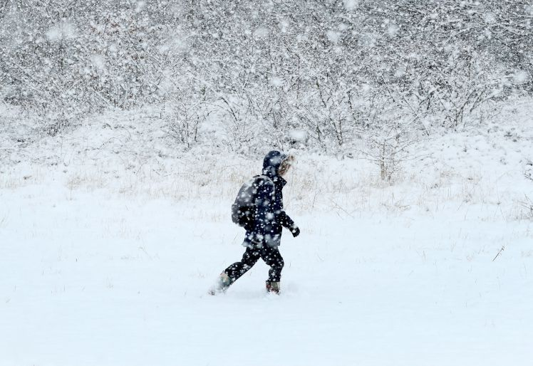
The ‘Beast from the East’ has certainly caused a period of unsettlement for all and I hope that you managed to keep safe and warm during the time the weather was at its worse. School closures are not taken lightly by West Lothian Council and our Head of Service have been doing everything to get services back to working order. I hope you and your family managed to enjoy some of the snow and I am looking forward to everything going back to normal and the supermarkets having bread and milk back on the shelves!

PEF Pupil Equity Funding


We are well on our way to fulfilling our PEF action plan. We have enjoyed many activities and events so far this session and we are finally looking forward to having our Mind, Body and Soul parental involvement programme up and running (weather permitting) week beginning the 12th of March. If you are interested in taking part in this experience it will run from approximately 2 pm to 4.30 pm on a Wednesday and you will have the opportunity to enjoy yoga, mindfulness, cooking and nutrition. The children will participate in the cooking and take part in homework reading tasks.

Another PEF initiative starting this term is Outdoor Learning with the talented and inspiring staff from Rowanbank who will be working with our whole school during a Magical Woodland Walk. This will include theatre, acrobatics, puppetry and storytelling all while we enjoy the great outdoors! Rowanbank will then be working with our P1-3, A1 and A2 pupils on literacy and forest schools learning experiences in our local wooded areas. These sessions will all take place after the Easter Holidays so please keep a look out for the dates and times relevant to your child’s class. We may be calling for parent helpers to join us on these exciting sessions so if you fancy coming along to see the children enjoy being creative when out and about, please let school staff know that you are interested.


In line with our PEF action plan, a lunch time soccer club was launched in February and the children have really enjoyed the first session. This lunch time club will run for another 9 weeks. P1-3 (Including A1 pupils) attend this club on a Thursday lunch time and P4-7 (including A1 and A2 pupils) attend this club on a Wednesday lunch time. This club is optional. All children who attend the club require a PE kit, including appropriate sports shoes. Please ensure your child brings a full PE kit every Wednesday or Thursday to ensure their participation. Thank you!

Burn’s Assembly


Well done to all the children who learned a poem and received a certificate for reciting a Scottish poem. I thoroughly enjoyed our Burn’s Assembly and was delighted to learn that we had special visitors from Paraguay who were the grand parents of one of our pupils in A1! I am sure they enjoyed listening to the Scots Language throughout ‘The Wee kirkcubright Centipede’ and ‘The Wee Lassie who Swallowed a Midgie’ as well as enjoying the traditional meal of haggis, neeps and tatties in A1’s classroom! I’m sure Paraguay have their own traditional food or unusual delicacies but I wonder if anyone informed them of the ingredients of haggis?

Community Action Blackburn (CAB) Conference

Our P6/7 pupils are currently preparing for their annual CAB conference. This year the CAB Conference is focusing on ‘Natural Space’ and ‘Life Long Learning’ and our children have been working with staff and ambassadors from the West Lothian Youth Action project (WLYAP). We are looking forward to coming together and sharing our experiences and learning at the Conference on Friday 27th of April at Our Lady of Lourdes Primary School.

Parent Consultations


Parent Consultations will be rescheduled to Thursday the 15th of March from 3.30 pm – 7.30 pm. This consultation will inform you of pupil progress this session, recap on learning journals and provide you with an interim report. Primary 7 parents and pupils will be asked to complete an evaluation of their experiences at Blackburn Primary School as part of their transition into Secondary School.


Easter Service

Our Easter Service will be held on Thursday the 22nd of March at 9.30 am at Blackburn and Seafield Parish Church. All pupils will be participating in this service and all parents and carers are welcome to attend.

Milk Prices and Lunch Prices
In line with the Council’s Charging Policy I advise you that the daily charge from 9th April 2018 will increase to 20 pence per 189ml carton.

Date Payment Due Period Covered Amount
31st March 2018 9/04/18 – 29/06/18 £11.40
30th June 2018 21/08/18 – 12/10/18 £7.40
13th October 2018 23/10/18 – 21/12/18 £8.80
22nd December 2018 07/01/19 – 29/03/19 £11.60

P 6/7 John Muir Award
Staff and pupils in Primary 6/7 are working on their John Muir Award with Mike Harvey an Outdoor Education Instructor from Lowport Centre. Throughout the weeks the children will be expected to engage in the four aims of the John Muir Award which are explore, investigate, experience and conserve the environment. Mike Harvey has planned a wealth of outdoor activities for the children to engage in. It will be a lot of fun and the children will have a fabulous time experiencing the opportunity to learn in the great outdoors and provide them with breadth and depth to their learning.

Lowport Outdoor Residential Experience
Pupils and staff in A 1 and A 2 are looking forward to their Outdoor Residential Experience at Lowport Outdoor Education Centre in the middle of May. The staff are in the process of finalising arrangements so please look out for further information to follow as we plan to have an information afternoon for parents very soon after the Easter holidays.


Sports Relief
The staff are busy making preparations for Sports Relief on Friday 23rd March. Please look out for more information regarding this event. All money raised will go to Sport’s Relief.

Saying Goodbye

Mrs Webster is leaving Hopefield Nursery on Friday the 9th of March and I would like to take the opportunity to thank Mrs Webster for working with the children, parents and staff of the nursery and wish her every success in the future.

Parent and Carers Comments:

Your views and opinions are important to us and will be taken into consideration. If you have anything to comment upon please use the cut off slip below and return to the school office.


……………………………………………………………………………………………………………………………………………………………………………………………………………………………………………………………………………………

Dates for your Diary 2018

March

Monday 5th P1-3 Storytelling session from Blackburn Connected Library manager Jill Williams

Thursday 8th Blackburn PS and Hopefield Nursery Class celebrate World Book Day!

Thursday 8th A1 and A2 visit to Blackburn Connected Library

Wednesday 14th Benchball festival for P4/5 pupils 1.30 pm – 3.00 pm Blackburn Community Centre

Thursday 15th P2/3 Class Assembly 1.15pm

Thursday 15th Parent Consultations for Blackburn PS and Hopefield Nursery class 3.30 – 7.30pm

Friday 16th P4-7 visit to Blackburn Connected Library

Monday 19th P2/3 Class Visit to Edinburgh Museum

Thursday 22nd Easter Service 9.30am at Blackburn and Seafield Parish Church

Friday 23rd School breaks up for Easter

April

Monday 9th All staff and pupils resume

Wednesday 11th Outdoor Learning initiative with Rowanbank Launch Day for Hopefield Nursery Pupils

Thursday 12th Outdoor Learning initiative with Rowanbank Launch Day for Blackburn PS Pupils

Friday 27th Community Action Blackburn (CAB) Conference 09.30 – 12.00 Our Lady of Lourdes Primary School

May

Monday 7th May Day holiday for staff and pupils

Tuesday 8th In-service Training Day for staff

Wednesday 9th All staff and pupils resume

Wednesday 16th Lowport residential experience for A 1 and A 2

Wednesday 16th Bathgate Academy Blazer fittings 6.30 pm

Thursday 17th Bathgate Academy Blazer fittings 6.30 pm

Monday 21st Victoria Holiday for staff and pupils

Tuesday 22nd All staff and pupils resume

Please note that John Muir Day visits for P6/7 and Lowport Outdoor Education afternoons for P4/5 will continue to run throughout the term. The class teachers have a list of all the relevant dates and information. Please ensure your child comes equipped with suitable outdoor clothing and footwear to allow for full participation throughout these initiatives. Thank you!

