Winter Ready
Practice your times tables and number bonds on sumdog/ topmarks | Time how long it takes you to build a snowman | Cosy up and read your favourite book to a family member
Write a diary entry about your day | Design and build an igloo in the snow | Practice your ‘tricky words’ writing them in the snow  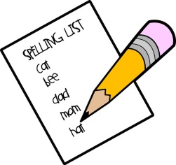
Write instructions for the perfect cup of hot chocolate | Watch Newsround and bullet point the main events in the news | Have a snowball fight
Tasks you could complete during a snow day (primary 4-7)

