Blackburn Primary School

Hopefield Nursery Class
January 2018 Newsletter

Head Teacher’s Comment:


It has been great to see all the children back at school and nursery after the Christmas and New Year celebrations! We have had a busy start to the year and the children are well underway with their interdisciplinary learning. This term is a very busy term and I am delighted to share the details of new initiatives and learning projects which will be kicking off over the next few months within this newsletter. I am also delighted to share with you some lovely news … we have a new member of staff who has joined us after the Christmas holidays. Her name is Mrs Bryce! As you know, Miss Dick was getting married on 29th January 2017. It was a beautiful day, enjoyed by all. I would also like to extend my congratulations onto Mrs Bryce, her husband and their daughter Lucia on their baby news! Mrs Bryce is due her second baby, a baby boy, in June of this year. Exciting times ahead!

Nativity, Cake, Craft and Coffee

Although Christmas is but a distant memory now I would just like to share how proud I am of the pupils’ accomplishments in this year’s performances, which were all wonderfully performed. Thank you to all parents, parent council members, staff and carers who contributed to the raffles and tombola and helped to raise money for the school and nursery fund. This was a tremendous effort by everyone and we raised a total of £886 for the school fund and £310 for the nursery fund.

Winter Readiness


I would firstly like to take this opportunity to thank everyone for their support during the severe winter weather. Our main concern is the safety of the pupils and we appreciate everyone’s patience with using the infant entrance for dropping off and picking up the children. In the event of wet and snowy weather can we ask that children come with a change of clothes in case they get wet when playing outside. Nothing worse than siting in soggy clothes! Although the snow can cause inconveniences with travel etc, I have to say it has been a pleasure to watch the children have fun and enjoy the winter weather. Many a snowman, igloo and snow angel have been built over the last few days. Check out our blog to see some of the children’s’ creations! Also available on the blog is a list of useful websites and activities for the children to complete if there was a school closure due to severe winter weather. Our school blog can be accessed using the following web address https://blogs.glowscotland.org.uk/wl/BlackburnPrimary and it can also be reached through our school website: www.blackburnprimary.co.uk.

Burns Week
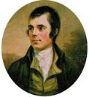
Our P4/5, P6/7 and A2 pupils are busy planning and preparing for the annual Burns Supper on Thursday the 25th of January. This is an excellent opportunity for pupils to learn about our Scottish culture and our National Bard. Relatives and friends of the school are invited and the children look forward to performing dances, songs and poetry of Robert Burns and enjoying a plate of haggis, neeps and tatties with everyone. This week our pupils will also be engaged in Scottish learning in preparation for our Burns Assembly on Friday 26th of January at 9.30am. All Nursery and School parents, carers and families are invited to attend our assembly.

Pupil Equity Funding and Additional Revenue Funding

Mrs Bryce and I have been very busy planning and organising a variety of fun and engaging learning experiences for the pupils at Blackburn Primary school, which will be starting soon! These initiatives are fully funded by the school’s Pupil Equity Fund (PEF) and therefore will be of no charge to the pupils. Woo Hoo!


Numeracy through Outdoor Education - P4/5 pupils will start their work with Lowport Outdoor Centre on 30th January and they will continue most Tuesday afternoons until 12th June. These sessions will go ahead in all weathers so please ensure your child has warm clothing, waterproofs and a change of clothes every Tuesday.

John Muir Award – P6/7 pupils will start their work towards the Discovery John Muir Award, with some pupils now working towards their Explore John Muir Award, on Thursday 8th February. These sessions will continue on various dates through to Thursday 3rd May. Miss Millar will keep you posted! As these training sessions will be for most of the school day, the children will need to bring snack, lunch, water, appropriate outdoor clothing and footwear, waterproofs and a change of clothes.

What else is in the pipe line for Blackburn Primary School?

Literacy and Creativity through Outdoor Education – we are delighted to announce that the talented and inspiring staff at Rowanbank will be working with our whole school during a Magical Woodland Walk. This will include theatre, acrobatics, puppetry and storytelling all while we enjoy the great outdoors! Rowanbank will then be working with our P1-3, A1 and A2 pupils on literacy and forest schools learning experiences in our local wooded areas. These sessions will all take place after the Easter Holidays so please keep a look out for the dates and times relevant to your child’s class. We may be calling for parent helpers to join us on these exciting sessions so if you fancy coming along to see the children enjoy being creative when out and about, please let school staff know that you are interested.

Food for the Mind, Body and Soul – We are very excited to be planning a weekly cooking, nutrition and movement session involving 8 – 10 of our lucky families. These sessions will start at 2pm and finish around 4pm and they will be run by Edvis, a fitness and nutrition coach from Spiral Fitness. We are still awaiting the ‘go ahead’ for this booking and for new kitchen supplies therefore we cannot share specific details such as dates and menus but please watch this space! As soon as we get the green light, we will let you know! As these sessions are very limited, we would like to find out who is interested in taking part in this very exciting opportunity. We recently put out a ‘note of interest’ to all families to see who would be keen to join these sessions. We have had some interest but there are a few spaces still available so please let school staff know if you would like to note your interest.

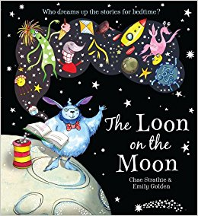
Author Visits and Storytelling Sessions – We have been in contact with the famous children’s author Chae Strathie, who’s award-winning children's books include The Loon on the Moon and Jumblebum. As you can imagine, Chae is a very busy man but we are currently discussing dates for him to visit our school and share some of his wonderful stories, songs and ideas with us!

We have also been in touch with Granny Lichen Leaf, who is a magical witch-like character from Rowanbank. She tells amazing tales of the forest, using puppets and props. We are currently organizing dates for Granny Lichen Leaf to visit our school and work with us on our storytelling. We are also trying to book Debi Gliori who is a Scottish writer and illustrator of children's books.

What is in the pipe line for Hopefield Nursery Class?

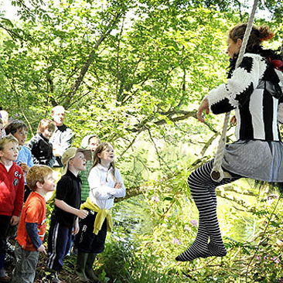
Literacy and Creativity through Outdoor Education – we are delighted to announce that the talented and inspiring staff at Rowanbank will be working with our nursery pupils and parents during a Magical Woodland Walk. This will include theatre, acrobatics, puppetry and storytelling all while we enjoy the great outdoors! Rowanbank will then be working with our nursery pupils and parents on literacy and forest schools learning experiences in our local wooded areas. These sessions will all take place after the Easter Holidays so please keep a look out for the dates and times. We will need as many parent helpers as possible to join us on these exciting sessions so if you fancy coming along to see the children enjoy being creative when out and about, please let nursery staff know that you are interested.

Box Clever – Mrs Kinnaird has been a very busy bee getting resources ready to start our Box Clever initiative in the nursery. Box Clever focusses on developing children’s vocabulary. Please keep an eye out when in the nursery and use the noun, adjective and verb word clouds displayed so that you can help your child learn new words at home too!

Paired Reading – Nursery and school staff are currently organising paired reading sessions between the nursery pupils and Blackburn Primary pupils in the upper school. Some P4/5 and P6/7 pupils will be coming round to the nursery to share a story or two with the nursery children.

PE


We would like to give a huge warm welcome to Mrs McAdam, our new PE specialist. All classes will be working with Mrs McAdam on a Wednesday on a variety of PE topics, starting with Scottish Country Dancing and Yoga. P4/5 and P6/7 will continue to attend Futsal on a Thursday afternoon and A1 will continue to attend swimming lessons on a Tuesday afternoon. Please ensure your child brings a full PE kit and swimming kit on these days.


Dogs Trust

Rachel Bliss from The Dogs Trust will be coming in to work with P1-5 pupils to read with the boys and girls. She will be bringing a special visitor (don’t worry, he is a teddy dog) for the children to practice reading aloud to.

School Clubs

The school will be running the following after school clubs this term for P1-5 pupils:

Tuesday : Scripture Union Club
Dance Club (please ensure children have appropriate clothing and footwear)


The school will also be running the following lunch time clubs for P1-7 pupils:

Wednesday : P1-3 Planet Soccer Club
Thursday : P4-7 Planet Soccer Club
(Please ensure children have their full PE kit on these days).

100th Day


Friday 2nd February sees the 100th day of our current school year and we will mark the occasion with fun, games and activities, all associated with the number 100. The whole school will be set challenges to complete, which will be entered into a whole school competition so keep your eye on the school blog for details. We all love a wee bit of friendly competition!

Valentines Disco


This popular annual event will be held on Thursday 8th February from 5:30 – 7:00pm. Tickets will cost £3:00 and will be available from the school office at the start of February however you will be able to purchase a ticket on the night of the event. The cost of the ticket includes a drink and a snack therefore children will not need to bring any extra money on the night.

Car Parking


The school and the nursery have experienced a number of issues regarding the use of the school car parks by parents for the picking up and dropping off of pupils. The car parks in the nursery and the school are for the use of West Lothian Council staff and taxis transporting pupils to and from school. Can I please remind parents that access to the car park is strictly prohibited and request that you do not enter the car park. In order to maintain the health and safety of all pupils, parents and staff it is essential that policies and car park protocols are adhered to. Parents/carers dropping off children for Hopefield Nursery Class should park out-with the grounds and use the path alongside the Nursery and parents/cares dropping off children at Blackburn Primary school should park out-with the grounds and use any of the 3 gates to access the playground. Please do not drop your child off at the front entrance unless the school day as already begun.

Class News

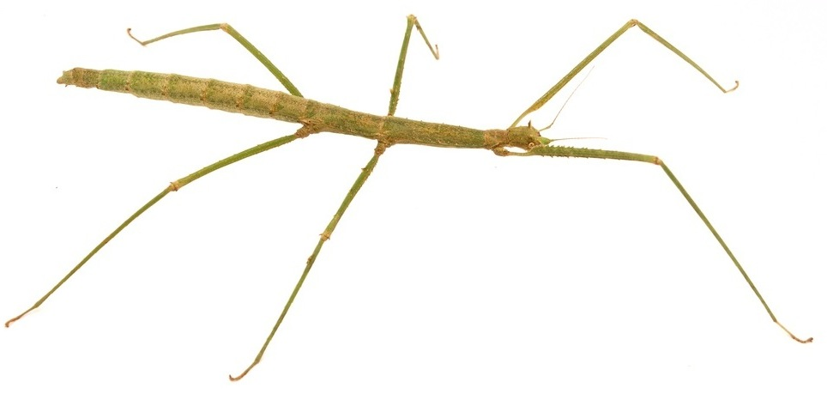
Hopefield Nursery Class – Hopefield Nursery Class have started off the new year by learning about Scottish songs and dance. The boys and girls enjoyed the Mousetale Puppet Show ‘Oscar and the Highland Castle’ on Wednesday 24th January where they learned about the story of Robert the Bruce. This term the children are learning about weather and the changing seasons. The recent snowy weather lended itself extremely well to this learning context and the children had a ball building an igloo for Mr Bear. Keep your eye on the Blog for pictures! The children have also been bringing their learning to life as they learn about hibernation. The children have helped build a ‘Cosy Cave’ in the nursery, where they store food and cuddle down waiting for Spring. As this cold weather can make life difficult for the birds, the children have been busy making bird feeders so keep an eye out when passing our nursery garden! We have been very lucky with our Stick Insect eggs as 5 of them hatched just before Christmas. Ask the children to show you our stick insect basket and see if you can spot them amongst the twigs and leaves. The Big Bedtime Read has started back up again following the Christmas holidays and we hope that you and your children continue to enjoy the books within the packs. The nursery staff are looking forward to receiving your feedback about the Big Bedtime Read!

P1/2 – The children in Primary 1/2 completed their second term in school by impressing their parents and carers with a very successful Nativity performance of, “A King Is Born”, which was enjoyed by all. The children in classes P1/2 and P2/3 had lots of fun at their Christmas party where there was dancing, games, party treats and a very special visitor!
We began the new term by thinking about our New Year Resolutions and what we can improve upon in 2018. We have also been learning about the months of the year by discussing when our birthdays are and this has helped us when reciting and sequencing the months correctly.
We are focusing on our ability to communicate and cooperate with our peers and have introduced weekly Talking Partners which has proved to be very successful so far. We are also participating more in group learning where each member has a specific role including Leader, Resource Manager, Recorder, Time Keeper, Volume Controller and Presenter and we plan to undertake lots more of this throughout this term.

This month, we have also enjoyed listening to and learning some Scottish songs and poems for our Robert Burns Assembly where all the children have participated fully.
Our IDL topic for this term is “Castles”, where we hope to undertake a variety of interesting activities with cross curricular links to Literacy, Expressive Arts and Technology.


A1 - A1 have had a great start to 2018 and are looking forward to all the exciting things we have planned this term! We have started by looking at Scotland and have been very busy planning our Burns Supper for our parents and carers on Friday 26th January after the whole school Burns Assembly. We will be making shortbread in class and we hope it taste delicious!
Later this term we will begin our Romans topic and will be looking back in time to see how the Romans have influenced how we live today. Last term we really enjoy our swimming block and are excited about this starting back. We also have an exciting trip to Glasgow Science Centre with A2 in March which will be fantastic!


P2/3 - Last term was filled with much excitement and lots of fantastic learning opportunities for P2/3. We really enjoyed creating our cosy corner and look forward to developing other areas of our classroom soon.
Before Christmas we started our new class novel ‘The Christmasaurus’ by Tom Fletcher. This is a lovely heart-warming and funny story about a dinosaur that lives in the North Pole. Whilst this is a Christmas story we voted to keep reading this book as we are desperate to find out what happens!
This term we will be learning about the Vikings and will be lucky enough to become ‘A Viking Day Out’ at the National Museum in Edinburgh on 19th March. This will be a fun packed day where we will get to handle some real Viking items, watch a Viking show in the theatre and explore other parts of the museum.


P4/5 - This term primary 4/5 have been very busy getting ready for the upcoming Burns supper. We have been creating Scots poems, learning songs, Scottish dancing and making artwork based on famous Scottish artists and the children cannot wait to show off everything that they have been doing.
For our topic this term we will be investigating the Romans and learning about their way of life and history. As part of our numeracy development the children will be undertaking an outdoor learning project with staff from Lowport outdoor centre. This will be taking place in the school grounds every Tuesday. I would please ask that on this day you send your child to school in warm and waterproof clothing as we will be going out regardless of the weather. Many thanks, Mr Riding.


A2 – A2 are excited about being back at school and about all the things that are to come this term. We've already started by having great fun working in teams to build snow creatures in the snow! We are starting this year all things Scottish while preparing for the Burns Supper and Assembly. A2 will then be focusing on their IDL topic on World War 2 - we will be learning about what it was like to be a child during the war and what life was like. Our Science topic will be Space and learning about the different planets, and we are particularly excited about our trip to the Science Centre in Glasgow in March, which will be an excellent finale to our space topic.

P6/7 - P6/7 have a busy term ahead. We have been planning our Burns Supper for parents which will take place on Thursday 25th January. We created our own poems and invitations during literacy and have been practicing Scottish poems, songs and dancing. We hope you can come along! All this practice of Scottish dancing will set us in good stead for P6/7 Ceilidh, which is part of Bathgate Academy’s transition program.
After our Burns Supper, we will be learning about Ancient Rome as part of our interdisciplinary learning context. Starting on the 8th of February we will enjoying 8 outdoor learning afternoons as we are taking part in the John Muir Award which will also be linked with the Heritage Award. We will be going to lots of interesting places to achieve these awards with the support of a member of staff from Low Port as part of our PEF funding. Your child will be given a pack which will detail what to wear during these outdoor afternoons.
We are really looking forward to meeting our Peer Educators from West Lothian Youth Action Project, who will be working with us over the next term on our natural space and lifelong learning. The Community Action Blackburn (CAB) conference will be held on Friday 27th April at Our Lady of Lourdes so keep your eyes peeled for information about this annual event.

Parent and Carers Comments:

Your views and opinions are important to us and will be taken into consideration. If you have anything to comment upon please use the cut off slip below and return to the school office.

………………………………………………………………………………………………………………………………………………………………………………………………………………………………………………………

…………………………………………………………………………………………………………………………………………………………………………………………………………………………………………………

…………………………………………………………………………………………………………………………………………………………………………………………………………………………………………….

………………………………………………………………………………………………………………………………………………………………………………………………………………………………………………….

………………………………………………………………………………………………………………………………………………………………………………………………………………………………………………………

…………………………………………………………………………………………………………………………………………………………………………………………………………………………………………………

…………………………………………………………………………………………………………………………………………………………………………………………………………………………………………….

………………………………………………………………………………………………………………………………………………………………………………………………………………………………………………..


Dates for your Diary 2018

January

Wednesday 24th Mousetales Puppet Show
Thursday25th Burns Supper
Friday 26th Burns Assembly and A1 Class Burns Supper
Tuesday 30th Nursery – Childsmile Flouride Varishing
Wednesday 31st Nursery – Childsmile Flouride Varishing

February

Tuesday 6th Nursery – Bookbug Launch
P6/7 Bathgate Academy Transition Ceilidh
Thursday 8th Valentines Disco 5.30pm – 7.00pm
Friday 9th P4/5 Class Assembly
Monday 12th Holiday
Tuesday 13th Holiday
Tuesday 20th P1 and P7 Dental Inspections
Wednesday 28th Parent Consultations 3.30 pm – 7.30 pm

March

Thursday 22nd Easter Service at Blackburn and Seafield Parish Church 1.30 pm
Friday 23rd Sports Relief Fundraiser and Round Robin
Monday 26th Easter Holidays Begin

April

Monday 9th All staff and pupils resume

