P5/6/7 Snow Day Pack
If you have a snow day off school, first of all get wrapped up then get out and have some snow fun!

- Take photos of what you get up to, write a diary about your activities or make a film.

- Be first to get outside and see if you can make your own snowflake design in the snow, just using your footprints and walking around very carefully. Remember that snowflakes have 6 points.

- Fill a bucket with snow and estimate the volume. Let the snow melt and estimate the volume again. Write an explanation for the difference.
If you can’t get out or need time inside to warm up again, here are some activities you can try. You do not have to do all of them. If you can’t print this off, then just write it out.
- Write a Winter poem using metaphors, similes or alliteration. Go outside and take some photos to give you some inspiration.

- Estimate the volume of snow that has fallen on your garden. You could work it out for the whole plot of land your house is on.

- Find out words for snow in as many different languages as you can.

- Write a list of good things about snow and bad things about snow. Which is longer? Overall, do you think it is a good thing or a bad thing?

- Write a questionnaire for your classmates to help you find out what the most popular activities were on the snow day.

- Try to think of or find as many songs as you can that are about snow or have the word snow in their lyrics. Can you write your own song or rap about snow?

- Choose a spelling activity to complete using your current spelling words or previous ones that you have found challenging.

- Do some Robert Burns research. Is there anything that you are interested in that you would like to find out more about? Practise you poem for the Burns Assembly.

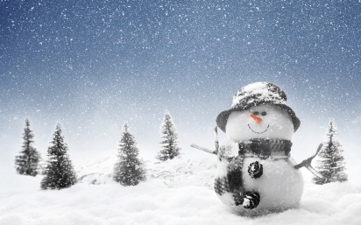
- Create a character profile of your favourite character from a novel you are reading. What do they look like? What are their qualities?

