

**Useful Websites**

**Maths**

[www.topmarks.co.uk](http://www.topmarks.co.uk)

<http://nrich.maths.org>

<http://www.sheffieldmaths.co.uk/>

<http://www.math-aids.com/>

**Literacy**

[www.topmarks.co.uk](http://www.topmarks.co.uk)

<http://www.rhlschool.com>

<http://www.bbc.co.uk/bitesize/ks2/english>

Winter Activities

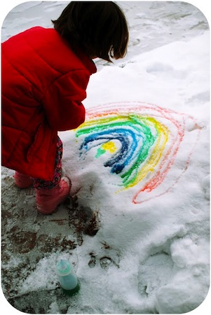

1. Build a living room campsite. Get the PJ’s on and bust out the sleeping bags. If you don’t have a tent then you can build a fort using blankets and cushions. Tell a story by your campfire.
2. Build an upside down snowman
3. Get some food dye and water and paint in the snow. See what you can create.
4. Imagine you live in an igloo in the North Pole. Can you write a story or draw a comic strip about the adventures that you and your pet penguin go on together.
5. Collect a snowball, bring it inside and put it on a plate. Watch what happens to it. Can you explain the changes and explain why it is happening?
6. Play noughts and crosses in the snow.
7. Get some stale bread and leave it out for the birds to eat. Time how long it takes for it to all get eaten.
8. Make a snow angel and measure it using your feet and hands.
9. Make 100 snowballs and throw them at a target. Count how many you hit it with. Repeat and see if you can beat your score.
10. Get a hot drink, lie back, relax and read a story (either to yourself or to someone else)