SCHOOL LOGO.wmfSCHOOL LOGO.wmf**Blackburn Primary School**

**Hopefield Nursery Class**

**Newsletter**

**November 2016**

**Head Teacher’s Comments**

The festive season is almost upon us and before the children start working on Christmas we need to acknowledge the excellent work that the children were involved in throughout their Olympic Projects. All the classes were involved in making the props for the Olympic Games and the Opening Ceremony and the children’s enthusiasm and learning was evident on both occasions (even although we had some very sleepy dragons!) I hope you all thoroughly enjoyed our Olympic Opening Ceremony and Games and I would like to thank all parents and carers for supporting the children and attending these events.

Parent Council

I am pleased to announce this session that we have a new Parent Council with newly elected members. Our Chair Person is Miss Karen Reid, our Secretary is Shona Elliot with Mrs Angela Forrester remaining as the Treasurer; our other members include Mrs Paula Graham and Miss Iveta Cakule. We had a very productive meeting this term and the Council set to work immediately with Christmas preparations and a recruitment drive to get other parents and carers to join. Their first initiative was to introduce a Dress Down Day at the cost of a pound on the first Friday of every month to raise money for school funds. The next dress down day will be on Friday the 2nd of December. If you would like to join the Parent Council, it is never too late to help out with Christmas preparations, please get in touch with the school office.

**2017 Primary 1 Enrolment**

Our enrolment process is beginning at the start of December. If your child will be 5 years old on or before 28th February 2018, you are invited to enrol your child at Blackburn Primary School from the 28th of November to the 2nd of December from 9.30 to 12 noon. Enrolment forms will be distributed from Pupil Placement to pupils at Hopefield Nursery Class and are also available at Blackburn Primary School. I look forward to meeting you on these dates and please remember to bring your child’s birth certificate.

**Christmas Nativity, Crafts, Coffee and Cakes Tuesday the 13th of December 1.15 pm**

****This Christmas we will be holding our annual Christmas Nativity, Crafts, Coffee and Cakes event. This will take place on Tuesday the 13th of December starting with the Nativity at 1.15 pm. Entry will be £2.50 which will include a lucky programme, refreshment and a mince pie. If you would like to help by contributing some home baking or donate raffle or tombola items, please contact the school office. I would appreciate if the home baking could be delivered on the morning of Tuesday the 13th of December. Donations or crafts should be delivered to the school by Friday the 9th of December and your efforts will raise money for the school fund and further develop our outdoor programme. We greatly appreciated the work that the Parent Council do with the school to organise Christmas stalls, raffles and tombola. Please note that the raffles will be drawn in the afternoon of our Christmas Nativity after the cake, coffee and craft. This is a very popular event with excellent prizes so please ensure that you have bought your raffle tickets well in advance.

Save the Children Christmas Jumper Day Thursday the 15th of December

This year the children are asked to donate £1.00 and wear a Christmas jumper/tee-shirt or Christmas bobble hat on Thursday the 15th of December which is the day of our Christmas lunch. All money raised will go towards Save the Children Fund.

Numeracy Workshops

As part of our School Improvement Planning we are planning to have a number of numeracy workshops throughout the year. We are therefore organising our first round of workshops over the next few weeks before the Christmas rush! Our focus for the first workshops is Number Sense and each class teacher will plan a bite size session which will last approximately 30 minutes. This is an excellent opportunity for you to see first-hand how number sense is taught, the types of resources that are used to teach numeracy, how the children are challenged in their learning and how number work is differentiated across all stages and Curriculum for Excellence levels. The workshop will take place on the following days and times:

Monday the 21st of November

9.00 am Primary 1 and Primary 2

Wednesday the 23rd of November

9.00 am ASD1 and ASD2

Monday the 28th of November

9.00 am P3/4 and P5/6/7

We are looking forward to seeing you there. The teachers are putting a lot of their own time and effort in to these workshops and we hope that you will support your child with their learning. Thank you.

Playground gates

A number of the Pinewood children use the playground throughout the school day therefore, for safety purposes, could you please close the gates when entering and leaving the playground.

Read, Write, Count Workshop Friday the 25th of December Blackburn Community Centre 10.30 am – 12.30 pm:

West Lothian Numeracy Development Team are planning a parent workshop to provide parents with ideas on how to use the Read, Write, Count Pack and how to support your child with understanding and developing numeracy skills. These workshops are for Primary 2 and 3 pupils only and if any parent wishes to attend this event please complete the tear off slip from the letter provided with this edition of the newsletter. I strongly urge as many of you to go as possible as your child will be able to get their Read, Write, Count goodie bags at this event.



Children in Need Friday the 18th of November

This is a reminder that Children in Need is this Friday! Children can dress down for a pound or wear something spotty. We will be selling cakes from 30p to £1.00. This event is for school pupils only and all money raised will go towards the charity Children in Need.

**Christmas is a busy time for everyone and the children are in the process of practising for the Christmas Concert and Nativity which this year is Jesus’ Christmas Party. It will soon be time to decorate the Christmas trees and look out the costumes for Mary and Joseph. Blackburn Primary School and Hopefield Nursery class engage in many opportunities to make this a special time of year for the children and I hope you can support the school and attend many of the events that will be running in the lead up to Christmas.**

**Janet Clarkson**

**Head Teacher**

**Blackburn Primary School and Hopefield Nursery Class**

**Nursery**

This term, the children have really enjoyed learning about autumn. Emily brought in apples which she had harvested from her Grandma's tree and the children were very interested in learning about where apples come from. We spent a lot of time investigating what apples looked like inside and out while we painted our still life pictures of apples and apple trees. All children learned loads about autumn while exploring Selm Muir Forest. Jim Smalls, the Forest Ranger, helped us learn lots about different trees, animals and how to stay safe when in the forest. We have used all the leaves, pine cones, conkers and nut shells to support our inquiry based learning in the nursery. Thanks to all the parents who came with us on the trip. We hope you had as much fun and learned as much as we did. As Halloween and Guy Fawkes are celebrated within autumn months, we have been learning about these celebrations in Nursery too! Thanks to all parents and grandparents who handed in Halloween treats and decorations for us! Please take time to look at our Learning Wall within the nursery cloakroom to see photos and children's work to show what we have been learning about this term.

To mark Children in Need this year children will be asked to wear their spots and donate £1 each on Thursday 17th November for PM pupils and Friday 18th December for AM pupils. We will be starting to organise our Christmas raffle and tombola prizes very soon so any donations for these will be greatly appreciated.

Story sacks started back last week. Each group will have a turn to choose story sacks so your child will get a new one every 3-6 weeks. Please take time to support your child with using the story sacks and all their resources. Story sacks are a great way to support your child with early literacy at home. Please take care with these story sacks and return them to nursery in the same way that you received them. This way, all children can enjoy them to the full.

Can we remind all parents to ensure that children come to nursery with a full set of clothes and underwear every day in case of any toileting accidents or in case the children get wet or dirty while playing outdoors. As Hopefield Nursery promotes outdoor learning, we ask that all children come to nursery with warm/waterproof jackets, hats, gloves and scarves so we are kept nice and warm when playing outside. Parents are reminded to write names on all your child’s clothing. The nursery has a real shortage of spare clothing. If you have any spare pants, socks, tops and trousers you no longer need, please hand them into the nursery for our emergency supply.

Thank you for your ongoing support.

**Primary 1**

The children in Primary 1 have had a busy first term in school. They have settled in very well and are now familiar with classroom routines and are aware of what is expected of them. Our core learning in Literacy has involved learning most initial sounds and we are becoming more able to identify words beginning with each of them and we have enjoyed practising their correct formation. In Numeracy we have been learning to recognise, count and form numbers from 0 - 10 and we are currently investigating the properties of simple 2D shapes.

Through IDL we have been discovering lots of interesting information about our chosen country for the school Olympics – China, where we looked the flag, food and customs and we presented our first Primary 1 Assembly on the Olympic value of Friendship to our families in September.

We created colourful Chinese dragon masks to wear during our Opening Ceremony where we performed our Chinese dragon dance accompanied by our Chinese dragon song. We enjoyed the opportunities for active learning through role play in our Chinese Restaurant so much that we celebrated with a Chinese Banquet in our classroom where we tried lots of traditional foods and we even had a go at using chopsticks!

  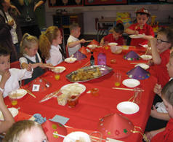

In preparation for our Olympic games we were lucky enough to participate in some sessions with visiting specialists where we learned some cool Judo moves, threw the javelin, tried the long jump and took part in some team races. We also experienced the Paralympic team sport of Boccia. We all thoroughly enjoyed competing in our Olympic afternoon and cheered on all of the competitors with great team spirit.

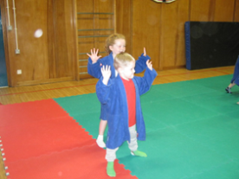 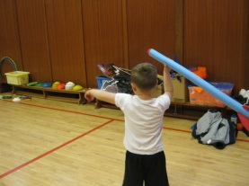 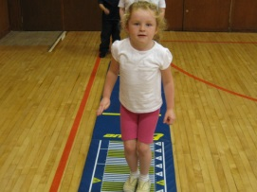

I am sure you will agree that we have made a very positive start to Primary 1 and we hope that this is set to continue. Now that the celebrations of Halloween and Bonfire Night have passed, we can look forward to preparing for the very special time of year that is Christmas and all the fun and excitement that it brings.



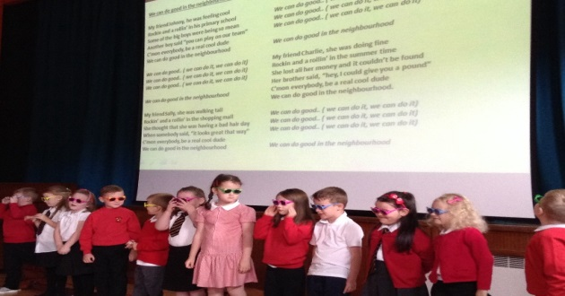**Primary 2**

We have had a very busy and productive start to the year. We were set the task of performing our class assembly on friendship after only a few weeks back in school and we did a fantastic job. We loved wearing our sunglasses, becoming cool dudes and performing our song ‘We can do good in the Neighbourhood’.

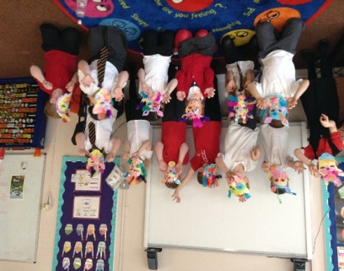

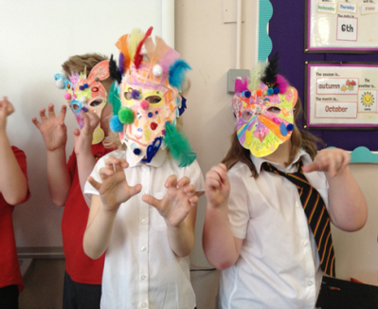We have thoroughly enjoyed all of the work we have been doing in class related to the Olympics. We have taken part in many different art activities which included creating carnival masks to wear during our performance at the Opening ceremony. Our Ancient Greek pots were displayed in class to show the many different sports that were included in the very first Olympic Games.

We now have the very special task of preparing for Christmas and are really looking forward to what lies ahead.

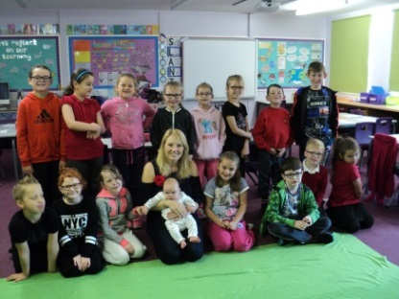**Primary P3/4**

We have had a great start to the session and have been enjoying learning all about South Africa and the Olympics as we prepared for the Blackburn Olympic Games. Some of our favourite things were creating our outfits, learning an African song and taking part in sports we would never have tried before such as Boccia. The Olympic Games were exciting to take part in and we enjoyed participating in our individual sport as well as cheering on our team!

This term we have begun a programme with Roots of Empathy who will be coming in every week for 27 weeks. We will be learning about what a baby needs to grow and flourish. We had our first very special visit from baby Zara and mummy Julie to our class. They will be visiting with us every three weeks as we look at how Zara is growing and the different things she is able to do.

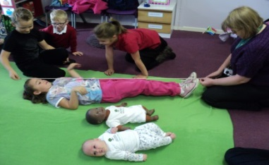We had great fun guessing baby’s weight in bags of sugar and measuring ourselves against a baby and a doll. P3/4 are all very excited for the next visit from Zara and are sure to be learning lots of new things throughout the programme.

**ASD1**

Pupils in ASD1 have settled in well since the start of term coping with new staff, in the form of PSW, Clara and teacher, Miss Carson and changes to the class set up and some routines.

Just before the October break pupils in the class did very well presenting a story, “Stone Soup”, at the Harvest Assembly. They made resources, read parts from the story, which was recorded into a PowerPoint presentation and they all took part in a mime which dramatized their story. Later on this month we will be presenting our St. Andrew’s Day Assembly on Friday 25th November.

Pupils enjoyed learning what superheroes Team GB’s Paralympians are and have even had an opportunity to try out some sports that feature in the Olympics and Paralympics; Judo, Athletics and Boccia.

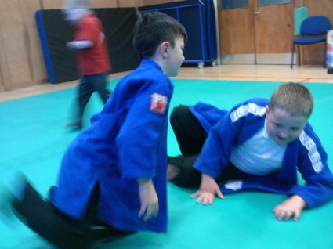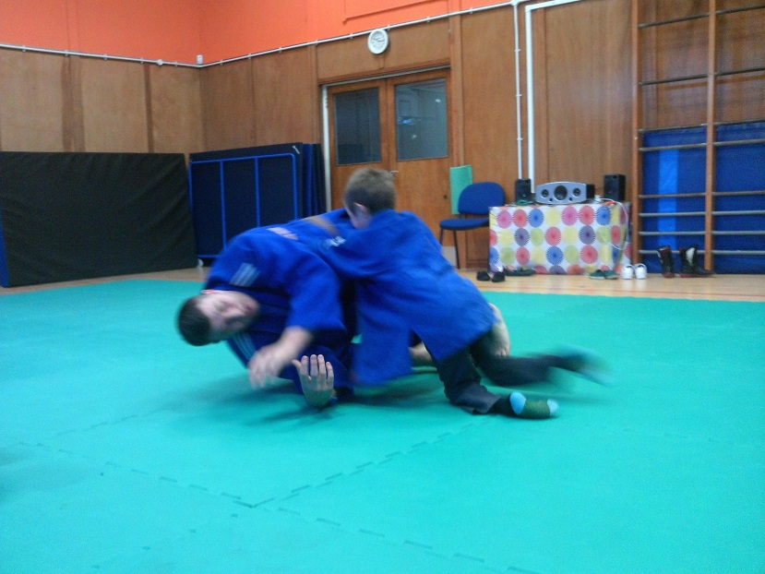

The bigger they are the harder they fall!

Practising our judo rolls.

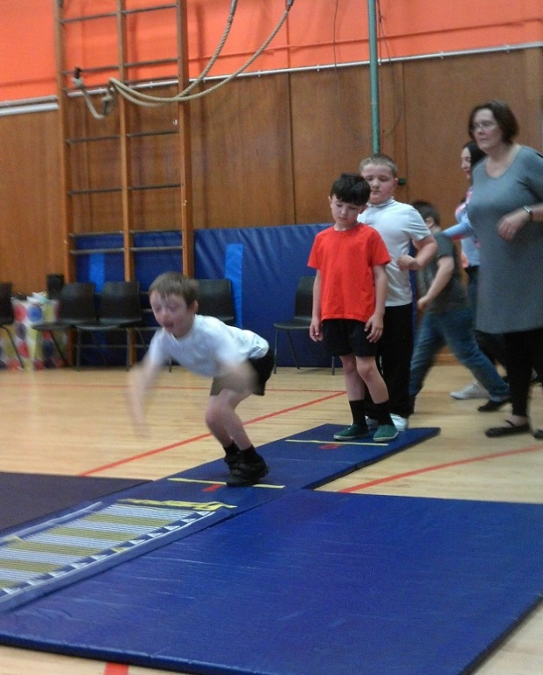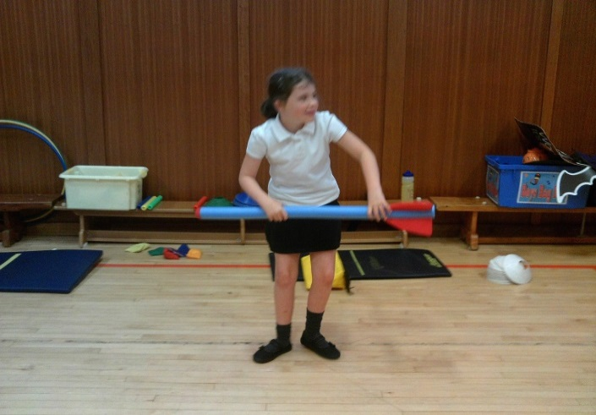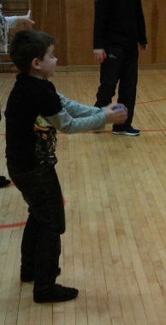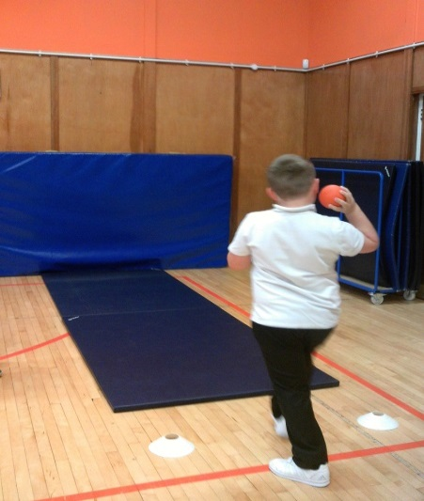Trying out the shot-put, javelin, Boccia and standing long jump ahead of the Blackburn primary Olympic Games.

All pupils from ASD1 competed with their countries as part of Blackburn’s Olympic Games Sports event and some even won medals for their country.

**ASD2**

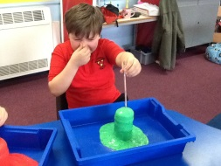ASD2 have had a great start to this session. We have thoroughly enjoyed our Olympics topic and the challenge set by Miss Clarkson of becoming Team U.S.A. We learned a little about the country itself, about its many states and some of its famous landmarks. Our highlight was making our hats and badges and learning our cheerleading dance for the Opening Ceremony. Performing was something we were all very proud of. Another thing we enjoyed was making homemade burgers and oreo cookies and cream milkshakes – they were delicious!

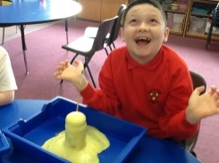The pupils in ASD2 also got into the Hallowe’en spirit after the holidays and enjoyed learning about chemical reactions in Science where we made our own Potions from bicarbonate of soda and vinegar. We decided to get into character though and add some bats blood, an eye of newt and a few hairs from a wizard’s beard. Some pupils perfected their cackle too!

We are looking forward to finishing off our Olympics topic and getting into the Christmas spirit by preparing for the end of term assembly.

**Primary 5/6/7**

This term primary 5/6/7 have been very busy on a number of different activities. To start things off we have been involved in our Olympics topic where the designs of our British flag, banner, hats and badges have engaged us in quality learning. The drumming and singing for the opening ceremony were a thumping success and the children really enjoyed their performance. I’d like to say a huge congratulations to all the winners of events during our Olympic games and a special well done to those children who took part in the 800m as they all showed real resilience in completing it.

We have also had the opportunity to take part in a few educational visits. The P5’s and 6’s had great success during the handball tournament. The P6’s and P7’s just about survived their visit to the risk factory. P4 - P7 footballers also took part in an after school inter football event. Here’s hoping with a little more practice success will grow.

During the month of November we have been learning about Remembrance Day and how Poppy Scotland helps veterans. We looked at famous poems and created our own having been inspired by images from WW1. I was very impressed with how poignant and considered some of them are. I’m sure you will agree that our assembly was a great success and we shared our learning very positively.

**Winter Ready West Lothian 2016/17**

****West Lothian Council has launched its public information campaign Winter Ready West Lothian 2016/17.

The campaign highlights the council's preparations for possible severe weather and encourages local people to prepare now. Severe winter weather can include snow, frost and low temperatures, high winds and flooding.

More information is available at [www.westlothian.gov.uk/winter](http://www.westlothian.gov.uk/winter)

As with previous years the council has:

• Maintained salt stocks.

• Set up contracts with local suppliers for severe weather support.

• Provided an email alert service so that regular information can be sent direct to your inbox.

• Delivered refresher training to staff on all severe weather equipment.

• Published a Winter Ready supplement in the winter issue of Bulletin, the council newspaper.

The council is also asking residents and local businesses to help:

• Park sensibly as abandoned vehicles can cause serious issues.

• Share information with friends and neighbours, and spare a moment for vulnerable neighbours.

• Stay informed. Sign up for the email alert on the council’s website at www.westlothian.gov.uk/email, or sign up on the council Facebook page at www.facebook.com/westlothiancouncil or follow on Twitter at www.twitter.com/lovewestlothian for updates

• If you are able, clear the path and pavement in front of your home.

• Prepare your car and home ahead of the winter.

• Keep the winter issue of Bulletin handy.

Parents and carers should also ensure that their child’s school has up to date contact information.   Should severe weather hit, Groupcall is the way that schools will inform parents and carers about closures.

We would also advise parents to check the following sources for up-to-date information:

Traffic Scotland

[www.trafficscotland.org/](http://www.trafficscotland.org/)

Ready Scotland

[www.readyscotland.org](http://www.readyscotland.org)

Local Customer Information Service (CIS) or telephone 01506 775000

Teachers will be able to communicate with pupils via GLOW. We are in the process of reissuing pupils with GLOW usernames and passwords and we will revisit with pupils how to access GLOW from home.

We are continuing to work on developing our Glow Blog. The School link is [www.blackburnprimary.co.uk](http://www.blackburnprimary.co.uk)

Nursery link is https:/blogs.glowscotland.org.uk/wl/snonursery/

You can also access the West Lothian Snow day group on Glow.

**WINTER 2016 NOROVIRUS ADVICE**

In recent years we have seen a large number of norovirus outbreaks in nurseries and schools during the winter months and these have caused service disruption with staff shortages and many pupils being absent.

Norovirus, is sometimes called ‘winter vomiting disease’ because it usually occurs during the winter months.   Norovirus is very infectious and high numbers of children and staff can be affected at once. The symptoms of norovirus include sudden onset of nausea followed by projectile vomiting and/or diarrhoea and usually lasts 12 to 60 hours. Some people may have a raised temperature, headaches and aching limbs. Most people make a full recovery within 1-2 days, however some people (usually the very young or elderly) may become very dehydrated and require hospital treatment.

A person can become infected as a result of contact with an infectious case, contact with a surface contaminated with the virus or ingesting contaminated food or drink.

Outbreaks can be difficult to control and long-lasting because norovirus is easily transmitted from one person to another and the virus can survive in the environment. The most effective way to respond to an outbreak is to disinfect contaminated areas, to institute good hygiene measures including hand-washing and ensure good hygiene in the kitchen.

**Those who have been infected should be isolated for up to** 48 hours **after their symptoms have ceased. Please contact the school immediately if anyone in your family is suffering from the norovirus. If your child develops this disease in school or Nursery he or she needs to be isolated and you will be contacted to remove your child from school or Nursery. For further information on the norovirus please use the following website**

[**www.nhsinform.co.uk/norovirus**](http://www.nhsinform.co.uk/norovirus)

**Term Dates Blackburn Primary School & Hopefield Nursery Class - Session 2016/2017**

Monday the 21st of November 9.00 am Numeracy workshops for P1 and P2 parents and carers

Wednesday the 23rd November 9.00 am Numeracy workshops for ASD1 and ASD 2 parents and carers

Monday the 28th of November 9.00 am Numeracy workshops for P3/4 and P5/6/7 parents

Monday the 28th of November 2.30 pm Nursery Numeracy workshops for Pm Nursery parents and carers

Tuesday the 29th of November 10.30 am Nursery Numeracy workshops for Am Nursery parents and carers

Thursday the 8th of December 10.30 am Nursery Am pupils to Our Lady of Lourdes to watch the nativity

Friday the 9th of December 9.15 am Nursery Am children invited to the school to watch the Nativity

Monday the 12th of December 1.30 pm Nursery Pm children invited to the school to watch the nativity

Tuesday the 13th of December 1.15 pm Nativity, Christmas Concert, Craft and Cake

Tuesday the 13th of December Nursery Pm pupils to Mossside Court 1.00 pm to sing for the elderly

Wednesday the 14th of December Nursery Christmas Singalong and Nibbles at Blackburn Primary School 10.00 Am for morning children and 1.30 Pm for afternoon children. Staff will accompany the children to the school

Thursday the 15 th of December Christmas lunch: Children to donate £1 and wear Christmas jumper/tee- shirt/bobbly hat

Thursday the 15 th of December Nursery Christmas Fair 10.30 am for morning parents and carers and 2.30 pm for afternoon parents and carers

Friday the 16 th of December Bathgate Academy Pantomime performance

Friday the 16 th of December 8.45 am Breakfast for taxi drivers and escorts of ASD pupils. Children are welcome to have their breakfast in the school

Monday the 19th of December 10.00 am – 12.00 pm Whole School to Little Red Riding Hood Pantomime Howden Park Centre

Monday the 19th of December PM P3/4 party and ASD1

Tuesday the 20th of December AM P1/2 and PM P5/6/7 parties

Tuesday the 20th of December Nursery parties AM pupil 9.15 am to 11.15 am and Pm pupils 12.30 pm to 2.30 pm. A special visitor has been invited

Wednesday the 21st of December 9.30 am Christmas Church Service Blackburn and Seafield Parish Church

Wednesday the 21st of December 3.10 pm Pupils break up for Christmas holiday

Wednesday the 4th of January Nursery and school pupils resume

