Blackburn Primary School

Hopefield Nursery Class
May 2016 Newsletter

Head Teacher’s Comments:

The end of the school year is just around the corner however there is still a lot of work and events to get through before the end of June! This term is a very important time for our P7 pupils who will be starting their Secondary Education and our Nursery children who will be transitioning in to Primary 1. Our new buddies have undergone their interviews and are looking forward to meeting the new P1 pupils over the next few weeks in school and in the nursery.

Blackburn Gala Day
Blackburn Gala Day is on Saturday the 11th of June and the theme this year is “Through the Ages”. We have had a very good turnout in the past from families and I am always very impressed with the variety of imaginative costumes that are worn. I will be looking forward to walking with you all again this year along with the nursery and school staff. We would like to wish everyone representing us at Blackburn Primary during the various Civic Week competitions the very best of luck. Let’s hope we win some prizes this year.

Transition

P 1 teachers and buddies will be making visits to the nursery and starting the transition process. Please refer to notice boards and letters to find out when your child will visit their feeder schools and have their P1 induction session.

New Arrivals!

I am sure that many of you already know our lovely news that Miss McLuckie and her partner are expecting a baby in July. Miss McLuckie will leave on the last day of term and plans to have a full year’s maternity. I wish Miss McLuckie all the best and hope she has wonderful summer with her new baby. Miss Dick’s maternity year will be coming to an end and we look forward to her joining us next session. I am also delighted to say that we have a new member of staff joining us in a weeks’ time. Her name is Laura Hart and she will be covering all the classes and in the nursery until the end of the session before she will be allocated a class. I look forward to welcoming her to Blackburn Primary.

P5 – P 7 Outdoor Education Week/John Muir Award

It was such a pleasure to see our children flourish during our outdoor education week before the Easter holidays. I am fully committed to providing the pupils with outdoor learning opportunities and I was delighted that so many of our pupils engaged fully in the John Muir Award. The new opportunities the children experienced left me feeling proud of their achievements as they met new challenges every day. I was also impressed with the way that the children handled the climbing wall and the assault course when visiting the Edinburgh International Climbing Arena at Ratho.

Hilly Cows

I was also delighted that half of our pupils in Miss Carson and Miss McLuckie’s class were able to enjoy an overnight stay at the wooden wigwams at Hilly Cows near Kirknewton. During their time away the children enjoyed forest walks, forest craft and they also had workshops on glass making and pottery. Well done to all who attended and many thanks to the staff for making this a wonderful experience for all.

Growth Mindsets

The children at Blackburn have been learning about Growth Mindsets. Through developing a growth mindset this helps children to tackle their work with a more positive attitude. They have already engaged in learning about growth mindsets in a variety of ways and what we have been learning will soon be displayed in the reception area of the school. The children have also been given homework and this has been discussed at recent assemblies and I hope you are able to watch the videos on the website and discuss some of the issues that are covered in the programmes. You can access the videos on the following website: www.classdojo.com/BigIdeas The development of Growth Mindsets will be a priority in next session’s School Improvement Plan.

On line Payments/Ipayimpact

The school has recently gone live with Ipayimpact. This is a facility that allows you to create an account for you child/children to pay for lunches and milk and help your child with their lunch choices. Although lunches are free for all pupils in P 1 to P 3 we would encourage you to still create an account in order for you to make the lunch choices for your child. This will allow us to engage more in learning time and help to reduce the time spent in the office collecting and counting money and giving out change. I hope you are able to log on and create an account for your child however if you have any issues please get in touch with the office staff. The web address for Ipayimpact is: www.ipayimpact.co.uk

School Self Evaluation

I will shortly be asking for your views and opinions on the workings of the school through a survey monkey. Your views are important to all of us and it helps us to make improvements and inform our planning priorities for next session. Please look out for this before the end of term and we will alert you of this through a group call. Please supply us with your e mail address on the tear off slip attached.

End of Year Outing

This year our end of year trip is to The Helix Park in Falkirk to visit the Kelpies and enjoy the freedom of the park to celebrate the end of a very successful year. More information will follow.

I hope you will be able to join us for some of the events that are planned for the rest of the session and the staff and pupils are looking forward in joining you and celebrating our success and meeting new parents and pupils in June.

Miss Clarkson

Head Teacher

Blackurn Primary School and Hopefield Nursery Class

Nursery
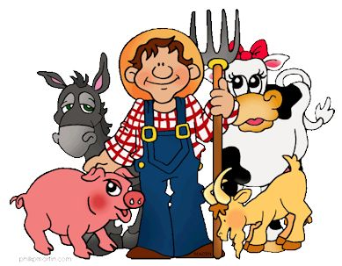
Our current context for learning in the nursery is farming. The main aim of this project is to learn about the different types of animals that live on a Farm, gain an understanding of how to look after them, and what farm animals produce milk, eggs, meat, wool etc.


The children were really keen to learn what jobs there were on a farm and who would do them. The children thought it would be a great idea to go and visit a farm to see the animals, the tractors and the farmers. We are all very excited about visiting Mill Farm. I am sure this will be very informative and consolidate what we have learned so far in nursery. We are also looking forward meeting with the Park Ranger from Almondell Country Park.

In the early years setting, learning is very much child led and our plans change depending on interactions and observations of your child, during structured and free play. We want to share with you (now on a new display board in the nursery entrance) what we plan to do during large and small group time and encourage you to share with us anything your child has enjoyed, found challenging or ‘taught you’ …


Our preschool children will be meeting their buddies this week from Blackburn Primary, Our Lady of Lourdes and Murrayfield. This is a very exciting time for the children and their families. Please look out for dates for your diary re transition and graduation dates.

We have recently had our Nursery painted and bought in some lovely new furniture and resources. The children have enjoyed using the new resources as have the staff. To quote Mrs Glen “it’s like a brand new Nursery”.

Primary 1/2
Well who can believe we are almost at the end of the school year. When our primary 1’s started they seemed so little and it’s amazing to see how much they have grown and developed their learning in just 1 year. Primary 1/2 have had a fantastic year and we are preparing ourselves for transitioning into primary 2 and Primary 3. This term we have started looking at Christian celebrations and have decided that we would like to have our very own wedding in Primary 1/2 so all parents and carers get ready to receive your invitation in the next few weeks. It will be a fantastic celebration to end the children’s time in Primary 1/2.

Primary 2/3/4

We have had a very busy time before and after the Easter holidays. The children enjoyed taking part and putting their practise to good use in the Blackburn Benchball Festival. We also had fun taking part in Book Week and particularly enjoyed being read to by all of the class teachers in the school. We have had fantastic time learning about Ancient Egypt and really liked writing our own stories about ‘The Hidden Tomb’ and ‘The Mysterious Mummy’. Along with ASD2 we had a very successful event to share our learning at our Egyptian museum and café afternoon. We would like to once again thank parents and carers for coming along to support our event. This term we look forward to our Celebrations and Festivals topic and making the most of the good weather by getting outside for PE lessons.

ASD1

We have started our new topic, Our Body, which is helping us to learn more about how our bodies work and the different ways in which we can be healthy and look after our selves. We have really enjoyed learning the skeleton dance which we will perform at our class assembly.

ASD2

The start of term 4 has been a busy one for pupils in ASD2. First of all we worked hard to finish off our Ancient Egyptian topic with P2/3/4 and we held a joint Sharing the Learning event with them on Thursday 21st April. This was split into two parts; a museum, which P2/3/4 took charge of, and the Pyramid Café, which ASD2 ran.

One of our pupils invited all the families and friends who came along to come and try some Egyptian food in our Café. We had researched foods from Egypt and even found a recipe that was made thousands of years ago. Pupils took on a variety of roles in the cafe; they were waiters, a cashier, a sous chef and kitchen porters and they did a great job.

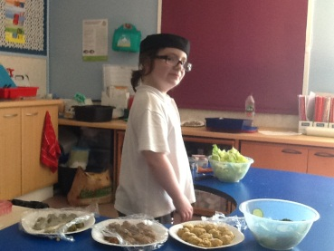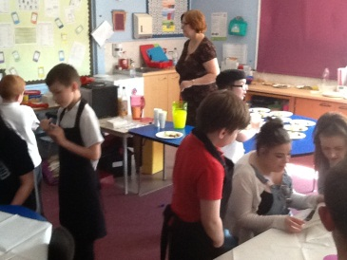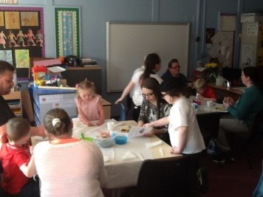

We want to thank everyone who came along and supported this part of our Sharing the Learning event. Read more about it on the blog.

Then on 28th April some pupils from our class, along with staff members, went on an overnight residential stay and outdoor learning opportunity at Hilly Cow wigwams. Read all about that on the blog at www.blackburnprimary.co.uk or in the Hilly, Chilly Adventure article in this newsletter.

In term 4 we’ll be looking at the different things we celebrate in our topic of Celebrations: fairs, feasts and festivals.

Primary 5/6/7

With the end of year fast approaching thoughts in P5,6,7 have turned to moving up and moving on and of course towards leavers assemblies and leavers trips (the children won’t let me forget the latter). However, prior to the heated debates about locations for the P7 leaver’s trip, the children have been working very hard over the course of this term on a number of things. I am sure you will all join me in recognising the huge success of our John Muir outdoor learning week cumulating in the fantastic effort the children put in for our assembly. I can honestly say that every single child worked their hardest, tried their best and challenged themselves over the course of the week and it was an absolute pleasure being able to see them all learning out with the classroom environment. This term in our interdisciplinary learning we have been looking at parliaments and elections. This has coincided nicely with the recent Scottish government elections which allowed the children to make relevant and real world links to their learning. Hopefully this will result in the children coming home and debating, not arguing, about doing their housework and tidying their rooms.

Health Committee – Fun Fives and beyond.

At the end of last term, the Health Committee held a sponsored event for Sport Relief. After many discussions we came up with the idea of the Fun Fives – running laps in the playground in multiples of 5, with some activities added in to make things more fun!
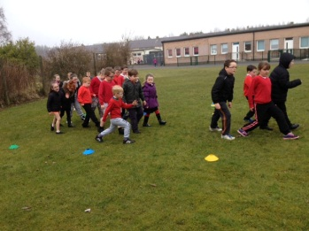
Movement Monday saw pupils run 5 laps of the whole playground with a different kind of Movement to do when they reached the movement lanes. Lap 1 was go fast, lap 2 was go slow, lap 3 was hopping, lap 4 was jumping and lap 5 saw pupils going low.
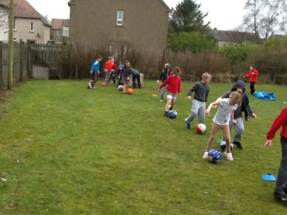
On Ball Skills Tuesday the lap area was reduced to a coned circuit at the top end of the school and pupils had 10 laps to do. Every second lap pupils took time out to practise a ball skill: dribbling or shooting a football, balancing a ball on a tennis racquet, jumping with a ball between their knees and shooting for basketball hoops.

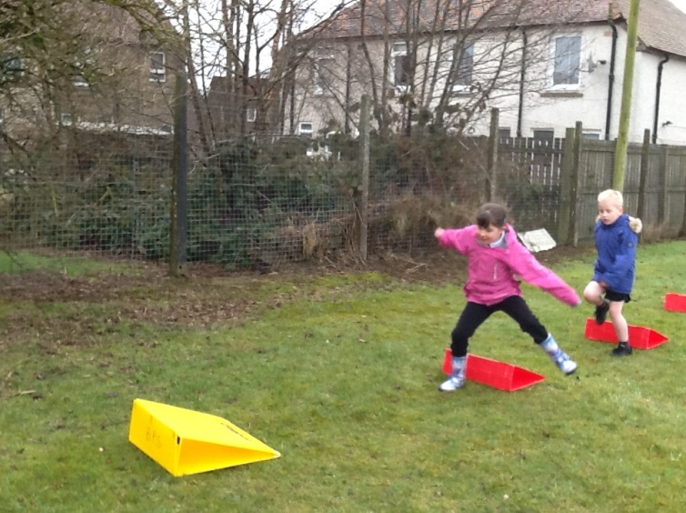
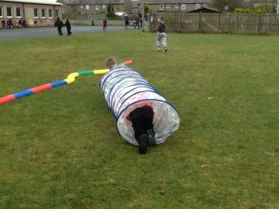
Up, over and under Wednesday meant pupils completed up to 15 laps with different obstacles to negotiate every third lap. Pupils went over hurdles, under canes, through a tunnel, side jumped or walked along a balance lane and then completed the trim trail.
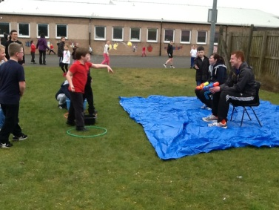
Throwing Thursday allowed pupils a chance to practise their aiming and throwing skills every fourth lap of 20. They threw beanbags into hoops, balls into boxes, distance threw beanbags and javelins and, best of all, got to throw a wet sponge at a teacher! Three members of staff volunteered to sit in the wet seat for this and got pretty wet by the end of this.

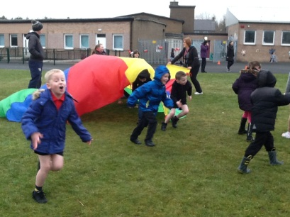
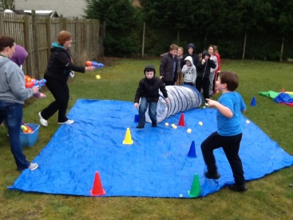
Frizzy, Freaky Friday was a mix up of more fun elements to sport. Pupils ran up to 25 laps and took time out every fifth lap to do a silly activity. They started by commando crawling under a big parachute, then it was time to pull something out the dressing up box to wear for the next 10 laps or so. This was followed by the egg and spoon lap and the hula hoop skipping lap and this finally led to the “Danger Zone” where pupils crawled through a tunnel to be met by staff armed with wet sponges and water pistols! Lots of pupils dodged this well but many of them managed to go through the Danger Zone several times!

We managed to have fun and raise a fantastic £150 for Sport Relief. Thanks to all involved. For more information and photos check out the school blog at www.blackburnprimary.co.uk

We are hoping to use feedback from this event and sport questionnaires to plan regular, structured, whole school exercising in line with initiatives like the Daily mile. We may start trialing this next session.

Parents Comments

If there are any comments you wish to make please complete this tear off slip below.

…………………………………………………………………………………………………………………………………………………………………………………………………………………………………………………………………………………………………………………………………………………………………………………………………………………………………………………………………………………………………………………………………………………………………………………………………………………………………………………………………

…………………………………………………………………………………………………………………………………………………………………………………………………………………………………………………………………………………………………………………………………………………………………………………………………………………………………………………………………………………………………………………………………………………………………………………………………………………………………………………………………

-----------------------------------------------------------------------------------------------------------------------------

Updated Parent/Carer Email Address

Name of Pupil/s: _____________________________________________ Stage: _____________

Name of Parent/Carer: ________________________________________

Email address: ____________________________________________________________________

-----------------------------------------------------------------------------------------------------------------------------

Dates for your Diary

Term 4 Session 2015/2016

Date | Event

May
Tuesday the 17th | Blackburn buddies visiting pre – school pupils at Hopefield Nursery 9.30 am and 1.30 pm  OLOL buddies visiting pre – school pupils at Hopefield Nursery 10.00 am and 2.00 pm
Wednesday the 18th | Bathgate Academy Blazer fitting 6pm – 7.30 pm
Wednesday the 18th | Nursery am pupils visiting Mill Farm 9.30 am – 2.30 pm
Thursday the 19th | Bathgate Academy Blazer fitting 6pm – 7.30 pm
Thursday the 19th | Nursery pm pupils visiting Mill Farm 9.30 am – 2.30 pm
Friday the 20th | Auditions for Gala Blackburn’s Got Talent
Tuesday the 24th | Buddies visiting pre – school pupils at Hopefield Nursery 9.30 am and 1.30 pm
Thursday the 26th | Am nursery children will be taken to OLOL at 9.30 am and pm children will be taken at 1.30 pm to meet with their buddies and their teacher

June
Friday the 3rd | Blackburn’s Got Talent Competition Blackburn Community Centre 6.30 pm – 9.30 pm
Tuesday the 7th | Pre-school pupils visiting Blackburn Primary School 9.30 am – 10.30 am
Tuesday the 7th | Inter School Gala Day Quiz at Murrayfield Primary School 6.30 pm – 8.00 pm P 5 – P7
Tuesday the 7th | Bathgate Academy Transition Day 1
Wednesday the 8th | Bathgate Academy Transition Day 2
Wednesday the 8th | Civic Week Magic Show for Nursery pupils 10.00 am – 11.00 am
Wednesday the 8th | Multi sports festival for P3 and P4 pupils Blackburn Community Centre 1.30 pm – 3.00 pm
Thursday the 9th | Bathgate Academy Transition day 3
Friday the 10th | Bathgate Academy Transition day 4
Saturday the 11th | Blackburn’s Gala Day
Tuesday the 22nd | Nursery Sports Day 9.30 am and 1.30 pm
Tuesday the 14th | Primary 1 Induction afternoon for pre-school pupils
Wednesday the 15th | St Kentigern’s Transition Day 1
Wednesday the 15th | ASD resource annual reviews
Thursday the 16th | ASD resource annual reviews
Thursday the 16th | St Kentigern’s Transition Day 2
Thursday the 16th | Sports Day 1.30 pm
Friday the 17th | Nursery Induction Afternoon
Friday the 17th | St Kentigern’s Transition Day 3
Thursday the 23rd | Whole School Celebration Award Ceremony 1.30 pm
Friday the 24th | P7 Leaver’s Trip
Monday the 27th | Nursery Graduation 9.30 am  P7 Leaver’s Assembly 1.30 pm
Tuesday the 28th | Outdoor trip
Wednesday the 29th | Last day of the session. School closes at 3.10 pm

After School Clubs:

The Basket ball club finishes on Monday the 6th of June

The homework club finished on Tuesday the 7th of June

The Jewellery Club finishes on Wednesday the 8th of June

The Walking club finishes on Thursday the 16th of June

Walking Club Dates
Date | Venue
Thursday the of 19th May | Blackburn Moss
Thursday the 26th of May | Beecraigs Country Park
Thursday the 2nd of June | Linlithgow Loch
Thursday the 9th of June | Polkemmet Country Park
Thursday the 16th of June | Union Canal Linlithgow

