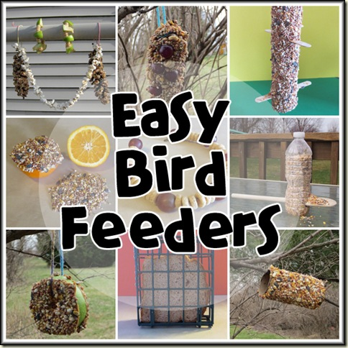
Of course, the easiest way to feed the birds is just to throw some popcorn and seeds on your patio table, but we want to have some hands-on, project-creating fun today!
For our first bird feeder, you only need 3 components: an empty toilet paper roll, peanut butter, and bird seed. Using a spoon or knife, spread a thick layer of peanut butter all over the cardboard roll. Spread it thick because #1: birds love peanut butter, and #2: the more peanut butter you have, the more seeds will stick to the roll. Roll it around in the seed, making sure to press.
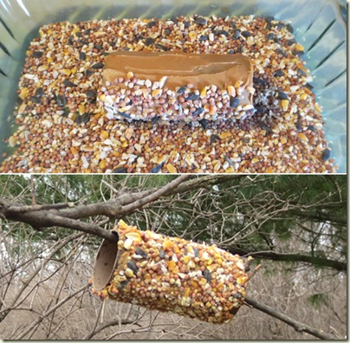
Your next step is to slide the roll onto a branch, like above. You can also do this with pinecones. Additionally, with pinecones, you can stuff grapes in between the scales for an extra sweet treat.
The next project involves another cardboard tube – a paper towel roll. For this bird feeder, you’ll need an empty paper towel roll, 2 wooden craft sticks, peanut butter, and bird seed. Follow the same steps that you did for the first feeder, but cut some slits in the cardboard tube before you spread the peanut butter. It is a good idea to insert the craft sticks into the slits before spreading the peanut butter, otherwise you may never locate your slits! The craft sticks provide a place for little birds to sit while they enjoy their treat.
