

Bankton Nursery Newsletter
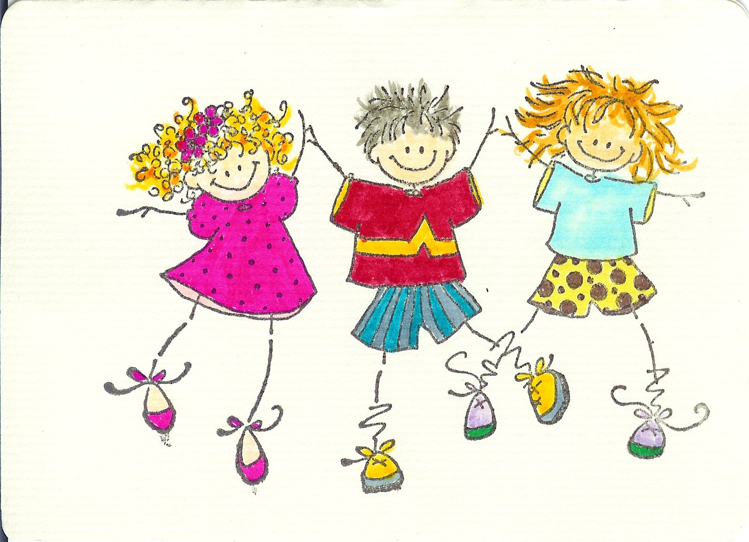

January 2015
Happy New Year

We would like to wish you all a Happy New Year. We are delighted to see everyone back at nursery. We have enjoyed hearing about all excitement of the holidays from the children. It seems Santa has been very good to everyone.

We are looking forward to lots of fun and learning in 2015.

Dates for your Diary

22nd January – Burn’s Day at Nursery
13th – 16th Feb – Holiday

Nursery News

We would like to inform you that Mrs Morrell has been successful in her application to reduce her hours. It has been agreed that she will work morning sessions and in consultation with West Lothian Council Gemma Lynch has been appointed for the afternoon sessions. Miss Lynch will start on the 2nd February and will work closely with Mrs Morrell to ensure a smooth transition.

Mrs Morrell will be greatly missed in the afternoon session but we wish her well in her new adventures and look forward to welcoming a new member to the nursery team.
Reminders

Please Remember - Thursday afternoon and Friday morning are our outdoor classroom days. Please ensure your child has suitable footwear and a warm, waterproof coat as we will be using the woodland areas and will be out in all weather.

Library

This term we will be making use of the library at the Lanthorn. We will be visiting the library every two weeks and would appreciate it if you could return the book bag so your child can select a new book each time.

Health and safety

We have now set up passwords for collecting children. Please ensure anybody new collecting your child knows the password. Feel free to contact us if you need a reminder of this password.

If you have not set up a password yet please do so as soon as possible.
This month in the Nursery our topics will be:

Winter
Big Garden Birdwatch
Burn’s Day
Up and Coming
Following the success of previous years we are hoping to organise a block of dance sessions with Danceworld.

This term watch out for dates for Come and Play week when parents and carers are welcome to come and join their children in the nursery.

