**Bankton Primary School**

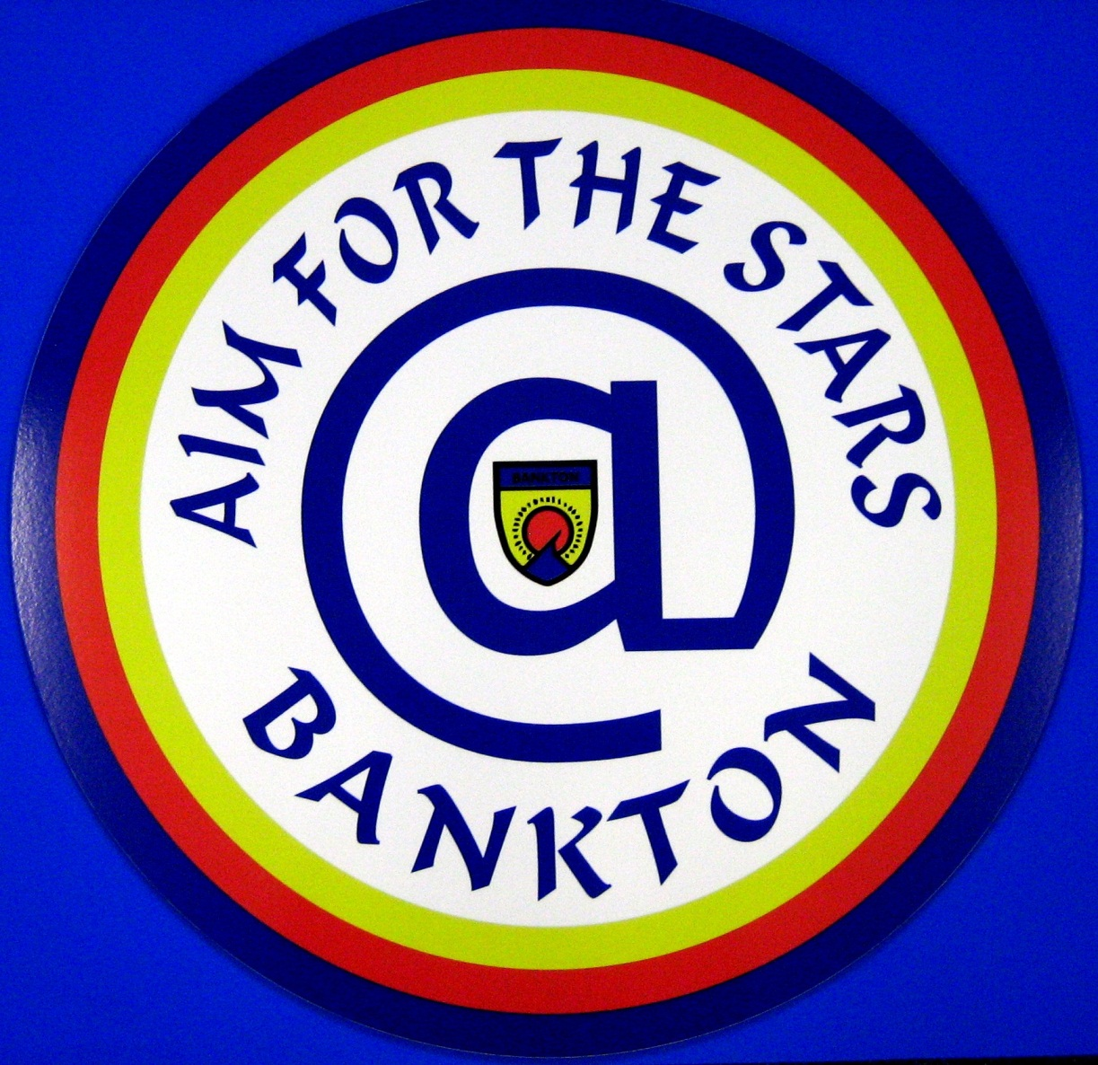

**School Handbook**

**A Warm Welcome to Bankton Primary School!**

On behalf of all staff I am delighted to welcome you to the Bankton Learning Community.

I hope that this will be the beginning of a positive partnership, both for you and your child, and that you will always feel welcome in Bankton!

Our school is at the heart of the Dedridge Community and therefore we value our strong home/ school partnerships, recognising and welcoming the support that parents can offer, not only to their children, but also to the wider school community. We aim to ensure that you are involved in your child’s learning at all stages of school and strive to communicate effectively with you to allow you to support your child in a wide variety of ways to improve their learning experience.

Above all we hope that your child will feel valued and achieve success at each stage of their learning journey and will grow increasingly confident in their skills development to become a successful learner and truly confident individual. We provide a wide range of learning opportunities in Bankton which will lead your child to become a responsible citizen and an effective contributor to Scotland’s future.

We aim to educate your child within a happy, caring and secure learning environment which stimulates and motivates them to develop a wide range of skills for learning, life and work. We encourage them from the earliest stages in Bankton to follow the ‘Big Messages’ – the most important of which is:

**Respect for All @ Bankton PS!**

Throughout your child’s learning journey we will provide support with their physical, social, emotional and intellectual development to help them to grow into a well-rounded adult of the future, able to problem solve and cope with life’s challenges, showing resilience.

We have a tremendous sense of pride in our school and its place in the community of Dedridge and we hope to make you, as parents and carers, feel welcome at all times, by fostering an atmosphere of trust, mutual respect, equality and fairness.

I look forward to getting to know you and to working with you and your child!

**Jacqueline Stewart, Headteacher**

**CONTACT DETAILS**

Bankton Primary School and Nursery Class

Kenilworth Rise

Dedridge

Livingston

EH54 6JL

Headteacher: Mrs. Jacqueline Stewart

Tel: 01506 413001

Council webpage: <http://www.westlothian.gov.uk/sitecontent/schools/Bankton>

Email:bankton.ps@wled.org.uk

**CONTEXT OF THE SCHOOL**

Bankton is a non-denominational school serving the communities of Dedridge and Adambrae in Livingston South. The school provides for both nursery and primary children from 3 -12 years old and is an integral part of The James Young Cluster of schools. The present role is 70 in Nursery and 329 in Primary.

Bankton Primary School is currently staffed by a Headteacher, Depute Headteacher, Principal Teacher and 12 Class Teachers from P.1 – P.7. The forty place Nursery Class is staffed by 1 Nursery Teacher and 3 Nursery Nurses. The Nursery is line managed by the Depute Headteacher.

Pupils at all stages benefit from the expertise of specialist teachers in Music ,P.E. and Support for Learning. Instrumental tuition is provided from P.4 in Recorder and from P.6 in Brass and Bagpipes.

An Administrative Assistant, Clerical Assistant, Pupil Support Workers, Facilities Management Assistants, Kitchen Staff and Cleaning Staff all fulfill important roles in the Bankton Learning Community and are instrumental to the smooth running of our school.

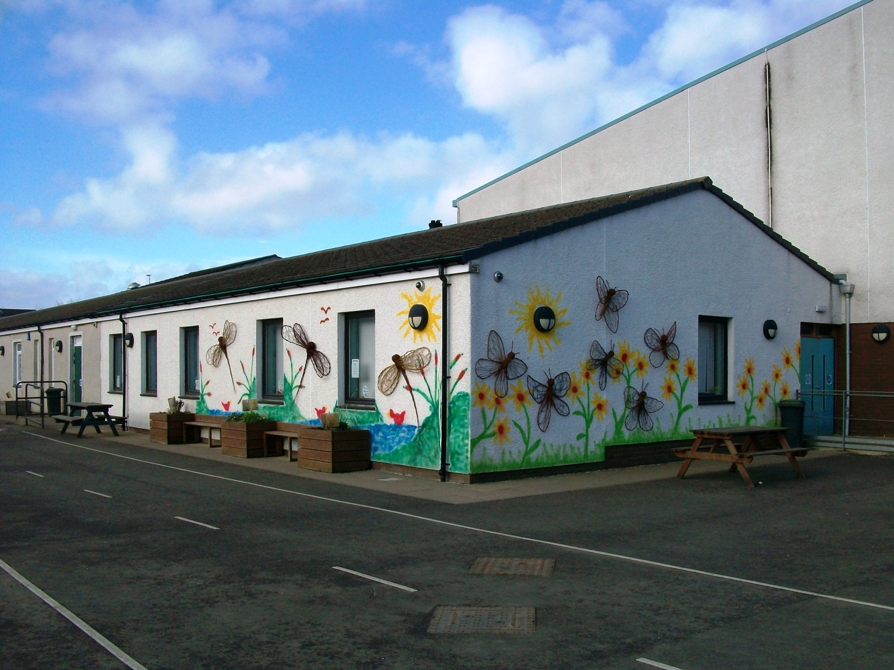

**P.1 Entrance at the rear of the school**

**THE STRUCTURE OF THE SCHOOL DAY**

Pupils throughout the school have the same start and finish times. Lunch times are staggered to provide positive supervision and maximise play space. Older pupils with a longer concentration span have a longer afternoon session.

|  |  |  |  |
| --- | --- | --- | --- |
| **P.1 – P.2** | | **P.3 – P.4** | **P.5 – P.7** |
| a.m.  Session | 8.45 – 10.30am | 8.45 – 10.30am | 8.45 – 10.30am |
| Break | 10.45 – 12.30 | 10.45 – 12.15 | 10.45 – 12.00 |
| Lunch | 12.30 – 1.15 | 12.15 – 1.00 | 12.00 – 12.45 |
| p.m. Session | 1.15 – 3.05 | 1.00– 3.05 | 12.45 – 3.05 |

On Fridays, all pupils finish at 12.30pm.

School term dates and holidays can be accessed online at :

[www.westlothian.go.uk/sitecontent/documentlist/educationpolicy/AttendanceatSchoolwithGuidelines](http://www.westlothian.go.uk/sitecontent/documentlist/educationpolicy/AttendanceatSchoolwithGuidelines)

**SCHOOL UNIFORM**

West Lothian Council has a dress code policy promoting the wearing of school uniform. This is detailed in the following link:

<http://www.westlothian.gov.uk/sitecontent/documentlist/educationpolicy/dresscodeforschools>.

At Bankton Primary School we are particularly proud of our school uniform and the standard this sets in the local community. The uniform is fit for purpose, allowing children to be comfortable in their learning. We would welcome support from parents in positively encouraging school uniform.

**Please note that if your child is representing the school in public, they should wear a shirt and tie as this will always be the official school uniform.**

The uniform is as follows:

Black trousers/skirt/pinafore White shirt/blouse School tie*

Black shoes Bankton l Sweatshirt* Blue Polo Shirt*

A black cardigan or jumper with the school badge and P.7 logo will provide a ‘status’ uniform for P.7 pupils.

Please label ALL items of clothing clearly with your child’s name and class to prevent lost property.

For PE pupils must bring a Tshirt / shorts and black/white gym shoes which will be kept in a drawstring bag supplied by school. **No football colours should be worn in school.**

For health and safety reasons we discourage the wearing of jewellery to school. **Please also note that girls should not wear make-up, coloured hair dye or nail polish to school.**

**OUR SCHOOL VISION STATEMENT**

**“Our vision is for Bankton Primary School to be the heartbeat of the Dedridge Community, providing rich and exciting learning experiences for all. To be recognised as a school which values wider achievement, and has high expectations and aspirations”**



**OUR SCHOOL AIMS**

* **We aim to provide learning experiences which are challenging, motivating and have high expectations for all**
* **We aim to deliver a broad, balanced range of experiences in a variety of different learning contexts, both in the classroom and in the wider outdoor environment**
* **We aim to help all pupils to progress in their skills development and build on their prior knowledge and understanding**
* **We aim to provide learning opportunities which allow all pupils to develop their full capacity for different types of thinking and learning**
* **We aim to support each child’s particular skills and talents by providing opportunities for personalisation and choice in learning**
* **We aim to help our children develop the transferable skills they will need to take their place in tomorrow’s world.**
* **We aim to deliver a curriculum which is relevant to our children’s lives, today and in the future**
* **Above all, we aim to value our children and to develop them as the successful learners, confident individuals, effective contributors and responsible citizens of Scotland’s future**

**SCHOOL IMPROVEMENT**

All staff, pupils, parents and partner agencies have an important part to play in school improvement. The work of the school is evaluated each year in May in the Standards and Quality report. Through this report new priorities are identified and presented to West Lothian Council and the Parent Forum through the School Improvement Plan. The priorities are clearly detailed with responsibilities and timescales and help to inform a clear sense of direction for the school during the coming year.



**THE CURRICULUM**

Curriculum for Excellence is now being implemented in Scotland for all 3-18 year olds. Pupils across all stages of Bankton will experience a broad and balanced curriculum which will encourage them to develop transferable skills to equip them for the future. Through active learning and collaborative working they will learn to work individually and in teams to solve problems, meet challenges, make informed decisions and explain their thinking.

Curriculum for Excellence enables professionals to teach subjects creatively, in a way which engages, motivates and excites children.

Teachers will share information to plan a child’s learning ‘journey’ throughout their time in school. This will ensure progression and a smooth transition from Nursery to Primary and Primary to Secondary. As part of this learner’s journey staff and pupils will discuss targets and next steps in attainment and wider achievement. There will also be a balance between the importance of knowledge and skills development.

Every child, whatever their level and ability is entitled to a broad and deep general education.

Every teacher and practitioner will share equal responsibility for the development of literacy, numeracy and health and wellbeing.

Through Curriculum for Excellence we aim to improve the life chances of all pupils, making them successful learners, confident individuals, effective contributors and responsible citizens ready to take their place in Scotland’s future.

**ASSESSMENT**

Assessment is an integral part of day to day teaching and learning. Staff monitor the progress of learners closely, helping pupils to reflect on their current strengths, learning needs and next steps for development.

Pupils themselves will be increasingly involved in this process as they learn to evaluate their own progress and make effective judgements on their learning.

A range of assessment tools will be used by staff and pupils to help build an achievement profile for all children. Assessments are carried out in many different ways, each appropriate to what is being learned. Assessments are based on what the child can write, make, say or do.

We use assessment to ensure that the work planned by the teacher is appropriate in meeting learners’ needs. Plans are altered in response to assessment to ensure that efficient and effective learning takes place.

C:\Users\jacqueline.stewart\AppData\Local\Microsoft\Windows\Temporary Internet Files\Content.IE5\2SUMWJ3R\MC900098039[1].wmf

**REPORTING**

Parents’ Consultationevenings arearranged twice a year, usually in October and March. Staff will report to you as parents, informing you of ‘how much’ and ‘how well’ your child is learning. A written report is produced in June detailing how your child has progressed in all areas of the curriculum over the year. It will give a clear indication of the knowledge and skills acquired by your child during the session and comment on the quality of progress your child has made in Literacy, Numeracy, Health and Wellbeing and Learning Across the Curriculum.

If you have any concerns about your child’s progress, please make an appointment to speak to the Class Teacher or a member of the Management Team.

**CURRICULUM 3-18**

**The primary curriculum is divided in to 8 main areas:**

**Languages:- Literacy and English; Modern Languages Numeracy and Mathematics**

**Health and Wellbeing Social Studies**

**Sciences Technologies**

**Expressive Arts Religious and Moral Education**



**Languages**

**Literacy and English**

Literacy skills are important skills for learning, life and work and are given high priority at Bankton Primary. From the earliest stages of P.1 pupils continue to develop the reading, writing, listening and talking skills already established at home and at nursery. They learn to communicate in a variety of ways including the use of technology and learn to read for a range of purposes. Writing is valued throughout the school and pupils are actively encouraged to develop their ideas and present their work to a high standard.

Staff use cross curricular opportunities to stimulate and motivate children in literacy and language development, to help children see connections across the curriculum and to make learning meaningful. We aim to encourage all of our children to use language interestingly, imaginatively, appropriately and precisely.

In line with the other schools in the James Young Cluster, pupils in Bankton will learn French as their core language from Nursery to P.5. From Nursery to P.4 Children will experience Modern Languages teaching through songs, greetings, games and role play. At these stages the emphasis remains on active learning, fun and enjoyment.

P.5 – P.7 children are encouraged to consolidate their learning in listening and talking and further develop more formal reading and writing skills in the appropriate language. From session 2014 – 2015, pupils will also have blocks of lessons in a second modern language. These lessons may include German, Spanish, Mandarin or Polish depending on resources and staff training.

**Mathematics and Numeracy**

C:\Users\jacqueline.stewart\AppData\Local\Microsoft\Windows\Temporary Internet Files\Content.IE5\2SUMWJ3R\MC900332680[1].wmf

In Numeracy and Maths we plan to enable children to:

* Develop essential numeracy skills which will allow them to fully participate in society
* Develop a secure understanding of the concepts, principles and processes of mathematics and apply these in contexts relevant to real life

Mathematics is made up of distinct outcomes and experiences:

Number, money, measurement / Shape, position and movement and Information Handling. In all of these areas children have the opportunity to develop problem solving and enquiry skills. The use of ICT is evident throughout the maths programme with suitable interactive programmes and websites used at all stages.

Development of mental maths from the earliest stages is a high priority to improve confidence in all numeracy activities.

During Numeracy and mathematics pupils have the opportunity to learn in new and exciting ways. These include learning as a whole class, in pairs, groups or individually. Often these experiences are related to real life contexts across the curriculum in order to motivate children in learning which has relevance for them.

**Health and Wellbeing**



All pupils in Bankton need to learn to develop, physically, socially and emotionally in order to enjoy and live a healthy life-style. Within a progressive framework, children are provided with opportunities to develop the knowledge, understanding, skills, capabilities and attributes which they need for mental, social, emotional and physical wellbeing, now and in the future.

Promoting Health and Wellbeing at school is embedded in a variety of activities offered during the day and through extra-curricular activities. We encourage healthy eating and discourage sugary snacks and drinks which could be harmful to dental health.

We take a holistic approach to health and wellbeing and our progressive framework aims to promote learning about:

* Health – mental, social, emotional and physical
* Physical Education and physical activity including sport
* Eating for health and hygienic practices
* Personal safety / relationships and moral education
* Drugs, alcohol and tobacco
* Planning Choices

Parents will be informed, in advance of any area of learning that may be of a sensitive nature. Full information will be shared with resources available to view if necessary.

**Social Studies, Sciences and Technology**

These areas of the curriculum are often taught in an inter-disciplinary learning context. This means that children can make meaningful links between subject areas, learning in a deeper way.

Through Social Studies, children learn about people and their values, in different periods of time and in different contexts, developing a better understanding of the world .

Opportunities exist for studying the local environment and how it has evolved. Visitors are encouraged to visit the school to discuss their business and help pupils develop their enterprise skills.

There are five main learning outcomes in Science:

Planet Earth Forces, Electricity and Waves Biological Systems Materials

Topical Science

Through Science pupils practise a range of inquiry, investigative and, thinking skills. Through active and experiential learning they will develop informed attitudes and attributes to become scientifically literate citizens of the future.

The Technologies framework includes creative, practical and work-related experiences and outcomes in business, computing science, food, textiles, craft, design, graphics, engineering and applied technologies. Children also develop an understanding of the role and impact of technologies in Scotland and the global community.

**Expressive Arts**

**C:\Users\jacqueline.stewart\AppData\Local\Microsoft\Windows\Temporary Internet Files\Content.IE5\X51IO9B9\MC900097543[1].wmf**

Teachers plan and deliver lessons in all four areas of Expressive Arts: Art and Design, Music, Drama and Dance. Pupils experiences are further enhanced through the input of a Music Specialist and Instrumental tuition in recorder, Brass and Bagpipes. Performance through assemblies and school shows provide confidence building and rich experiences for pupils at all stages of school. Wider Achievement is highly valued at Bankton and the school has a positive reputation for success in choral singing, poetry performance and instrumental performance in many local and national competitions.

**Religious and Moral Education**

Through the Religious and Moral Education programme pupils extend their awareness and understanding of the practices and traditions at the centre of world religions.

The main Christian festivals are recognised and celebrated through Assemblies and Services organised by the Chaplaincy team based at the Lanthorn.

Parents have the right to withdraw their child from religious observance and would do this after consultation with the class teacher. Alternative learning experiences would be planned that promote personal reflection on values and other moral issues.

We encourage all children to appreciate moral values such as honesty, respect, fairness and concern for others.

**OUTDOOR LEARNING**

**The Outdoor Classroom**

There is a strong commitment in Bankton to developing children’s knowledge, understanding and skills beyond the classroom. Staff plan motivating cross-curricular experiences using the ‘outdoor classroom’. These lessons allow pupils to extend their learning within relevant contexts and to understand that their learning is deeply rooted in real life. The ‘outdoor classroom’ can mean using the school grounds or local outdoor environment for ECO / Maths / Citizenship / Health and Wellbeing skills activities. It can also mean visiting heritage sites or ancient buildings to develop a deeper understanding of people in the past. Classes at all stages of the school have opportunities throughout the year for visits which are directly related to topics being studied. Vertical groups also use the school grounds as ‘Garden Groomers’ and ‘ECO Watch’ litter patrollers. This ensures a real understanding of environmental issues and citizenship skills development

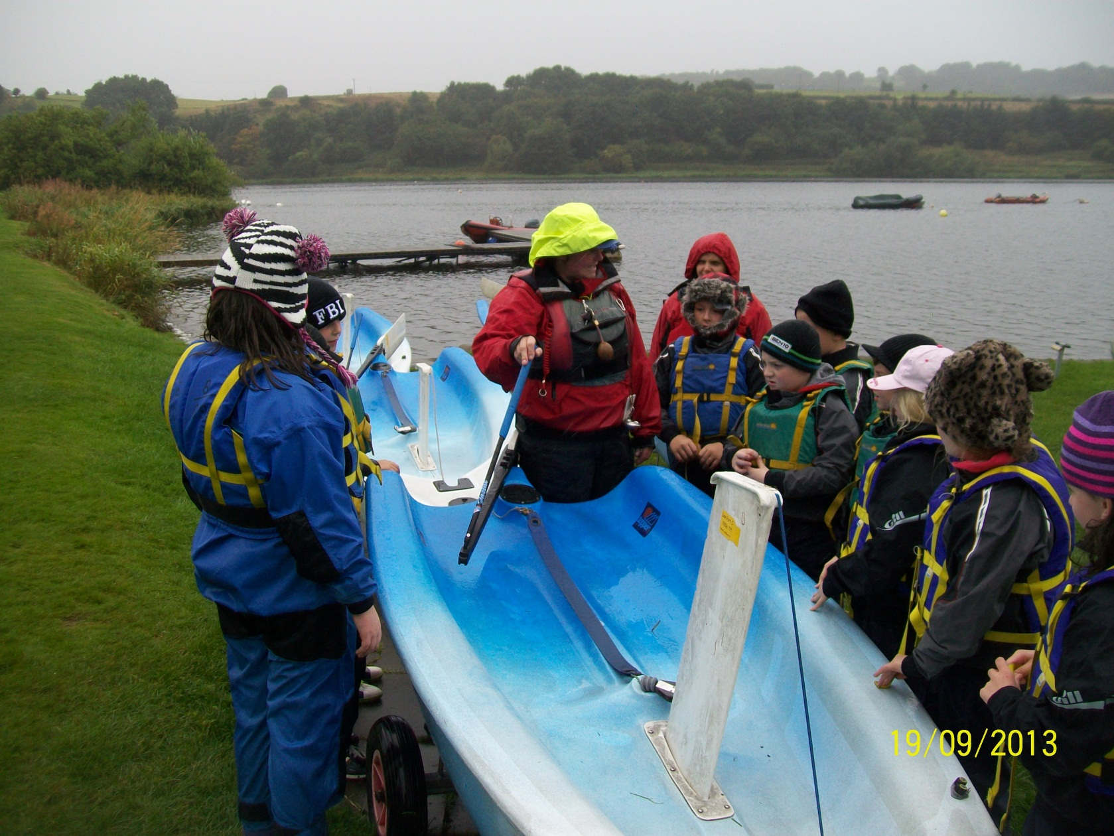

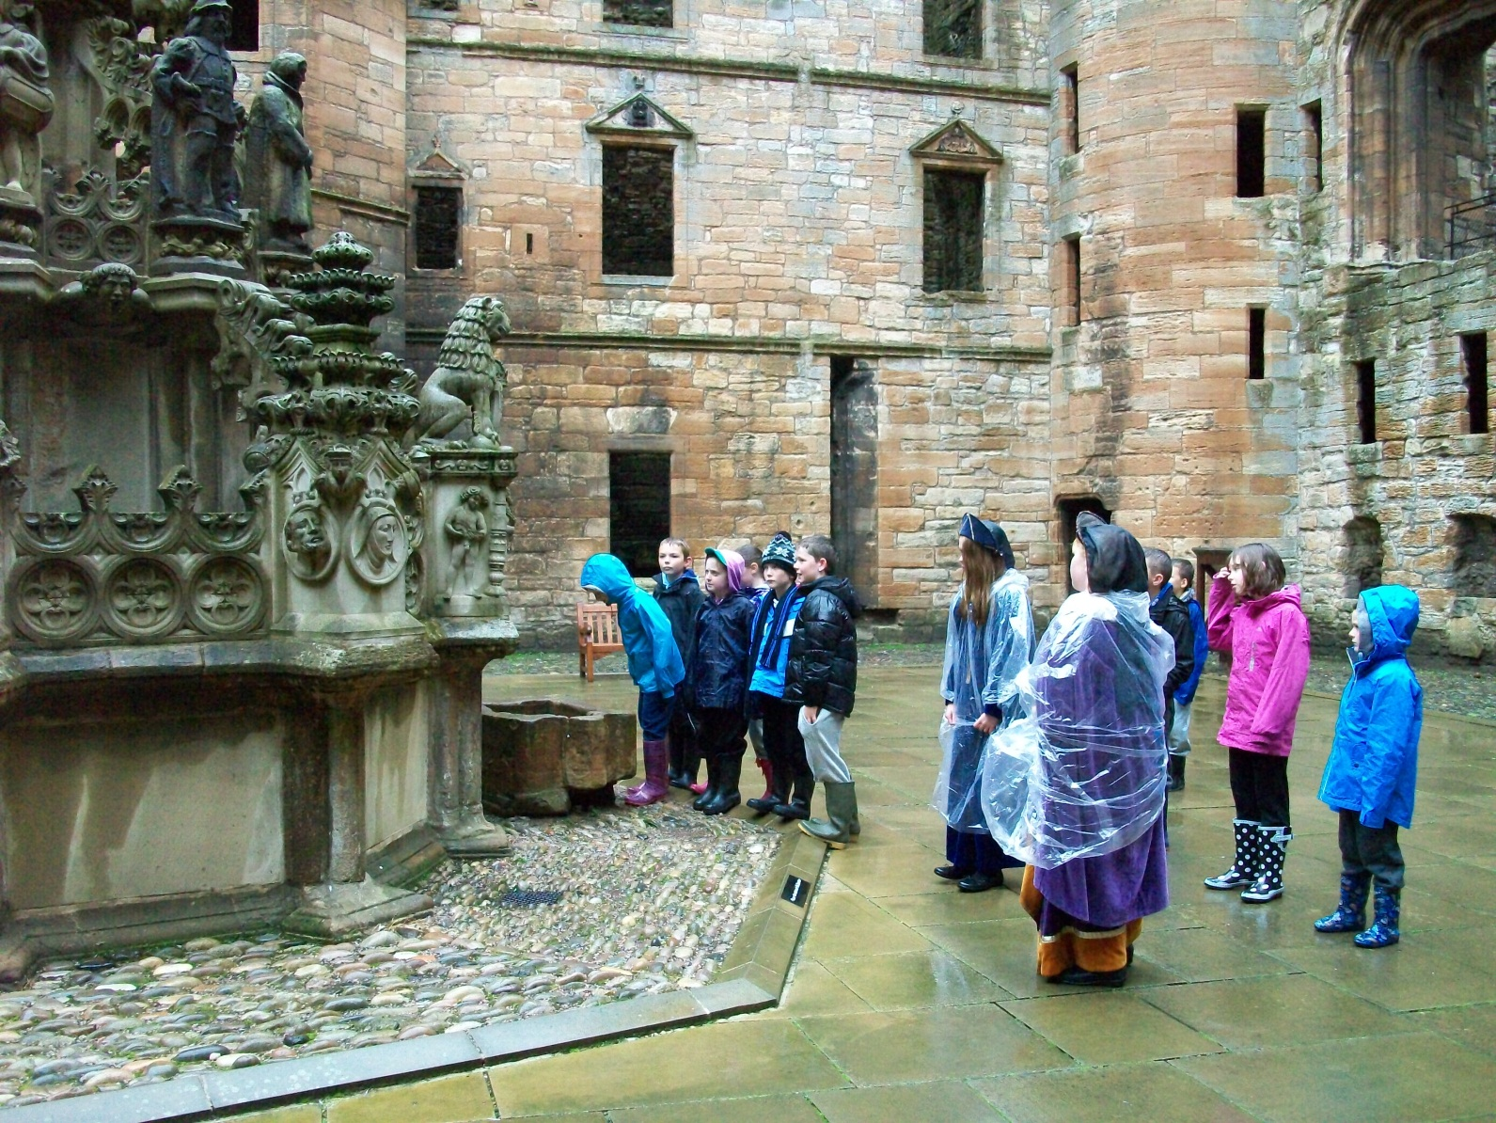

**Residential Programme**

To enable our young people to develop their social skills alongside others in a range of situations, the school has a well- established residential programme. All residential venues and activities are fully vetted and risk-assessed.

P.5 Pupils have 3 nights residential experience at a local outdoor education centre, while P.7 travel further afield for a week’s residential. The benefits of this experience are tangible as young people grow and develop through problem solving and challenge activities. A Parents’ Meeting is held prior to the residential trip to inform parents about staffing, activities and practical arrangements. A clothing list and information sheet is issued at the meeting.

**Pupil Voice Groups**

Children in every class are involved in vertical groups to share leadership of learning in a variety of areas. These groups are very pro-active and are instrumental in driving school improvement in the following areas:

**ECO RIGHTS RESPECTING SCHOOLS JRSO / ROAD SAFETY**

**JUNIOR LIBRARIANS PUPIL COUNCIL CREDIT UNION**

**CAPTAINS AND VICE CAPTAINS PEER MEDIATORS FAIRTRADE**

Pupil Support Workers have a valued and important role as Co-ordinators of the Pupil Voice Groups.

**CLIMATE FOR LEARNING**

**Promoting Positive Behaviour**

Behaviour of pupils impacts directly on learning in the classroom. In Bankton we truly believe that BETTER BEHAVIOUR leads to BETTER LEARNING for all. We promote respect at all times, for self and others and are committed to the Unicef Charter for Children’s Rights which educates children to think of their personal responsibilities and actions towards others. Bankton has been accredited as a Rights Respecting School and has a Rights Respecting Committee made up of pupils and staff who meet regularly at Team Time to discuss the Unicef Charter in relation to our school.

|  |  |
| --- | --- |
| **RIGHTS** | **RESPONSIBILITIES** |
| The right to teach / the right to learn  (Article 28) | To work hard and do our best at all times |
| The right to feel safe and secure  (Article 31) | To be gentle and honest with others |
| The right to be treated with dignity, respect and be equally valued  (Article 29) | To be kind and helpful, thinking of others |
| The right to be listened to  (Article 12) | To listen to others and respect their opinions |
| The right of respect for property | To be respectful of school property and look after our own belongings. |

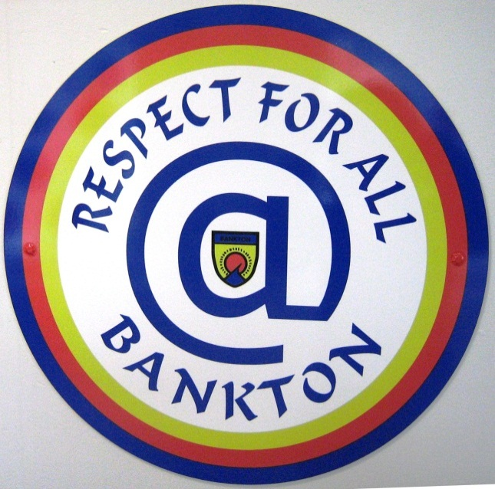

Children are rewarded for positive attitudes, good behaviour and respectful manners each week through Golden Time and House Points. Golden time may be lost as a consequence of inappropriate behaviour but may be regained by making better choices. From January to June each session pupils will work collectively to earn stalls and experiences at Fun Day.

Pupils who have difficulties with behaviour will have a Behaviour Profile with short term targets agreed with the Class Teacher and the Management team. Parents will be asked to attend a meeting to discuss these targets and to support the work of the school by reinforcing the targets at home. Working together in positive home/school partnership we aim to help all of our children achieve their full potential.

**CELEBRATING SUCCESS**

Pupils are encouraged to have high expectations of themselves and their success is recognised in a variety of ways.

**Class Assemblies** will be held throughout the session and parents will be invited to attend. At these assemblies the teacher will present pupils with awards for particular aspects of classwork. A Maths and Language trophy will be presented at assembly to a pupil who has made progress in both of these skills areas. Headteacher Awards will also be presented at assembly to pupils who have been recognised for hard work, exceptional attitude or an outstanding piece of classwork. We look forward to welcoming you to our class assemblies. A timetable for assemblies will be issued at the start of the year to allow you to plan ahead.

**The School Blog** will be used by teachers and pupils to exemplify successful learning in the classroom. Learning will be discussed and evaluated as part of a weekly reflection on a Friday. Please check the blog over the weekend and respond with encouraging comments to motivate pupils.

**The Plasma Screen** in the Reception Area will provide regular updates for parents and visitors of a range of school successes. It will detail achievements of classes, groups and individuals.

**The local media and regular newsletters** will be used to publicly celebrate success.

**ADDITIONAL SUPPORT FOR LEARNING**

Most children can access the wider curriculum and progress on their learning journey without the need of additional help. In Bankton Primary School we aim to ‘Get it Right For Every Child’ (GIRFEC) by identifying each child’s learning needs at a very early stage in their school life, planning appropriate support and monitoring the support with pupils and parents.

Children at this stage will be well supported in Bankton Primary through the provision of P.A.T. groups (Phonological Awareness Training) and Busy Blender groups (To help blend sounds together for Reading and Spelling)

Children and young people who have been identified as having additional support needs will be supported through an Action Plan (AP) or an Individual Education Plan (IEP) or in some cases a Co-ordinated Support Plan. Some children and young people may require a Care Plan for Health needs. Parents will be fully consulted at each stage in the planning process through Assessment of Wellbeing Meetings and Child Planning Meetings. If a pupil’s needs require specialist help, referrals will be made, with prior parental consent to other agencies or outreach teachers.

Parents as partners in their child’s learning and children at the centre of all we do are two of our greatest aspirations in Bankton.

**COMPOSITE CLASSES**

When pupil numbers make it impossible to create a full class at a particular year group, it is often necessary to form a composite class with a maximum of 25 pupils. This class will have children at 2 or more stages. Teachers will differentiate the curriculum to ensure the needs of all learners are met. A range of criteria is taken into account when forming composite classes including age, gender mix and learners’ needs.

Teachers take account of all learners’ needs in planning so parents should not be overly concerned about composite classes.

**CHILD PROTECTION**

All children and young people in Bankton should be safe, healthy, achieving, nurtured, active, respected and included. These attributes are known as the SHANARRI Indicators and are at the heart of the ‘Getting It Right For Every Child’ agenda.

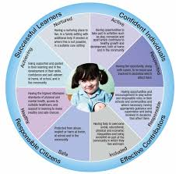

We aim to keep them safe and secure at all times. All staff are trained annually in Child Protection legislation and practices and it is our job to follow them when there is a concern, ensuring that the wellbeing and protection of our children is at the heart of decisions taken. Procedures for staff are displayed prominently. Designated Members of Staff for Child Protection are:

**Jacqueline Stewart / Headteacher Yvonne Ferguson / Depute Headteacher**

All pupils have Personal Safety lessons as an integral part of their Health and Wellbeing programme. Through these lessons pupils are increasingly aware of how to protect themselves and who to speak to if they have a concern or worry.

All adults who work with children are fully vetted under the national PVG scheme. WLC Human resources Staff check and verify disclosures prior to appointments being made. If you would like to help in school as a Parent / Grandparent helper, please ask for a Disclosure form at the school office. When this has been completed and verified, please make an appointment to speak to the Depute Headteacher.

**BREAKFAST CLUB**

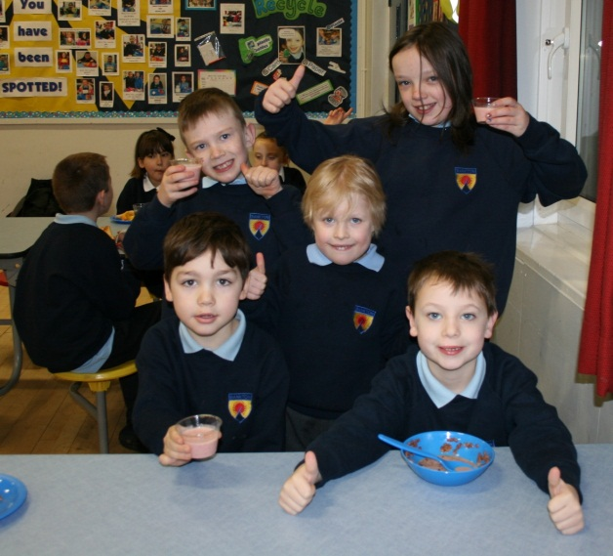

Children who have breakfast before classes begin are fuelled and ready to learn. Bankton Primary School has a free Breakfast Club for all pupils, where they are given a choice of cereal, toast, yogurt, a selection of fresh fruit and a drink. Pupils who attend will be registered by a Pupil Support Worker. They can then enjoy breakfast in a social situation with their friends.

The Breakfast Club aims to establish positive relationships at the start of the school day, helping to reduce lateness or poor attendance and improve attitude, behaviour and motivation to learn.

It runs from 8am to 8.30am, at which time Playground Supervisors are on duty and children can then join their peers in the playground.

**SCHOOL MEALS, FOOD AND DRINK**

Well fed children learn better and grow to develop a healthy life style. Pupils in Primary School are offered a two course meal with a choice of main course, supplemented by salads and bread which meet the new Scottish Nutrient Guidelines for School Meals. Special dietary requirements will be catered for. If your child has food allergies or special dietary requirements, please contact Mrs.Connell, Kitchen Supervisor or the school office to discuss this.

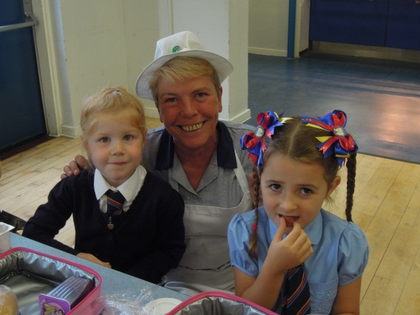

As a health promoting school we are in favour of healthy lunch boxes and encourage our children to eat fruit and drink water, milk or fruit juice. Fizzy drinks will not be permitted in school in line with WLC policy.

If you are in receipt of :

Income Support / Tax credit / Income-based jobseeker’s allowance /Working tax credit / Child tax credit and your household income does not exceed:

£6420 (Working tax credit) / £16,010 (Child tax credit) you can apply for free school meals.

**ATTENDANCE, GROUP CALL and EMERGENCY ARRANGEMENTS**

In order to be successful learners, all children must attend school regularly. We would ask all parents to strive to help their child achieve perfect attendance and arrive in school on time. If, for any reason, your child is unable to attend school, please inform the school office by 9.30am at the latest. Any children who are unaccounted for after this time will receive a Group Call text message asking parents to contact the school to verify the reason for absence. It is imperative, therefore that parents regularly update their mobile phone details, so that school can contact you in an emergency.

If you are delayed at the end of the day, your child will be held at the school office until you arrive.

In emergency situations where your child may be ill in school, or have had an accident, we will contact the parents immediately. Every child requires to have an emergency contact person who will only be contacted when we cannot reach the parents first.

Bankton Primary School and West Lothian Council reward our children for perfect attendance with certificates and medals. Please help your child to achieve in this area.



**MEDICATION IN SCHOOL**

If your child requires medication for any reason during the school day, an appropriate form must be filled out in school with details of dosage, reason for medication and a parental signature.

Medical conditions requiring longer term care should be detailed on the Annual Pupil Data checks which will be sent out to parents each year in May. Medical details must be updated regularly, so please keep the school informed of any changes.

**TRANSITION**

**From Nursery**

We are very fortunate to have an excellent Nursery facility within the school which ensures effective liaison and a smooth transition for children between Nursery and P.1. Staff operate within a well - planned transition programme which is overseen by Senior Management in the school. Children from Nursery visit the school for learning visits over a number of weeks during the final term to take part in transition activities in the P.1 classrooms. This allows P.1 staff to get to know your children very well and to plan appropriately to meet their needs in the early days of P.1.

P.6 pupils are given the responsibility for a new P.1 Buddy and spend some time with them during one of the learning visits. These visits are followed by an informative Parents’ Meeting in June and an opportunity for parents to experience school lunch with their child in the lunch hall.

**From Stage to Stage**

Teachers plan effectively to ensure that all children feel comfortable moving from one stage to the next. A ‘Moving on’ afternoon in June allows pupils to share time with their new teacher before the holidays. Pupils with additional support needs may require visual supports and enhanced transition visits to smooth this transition for them.

**From School to School**

When a pupil moves from Bankton to another school, information is shared quickly with the new establishment to allow the pupil to continue on their learning journey. Personal Pupil Records contain all necessary relevant information from the school and are delivered as soon as possible to the new school.

**From Primary to Secondary**

Children transfer from P.7 at Bankton to our Cluster Secondary School which is The James Young High School. There are well planned collaborative working opportunities throughout the year to allow secondary staff to get to know the children better. Several activities are planned to allow pupils to mix with peers from the other Cluster schools including church services, P.7 conference and James Young learning visits. There is also a two day Induction Programme in June, where pupils experience a range of activities at secondary school. Application forms are delivered to school from Pupil Placement in December and parents are informed of places by April.

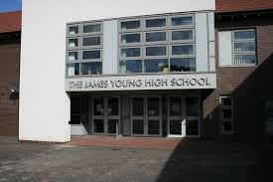

Parents’ Evenings are arranged by The James Young High School early in the new term to provide parents with necessary transition information.

**Contact details: The James Young High School, Quentin Rise, Dedridge, Livingston, EH54 6NE**

**Headteacher: Mrs. Catrina Hatch Tel: 01506 414244**



**In Bankton Primary School we aim to work in positive partnership to improve learning across our school community.**

We would like you, as parents and carers to support the work of the school in the following ways:

* Supporting the ethos, values and aims of the school
* Ensuring that my child comes to school regularly, on time and is ready to learn
* Co-operating with school staff to encourage and maintain positive attitudes and behaviour
* Contributing to my child’s learning by helping with homework and making sure this is returned on time
* Supporting my child’s progress by attending Parents’ Consultations to discuss next steps in learning
* Communicating effectively with the school on any issues which may affect my child’s ability to learn
* Helping the school to maintain an appropriate dress code and provide my child with suitable P.E. kit
* Checking that my child takes to school what he / she needs each day
* Informing the school if my child is absent
* Supporting the school’s efforts to improve standards in all areas of school life: work, attitude, dress and manners to ensure that Bankton Primary School continues to enjoy a positive reputation for many years to come.

**PARENT COUNCIL**

Bankton Primary School has a highly valued and pro-active Parent Council who currently meet once a term. They are instrumental in the recruitment process for senior staff and their views and the views of the Parent Forum help to shape school improvement.

The Headteacher and Senior Staff attend Parent Council meetings in an advisory capacity.

The Parents’ Association is an important part of the Parent Council. Parents organise fundraising and special events for pupils and parents. They also help with refreshments at school shows and curricular showcases. They are important partners in the P.7 Transition Activities and organise social events such as the School Fair, Hallowe’en Disco and the P.7 Leavers’ Party.

For more details of who to contact, please see the Parent Council Notice Board at the Parents’ Entrance near the Great Hall.

**YOUR SCHOOL NEEDS YOU!**



**In Bankton Primary School we welcome your help.**

**Can you help with outdoor visits?**

**Do you have a special talent you could share?**

**Do you enjoy baking with children?**

**Do you have an interesting job or business you could talk to children about?**

**Could you commit some time for paired reading activities?**

**Could you help organise events / coffee mornings?**

**WE NEED YOU**

**However, in the interest of child protection and safety, all parent helpers must be disclosure checked before being permitted to assist in class with children. Disclosure forms are available from the school office.**

**HOW GOOD IS OUR SCHOOL ?**

**“ My school is like a big family” – Louise, P.1**

**“I love coming to school because we have lots of fun learning” – Farrah Hughes, P.1**

**“Bankton encourages high standards, especially in music and choir” Mia Ballantyne, P.7**

**“Bankton is like a second home to me. It doesn’t feel like coming to work” –**

**Alex Walker, FMA**

**“Bankton is a school at the heart of the local community and the children are very community conscious” – Heather Reilly, Pupil Support Worker**

**“In Bankton my children have always been taught respect from an early age” – Mrs. Hunter, Parent**

**“Bankton is always welcoming. The staff are helpful and very concerned about the children” –**

**Julie Clarke, Simply Play**

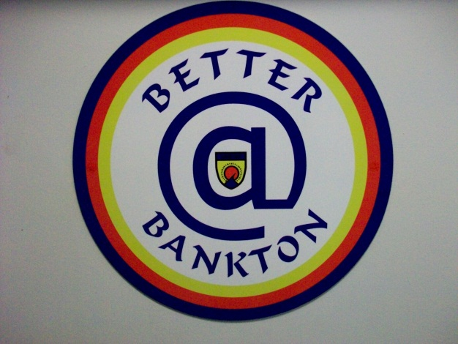

**“There is a family atmosphere in all areas of the school”, Mrs. Vercoe, Parent**

**“Pupils are well supported in all of their needs” – Jack Falconer, P.6/7**

**“When I arrived as a new girl, people were friendly and helped me settle in.” – Leah Jackson, P.6/7**

**“I love coming to work in Bankton. The kids are amazing!” Carolyn Smail, Pupil Support Worker**

**“Bankton is a great school because pupils have responsibilities. I love being a Peer Mediator” –**

**Skye Hutchison, P.6/7**

**“Everyone is treated equally in Bankton” – David Ponechal, P.6/7**

**“We have super fun Maths in my school” – Owen Phelan, P.1**

**WEST LOTHIAN COUNCIL PROCEDURES and USEFUL CONTACTS**

It is expected that most concerns or complaints can be resolved quickly in school through discussion with Staff or the Headteacher.

Unless there are exceptional circumstances, there should be full discussion with the Headteacher about any concerns or complaints you may have with regard to the service the school provides.

Where an occasion arises where you remain dissatisfied with the service, you can telephone, write or visit to discuss your concern with local senior staff. Every attempt will be made at this local stage to deal appropriately with concerns raised, discuss problems and find solutions.

Complaints will be dealt with within three working days by either giving a direct response or a clear indication of when to expect one. Complainants will be informed of progress or given an explanation if deadlines are not met.

**A Complaint to Customer Care**

If the complaint is not resolved locally then concerns can be raised with **West Lothian Council Customer Care.** A booklet detailing how to raise a complaint is available from the school entrance area.

A free Helpline Number: 0800 328 513 can be used during office hours for information on how to raise a complaint. You can call, write or visit to raise your complaint and you may be asked to put your concerns in writing. In the written complaint, your home address and telephone number should be included with an indication of the nature of the complaint and what you would like to be done.

The address for complaints is as follows:

**Customer Care, Education and Cultural Services**

**West Lothian Civic Centre**

**Howden Road South**

**Livingston EH54 6FF**

**Email:** [**customerservice@westlothian.gov.uk**](mailto:customerservice@westlothian.gov.uk)

**Useful Contacts:**

**Customer Care: 01506 280000**

**Pupil Placement (Admissions / Transition): 01506 280000 (Choose option for Pupil Placement)**

**Educational Psychology Service: 01506 283130**

**The following useful Websites for parents can be accessed from links on the Education and Learning Section of the West Lothian Council Website:**

**Parenting West Lothian Parent Zone Scotland Sure Start Scotland**

**Family Lives**