**P.6/7 and P.7 Share their Learning**

**Thank you to P.6/7 and P.7 for sharing their learning from their Decades project.**

**Parents were very impressed by their effort and by the high standard of their presentation. Staff across the school were interviewed about their experience of different decades often with humorous results. I particularly enjoyed my private viewing of the dances from each decade where P.7 demonstrated dances from the Jive to the slosh, Macarena and the Cha-cha slide. Well done P.7 – relevant learning at its best!**

**Nursery Nativity**

**Our Nursery children performed their Nativity with confidence and enthusiasm for parents and families on Thursday, 18th December to rave reviews from the audience. Mrs. Sutherland, Mrs. Morrell and Miss Rae would like to give all the boys and girls a big**

**‘thumbs up’**

**for a brilliant performance!**

**Mrs. Ferguson and I would like to thank all Nursery staff for all of their hard work in organising**

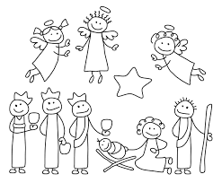

**Many thanks to the Parent Council who financed two visits from ‘Magic Mac’ . Nursery children and staff were laughing at his Christmas magic tricks and thoroughly enjoyed their special visit from Paul – Santa’s polar bear.**

**Thank you also to all Nursery parents who donated prizes for the raffle. This added an extra dimension to the Nursery Nativity.**

**Enterprise Champions**

**It’s official! P.3/4 and P.4 are our Christmas Enterprise Champions, raising more money than ever before through their hard work! A grand total of £753.13 was raised – thank you to parents for your generosity!**

**As you know they recorded a Christmas CD, sold Christmas decorations and home baking and performed for shoppers at Asda.**

**Mrs. Balfour and Miss Henderson are extremely proud of their Christmas Superstars.**

**I know which CD I will be playing on Christmas morning!**

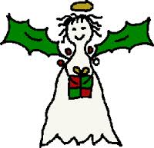





**Christmas Greetings from all at Bankton**

**I would like to take this opportunity on behalf of all staff in Bankton to wish all of our children, parents and families a very happy Christmas. We hope you will enjoy your special time together over the holidays and that 2015 will be a happy and healthy year for you and your loved ones.**

**With Best Wishes from Mrs. Stewart and Mrs. Ferguson**

**Bankton Primary School Newsletter**

**Christmas 2014**

