[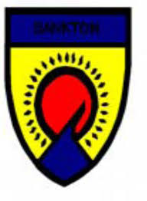](http://www.google.co.uk/url?sa=i&rct=j&q=&esrc=s&source=images&cd=&cad=rja&uact=8&ved=0ahUKEwib7qqLrc3PAhWEXhQKHXtqAm0QjRwIBQ&url=http://www.westlothian.gov.uk/media/3948/Bankton-Primary-School---School-Improvement-Plan/pdf/Bankton_Primary_School_-_School_Improvement_Plan.pdf&psig=AFQjCNE1kkRBTDugQYXSlO0B-m0s0cNgJQ&ust=1476089781310517)

How can parents/carers support what children are learning about the Convention at school?

* Ask your child what he/she has learned recently regarding children’s rights.
* Discuss the ideas he/she is learning in class and try to think of examples from your own experiences, or from the media, of rights being respected or denied.
* Ask your child’s opinion on children’s rights
* Watch or read the news with your child and discuss current world events
* Please encourage your child, ask questions about what is happening at school

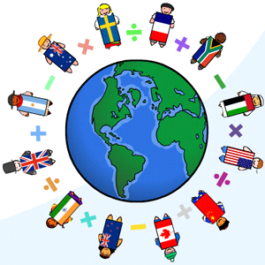

Together, we will all learn about friendship, respect, rights and responsibility and make our school even better. Thank you again for your continued support to ensure that Bankton is a safe and nurturing environment for our children to learn and develop to the best of their abilities!

For further information on Rights, Respect & Responsibility go to the Unicef website -

[www.unicef.org.uk](http://www.unicef.org.uk)

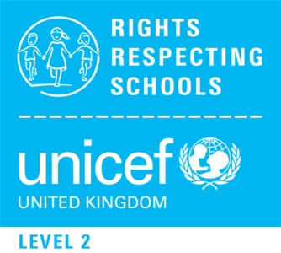

# **Who are Unicef?**

# Unicef UK is a registered charity and is the world’s leading organisation working to keep children safe and make sure children receive their rights.

Bankton

Primary School

Rights Respecting Schools Award

Parent/Carers

Information Leaflet

For Parents & Carers



# **What is the Rights Respecting Schools Award?**

# The award recognizes achievement in putting the United Nations Convention on the Rights of the Child (CRC) at the heart of a school’s planning, policies, practice and ethos.

# A Rights Respecting School not only teaches

# about children’s rights but also models rights and respect in all its relationships: between teachers/adults and pupils, between adults and between pupils.

# Bankton is currently holds the Level One RRS award but we are now working hard to achieve the Level Two award

What is meant by rights?

These are not the same as wants. What are termed ‘rights’ are the basic human needs and values that apply - or should apply - to everyone. The UN Convention on the Rights of the Child consists of 54 articles. These can be found on the Unicef website.

Key Rights from the convention are ..

The right to a childhood (including protection from harm)

The right to be educated

The right to be healthy (including having clean water, nutritious food and medical care)

The right to be treated fairly (which includes changing laws and practices that discriminate against children)

The right to be heard (which includes considering children’s views)

How does teaching about children’s rights fit in with the aims of the school?

The aim of the RRSA and of the school is to help children in achieving their potential and become responsible citizens.

What is taught in the rights, respect and responsibilities curriculum helps children learn respect for self, others, critical thinking skills and informed decision-making.

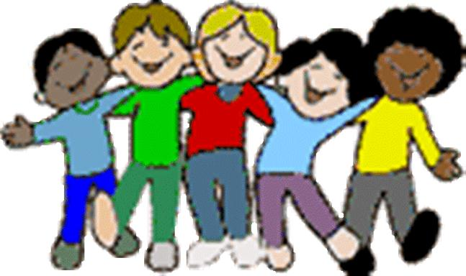

A Rights Respecting School is where:

Pupils gain self esteem by learning about their rights

Pupils learn that rights bring responsibilities for adults and children

Pupils become active global citizens

Pupils have a powerful voice

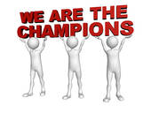

Who are your Rights Respecting Champions?

Bankton has just appointed RRS Champions to help to promote the rights in school and in the local community

They are …

P2 – Lauren Robertson, P2/3 –Chloe McGregor,

P3 - Finlay Mullen, P4 - Jamie Ure, P4/5 - Erin McMeechan,

P5 – Matthew Robertson , P5/6 – Abbie McIvor, P6 – Kasia Malcolm - Richie, P6/7 – Xander Whiteman