The Big Bathgate Blog

Rose, Ben, Jay, Jaime-lee, Jacob and Tyler
HELP THE TRIBE
The Yanomami tribe face lots of threats and we are trying to help them and you can too.

Sadly, there are many threats to the life of the Yanomami tribe. They face threats from disease, lack of health care, Cattle farmers and development of gold mines. As deforestation rages on, the Yanomami are losing their home.
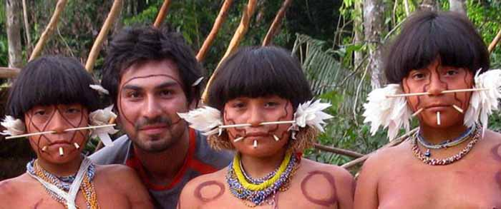
The Yanomami tribe
They live in large circular buildings. The centre is for meetings and they make decisions as a group. And their homes can hold up to four hundred people. The Yanomami people occasionally farm for food.
“Hello Jacob Dignall from the WWF here we will close the gold mines by persuading the miners to go away because they are decimating wildlife and we will gift medicines to the Yanomami to donate £5, £15 or £50 phone 978564231 now!”
We will hopefully help the Yanomami tribe with closing gold mines and better health care and also we will protect them. Thank you.

