BIG BATHGATE BLOG
Skye/Hope/Elliot/Jason/ Isaac P6B BPS
Technology does it again
Pygmy tribe love music/singing/dancing and modern technological tries to find new tribal people and what they do.
The Pygmy tribe are under threat by, deforestation ,cattle farmers, poachers ,gold miners , and projects. Disease is a constant threat because of people bringing rats and mice from different countries. The Pigmy tribe and the other tribes are getting more westernised.
The Pygmy tribe use bark, wood and grass to build their own houses. They hunt for different animals for food to eat and to survive . They survive by catching their pray with their bare hands and use wooden spears.
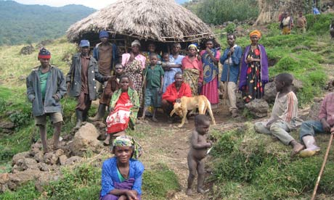
The pygmy tribe and their houses
Jason Knox, who is from GREENPEACE USA, is trying to stop as much farmers , deforestation and to shut down gold mines
To give medicine to stop the diseases that are happening please call 077247496.
Should these inivates takes place it is hoped that the Pygmy people will no longer face a grim future.

