The Big Big Blog

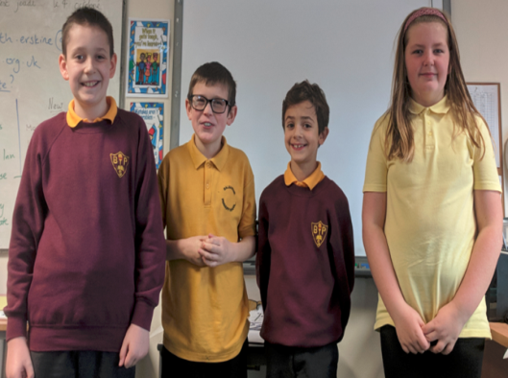
Your reporters Owen , Luke , Rayen , Dani and Emma

Deforestation is threating the pygmy tribe also their losing their huts at a rapid paces because deforestation and trying to stop it NOW!!!
fishing and growing crops. Before they hunt or fish they ask the forest spirits if they can do so.
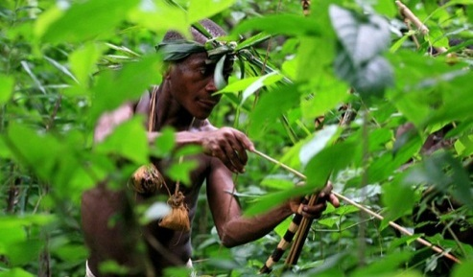
A Image of The Pygmy Tribe hunting
‘’Hello, my name is Emma Cameron and I am with WWF I think we should close gold mines for good because they could collapse and could trap animals or any tribal peoples and give £2 to get in touch call 077568399.’’
Should these initiatives take place, it is hoped that the pygmy people will no longer face a grim future. Hopefully they won’t loss their rainforest home

