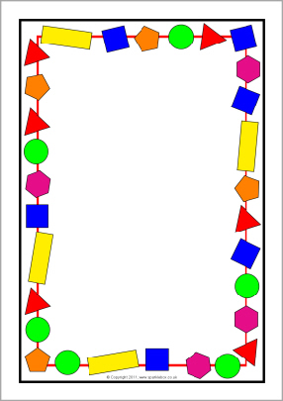

Shape Biscuits

1. Wash your hands 
2. In a  mix

 1 of icing sugar

* 2 bits of butter

1. Add  of flour and

a  of baking powder

1.  until combined
2.  your dough
3. Use 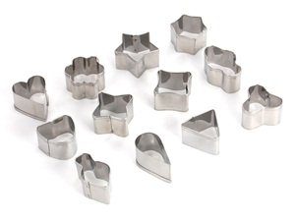 to cut a shape and decorate with 