

WRITE IT!

Practise writing your sounds and numbers in the snow.

Can you write your name?

Draw pictures of your snow adventures to show the rest of your class.

SAY IT!

What does the snow feel like?

Can you describe your snowman to an adult?

Why don’t you try asking your brothers and sisters or friends to play with you in the snow?

Can you play ‘I spy’ with the sounds that you already know.



**DO IT!**

Can you get yourself dressed for playing outside in the snow, what will you need? Remember to wrap up nice and warm.

Go Outside and explore!! What can you make with the snow?

Can you make snow angels or a giant snowman?

PROVE YOU KNOW IT!

Take some pictures of your snow learning and bring them into class we would love to see them.

Play pairs, snap or bingo with your reading words to practice the words that you know so far.

**A note from Mrs O’Neill and Mrs Mallin**

**Please help your child to complete as many of these tasks as possible during any period of school closure.**

THINK IT!

Here is a science experiment for you to investigate. You will need to build 2 snowmen to find out if putting a coat on a snowman will melt him quicker than not putting a coat on him. What did you discover?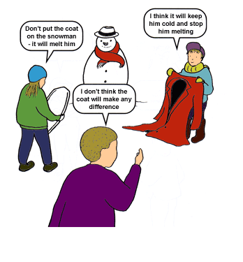r?

**Date Issued: To be submitted by:**