P1L – Week beginning 2nd of March.
Last week we were learning the “y” sound in Phonics. We found “yellow” and “yo-yo” words in our “y” picture. Our sentence was “The youngster yelled when he found his yellow yo-yo lying in the yard”.
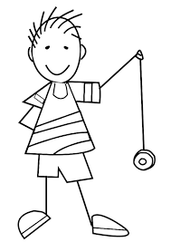

We worked on wax resist pictures in connection with our “Treasure Island” topic. We practised using a scraper to carve out the treasure ww would see if we entered a pirate’s cove. It was a very difficult skill as we had to lean quite heavily to scrape away the black paint but seeing the colour behind the paint was exciting!
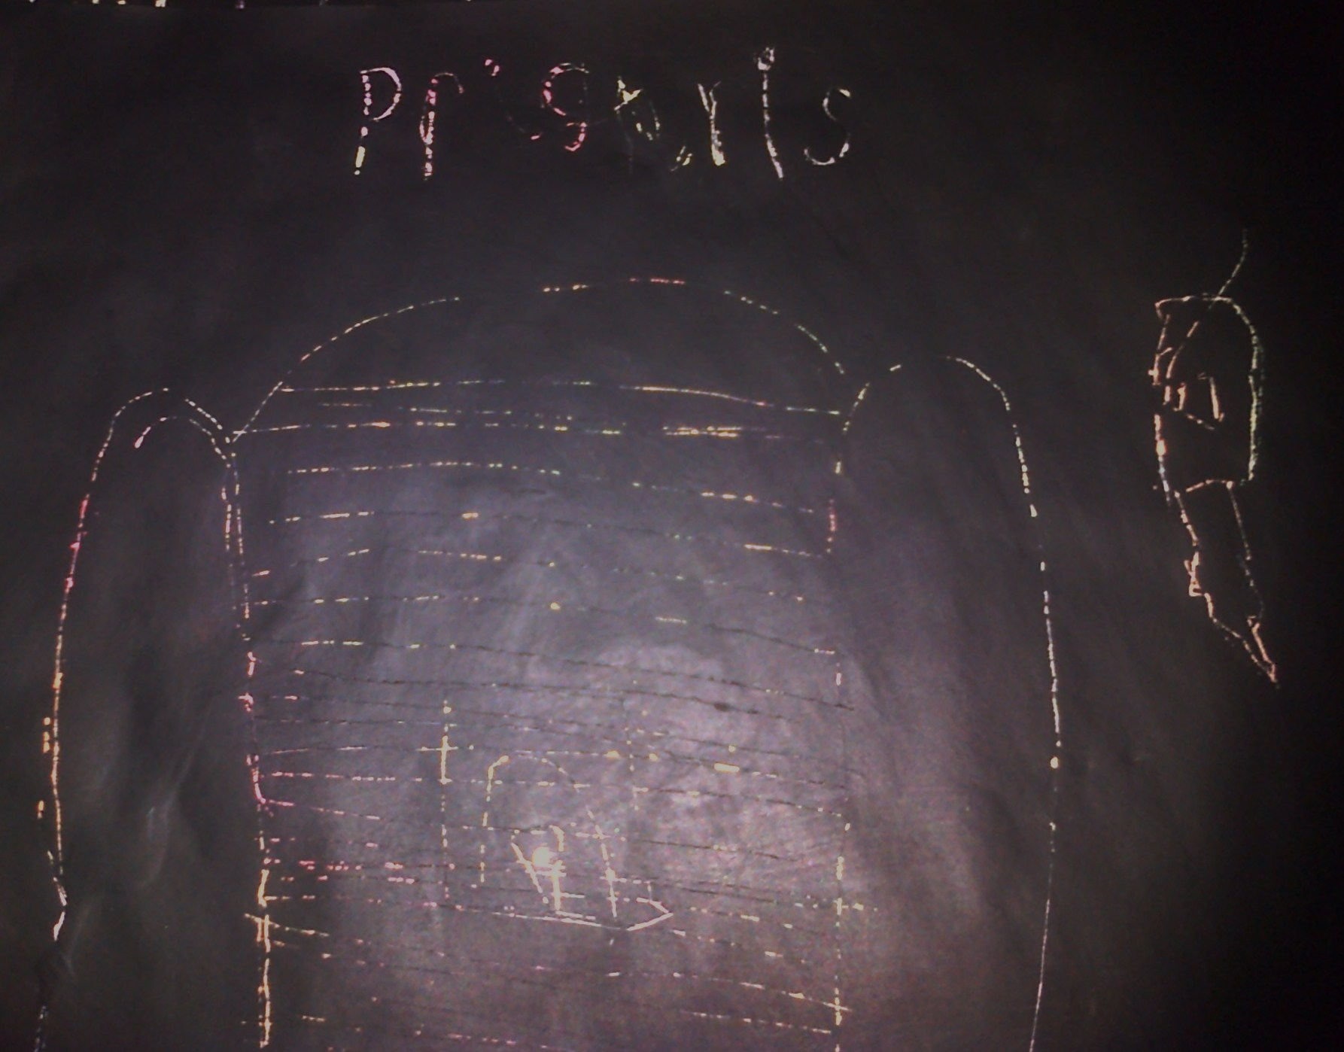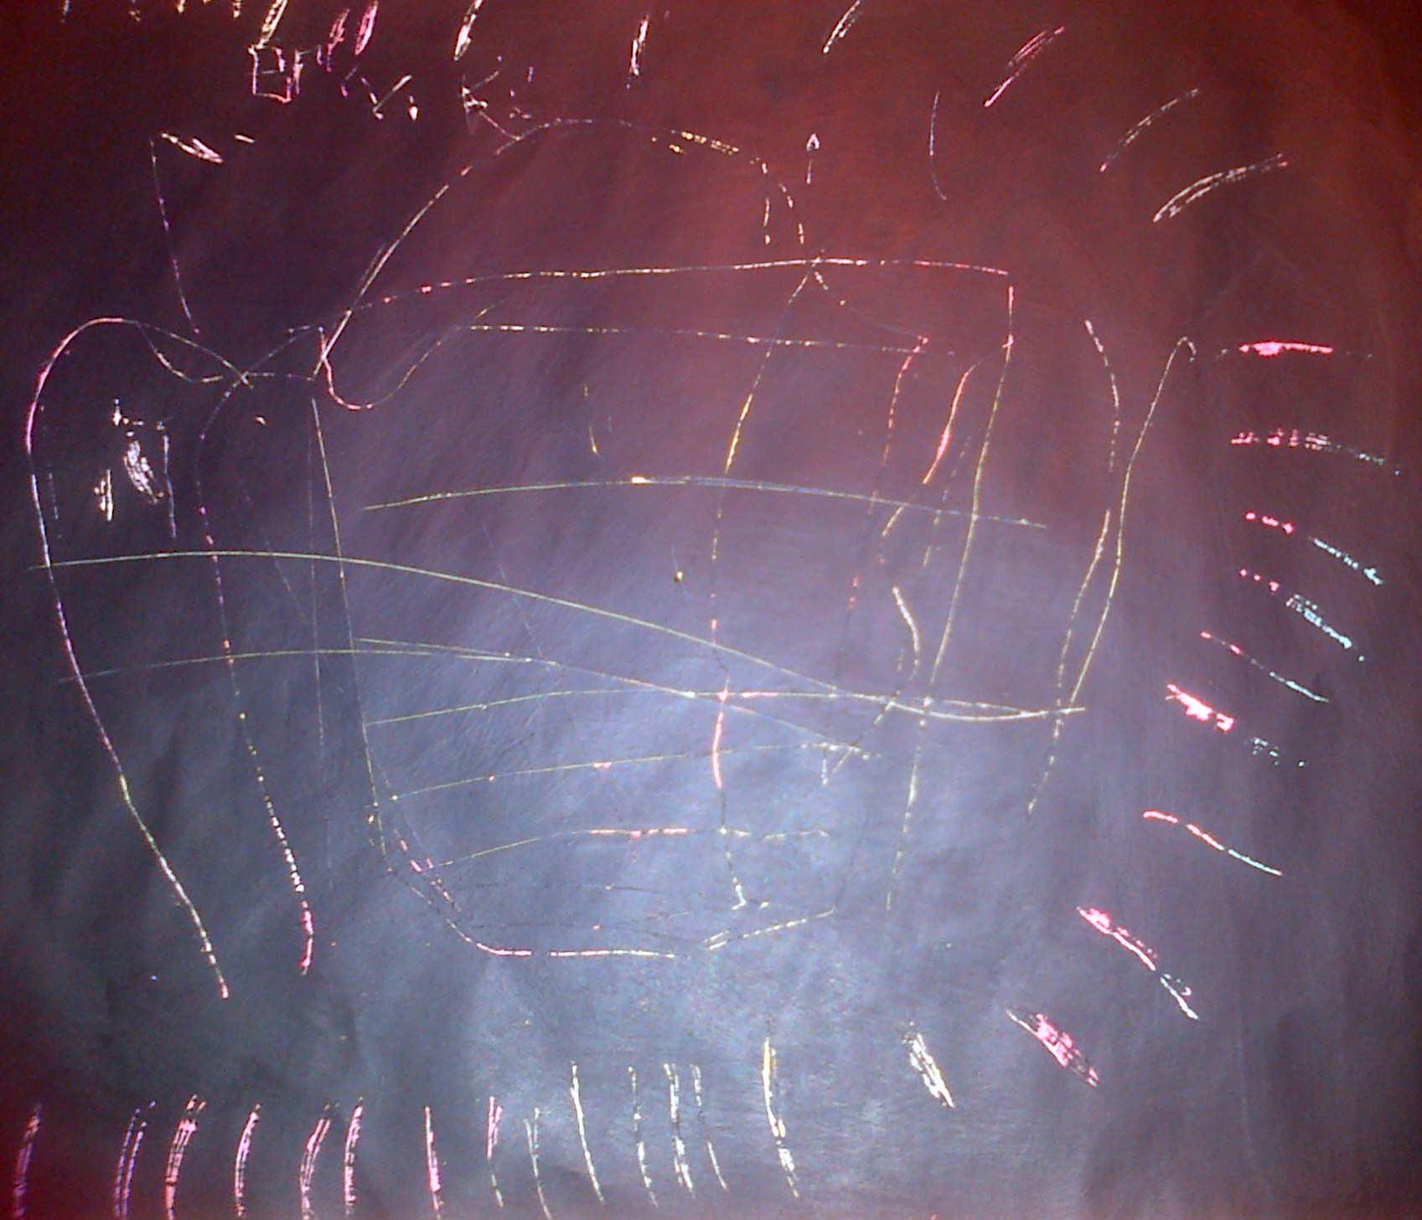
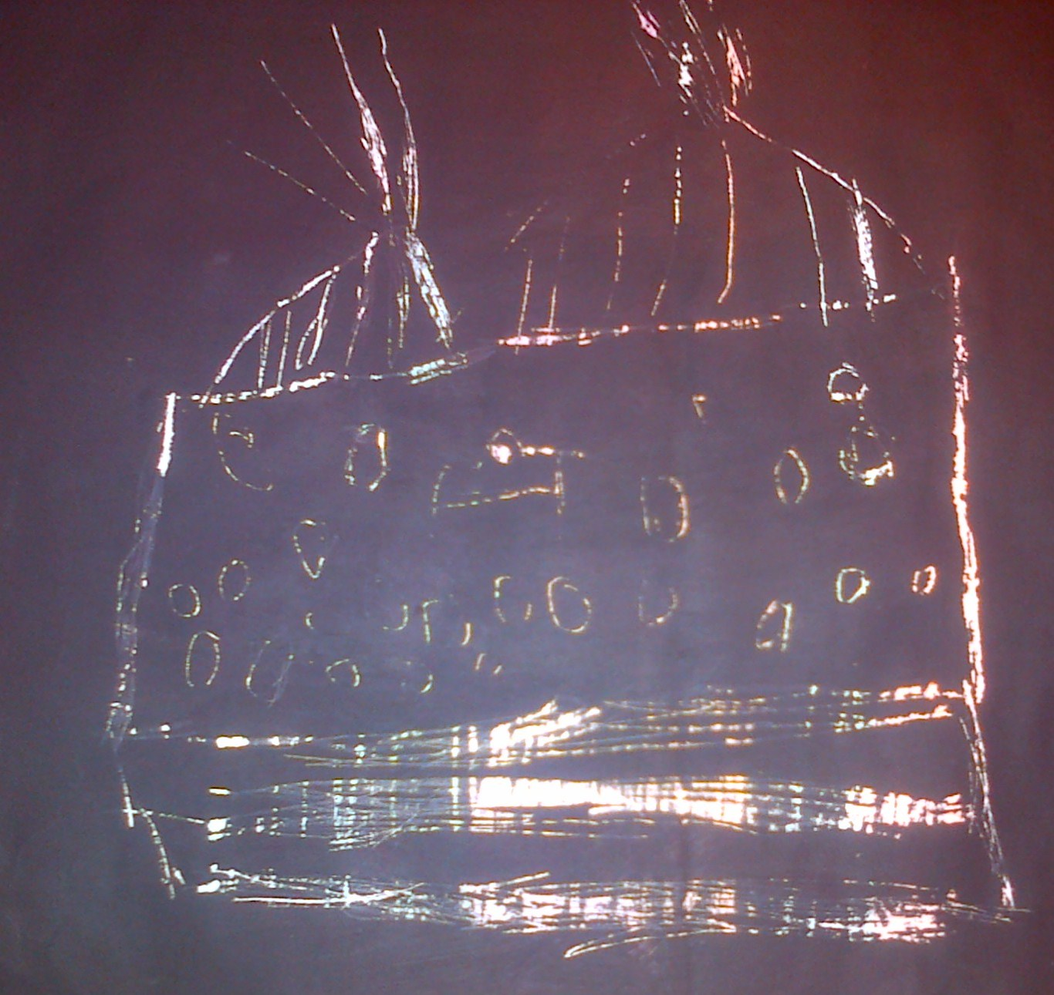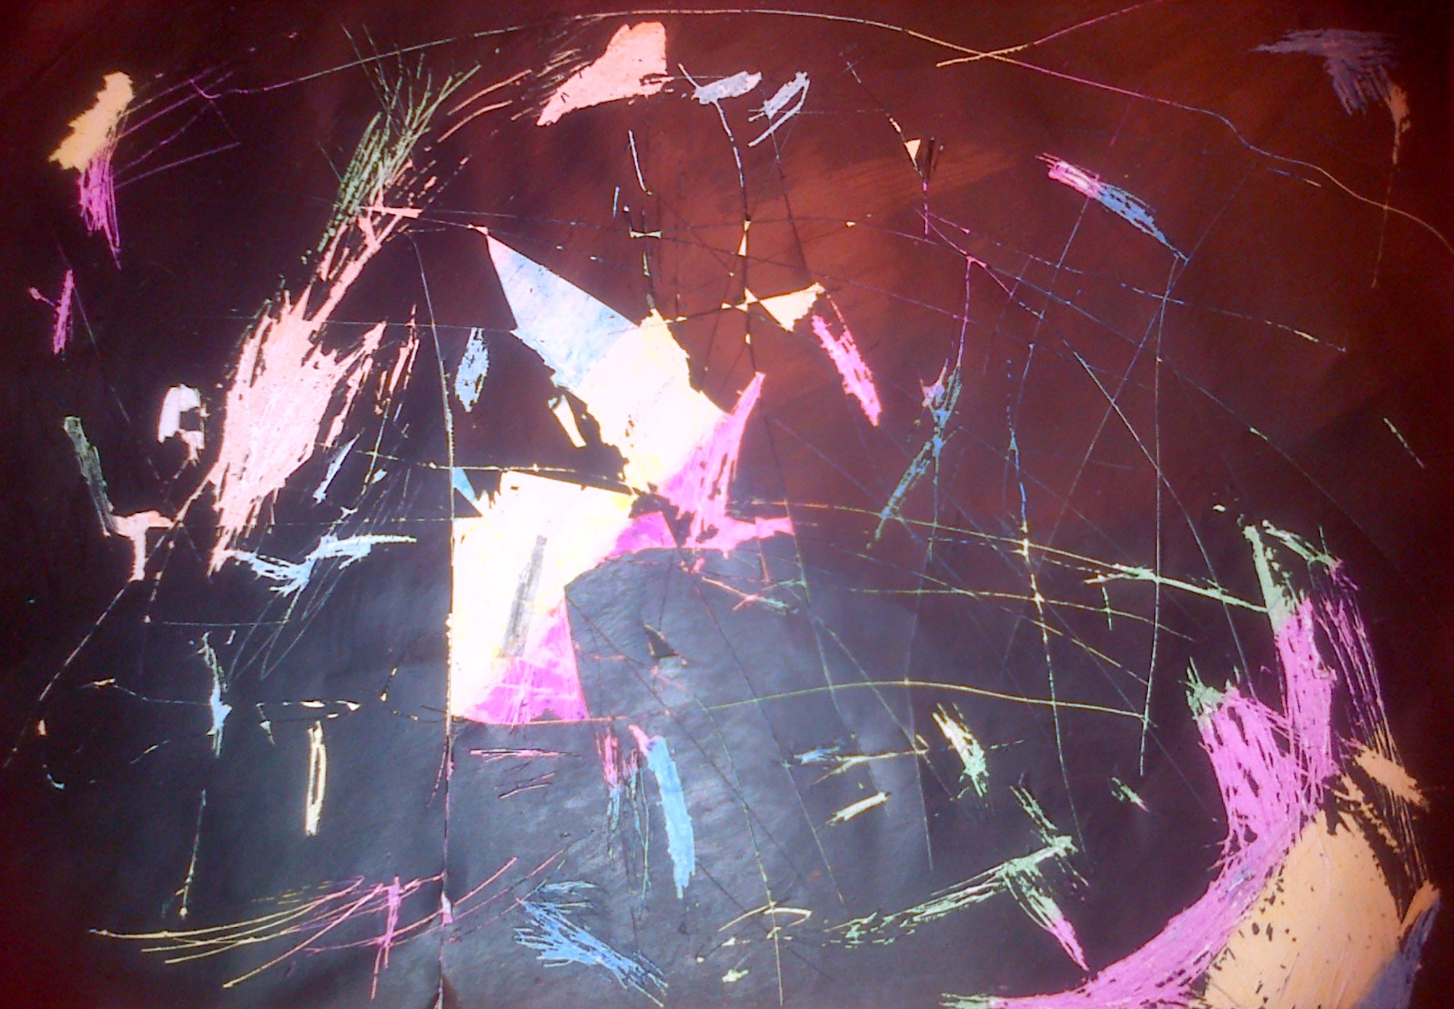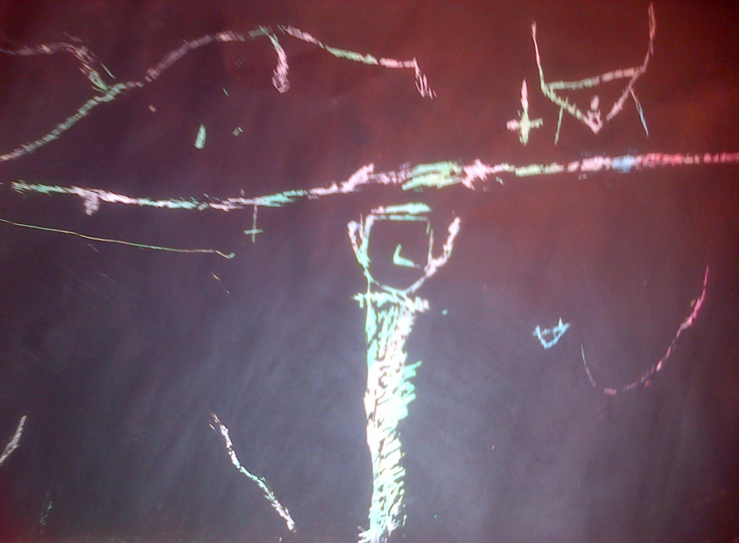
Cameron and Owen delivered their “Treasure Chest talk” on Wenesday. Both boys had put a lot of time and effort into preparing what they were going to say and the interesting things that they could show their audience. Cameron explained his favourite hobby “Minecraft” to us using toys and the “Minecraft Manual” and Owen described and named all of his “Ninja Turtle” collection. We were all very impressed, especially as both Primary Ones remembered what to say using pictre clues instead of written notes. Well done! ☺ 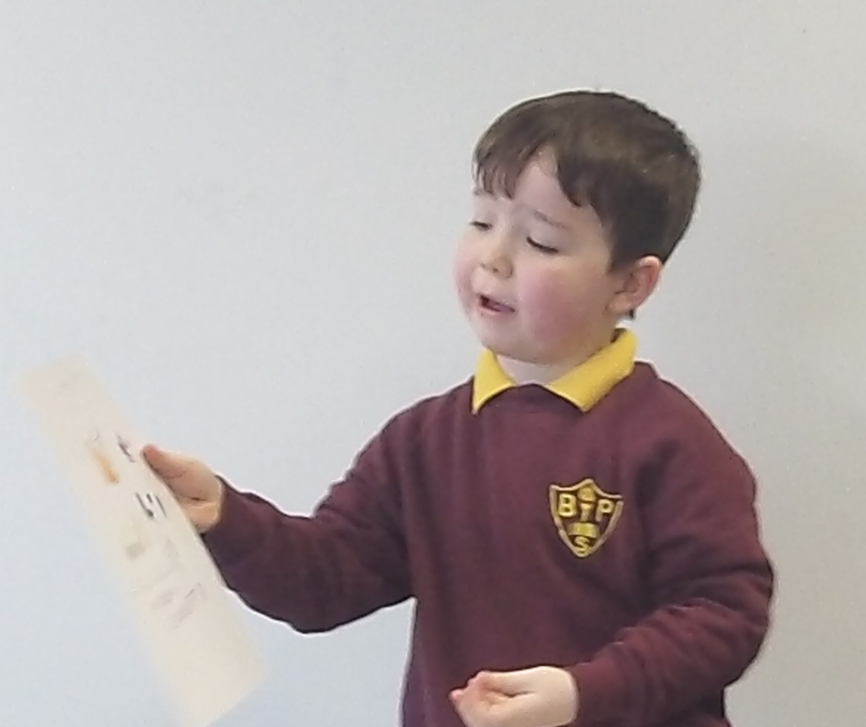 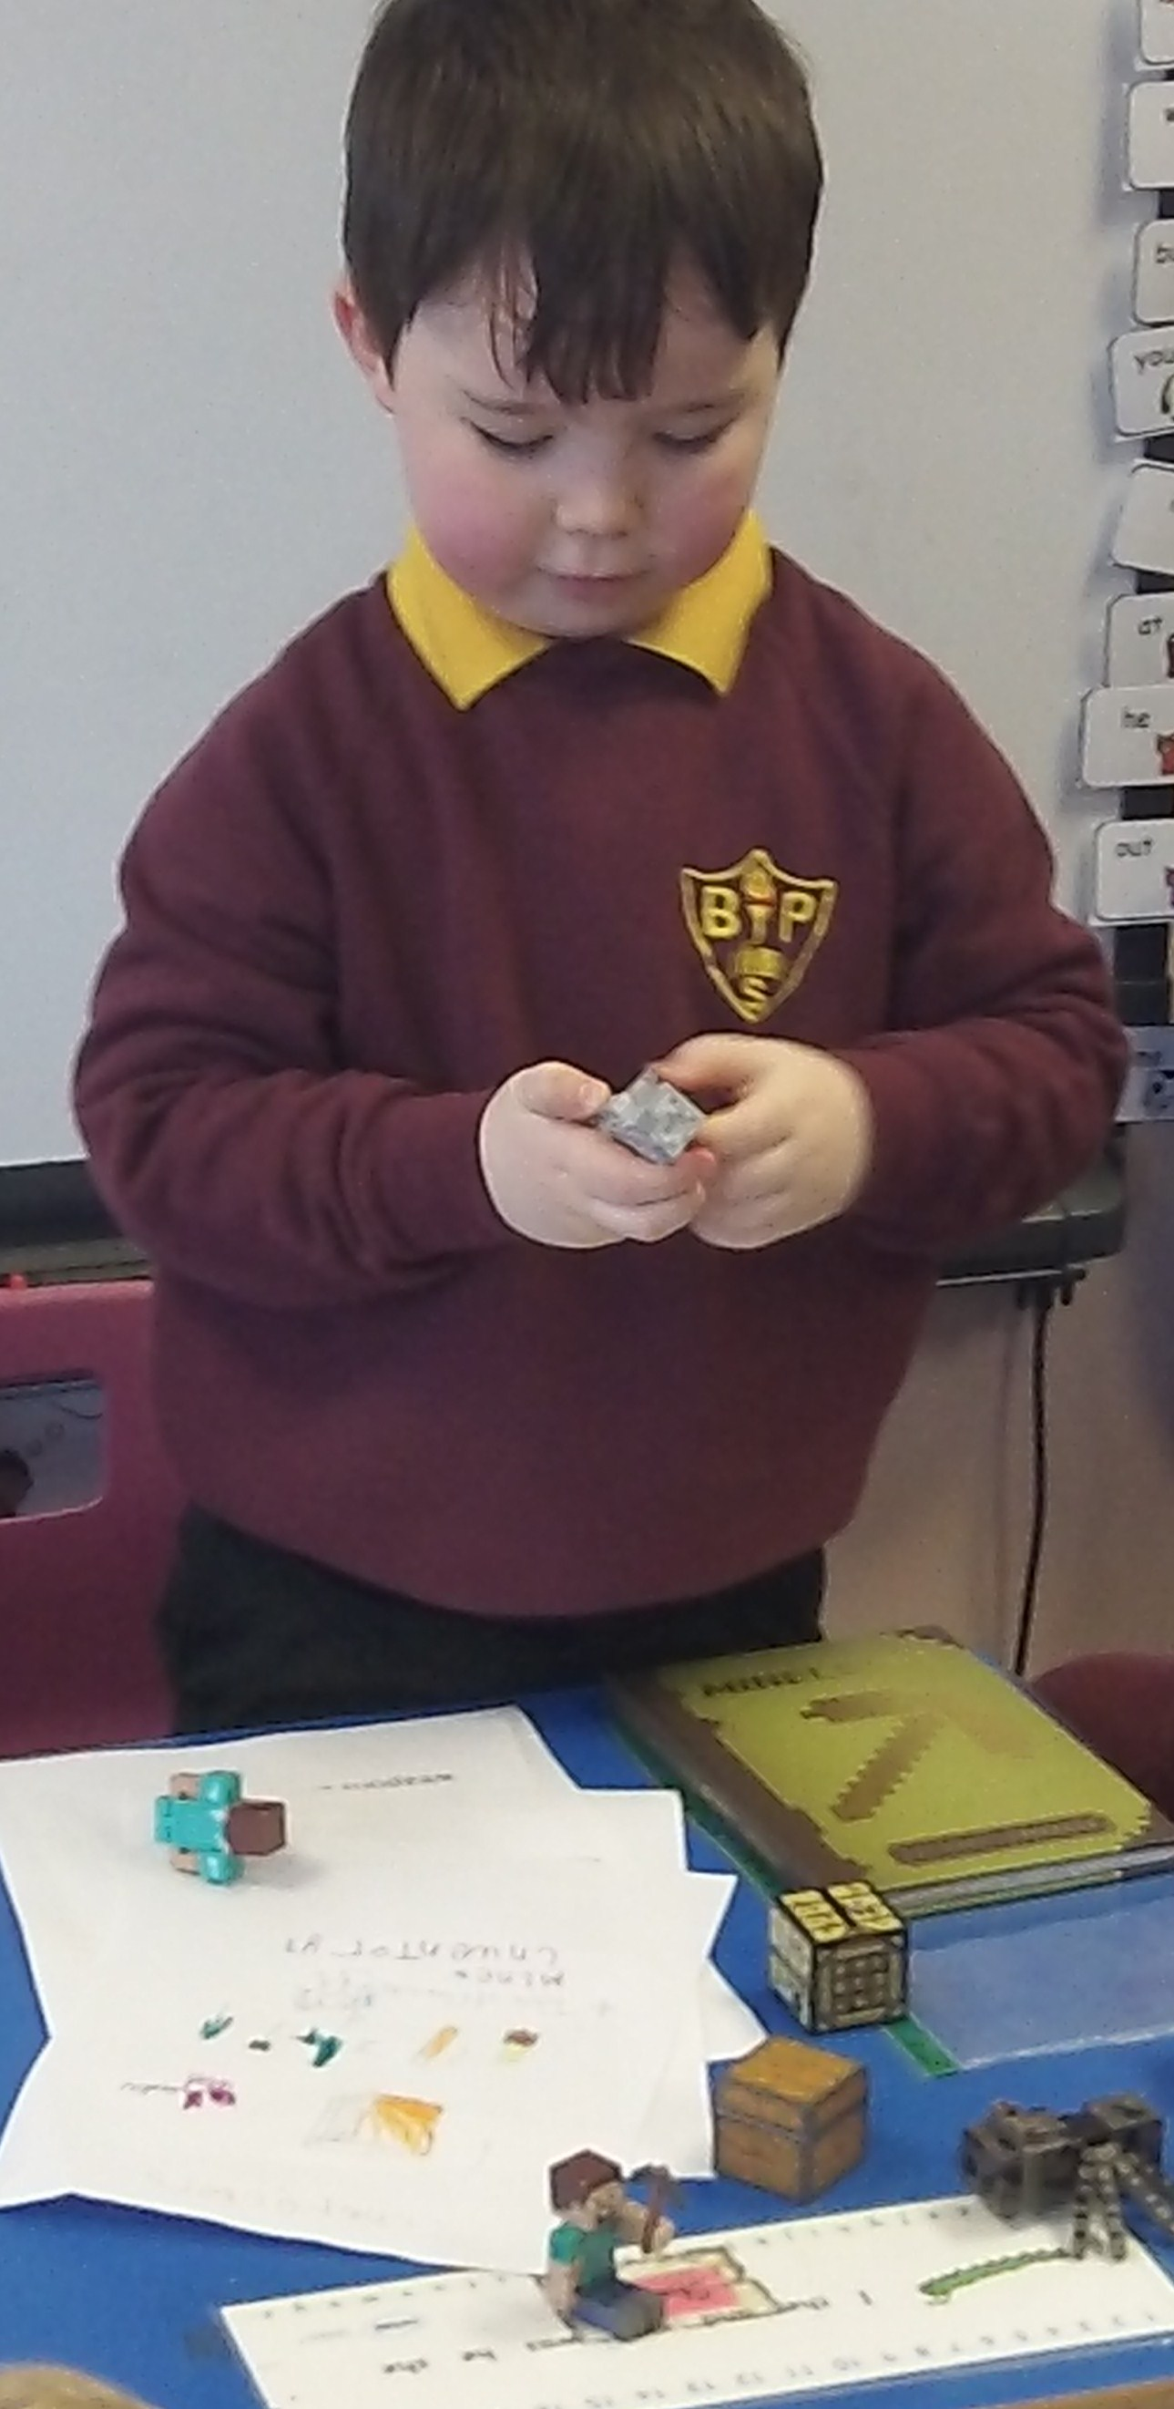
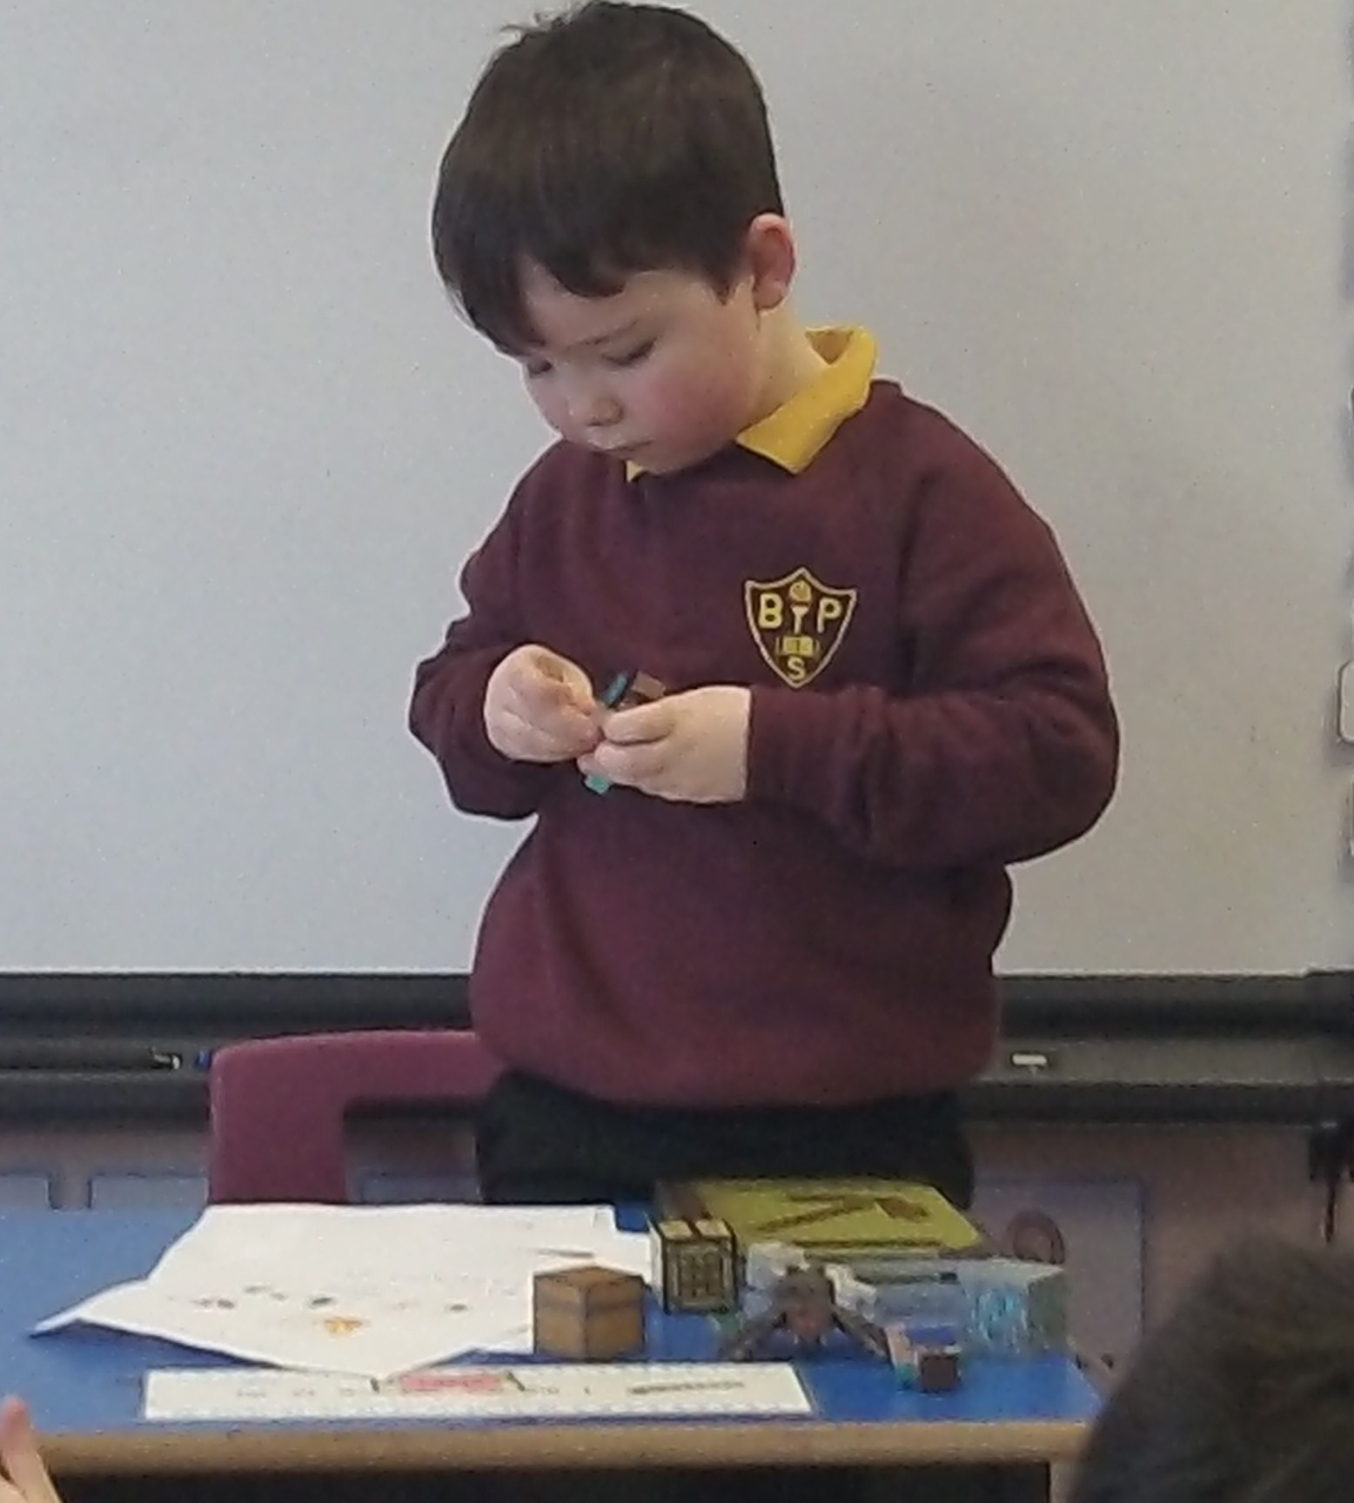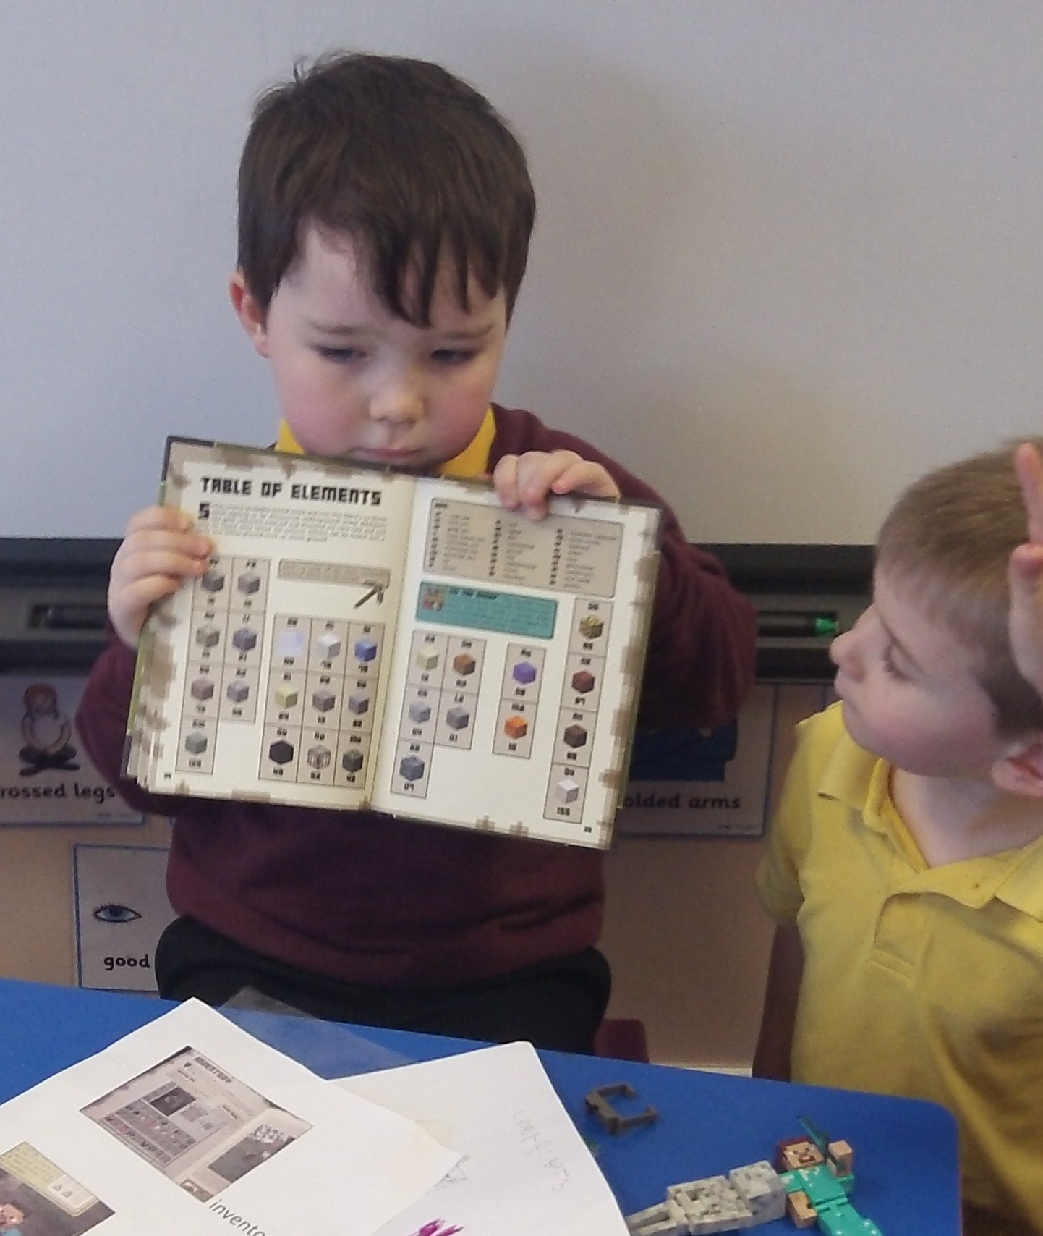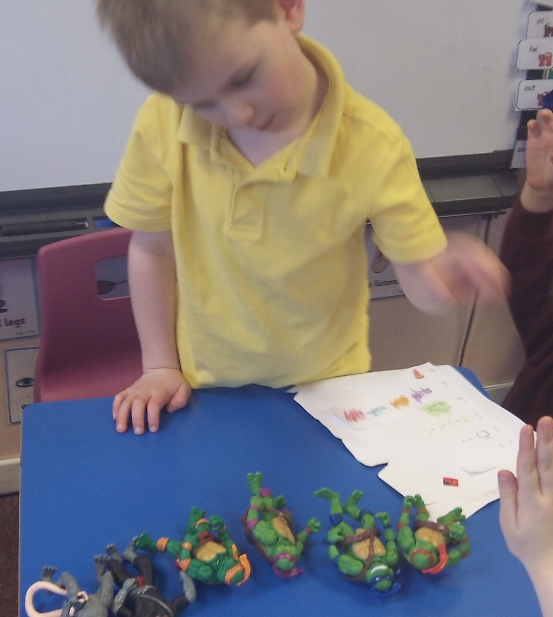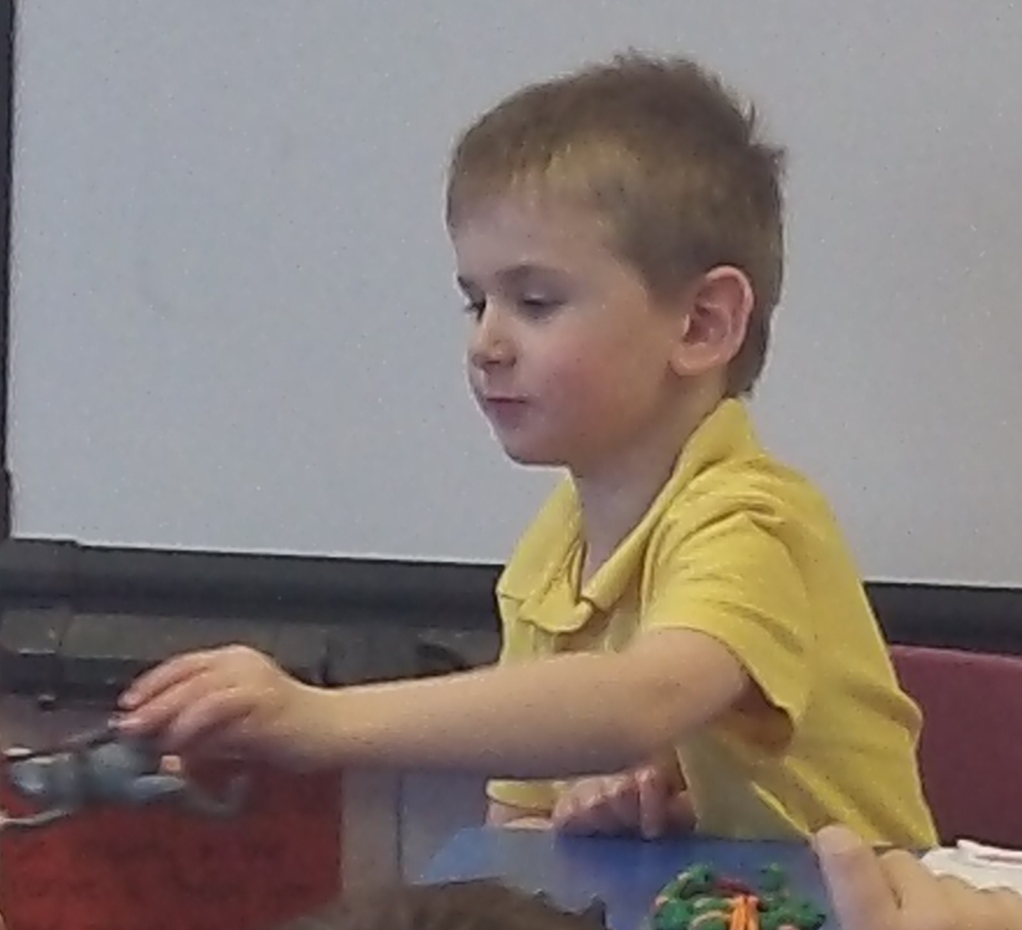
This is a picture of an airport construction that Kyle, Liam and Lucas worked on during free-play on Thursday. They were very plesed with how it turned out. 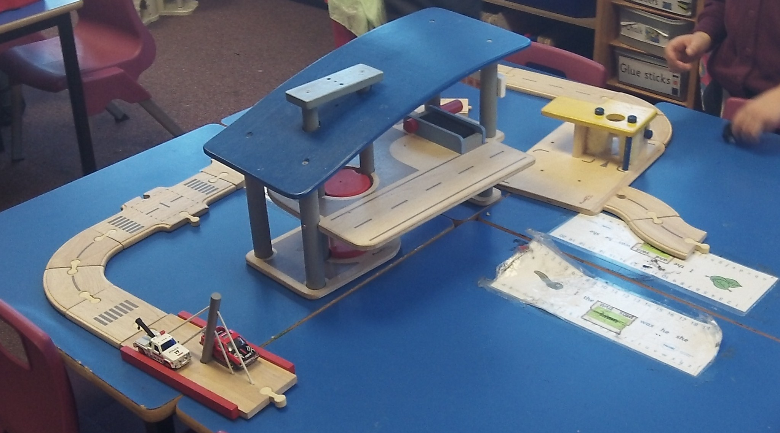
In maths we completed our work on 2D and 3D shape – we identified all cones, cubes, cylinders, cuboids and spheres using cut and paste labels.
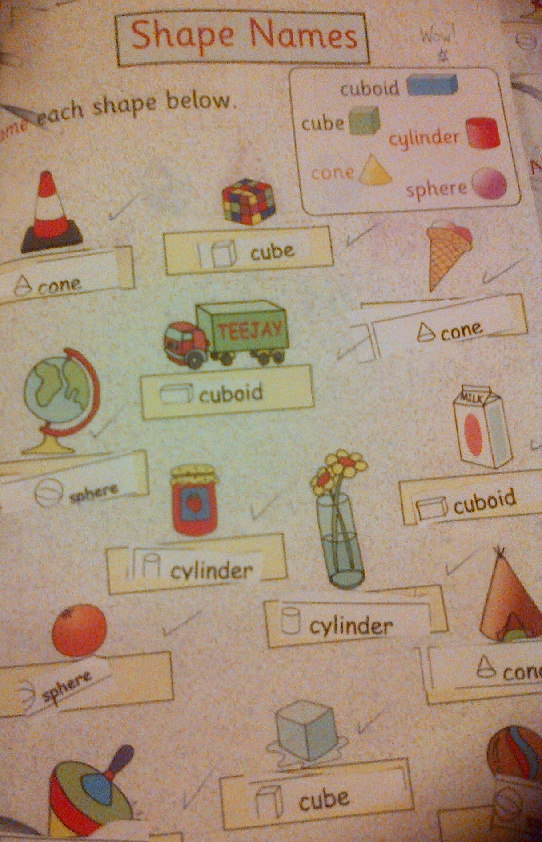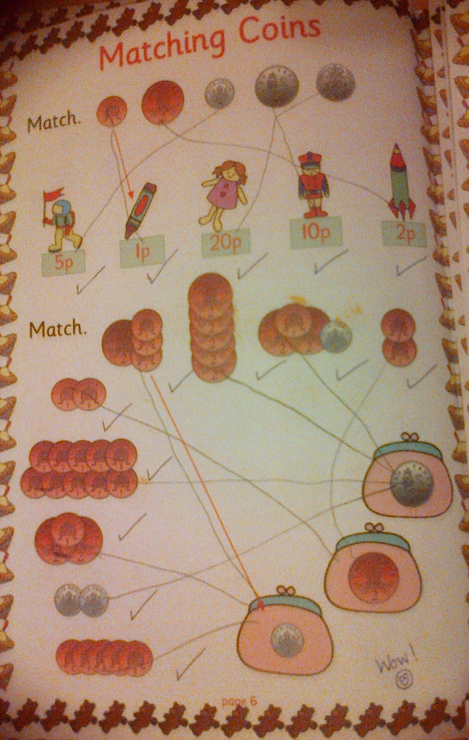
We were building on our knowledge of addition and money. We can count how many coins altogther and we can count the value of coins altogether too! Zara and Annie played with coins and sorted them into the correct sections of till trays – they were very good at it. ☺
At “Buddy-time” we learned about jobs onboard a pirate ship with our P7 buddies. We thought about what job we would like to do. We had eight to choose from; “Ship’s Captain”, “Quarter Master”, “Sailing Master”, “Boatswain”, “Carpenter/Surgeon”, “Master Gunner”, “Cabin Boy” and “Rigger”. 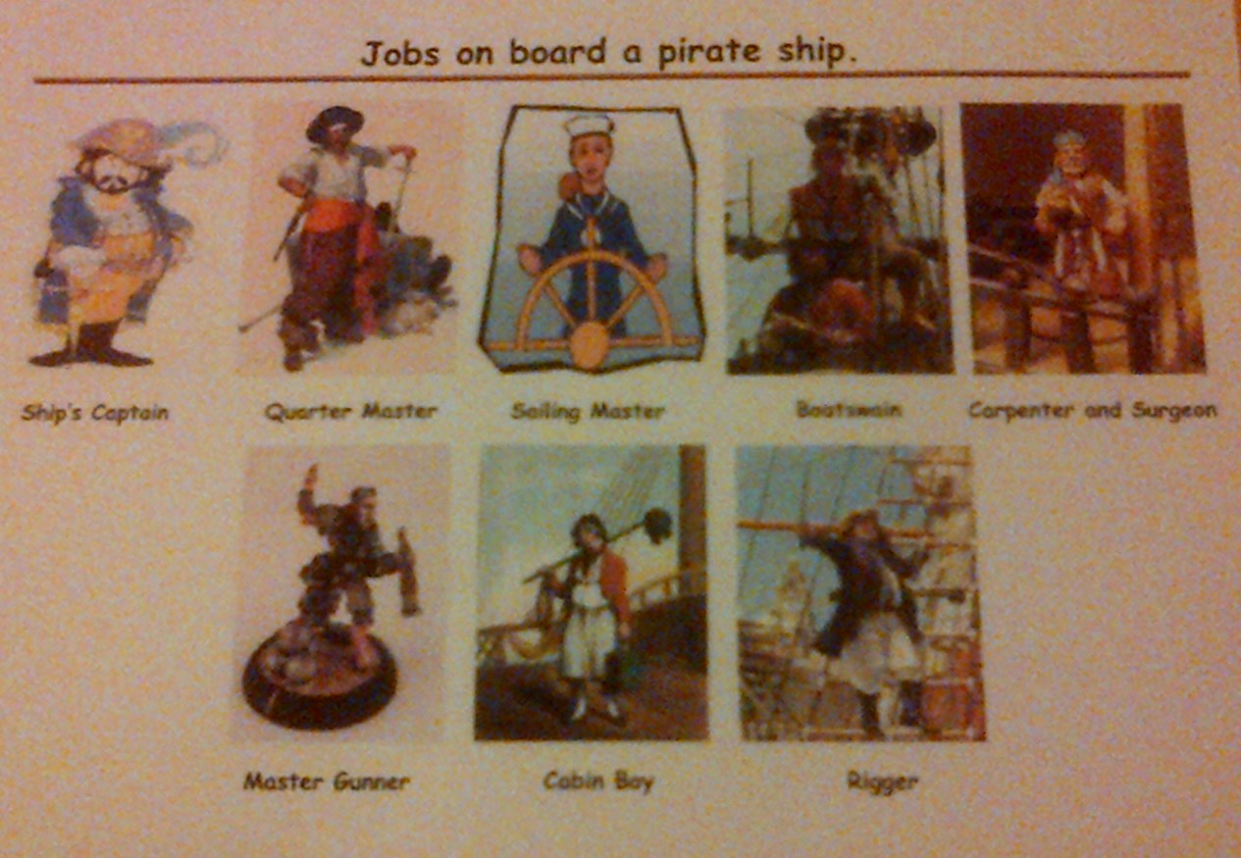
We had very good reasons for our choice of jobs, for example, Jackie chose the “Quarter Master” job as his favourite because “he’s second in charge” and Owen chose the “Carpenter/Surgeon” job because he “likes building”. Liam’s favourite job is the “Quarter Master” because “he has all the gold” and Nathan chose the “Sailing Master” job because he would “want to steer the wheel”. Good choices P1L.
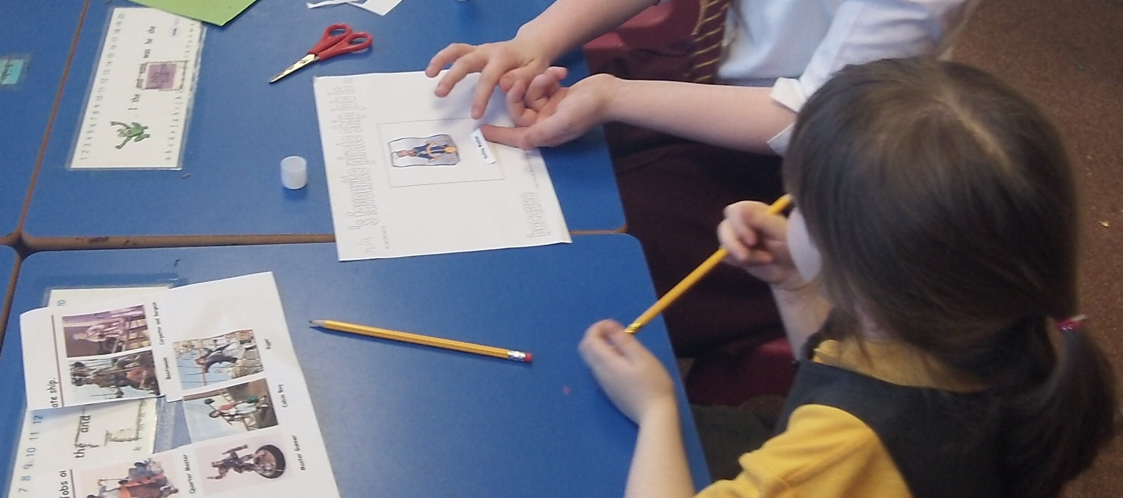
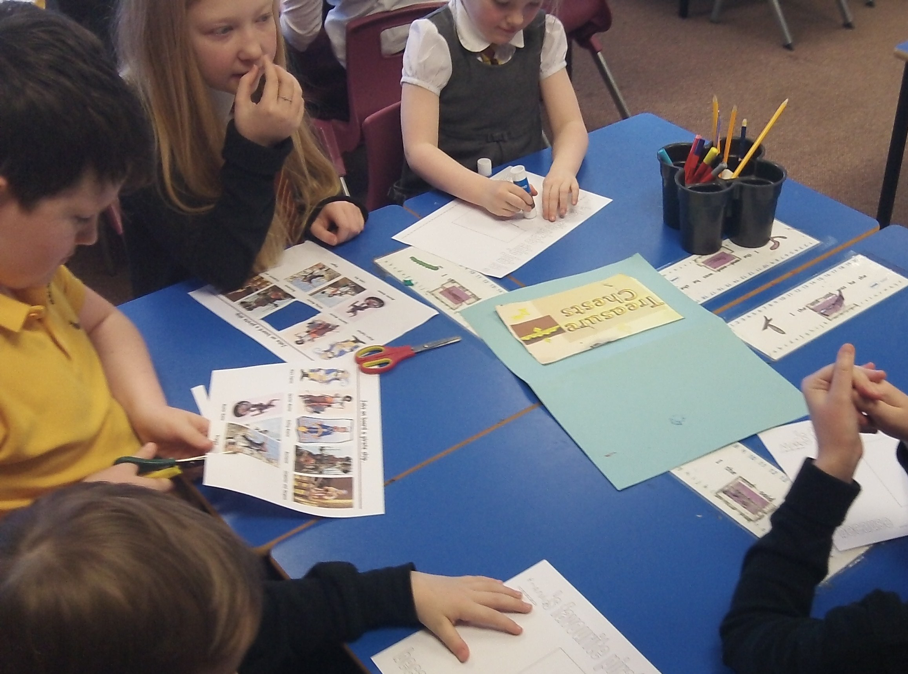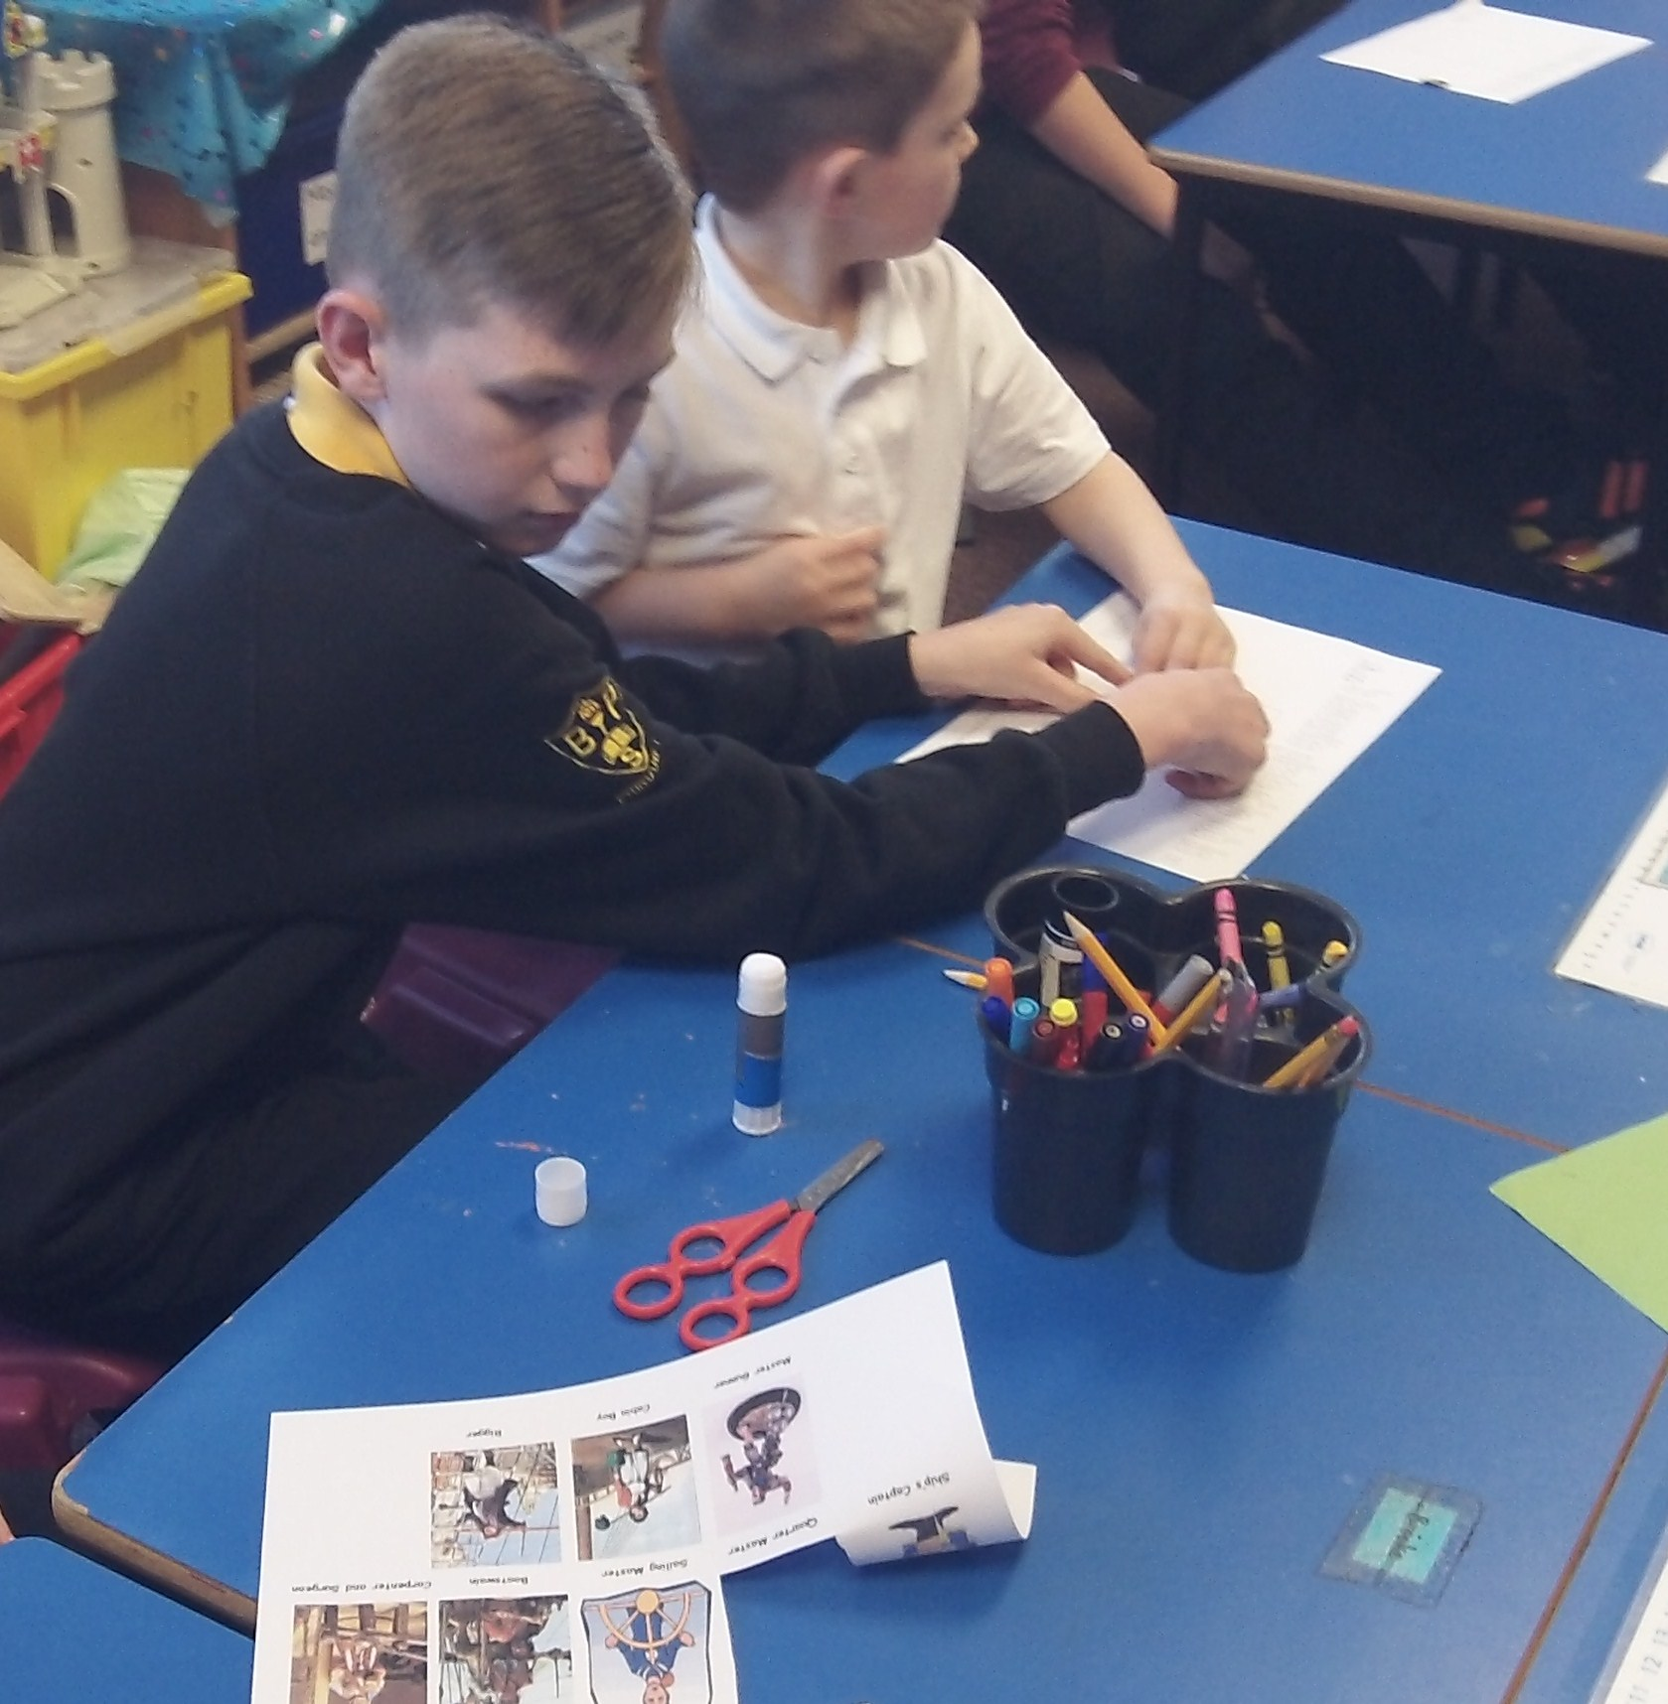
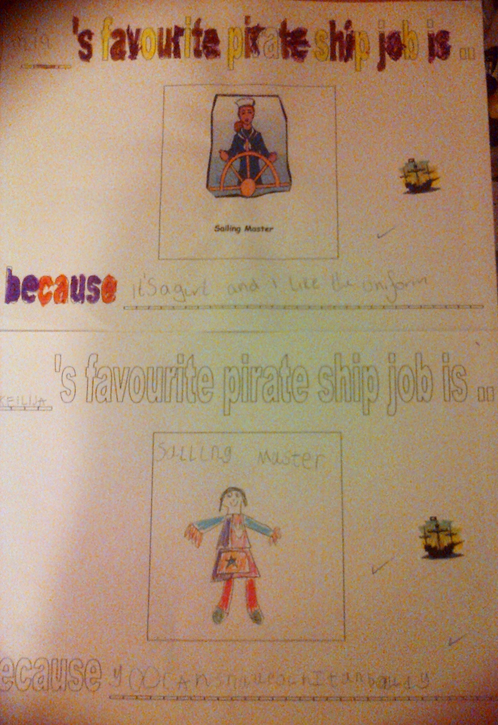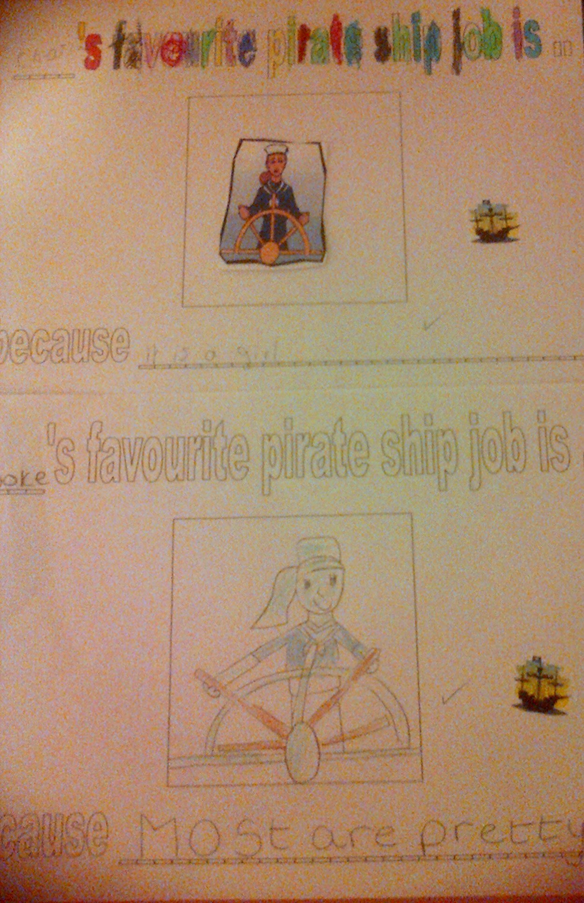
Our P7 buddies alsohelped us with coordinates as we pasted pirate items into the correct position on our treasure grid.
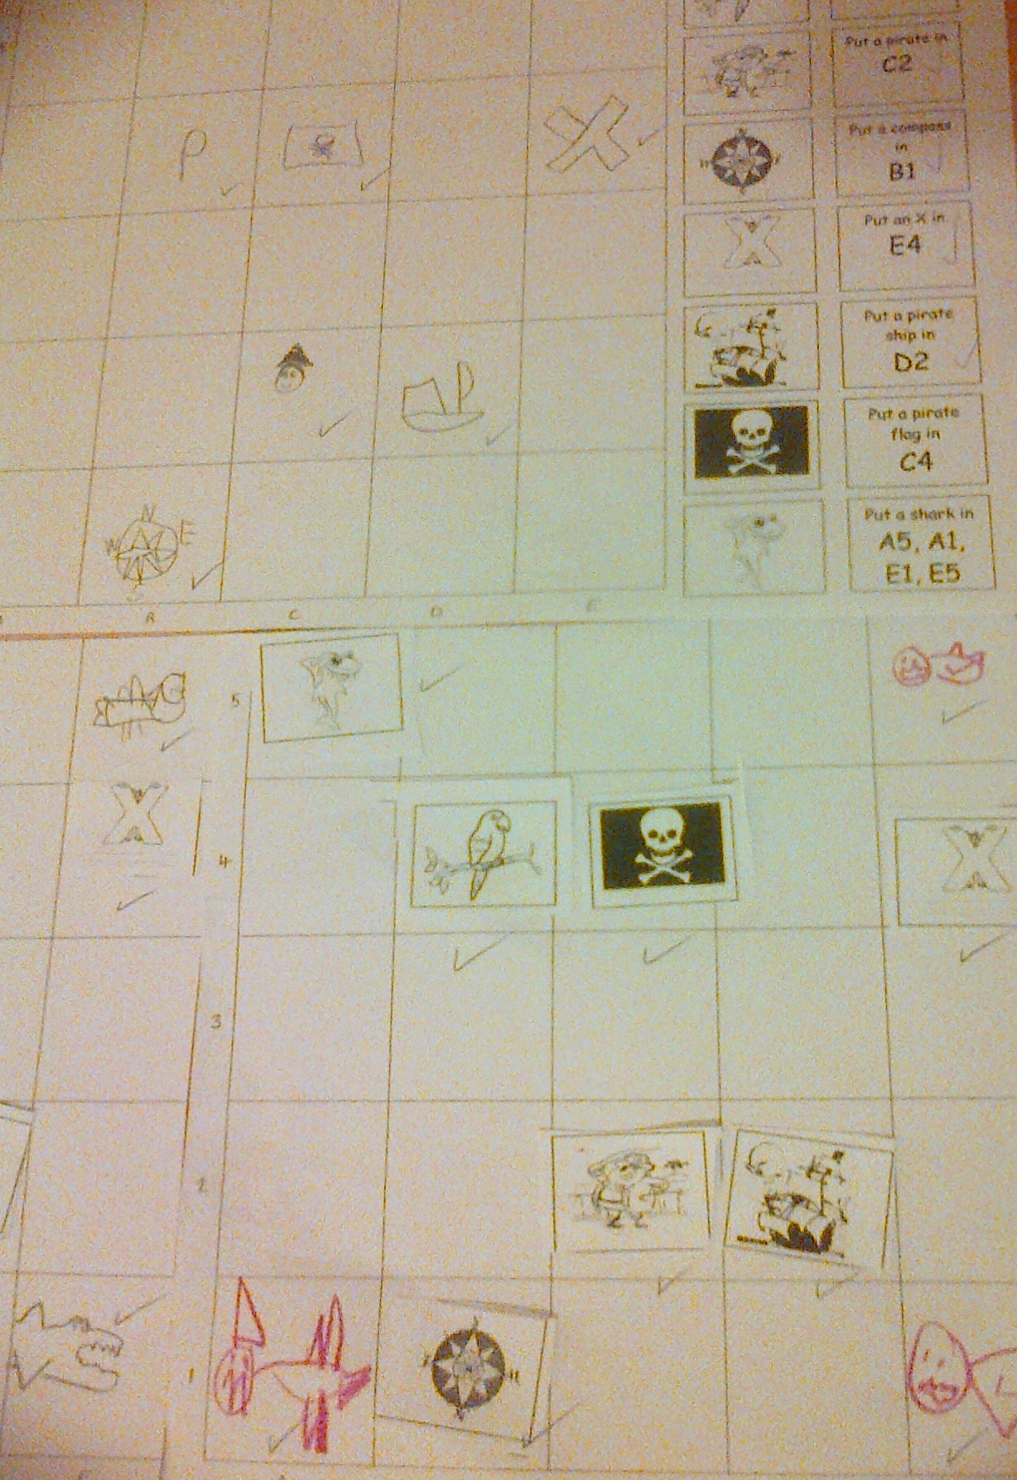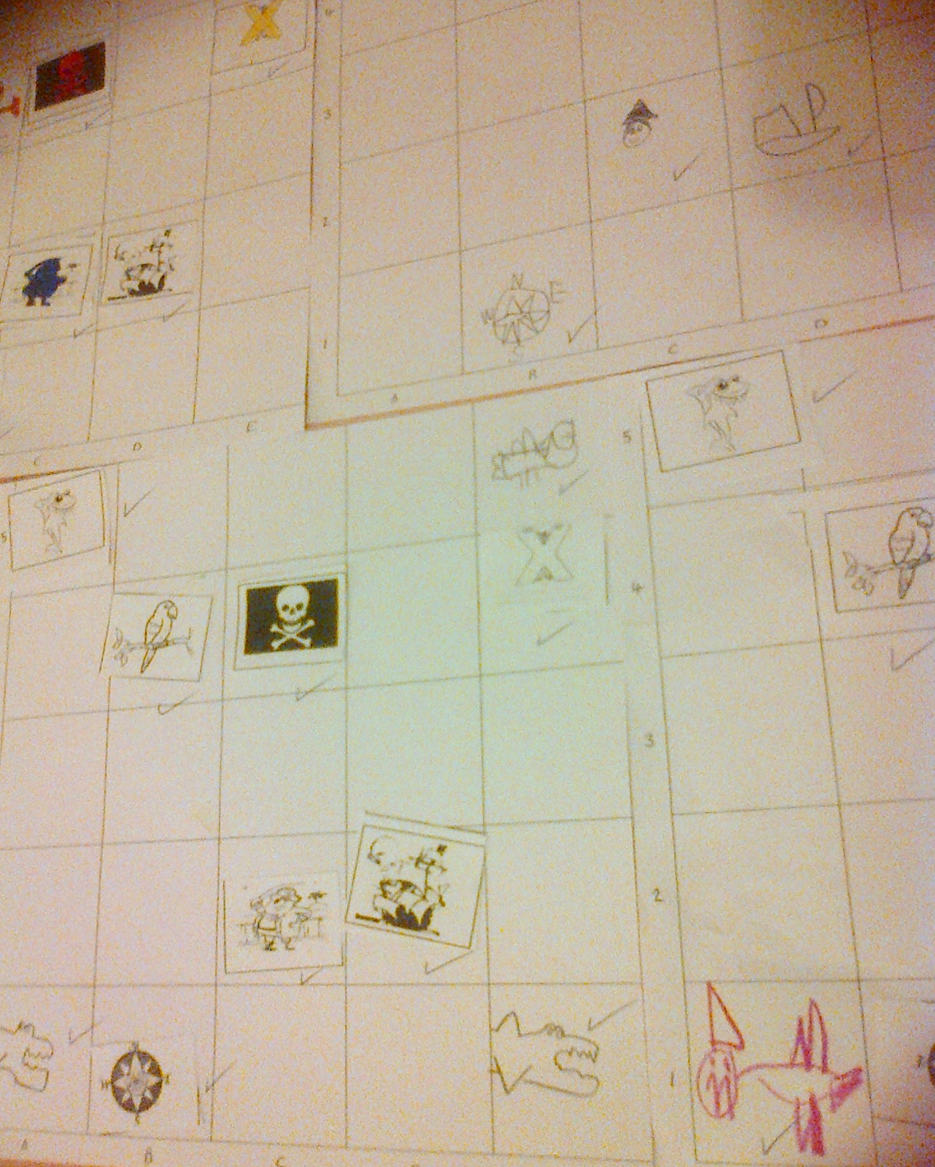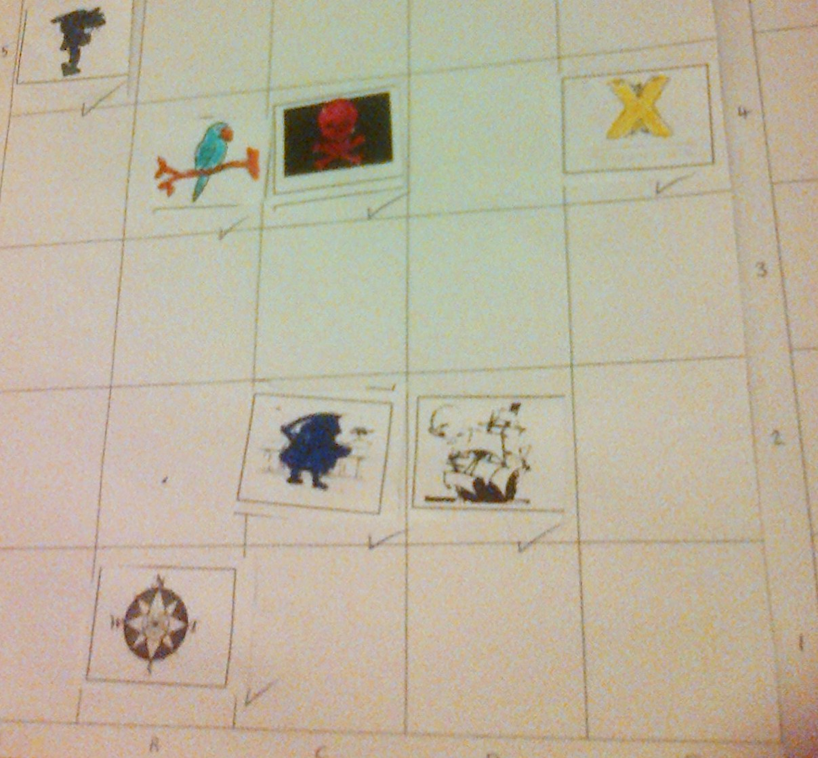
For out topic we used materials to design pirate ships. We used plasticine, lollipop sticks, and paper for flags. It was very hard work trying to mould the plasticine into shape but we got there. 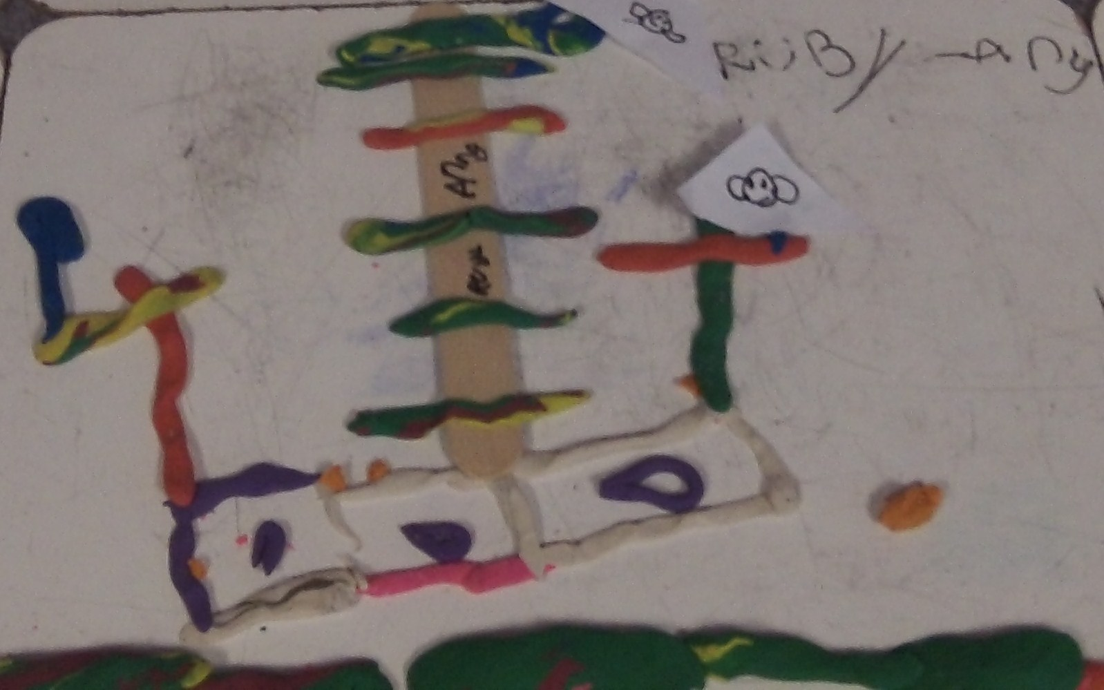 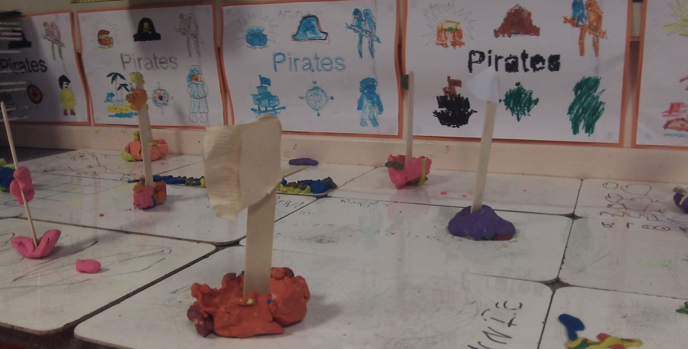 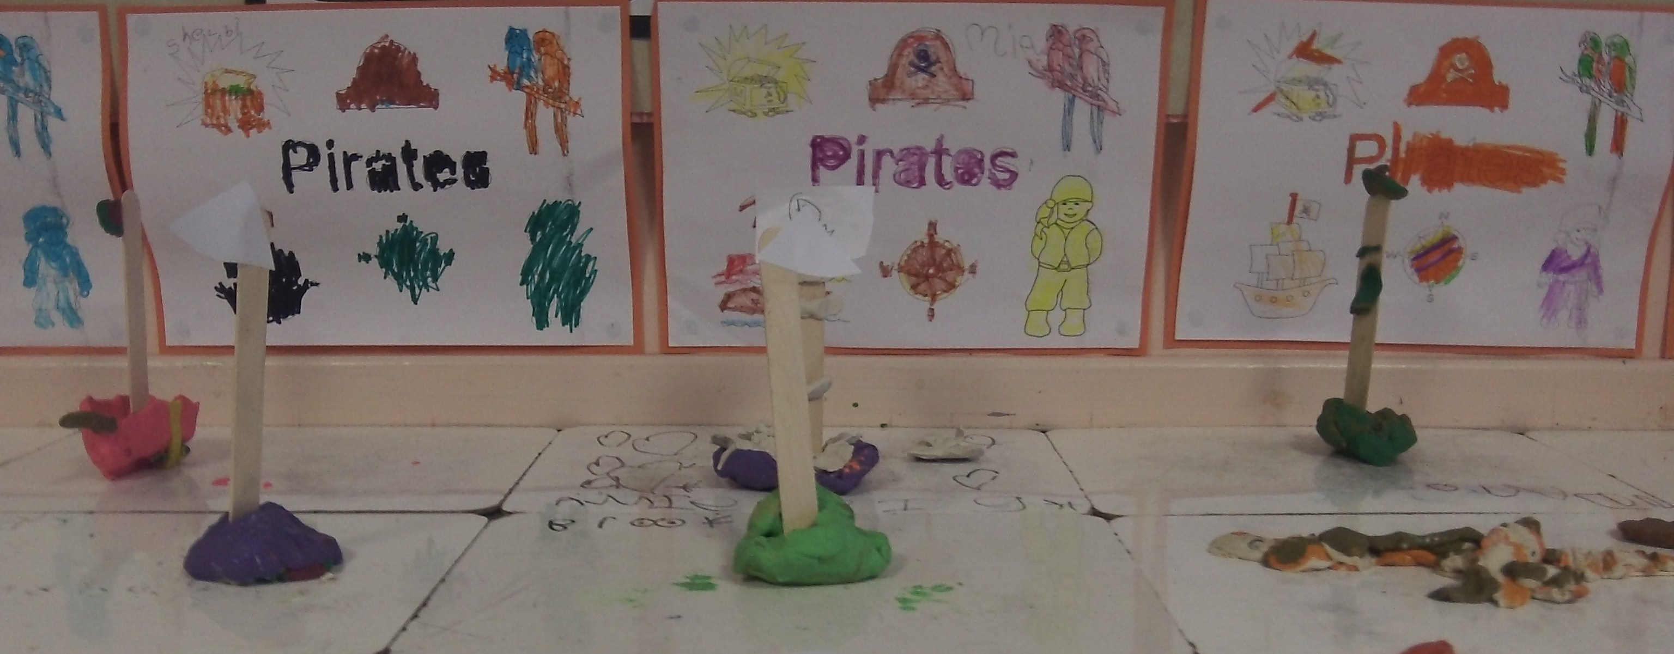
To celebrate “World Book Day” on Thursday Brooke brought in one of her favourite books – “Rumpelstiltskin”. We really enjoyed the story – phew, the Queen was very lucky to find out the dwarf’s name just in time! We practised our drawing and colouring skills with Dr. Seuss, “Charlie and the chocolate factory”and “Matilda” activity sheets during free-play. 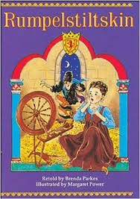
In “Circle-time” we played “Find the hiding hedgehog” to warm-up. We danced to music and then everyone curls up when the music stops. A “hedgehog” is covered up with a sheet and then the other hedgehogs have to guess who is the hiding hedgehog. We had three guesses to get it right before moving on. It was tricky at first but then the “hedgehogs” became quicker to find. Then we played one of our favourite games - “Questions from the hat”.
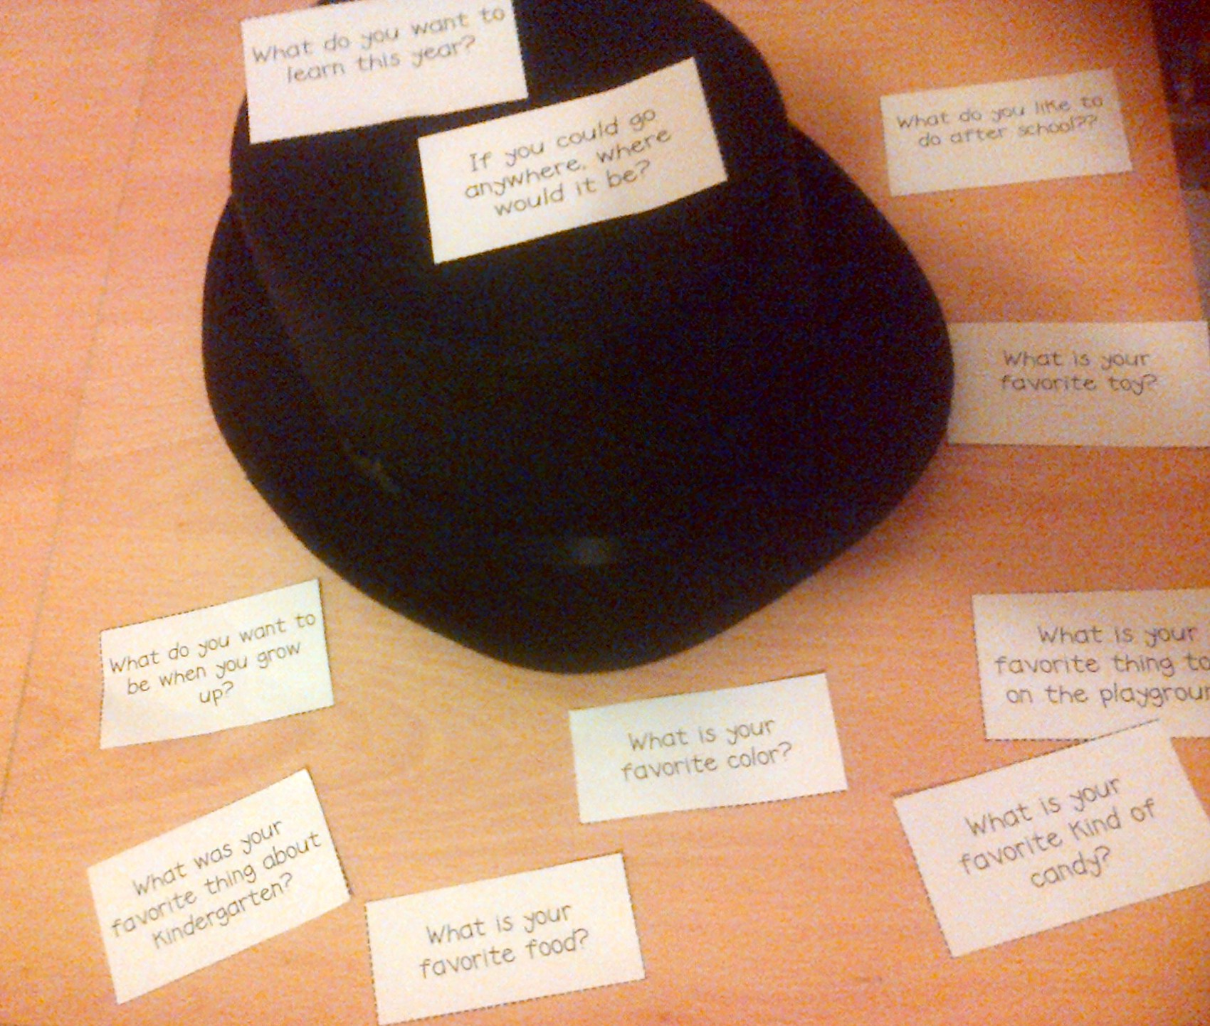
Kyle was asked “What was your favourite thing about nursery?” and he remembered it was playing with the water. Liam was asked “What do you want to learn this year?” and he told us that he would really like to learn new sounds. Cameron was asked “If you could go anywhere, where would it be?” and he told us it would be “Morrisons” or “Tesco” because they have toys, clothes and food. Rory was asked “What is your favourite toy?” and he told us it would be his “Minecraft” toys, figures and blocks. Brandon was asked “What is your favourite colour?” and he said it is sky-blue because he likes that colour. Ruby-Anne got the question “What do you like to do after school?” and she said that she likes to play with her animal toy “Lambie”. Charlotte was asked what her favourite food is and she chose “Macaroni cheese”, “Spaghetti bolognaise” and “the school’s beefburger”. Callum got the question “What is your favourite kind of candy?” and he said he likes red, pink, blue and marshmallow candy. Charlie was asked “What do you like to play out in the playground?” and he said that he likes to play “Wolverine” and “Minecraft” with Liam and Kyle. Mia finished with the question “What do you want to be when you grow up?” and she said Elsa from “Frozen” because she loves “Frozen”. ☺

Have a good week from P1L.☺

