This week in P1h!

We are learning how to work in a group successfully. This week we had to gather everything we needed quickly and quietly. We made biscuit to have with our milk.

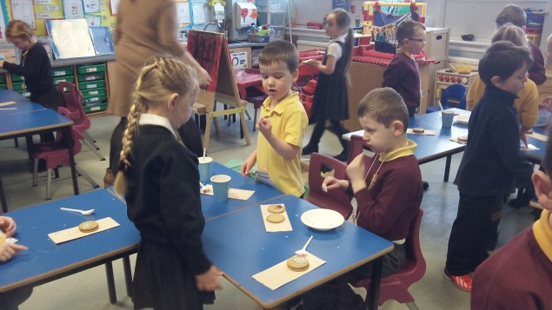

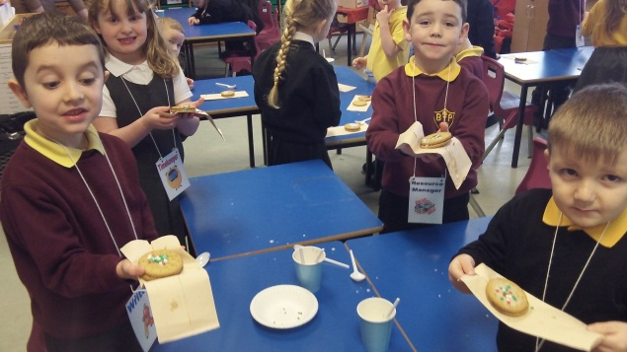

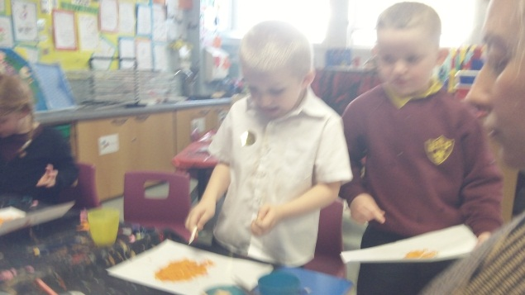

In art we are learning about collage.

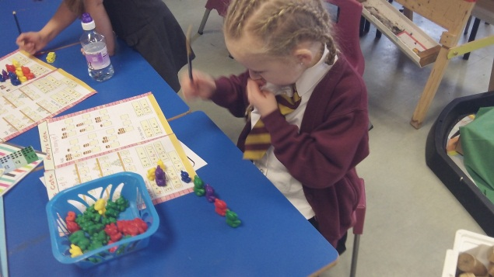

In maths we have been practicing our adding skills and finding out about properties of number. On the smart board we are working out odd and even numbers.

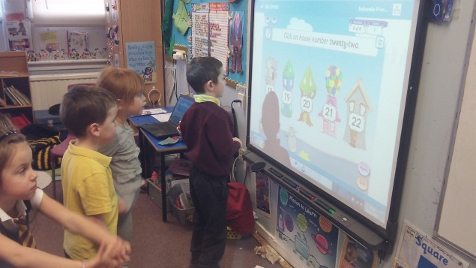

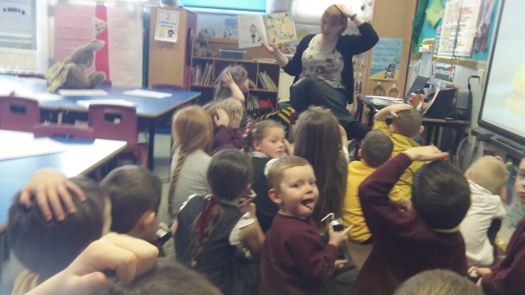

We have been reading the story of ‘There was a wee lassie who swallowed a midgie’. We had to listen out for the Scots words and then we made the wee lassie so we could retell the story using the Scots words.

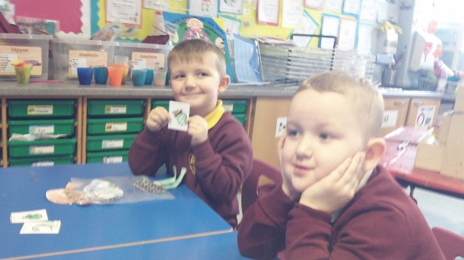

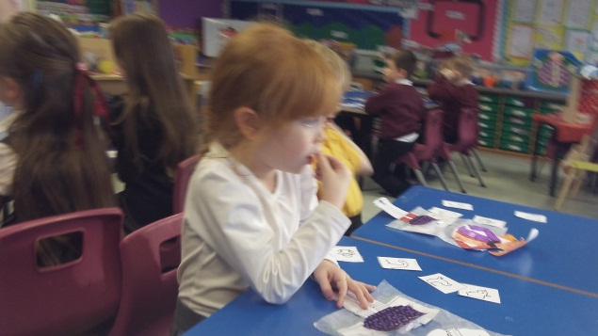

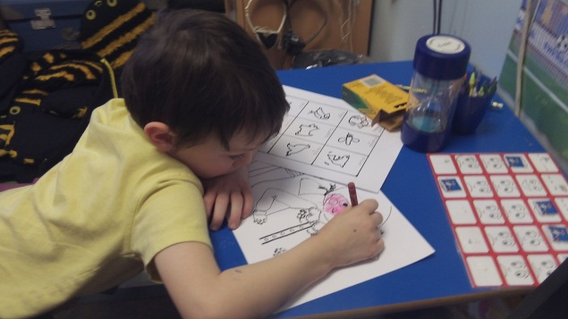

Thanks to Alexander for being our class photographer.

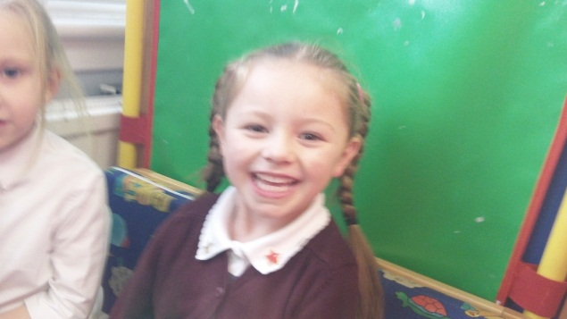

Bye for now!