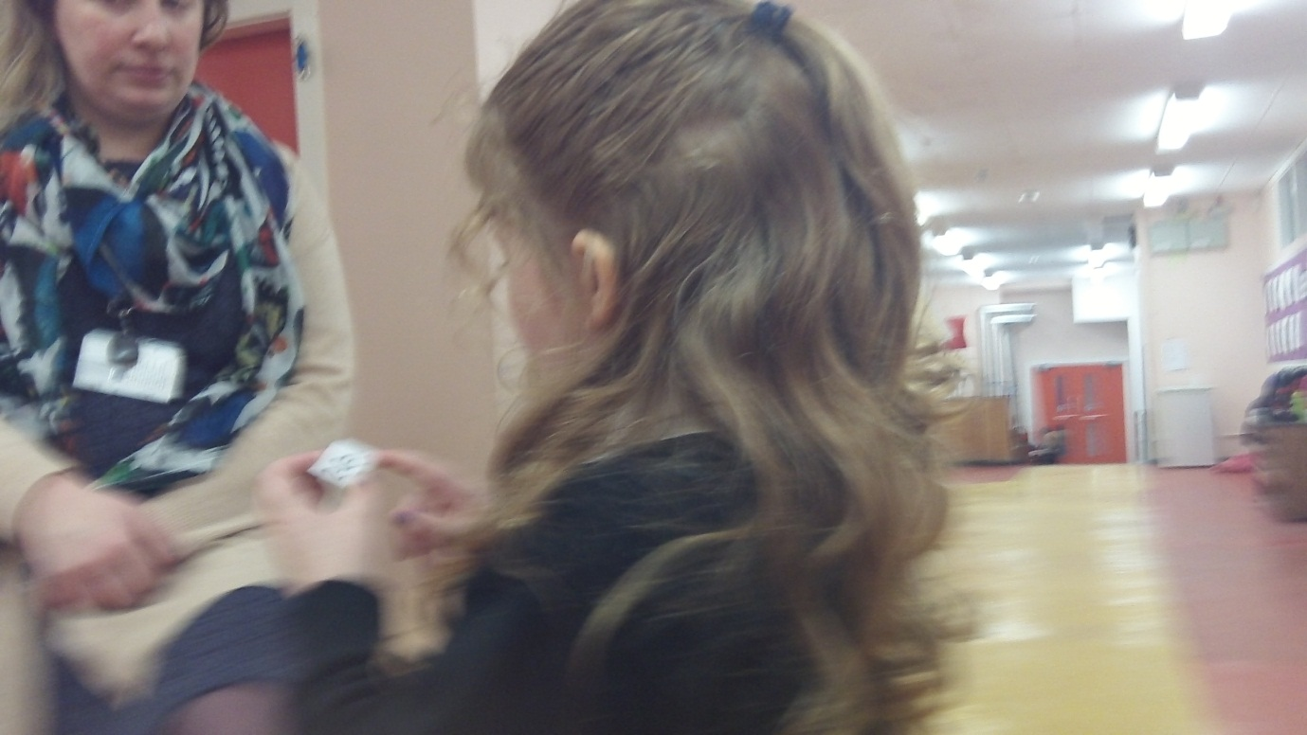The week beginning the 26.01.15 in P1h

In maths we have begun to learn about subtraction. We went on a calculation hunt, we had to find a calculation and answer it correctly before we could find another. Jay was very speedy at this.

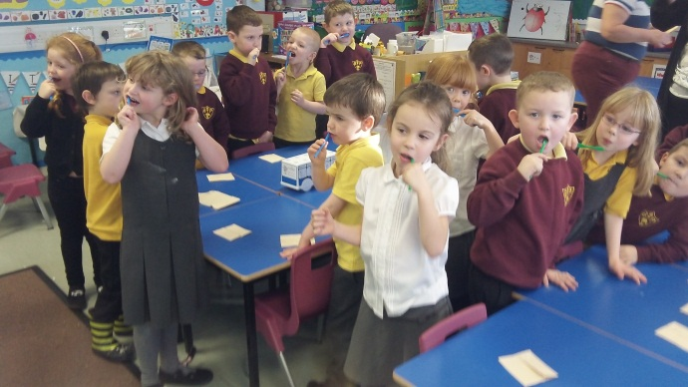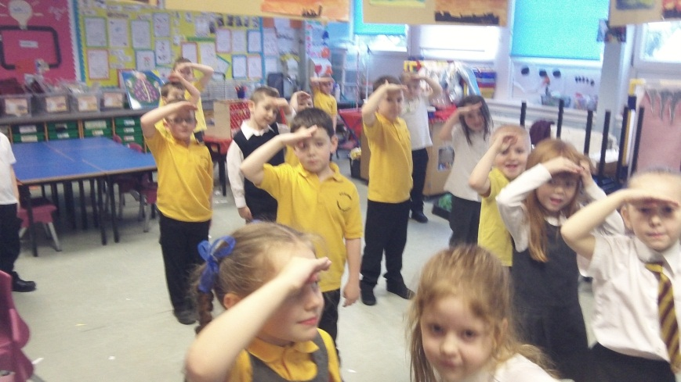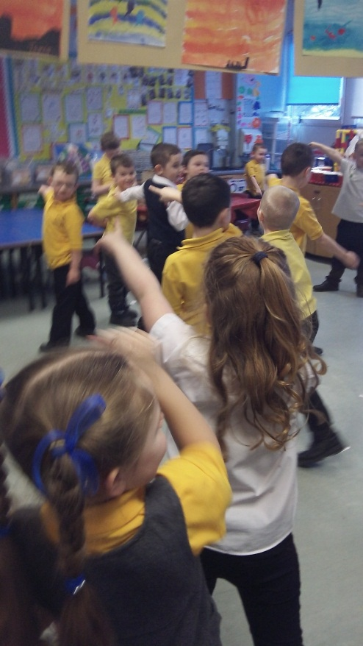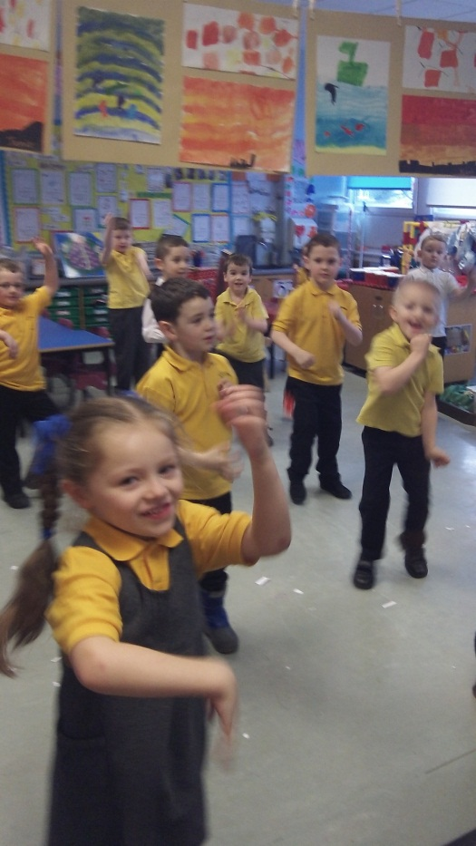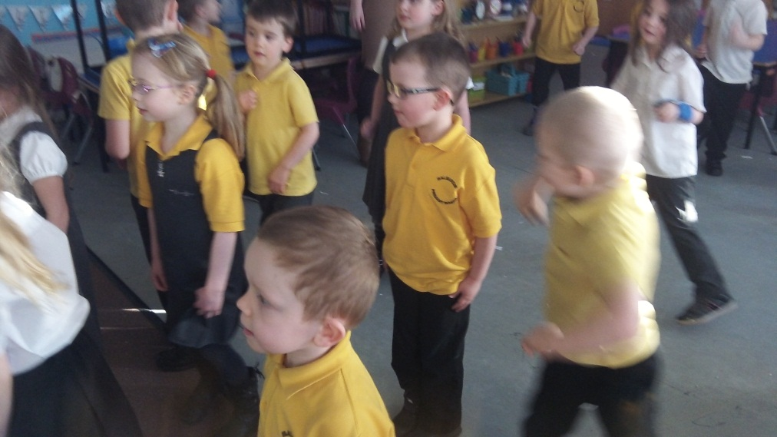

We have started out learning context of Treasure Island. We all made a floor book to share our ideas. We had lots of questions about the ships. To learn to parts of the ship we played a game, these are the actions for: rigging, stern and the Captain.

We have also been busy transforming our classroom.

Making our teeth nice and strong.

It was snowing this week so we had to have outdoor PE in the classroom…here we are doing Latin aerobics. Thanks to Niamh for being our class photographer.