P1L’s third week in January (week ending 23.01.15).
This week we were learning how to write numbers 1 to 10 in Chinese with the help of our wonderful P7 buddies! We used paint so that the writing was in brushstrokes.
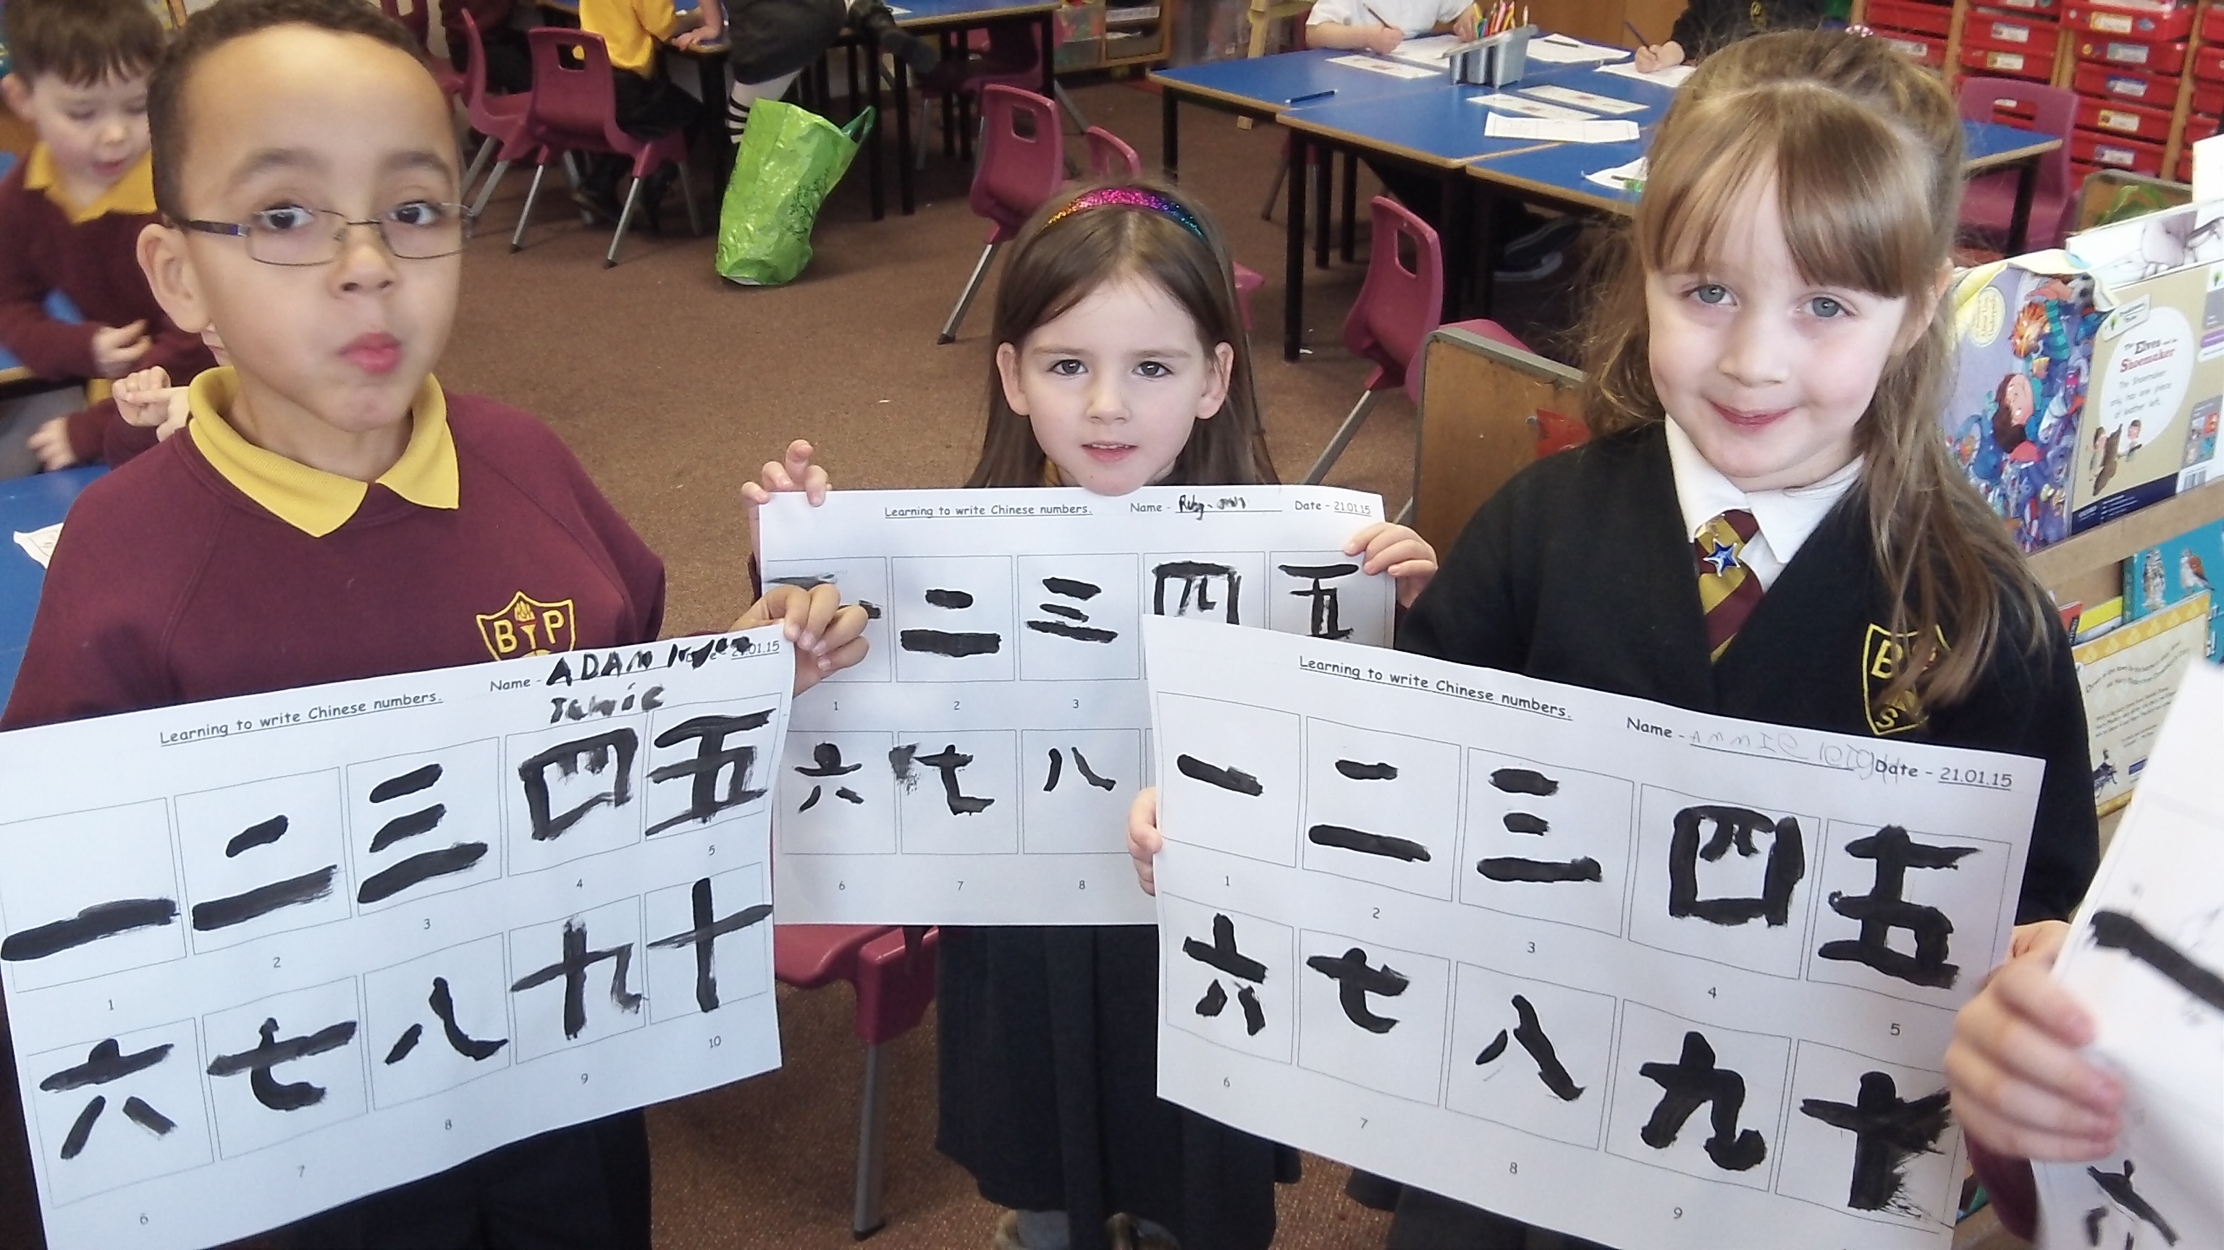
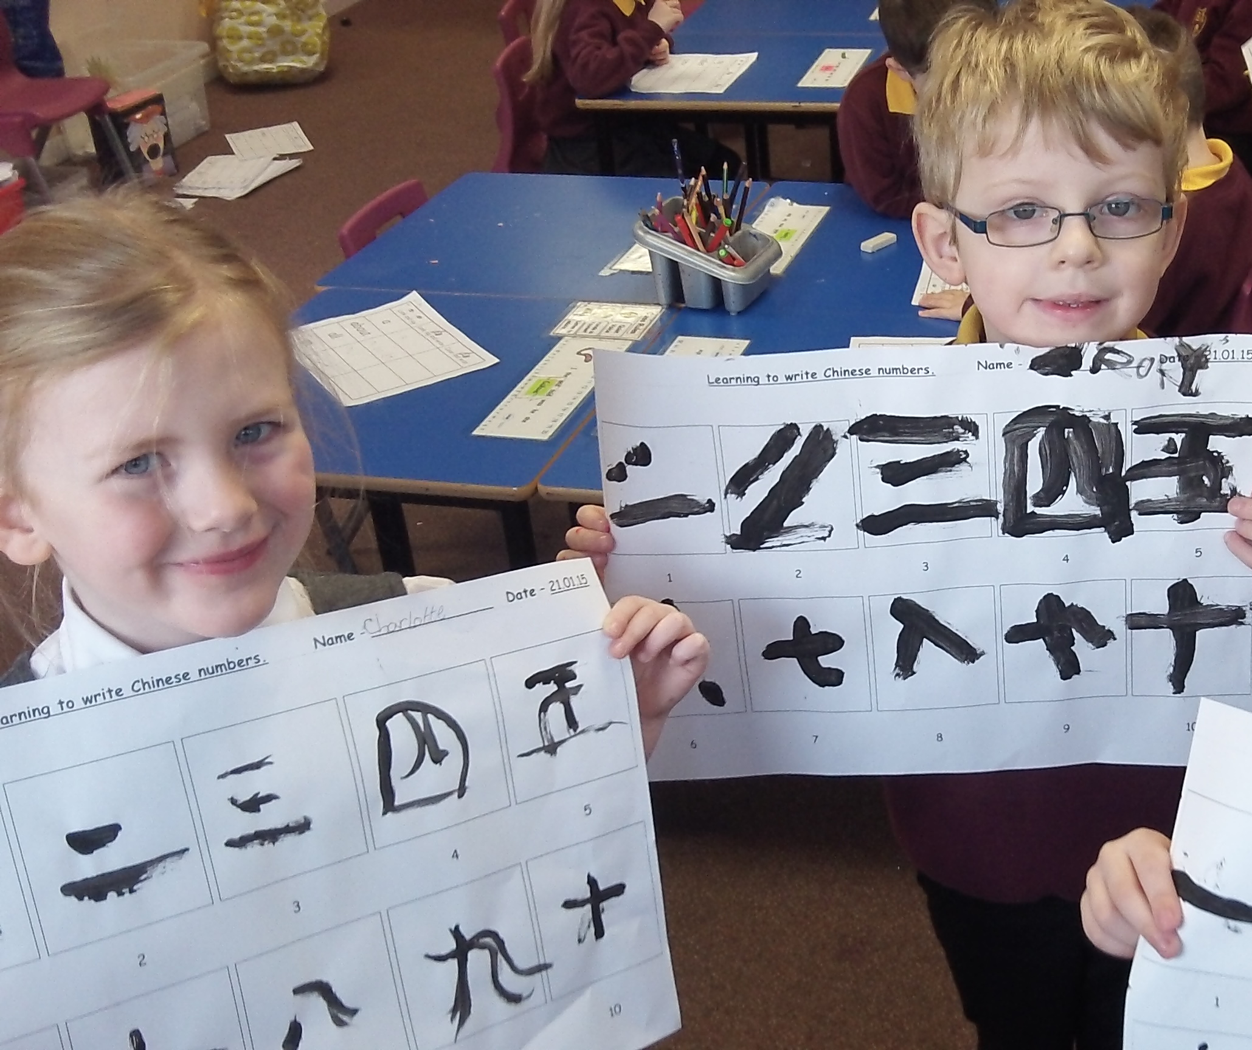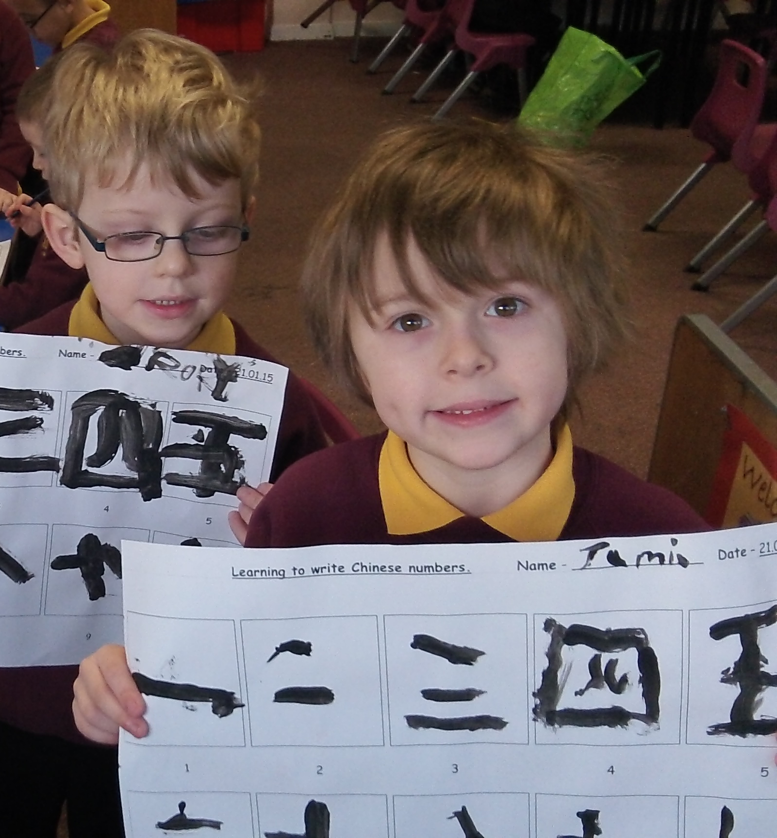

Our buddies made up some Chinese addition sums for us to solve - like 1 + 3 and 1 + 9. We thought of the answer and then looked for the Chinese number symbol to paint in the box after the equals sign. We managed very well with the challenge.

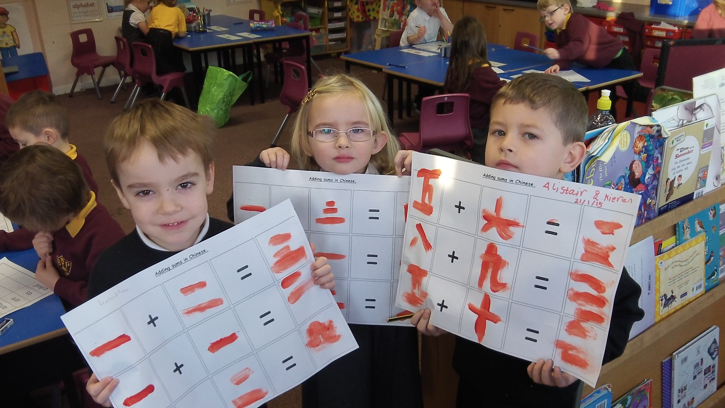
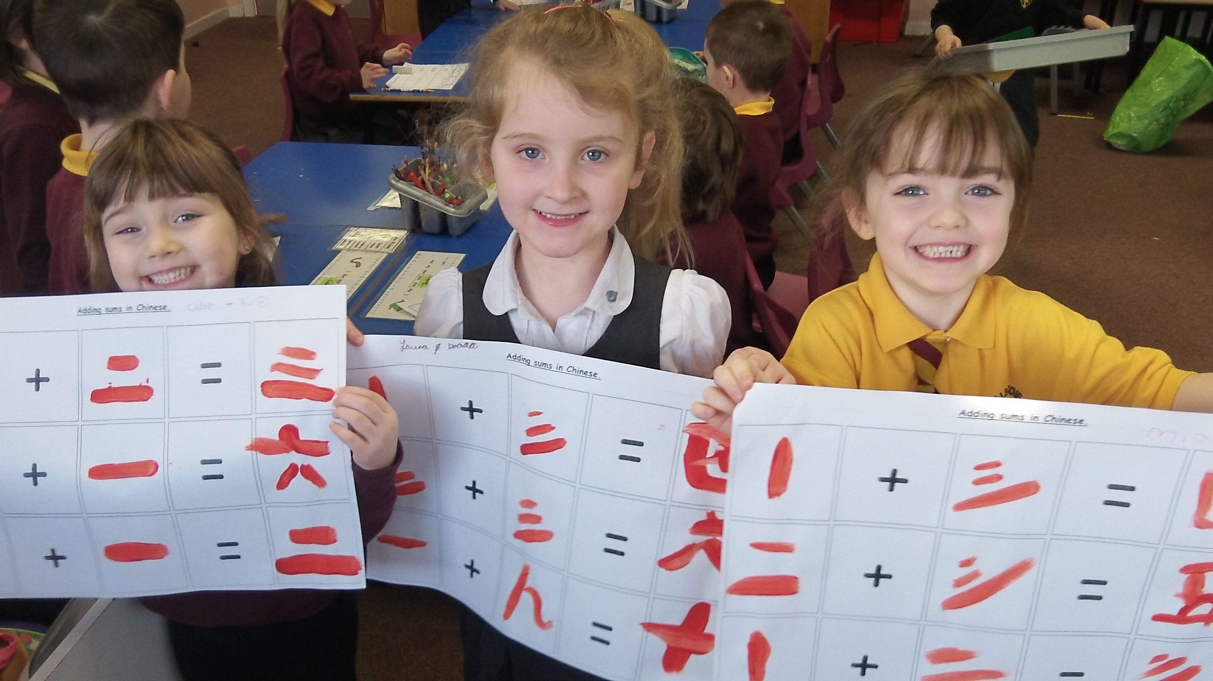
We looked through newspapers for letters to spell “oo” and “ee” words in our phonics group – we had to hunt very carefully to find the letters we needed.
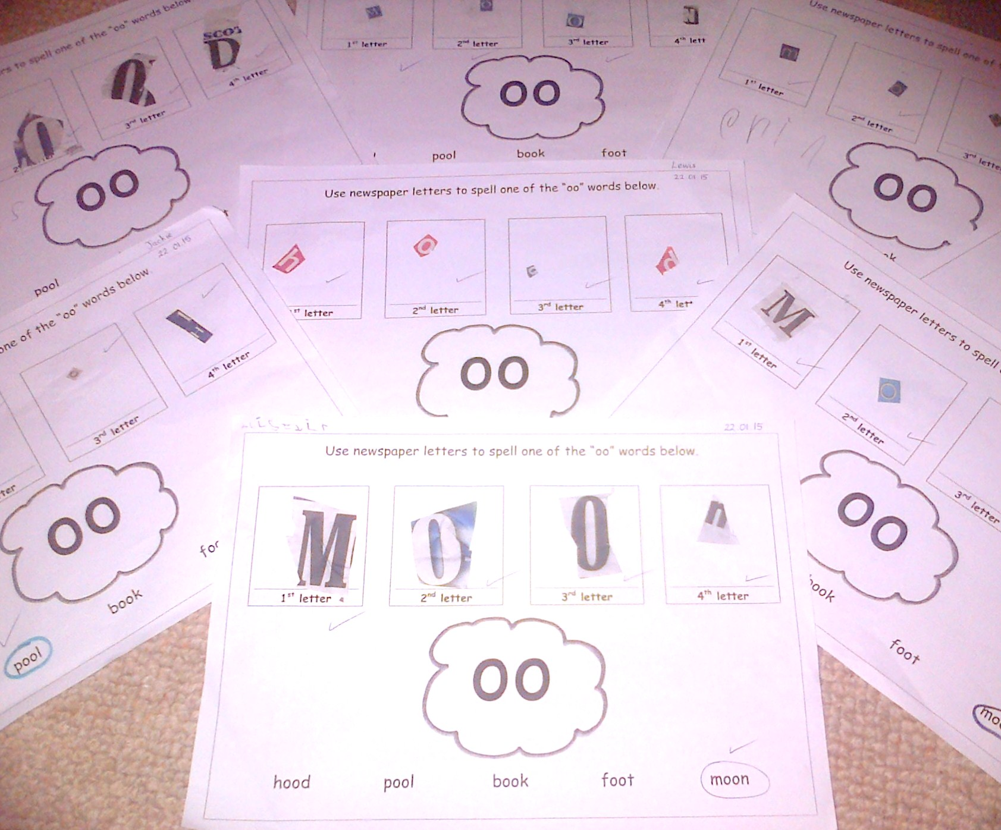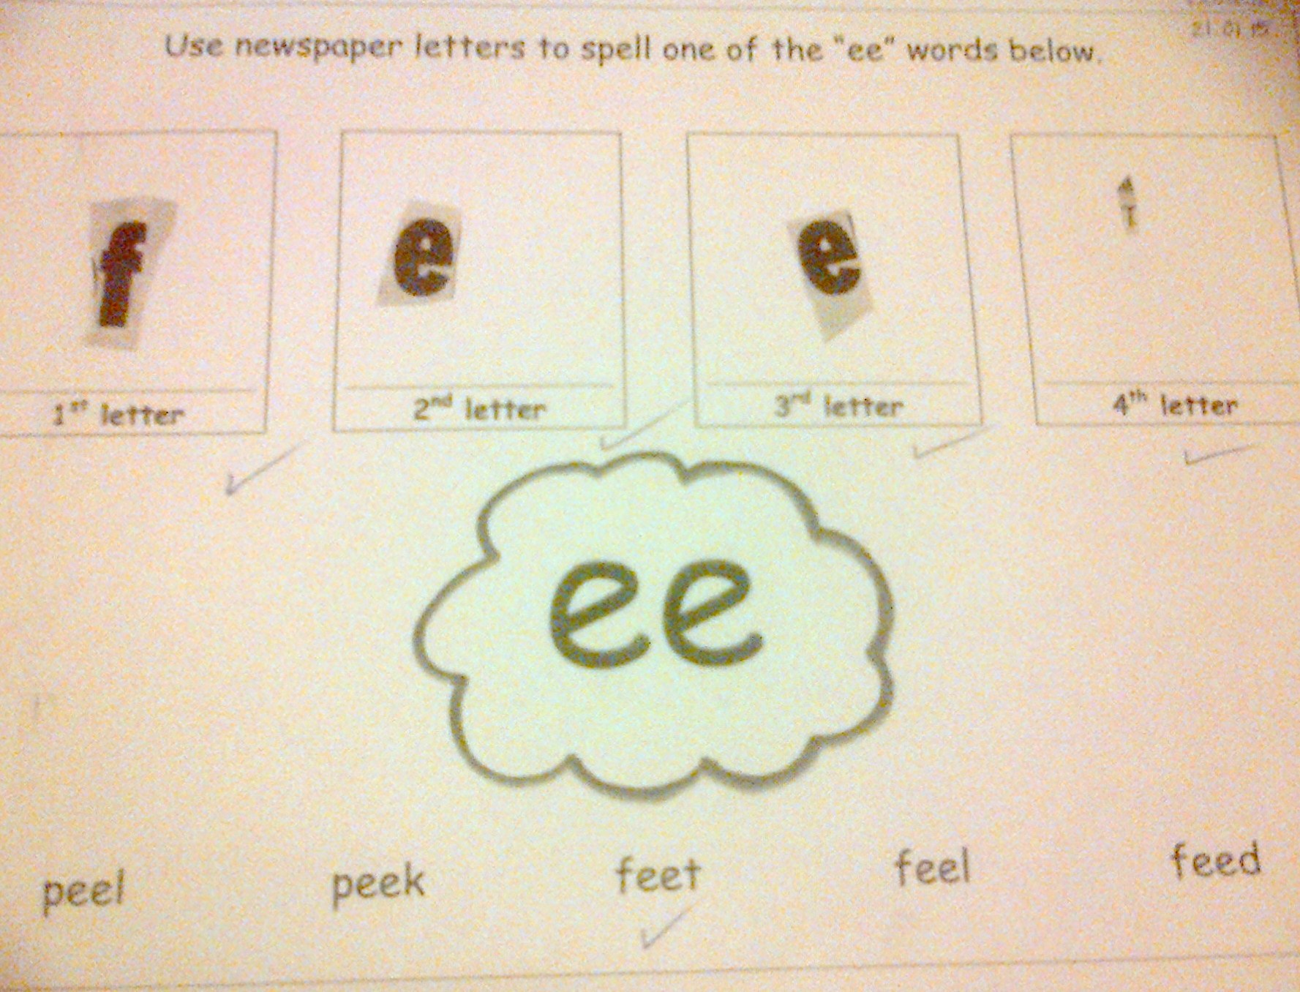
We have been busy practising “tricky words” to help us with our reading and writing.
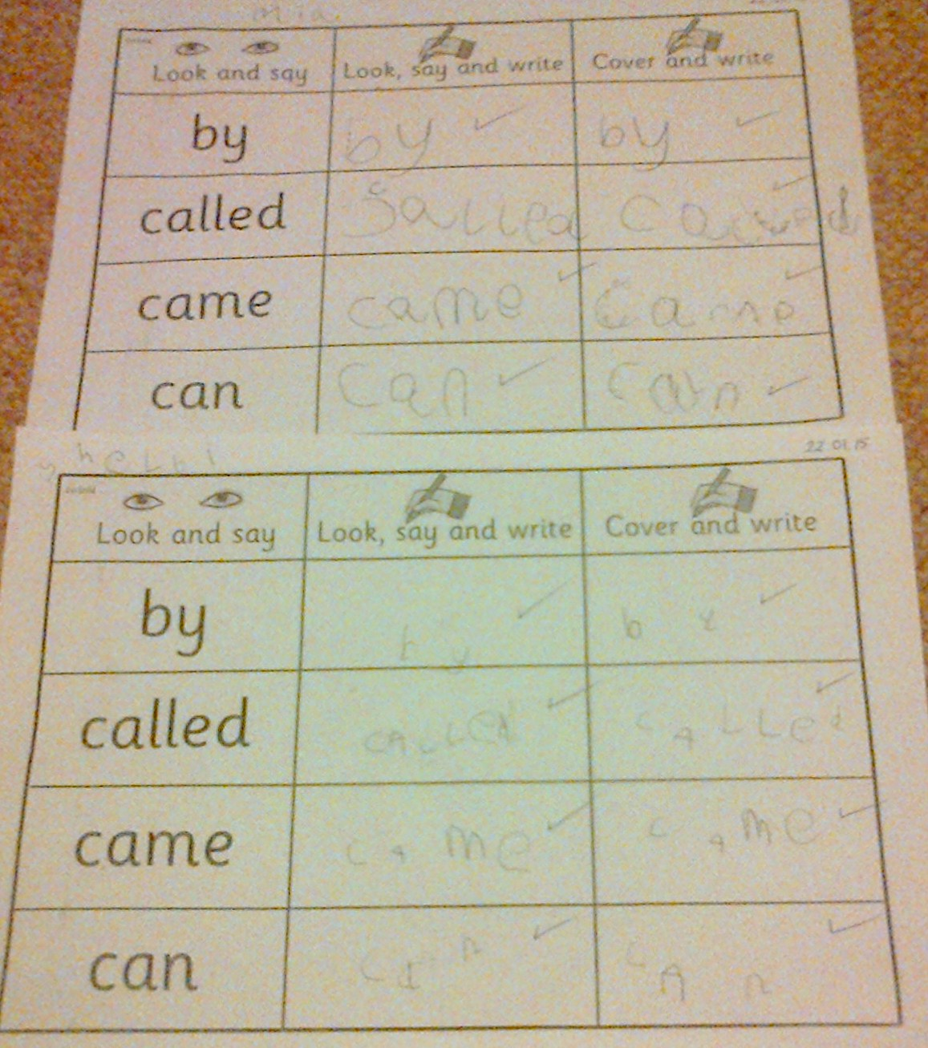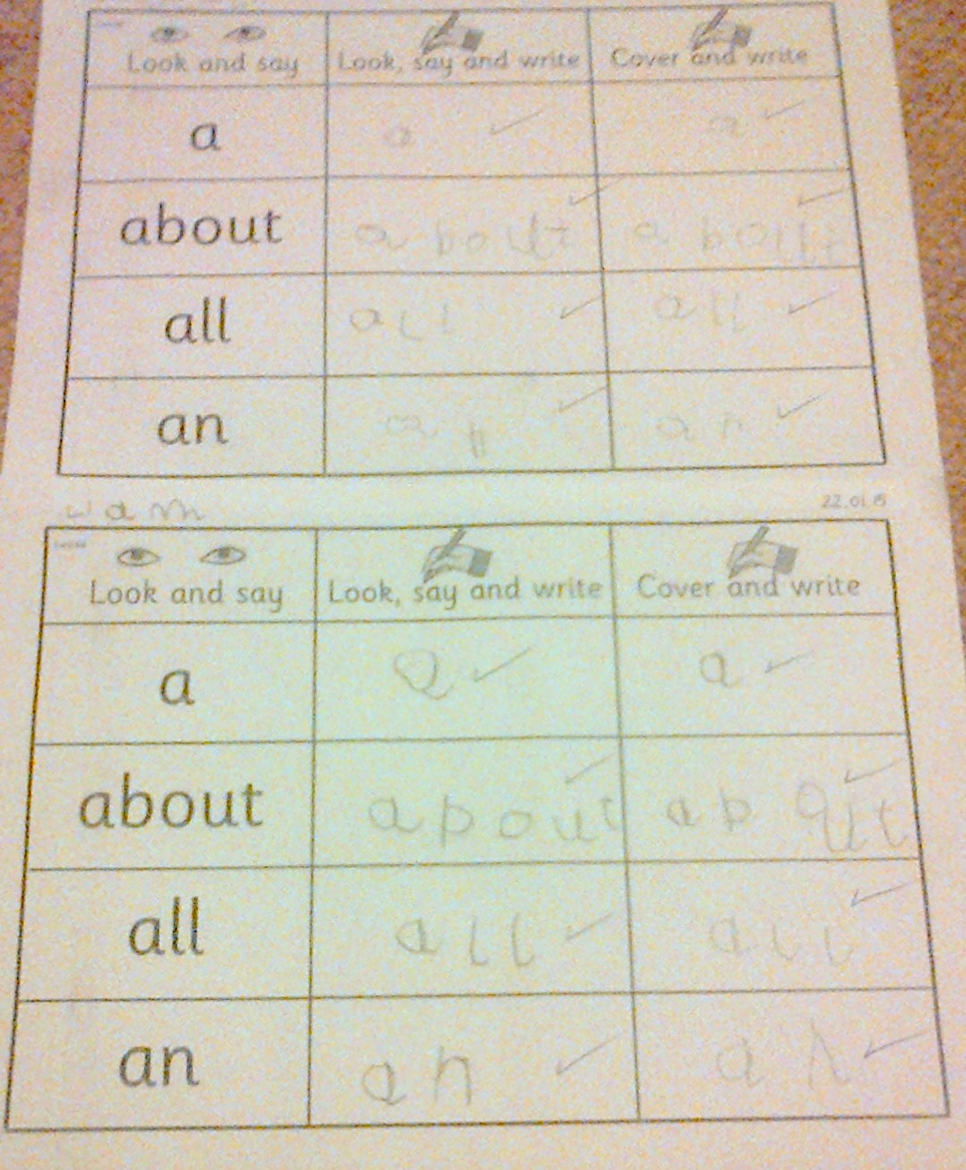
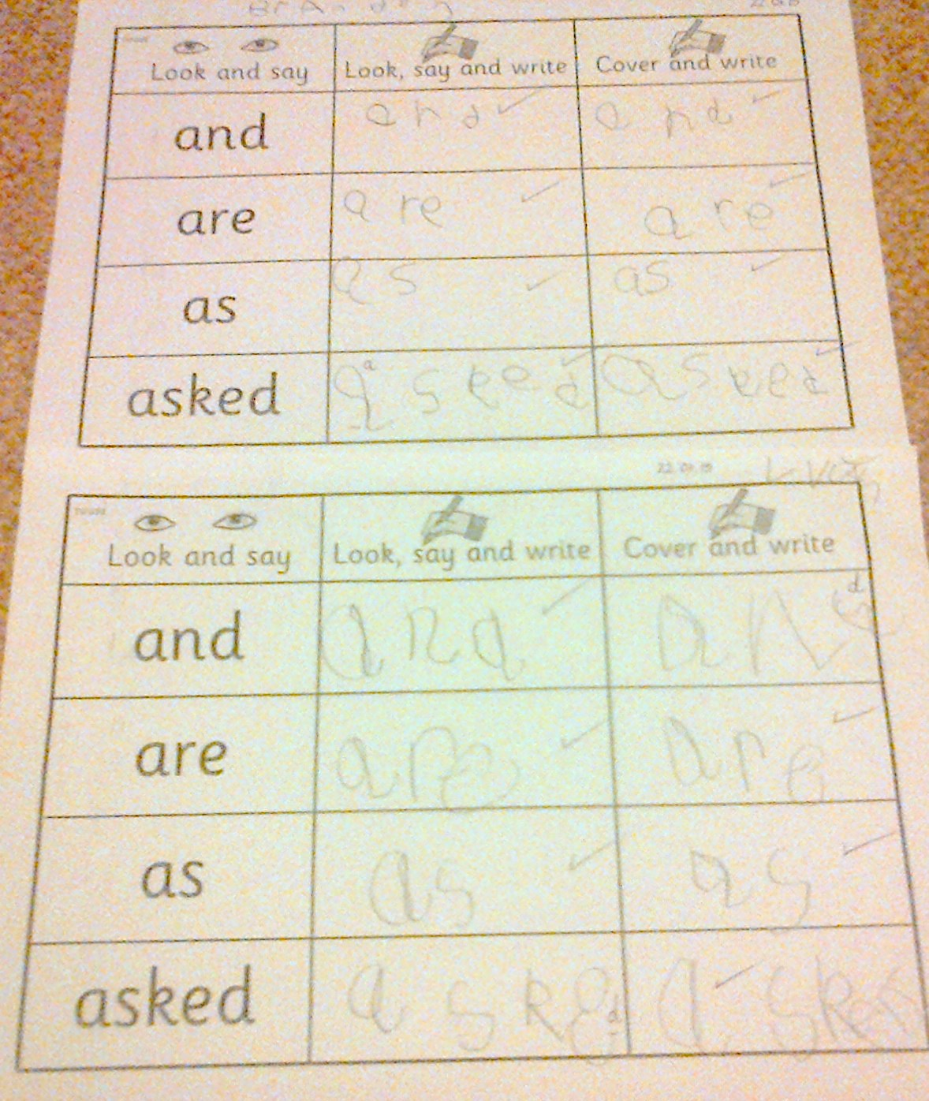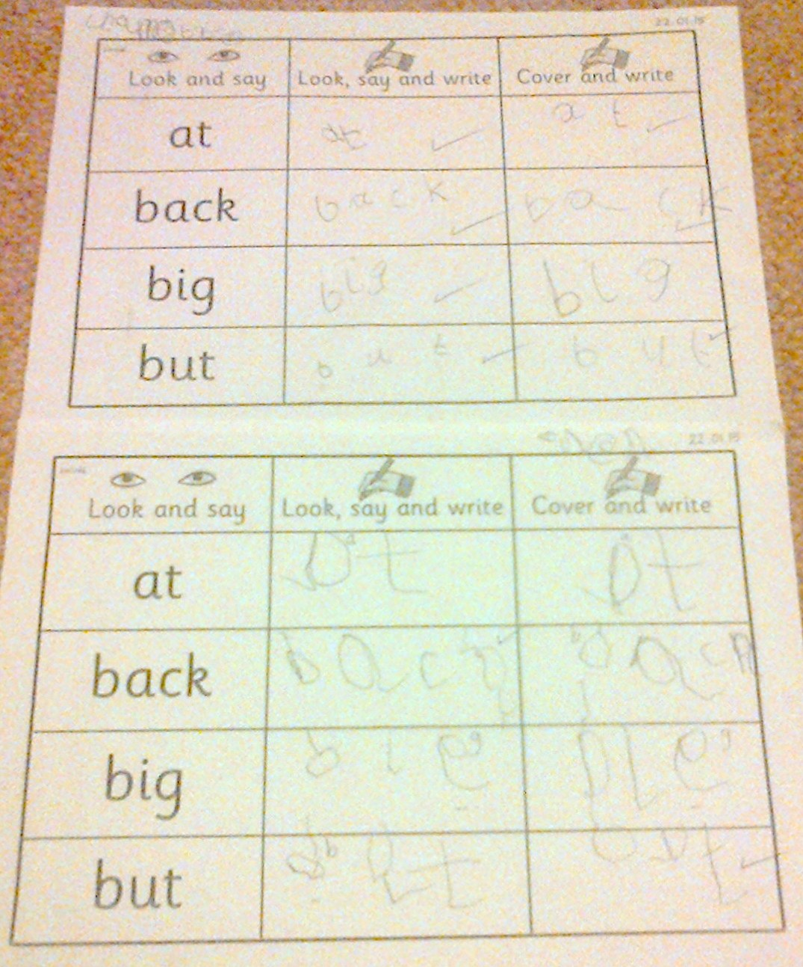
In “Circle time” we played a “questions” game – pupils make a choice and then give a reason to the circle to explain. We listened very carefully to each person because we wondered if we would give the same answer to their question. The answers were amazing because everyone thought of a good reason for their choice. It was very interesting. ☺
Q1. “Would you rather go on a boat or on a train for a journey?” – Kyle answered “a train” – why? “because a train can go fast”.
Q2. “Would you rather go running or swimming?” – Liam answered “swimming” – why? “because my Dad plays ‘Shark attack’ and tries to bite my toes”.
Q3. “Do you like fruit or vegetables best?” – Zara answered “fruit” – why? “because it tastes nice”.
Q4. “Where would you prefer to go for a day out, the beach or the woods?” – Charlotte answered “the beach” – why? “because it would be warm and there is sea and sand at the beach”.
Q5. “Which do you like helping with at home – cooking or cleaning?” – Ruby-Anne answered “cleaning” – why? “because I like cleaning and tidying”.
Q6. “Would you rather build a tower or do a jigsaw?” – Brooke answered “a jigsaw” – why? “because I have lots of jigsaws at home and I like doing them”.
Q7. “Do you like reading or drawing best?” – Mia answered “drawing” – why? “because you can draw what you like and colour in”.
Q8. “Would you rather play in the house or in the garden?” – Owen answered “house” – why? “because there are more toys in the house”.
Q9. “What do you like best – chocolate or cake?” – Lucas answered “chocolate” – why? “it’s my favourite”.
Q10. “Which colour do you like best – purple or orange?” – Ruby answered “purple” – why? “because it is a nice colour”.
Q11. “Would you rather play in the snow or the rain?” - Shelbi chose “snow” – why? “because you can build snowmen with snow”.
Have a good week. ☺

