Hello from P1l – Week 6

We are nearing the end of our “Mystery toy talks”. Zara, Jackie, Liam and Keilija presented their toys very well with clear descriptions and tricky clues. This made the class work very hard to guess what could be inside each box.

Zara brought in an unusual toy – a tiny, furry felt parrot inside a little cage with room for a feed box. She let us hold it for a close look and she told us what most parrots learn to say – “Pretty Polly”.

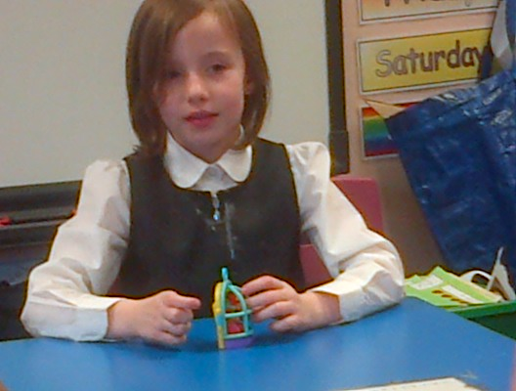
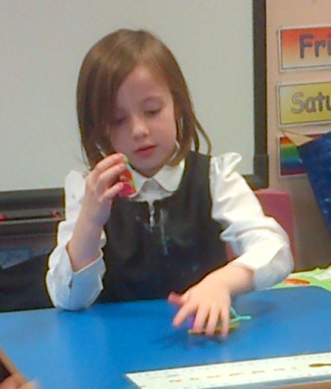
Jackie described his cute monkey to us. He listed six facts –

1. “It’s an animal”.
2. “It lives in the jungle”.
3. “It is brown”.
4. “It eats bananas”.
5. “It swings from trees”.
6. “There’s one called ‘Curious George’ on TV.”.

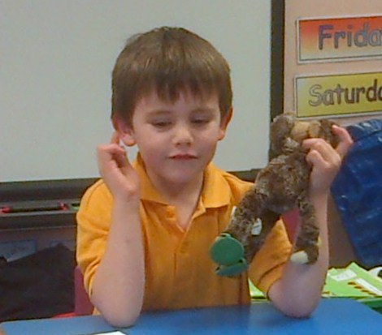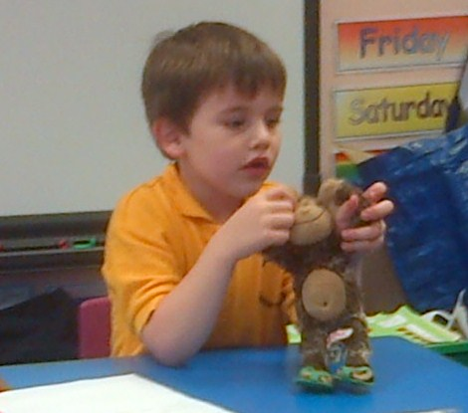

George is a very special monkey because he is the only monkey we have seen wearing lovely summer flip flops!
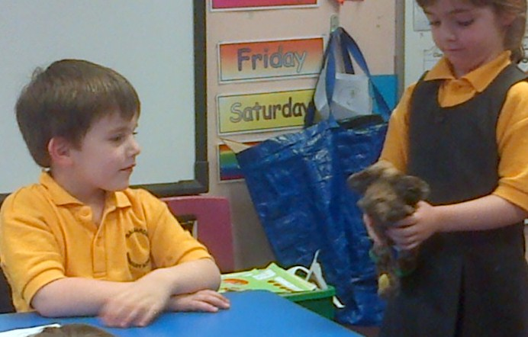

Liam brought in his favourite toy “Wolverine” – the class guessed Liam’s toy fairly quickly as he is quite the “Wolverine” fan. ☺

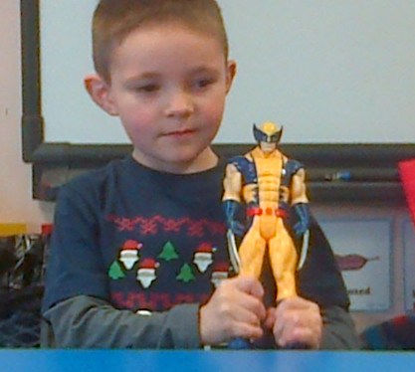

Each claw on the gloves can be removed if “Wolverine” is not angry. Liam likes the blue and yellow colours of the toy as well as the “Wolverine” character.

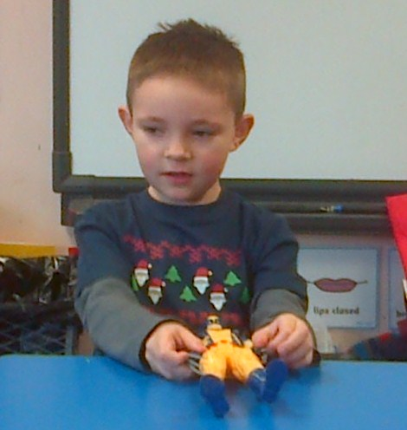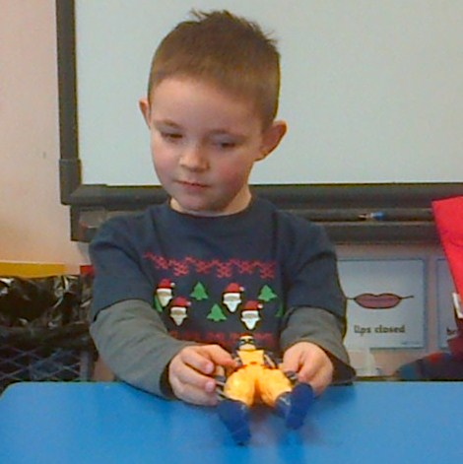

Keilija brought Anna and Elsa into class. She explained to us that they were bought “online” and not from a shop. This was an interesting talking point as Keilija told us her Mum saw them on the internet and bought them by clicking buttons. Then her family waited for the dolls to arrive through the post. Keilija plays with the dolls when she decides it is time to switch their clothes around.
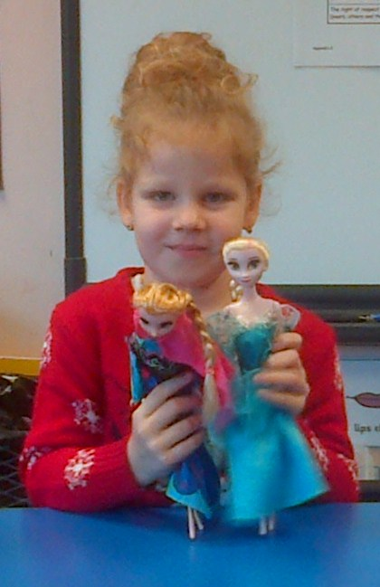
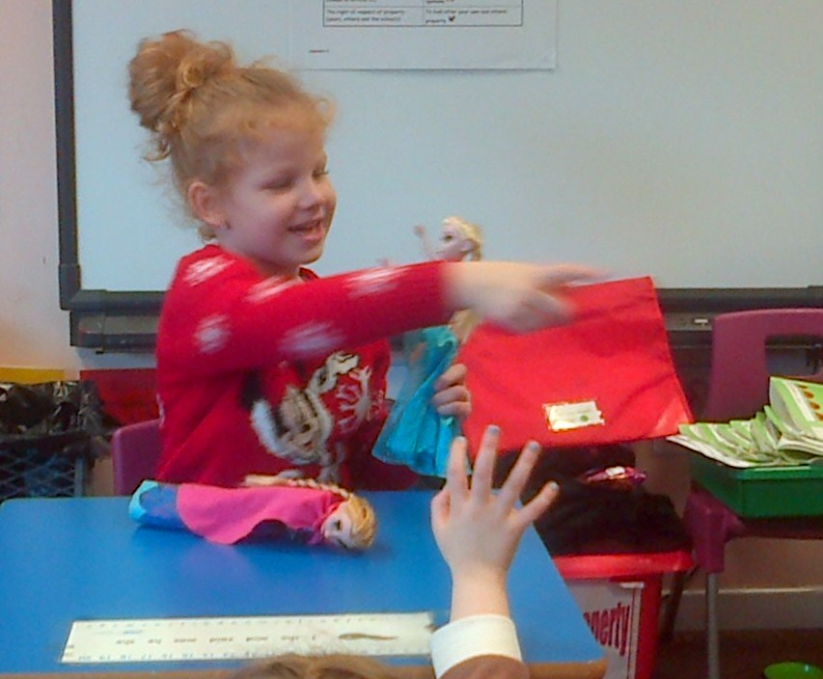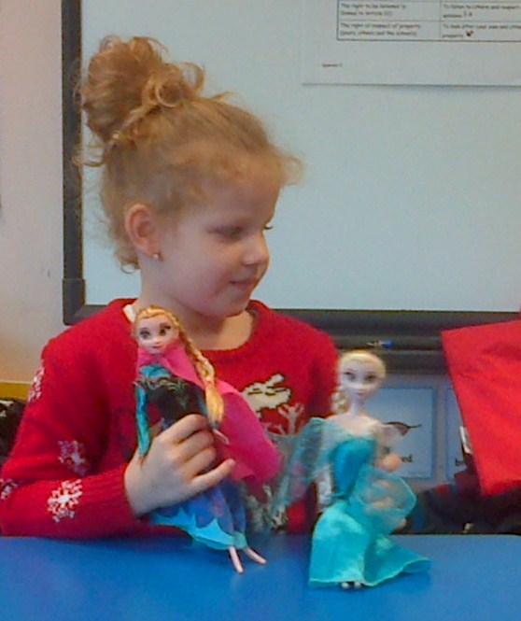
Ruby-Anne and her Mum won a lovely cake at the Christmas Fayre. They very kindly gave us a slice of the Christmas cake – it had edible glitter on the icing! Here are some photographs of us enjoying the cake before going home at the end of the day. Thank you. ☺

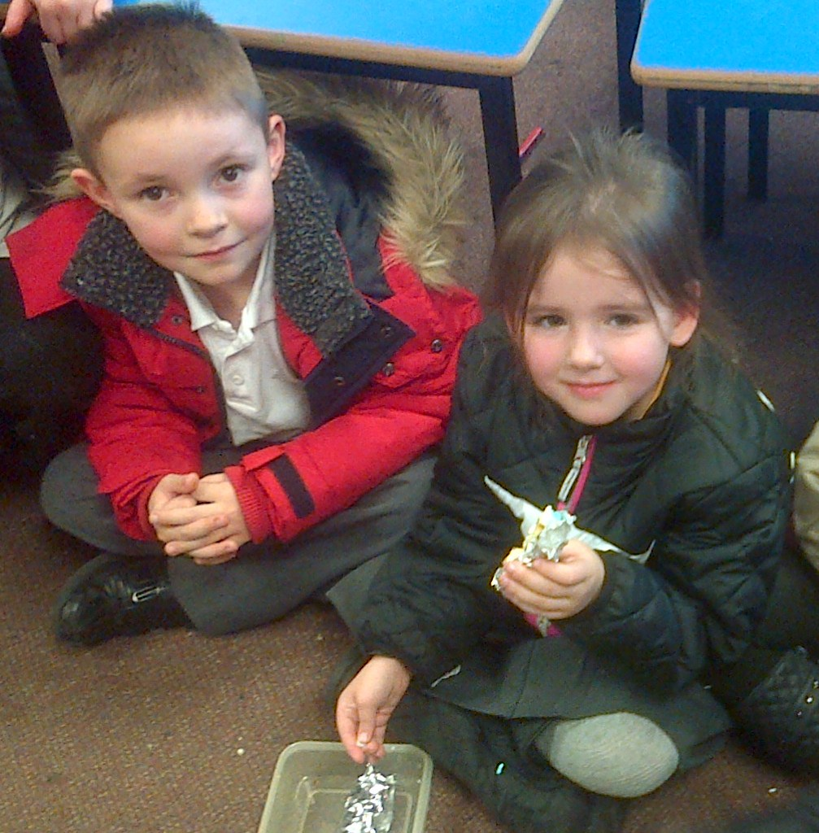
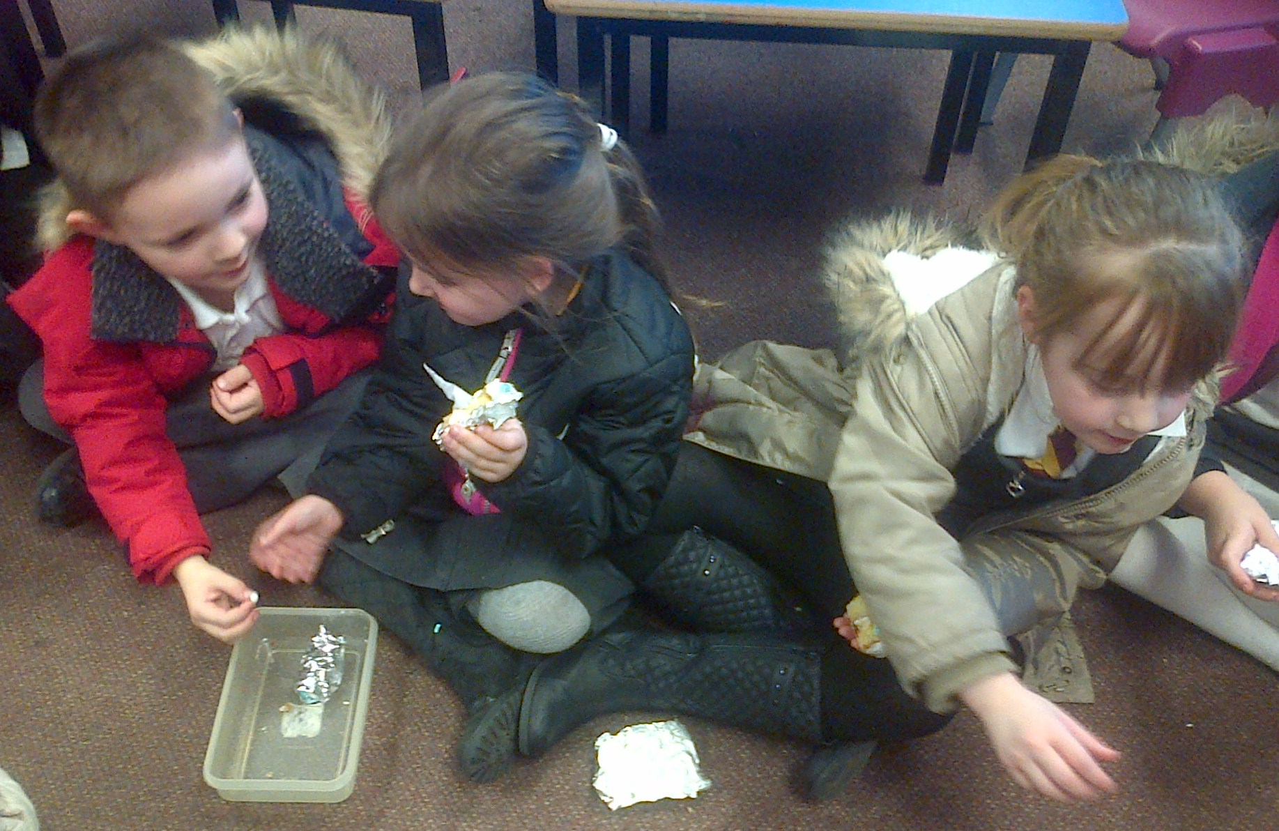
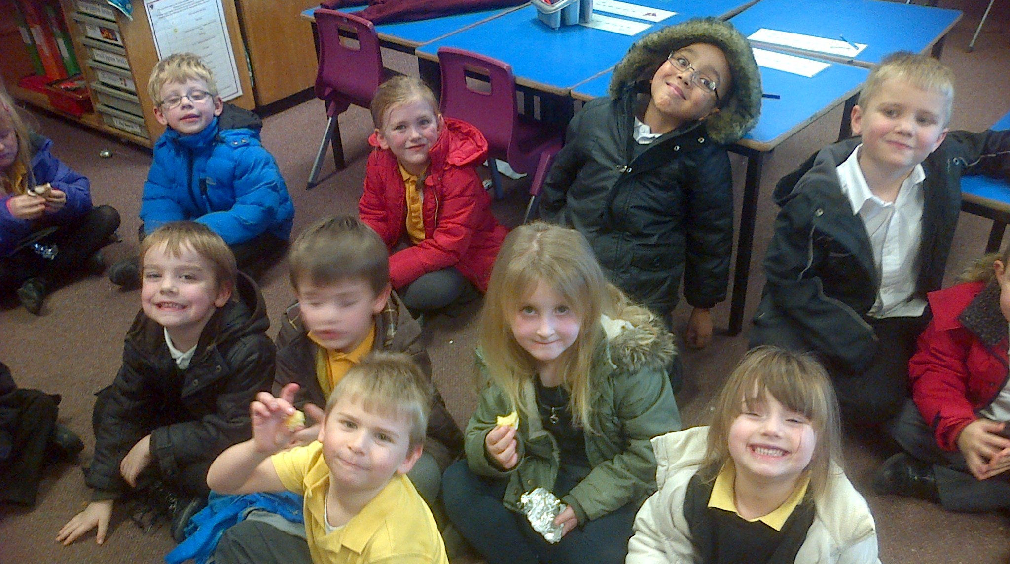
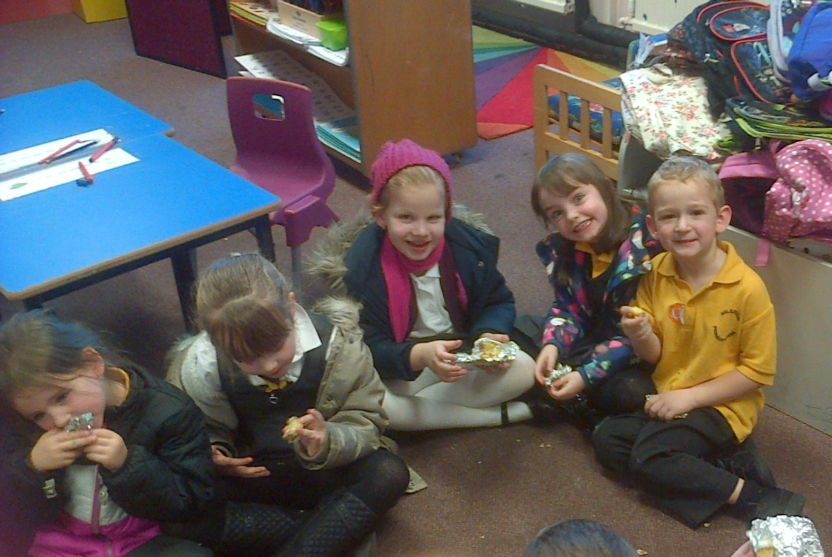
We did a quick survey in class to see how many penguin, polar bear, reindeer, Santa, snowman, Christmas tree or Christmas pudding jumpers we could see on Friday for “Dress down day”. Snowmen and reindeer jumpers were the most popular! Here we are looking festive and ready for Christmas. ☺
