Hello from P1l –
Here is what we have been doing this week. We continued with our “Mystery toy” talks. Rory described his red, fiery dragon very well without actually telling us what it was. However, the class used their imagination to guess. We thought the flexible wings and orange, fire breath was amazing – what a great toy!
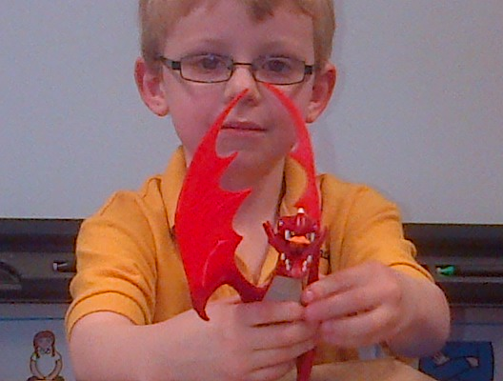
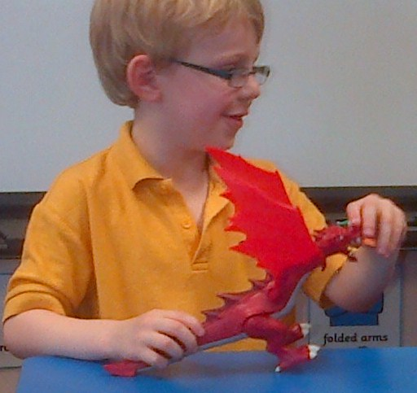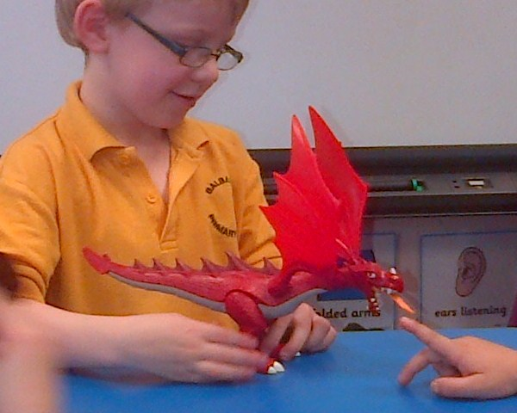

Jamie’s toy was quite hard to guess but the class narrowed it down to “Toy Story” ... it was of course, “Buzz Lightyear”. The class loved the blue light on its back and were asking Jamie how to make it work.
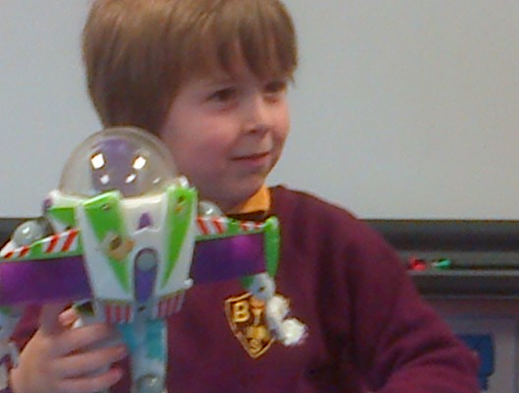
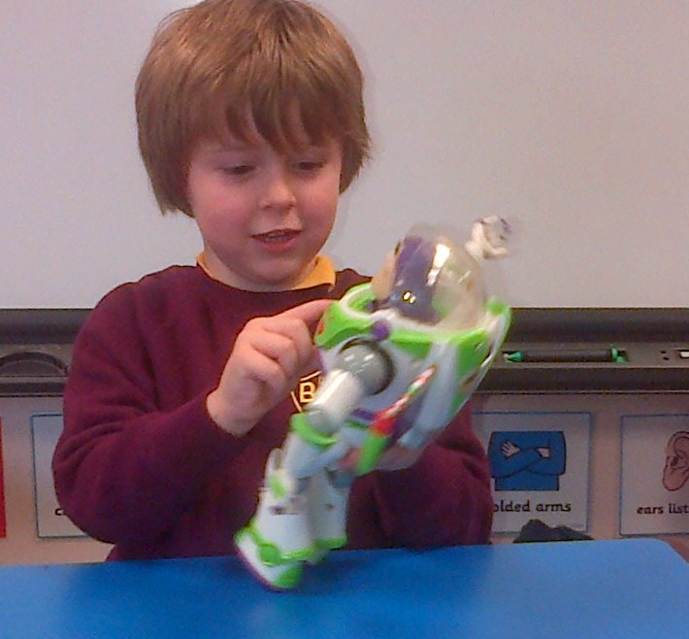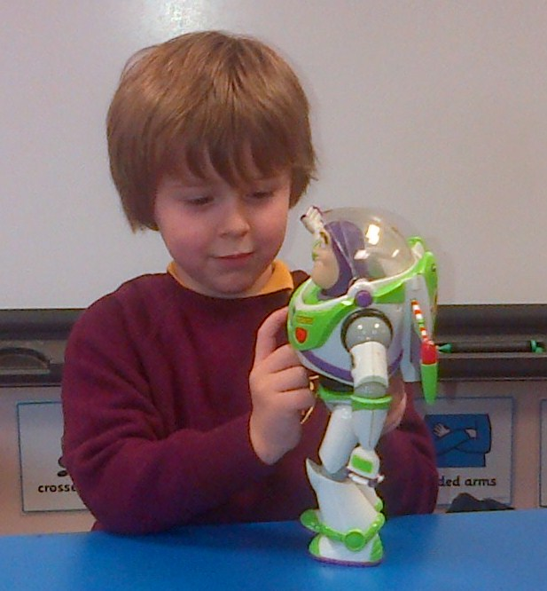

Lucas surprised us with his mystery toy being “Spiderman”. Although we should have realised sooner that it could have been a “Spiderman” toy as Lucas dressed up as him for the “Dress up” day a few weeks ago. When Lucas mentioned that his toy was a red colour, we started to think about “Postman Pat”.
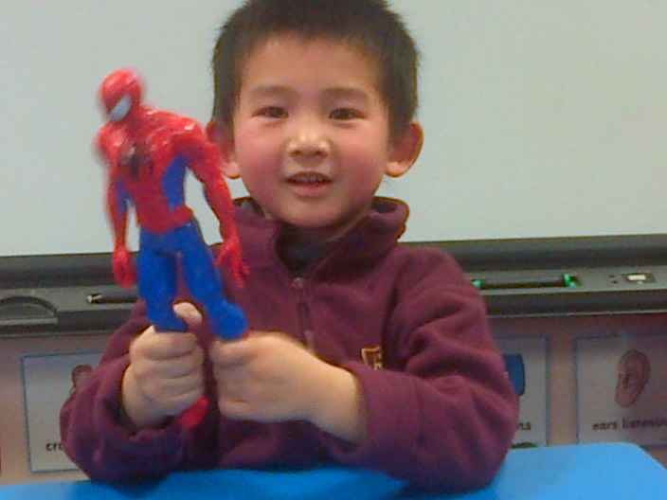
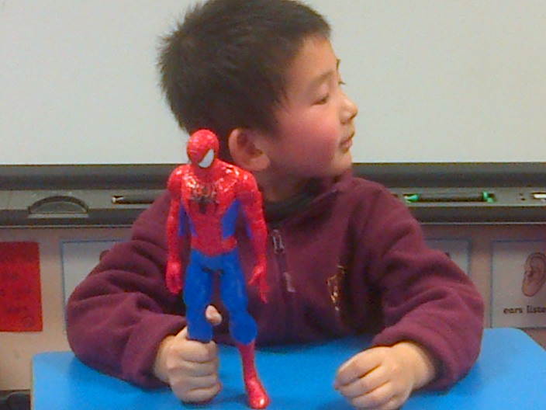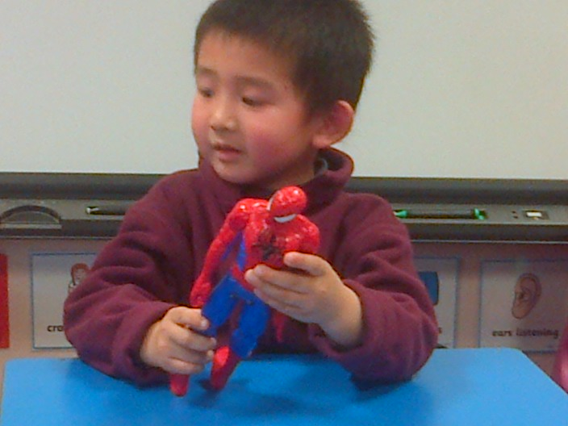

Nathan’s toy was “Postman Pat’s van” which was completely unexpected. We all know that Nathan loves “Fireman Sam” so we were positive that it would be Sam or a fire engine, especially when he said his toy had four wheels.
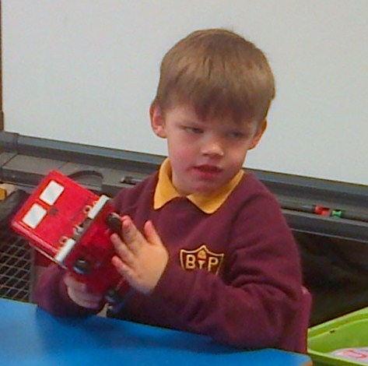
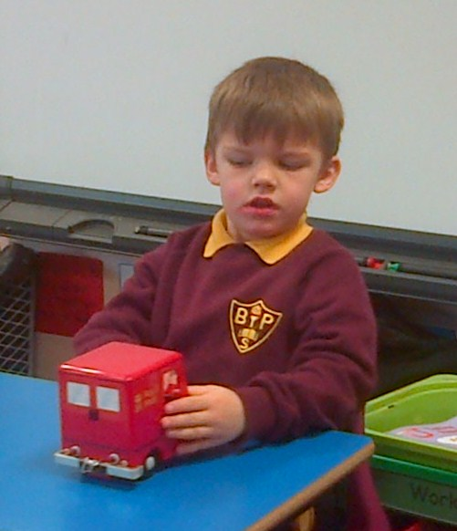
Charlotte had to be very careful to keep the mystery box closed during her talk. Her mystery toy was a lovely horse from the “Frozen” film. She told us that she had boots and different outfits to help dress the horse. We thought it looked like great fun!
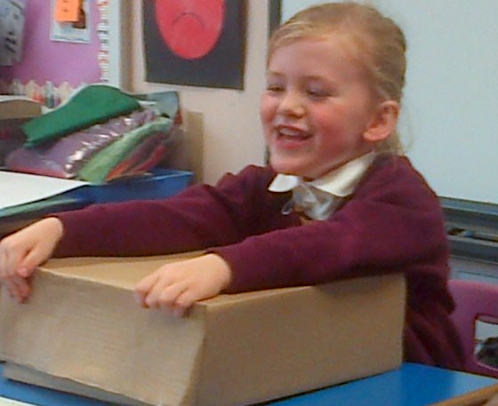
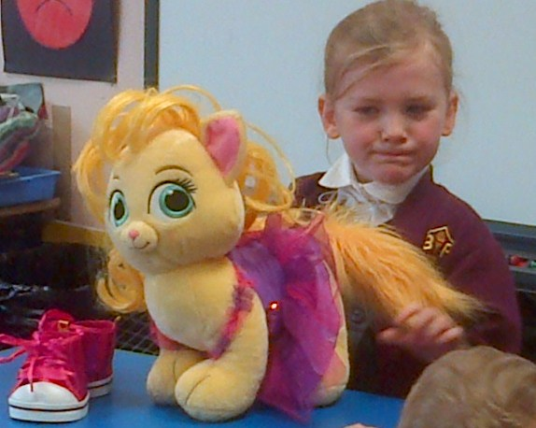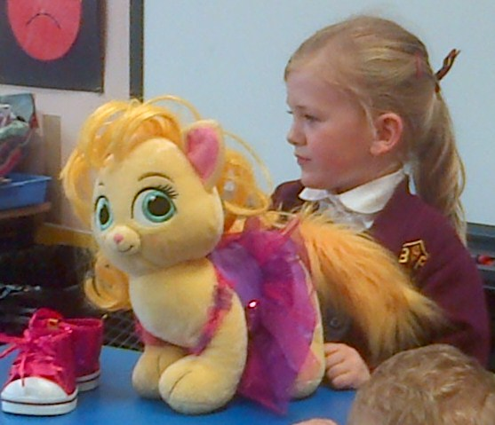

Owen gave a very good description of his mystery toy – it was a yellow crane which could change into other vehicles as well. He showed us how to make it go up high and how it can pick up objects with its hook. He had lots of questions to answer.
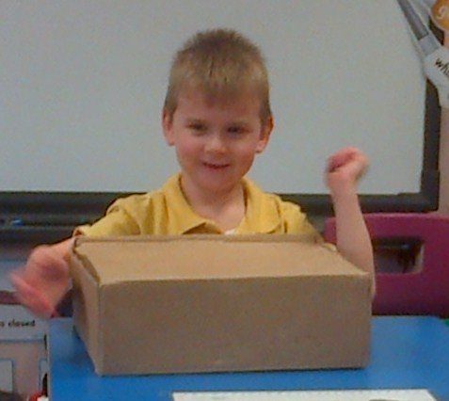
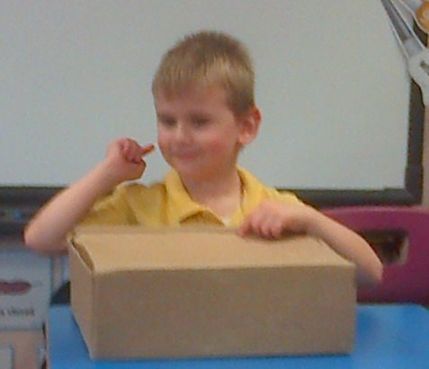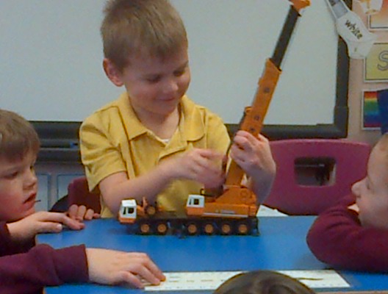
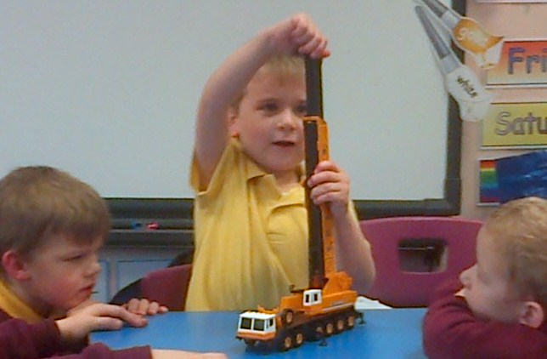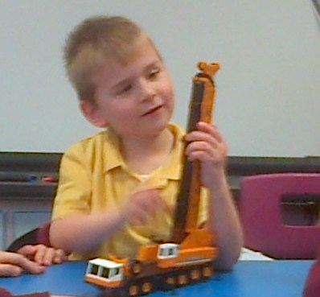

Callum described six facts about his mystery toy before the class guessed what it was. It looked very impressive; it was like transformers with lego parts that join on. Callum had made a giant transformer and a smaller one to go with it. We thought the taller one was amazing, it was so colourful. Callum called it the “Rainbow one”. He showed us how to build it and took the helmet off for us to see the face. Everyone wanted to know where he had got it from so Callum explained that it was a gift from his cousin. ☺
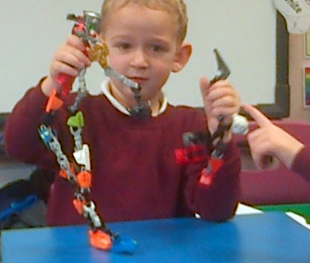
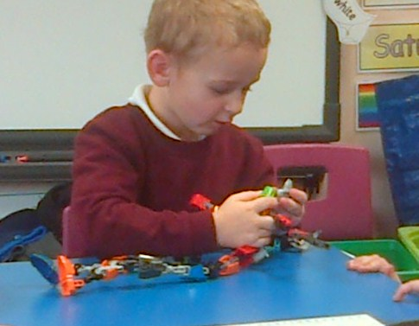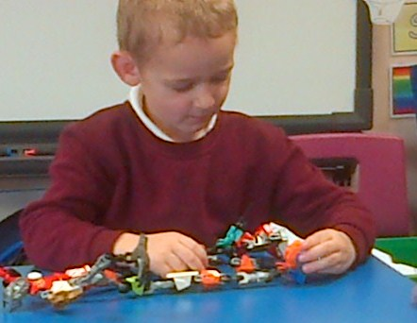
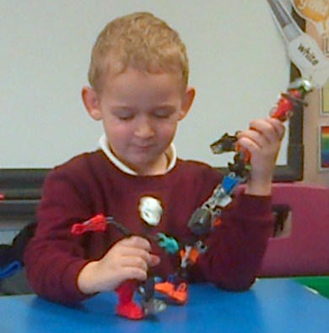

We decorated our tealight candle holders with our P7 buddies this week. We used paint, glitter and gems to make them extra special for sale next week at the “Christmas Fayre”.
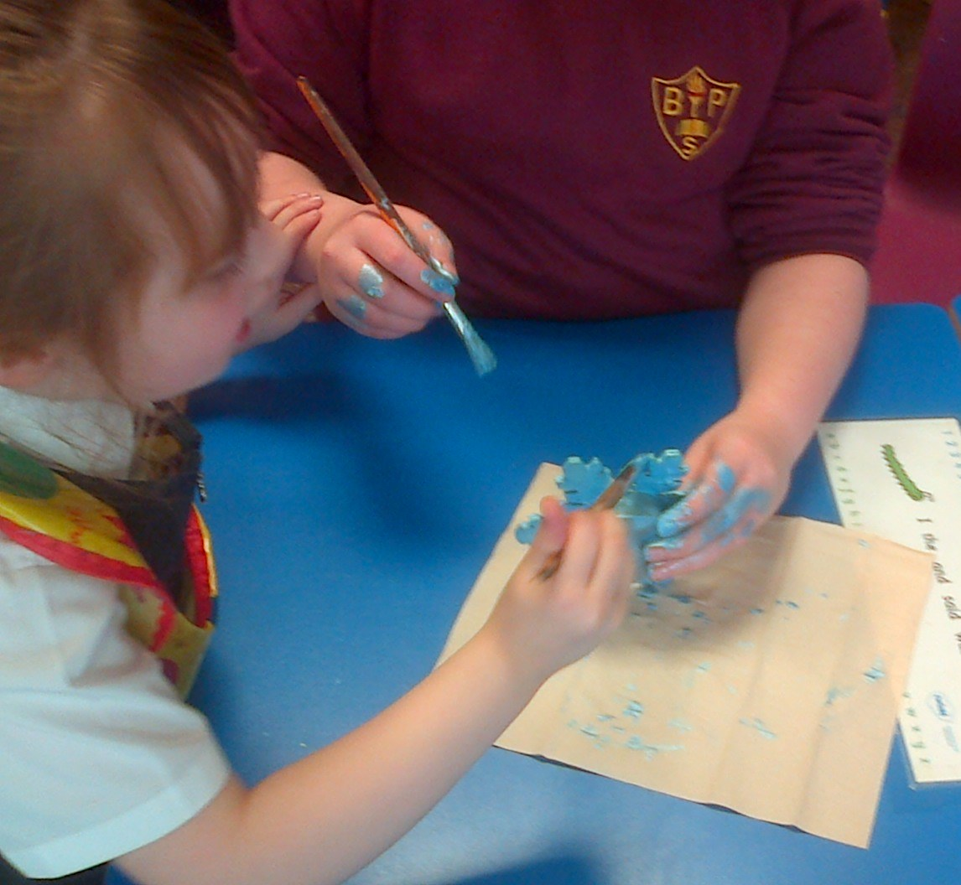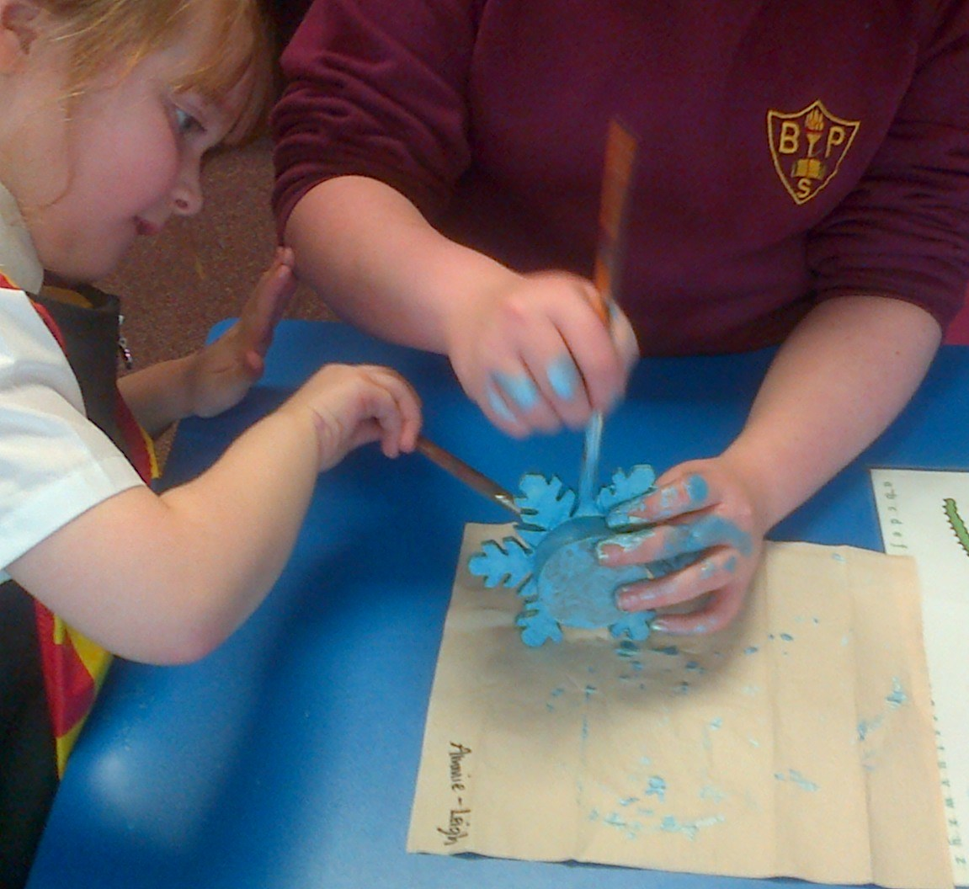
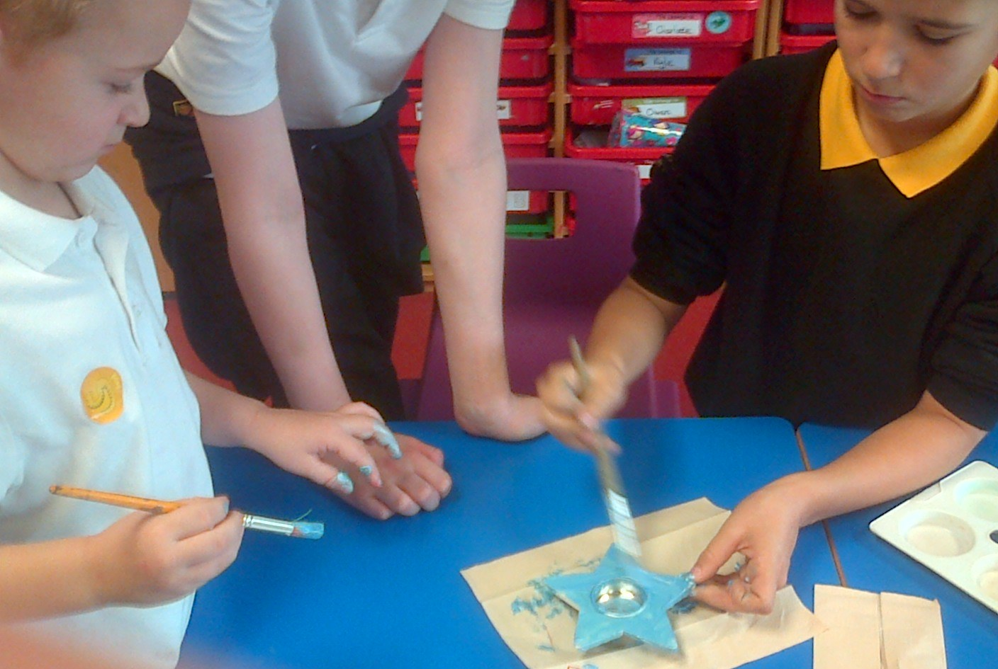

*We were impressed by a very organised Primary One on Friday who was ready to give out her Christmas cards. We saw great card-writing – well done Ruby-Anne!

