P1l – week beginning 06.10.14

We started the story of “The Emperor’s New Clothes” this week. We had fun designing different clothes for the Emperor to wear on holiday. Some of us dressed him in summer clothes for a sunny holiday and others dressed him in winter clothes for a snowy holiday. Here are some of our designs.

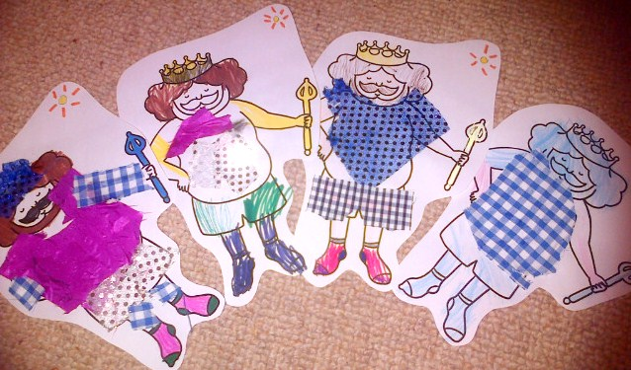
The Emperor dressed for a sunny holiday.

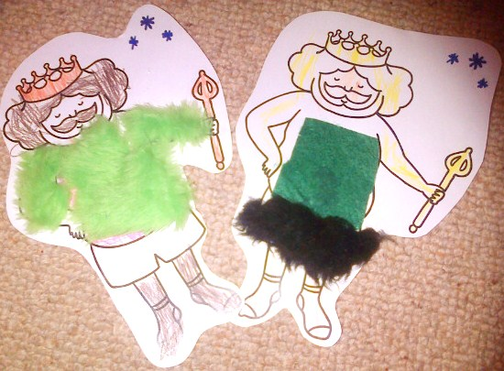
The Emperor dressed for a snowy holiday.

We also enjoyed listening to the story of “The Emperor’s New Clothes” from the CD in our listening centre.
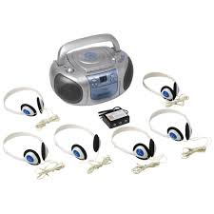

We love our buddy visits every Wednesday. This week we discussed our story writing with our buddy and then we read them our reading book. After that, we used our sound word mats to blend sounds together to make words - our buddies helped us to learn.

On Thursday we reflected on the last “Procession Day” at the school and remembered that our school’s theme was “The Wizard of Oz”. Then we started to discuss our thoughts about what would be a good theme for the “2015 Procession Day”. We came up with some terrific ideas – our topic about fairytales really helped us to come up with good characters!

