P1l – week beginning 29.9.14
We finished our “Magic pots” this week.
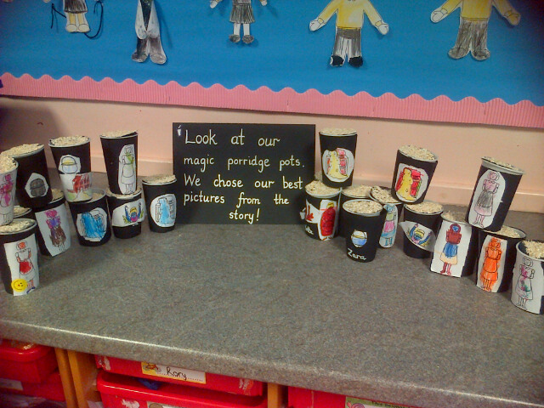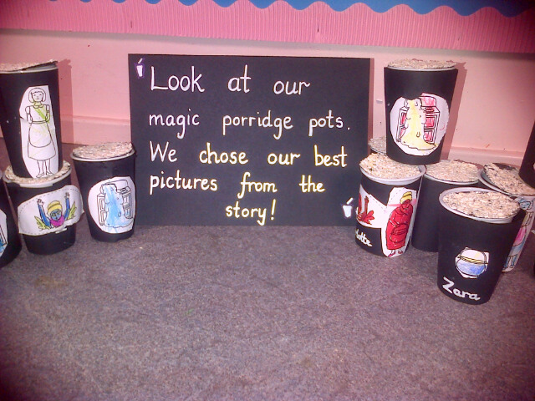
We started our new story - “The Gingerbread Man”. We wrote some wonderful ideas about what we would run away from if we were the Gingerbread man.
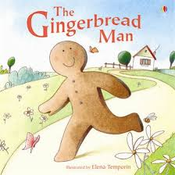
We worked with our buddies to play “Colour the robot” game. Our P7 buddies were very impressed with our playing and neat colouring in – the robots looked amazing!

We have been busy practising our “Harvest songs” for the Church Service in two weeks time.

