We have enjoyed lots of things this week in P4m! Everyone enjoyed outdoor and indoor P.E: we were working on our travelling and balancing skills in both sessions which we are learning will be skills which we need for taking part in the handball festival.

We have learning a lot in our topic work; we explored the invention of the radio and worked in groups to invent a radio show. We were very lucky to be able to join P4g to hear the radio show they had invented which gave us some great ideas for our radio show that we will perform to P4g next week! We had a great discussion about how the radio works and were all amazed to discover that radio waves are all around us and travel through the air and objects.

In writing we have been working on creating fact files about Alexander Graham Bell. These look great and will be going up on the wall very soon!

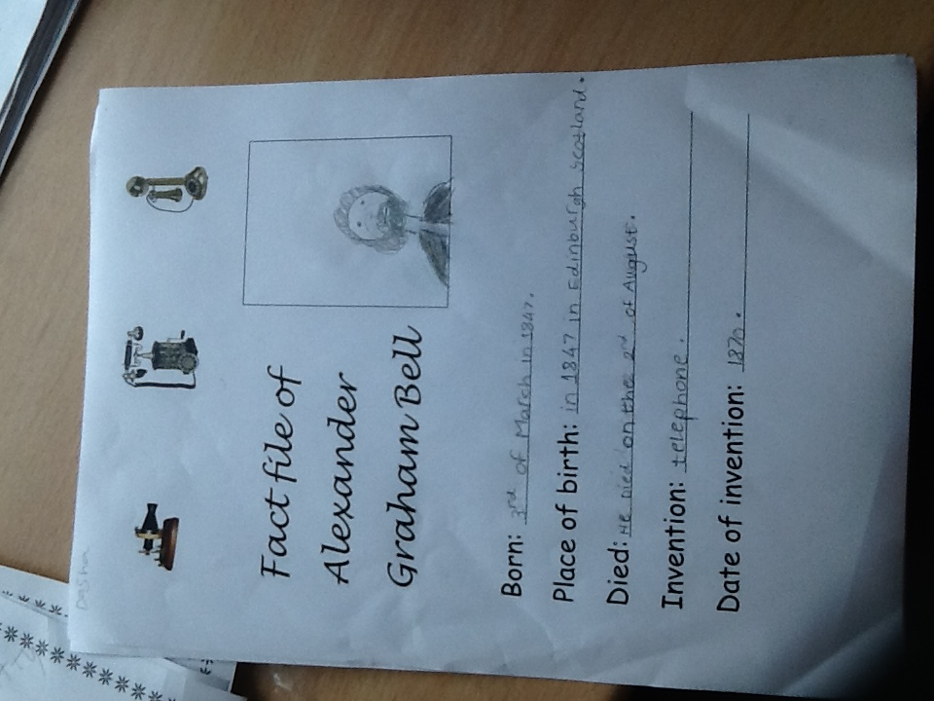

Finally, we had a great time with Mrs Clark, at the end of the week, learning more about switches in science and finding out different numbers and greetings in Spanish.