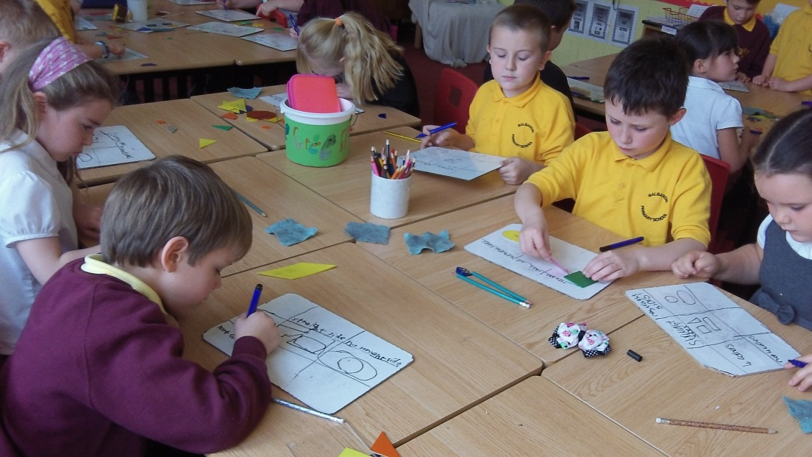
This week P4m have been very busy! To start off the week we shared our news from the weekend with each other. In maths we have been working with new concepts in our number work. We found working with numbers to 1000 and 10000 quite a challenge to begin with, but after a lot of hard work we are making progress. We have also been learning how to present information about 2d shapes and their properties in Carroll diagrams.

We all enjoyed using new activities to practice our spelling words and thinking of different strategies to help us remember the spelling patterns.
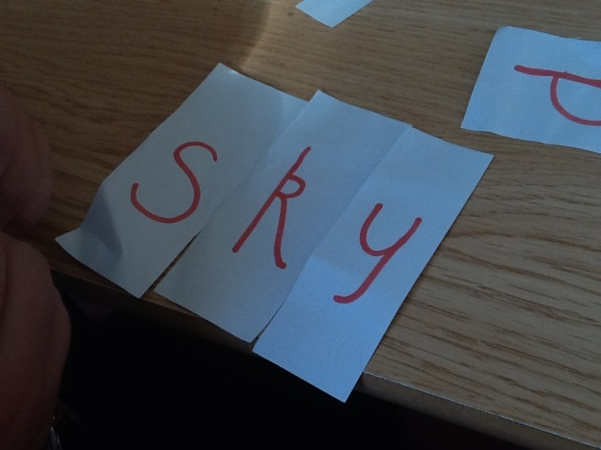
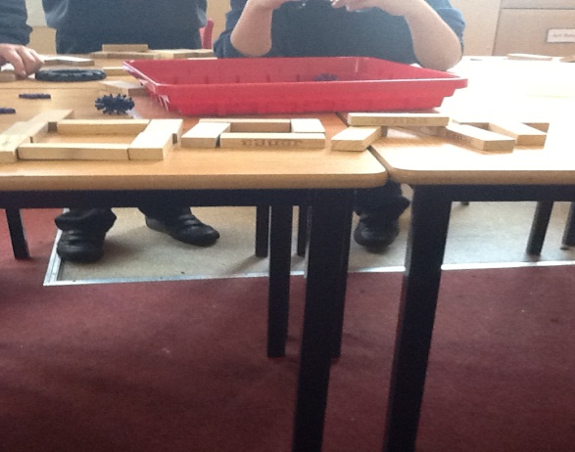

We also started our new topic- Wallace Wacky inventions. We were very excited to explore some inventions that children have created and research some famous inventors and their inventions.

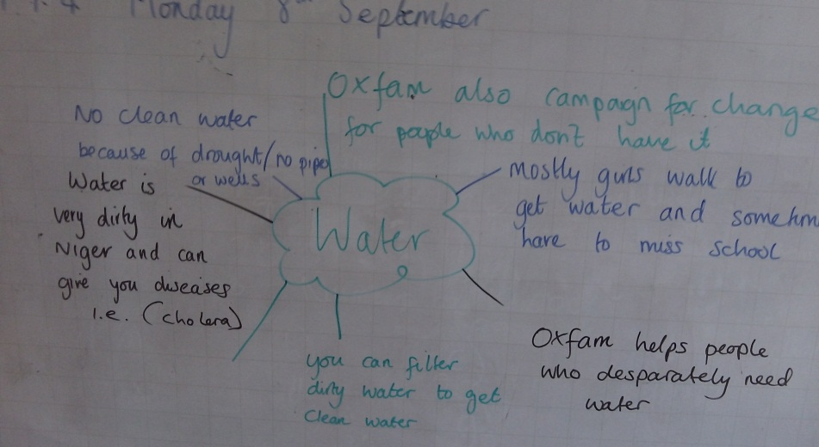
To finish off our water topic we completed a water challenge during outdoor P.E. This challenge allowed us to discuss the importance of water and how people who don’t have clean water, like us, feel.

