P2bg – week beginning 01.9.14
We enjoyed our “Big Start” activities this week with cars and map mats, Lego construction and our writing table.
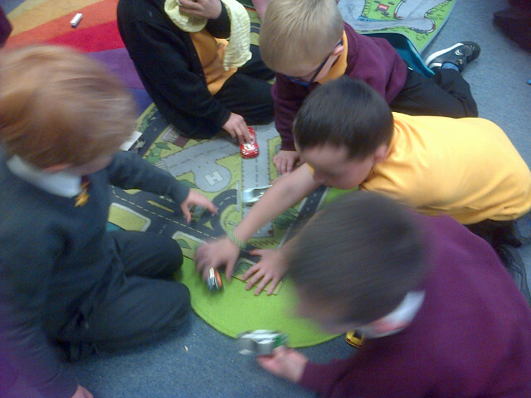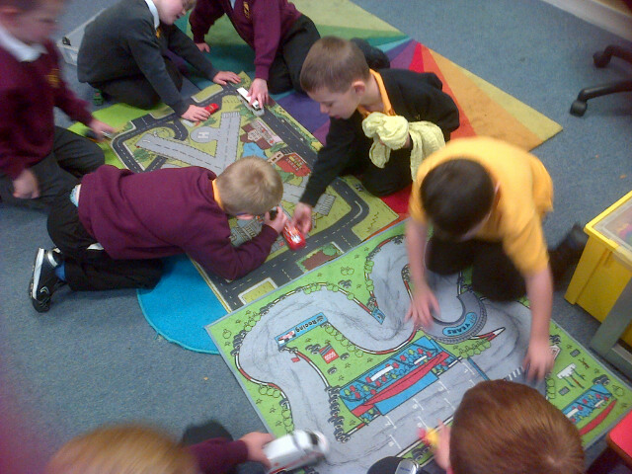
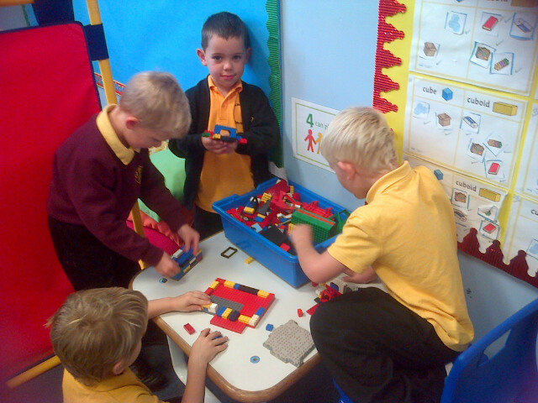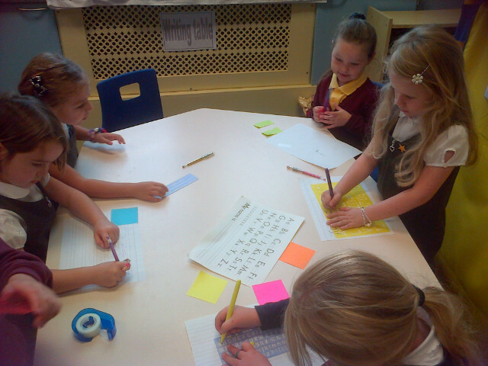

In maths we counted up to 100 in ones and then in twos. We noticed that it is much quicker to count in twos and it helped us to get to know our even numbers better.
In writing we wrote all about ourselves – our name, age, what we look like and our hobbies. We drew a lovely picture to match our writing.

In topic work, we practised making lots of different sounds and discussed how our ears can hear a wide variety of sounds and the importance of looking after our hearing so we don’t cause any damage. We also talked about different parts of the ear; the ear canal, the ear drum and the tiny bones inside the ear.
This week with Mrs Gallagher we have been working on the concepts more, less, before, after and between. We used these words to describe number sequences and to identify missing numbers. We also learned about odd and even numbers and had fun helping Bob the Builder to solve a problem using odd and even numbers.
In Health we started the Being Cool in School programme and had lots of discussion about feelings. We discussed what makes us angry and made some angry faces for our wall display. We will learn how to deal with angry feelings in a ‘cool’ way next week.
To help us appreciate our sense of sight we have been doing some activities which show us what it might be like if we lost this sense. We did a blindfold assault course with a partner guiding us through it. We talked about what it felt like not being able to see and many people said it made them feel sad or scared. Next week we will be learning about how blind people can read.
Lots of people in the class have made it onto step 1 on our steps system. Well done to them and keep working hard everyone!

