Romanian National Festivals

- Wine making festival: October
- Medieval Days 3 days to celebrate the olden days July
- Christmas Markets December
- In Romania they celebrate Christmas from 20th of December to 7th of January
- Sibiu March 21 -24 (ballet competition)
Ballet means ballerina
- Bike festival May 17th -18th
- Flower festival
- Sadi festival of dance and music June 8th
- Rimetea festival of traditional foods
- Comana bike fest 17-18

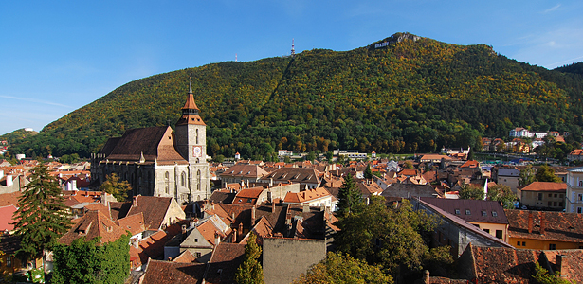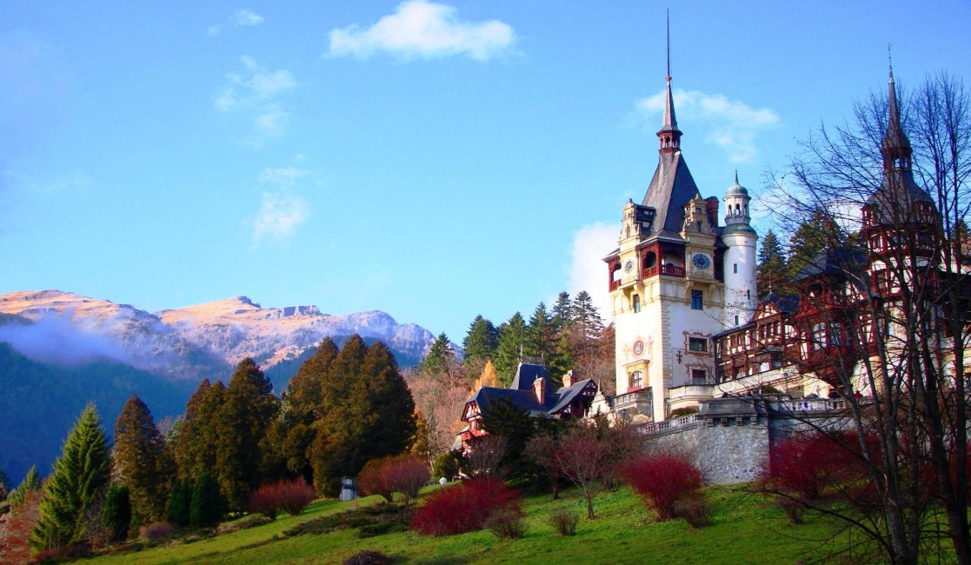

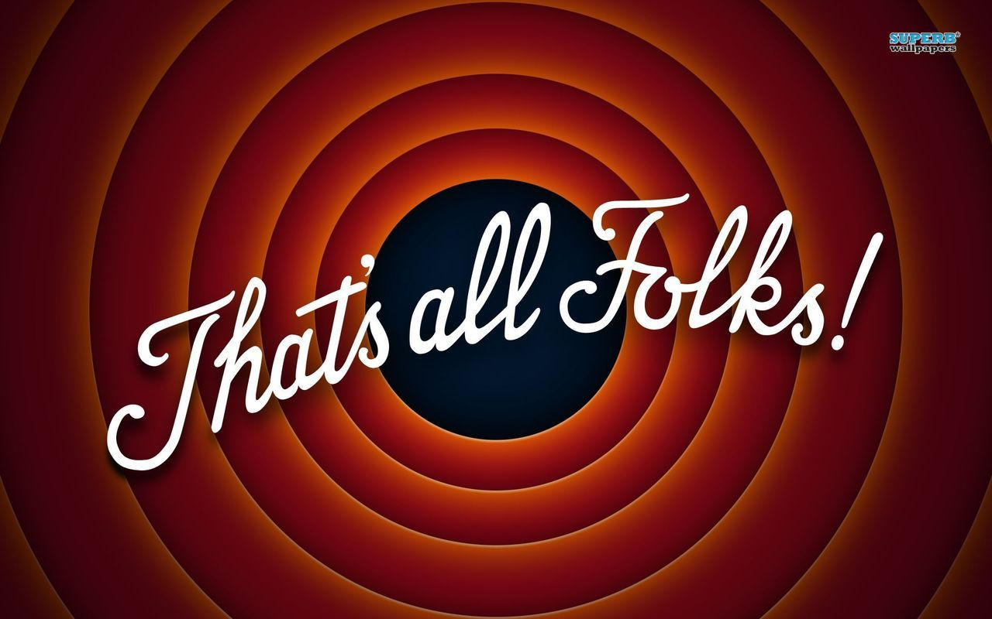

THE END

