P7 Teenage Market Project
December 2016

Last term in maths we learned about money, businesses and enterprise. For homework we learned spelling words like: sell, profit, loss etc. Then a lady called Kate from Business Gateway came in to see us and talked about how to run a business. She told us more about profit and loss, she also mentioned about something called the ‘Teenage Market’. The Teenage Market is where young people from around West Lothian come and sell items they have made to the public. This got the teachers interested and they decided to book a stall.
Kate told us that a business needs different roles. We decided we needed for our business:-
Finance Directors: who would deal with all the money related tasks such as costs, prices, revenue and profit.
Marketing and Advertising Executives: who would create information to advertise the Teenage Market through such things as ‘blogs’ and posters.
Market Stall Managers: who will oversee the stall, manage the stock, including checking on quality of items and resources needed on the day.
Kate from business gateway agreed to interview those who wanted to apply for the jobs. Those interviewed were quite nervous. Some people got a job and some didn’t make it successfully. Kate told the teachers that she was very impressed by all of the applicants and the responses she got to her questions showed the children had put thought into the interview and skills needed for the roles.
The next step was to decide what we would sell at our stall. As it was a Christmas market we agreed to sell Christmas decorations and cards. First of all we worked together to look through books with Christmas craft ideas. We decided on decorations and cards we liked then we tried to make one of each. These are called prototypes. Prototypes helped us find out how easy it was to make each item, any problems that needed to be solved and also how much each item would cost. Some of the products we made were snowflake tree decorations, snow globes, pretty boxes, favour boxes, night jars and a variety of different Christmas cards. We worked for a week producing all of the items to sell. We had to check that the items were good enough to sell. Once we had made our products we set up a stall in the classroom to get an idea how to lay it out on the day. We also bought some Fairtrade items at cost price and sold them at a profit along with our own items.
We then asked for volunteers to help at the market on the day, which was a Saturday from 10am until 2pm at Broxburn. Forms were sent out to ask for parents’ permission.
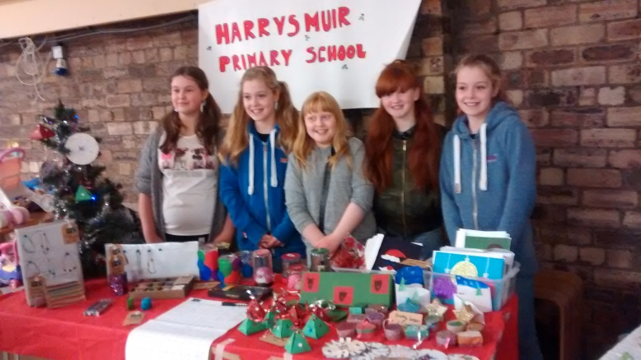
Finally we had to actually sell the products at the Teenage Market, Lucy Swan also helped here. We had some items left so we also had a stall in school for parents and classmates.
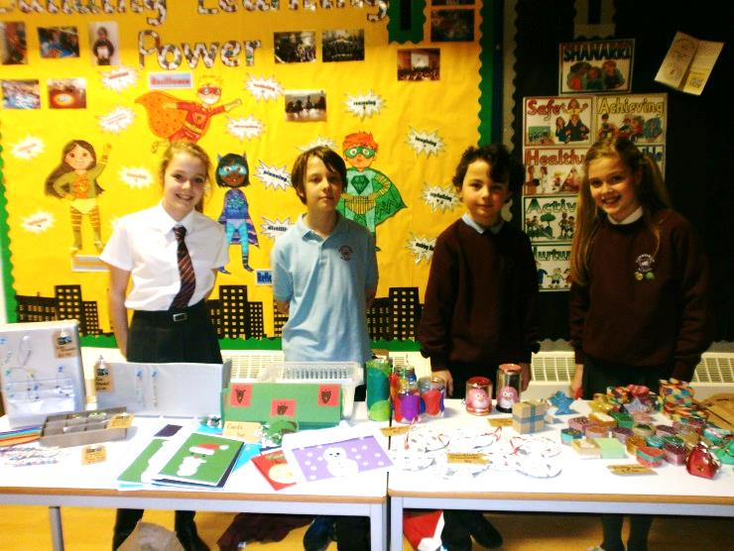
We made a profit of £76.40 from both sales which was pretty good .We loved working on our enterprise project during school at Christmas time. The money raised will be used for Eco/gardening projects in the school.
Kate Ashcroft from Business Gateway sent this message to our teachers:-
‘I would like to take this opportunity to pass on some feedback from Broxburn Business Gateway’s Town Centre Officer following the Teenage Market Event.

Hazel said that your pupils stood out above everyone else.
She said that they were very confident approaching potential customers, excellent selling skills, showed confidence in talking about their products and that they could sell snow to Eskimos!
I heard all about their snow globes and cards. Very impressive and they should all be proud of their achievements.
I hope your young Entrepreneurs had a great day at the event.’

