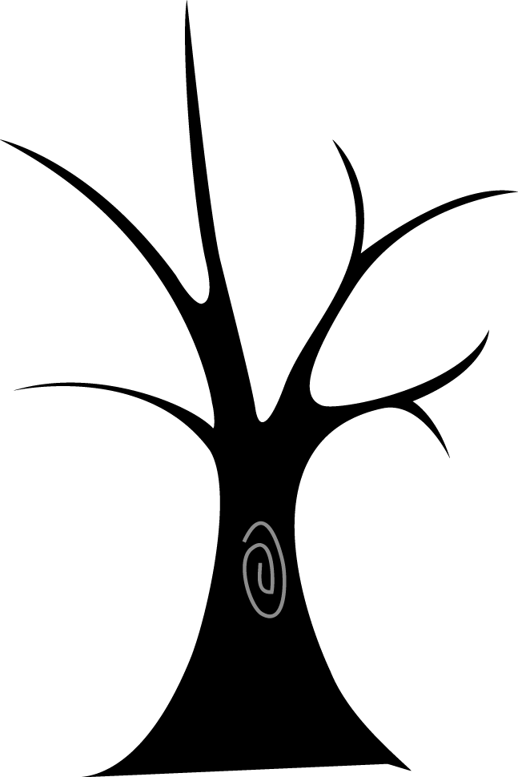

**Who will be the Named Person for your son/daughter?**

The Named person will be your Health Visitor in Nursery provision and prior to school entry.

At school entry the Named person transfers to Education services.

In Primary and Special schools this will be the Head teacher.

In Secondary schools the Head teacher will delegate responsibility to House/Year Heads.

**What will the Named Person do?**

The Named Person will be the point of contact for all involved and will co-ordinate support, communicate information and update records as required.

They will continue to liaise with you frequently.

**Further information can be obtained on the Scottish Government website**

http://www.gov.scot/Topics/People/Young-People/gettingitright/named-person

The GIRFEC approach recognises that at different stages of their life each child will have specific needs. Services need to be responsive to how these needs differ between children, how they change as they get older and whether they can be met with the universal support available to all children. Some children and young people may have temporary difficulties, such as illness, bereavement or moving school and some may live with challenges such as the effects of disability or long-term conditions. While most will get all the help and support they need from their parents, wider family and community, sometimes they and their families may seek extra support.

The Act requires the promotion, support and safeguarding of wellbeing, as a common approach across all services engaging with children and families. It relates to the Getting it Right for Every Child (GIRFEC) approach to improving outcomes through the delivery of services to support the wellbeing of children and young people. GIRFEC will help realise the shared ambition of making Scotland the best place in the world to grow up.  **The Act becomes law on 1 Aug 2016.**

**Named Person – The Children and Young People (Scotland) Act 2014**



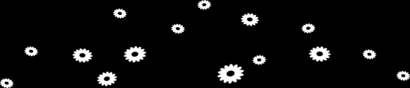

[Your message here or delete this text and add your own handwritten message.]