Hello from P1l – Week 5
Annie, Cameron, Brandon, Kyle, Shelbi, Brooke and Ammie-Leigh treated us to their “Mystery toy talks” this week. Annie introduced us to her puppy which she received as a present.
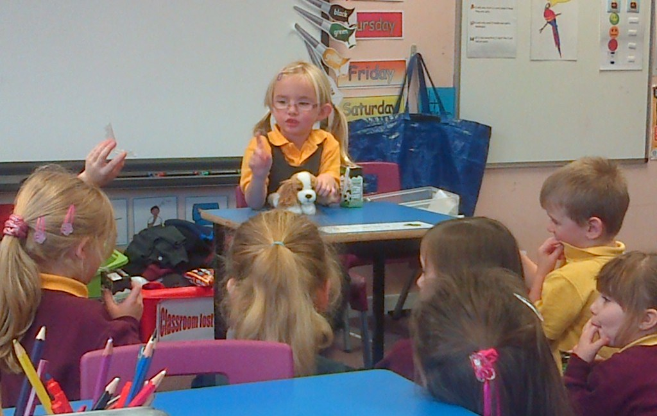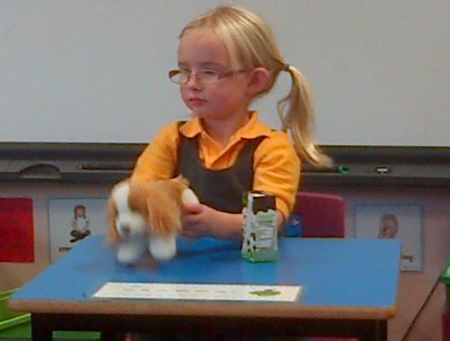

Then Cameron surprised us with his Lego creations. Some of the boys thought that it might be Lego inside Cameron’s box before he gave us any clues!
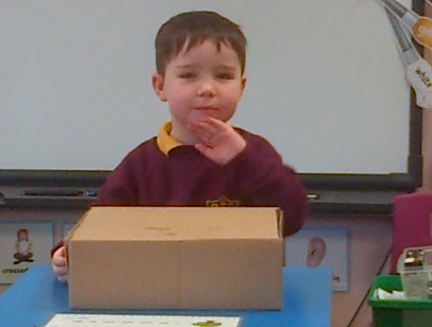
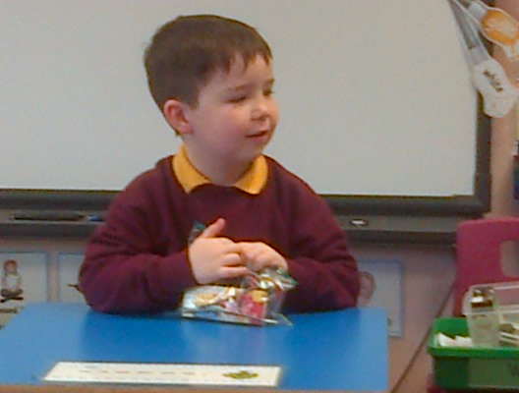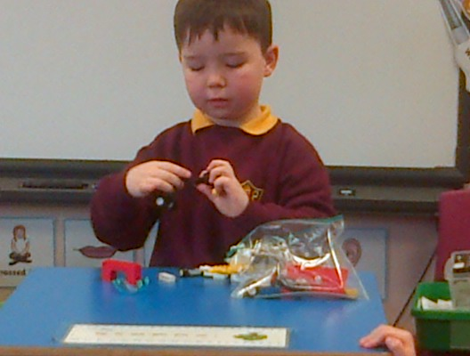
Brandon impressed us with his emergency vehicle. It was an “Emergency ambulance” with flashing lights and the number “17” on the roof for identification. We asked Brandon if he would like to drive an ambulance when he is older. Brandon said that he would and many other pupils in the class would like to join him.

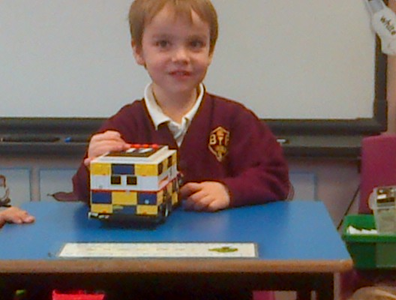

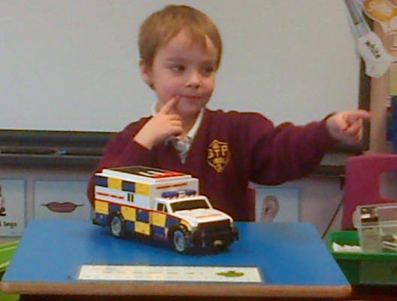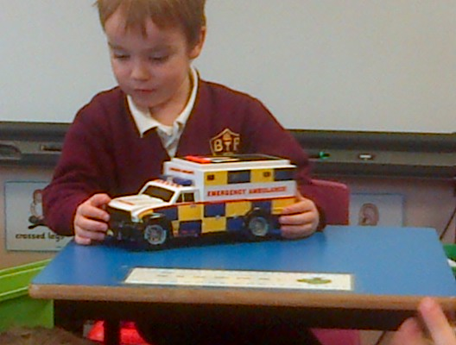

We had a dinosaur expert in class for our next talk. Kyle brought in his amazing walking, roaring dinosaur for us to look at. Kyle collects dinosaurs and all kinds of information about them – he has many dinosaurs in his collection at home.

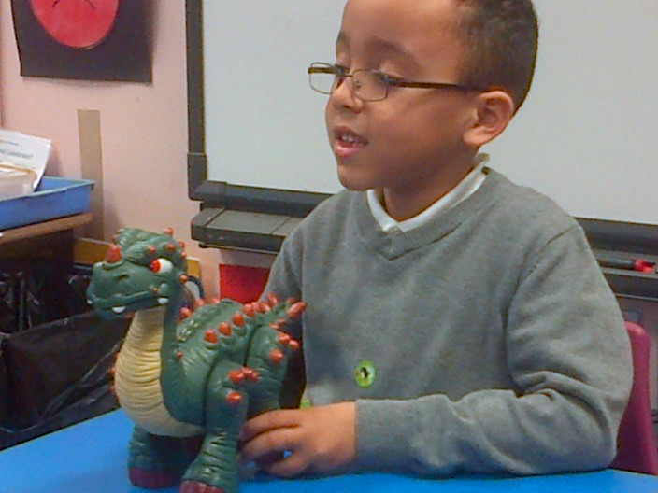

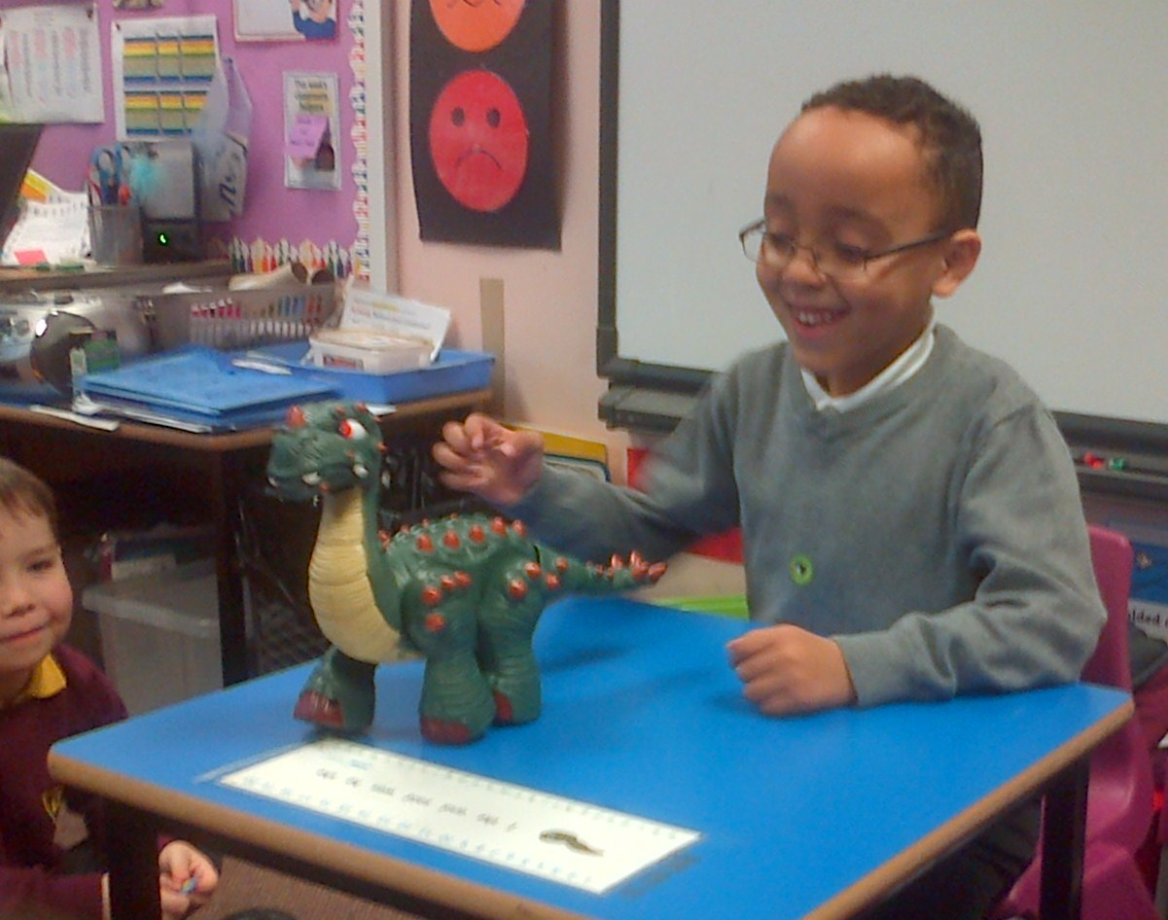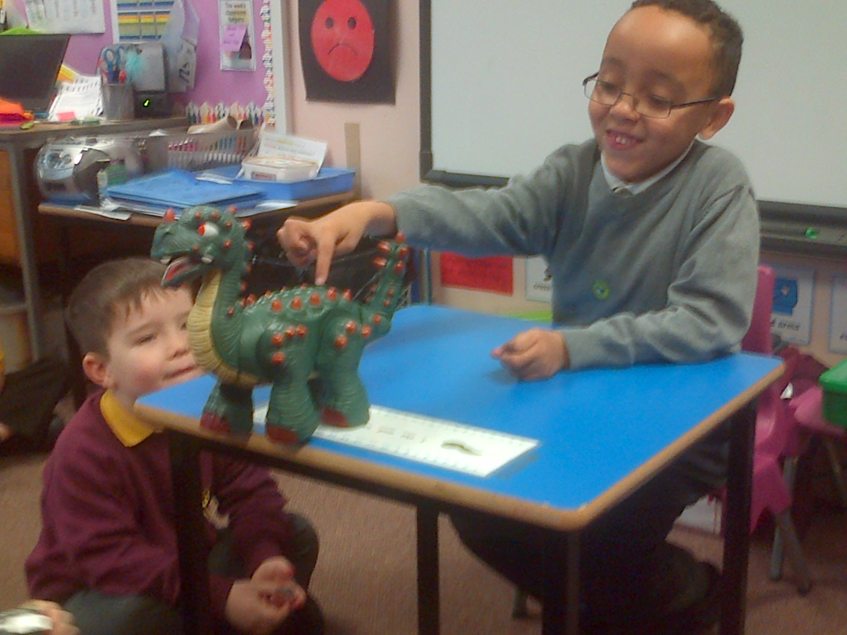

Shelbi brought in her fluffy Christmas bear which was very fitting for this time of year. This is her bear’s first Christmas as Shelbi got her bear last March (in her birthday month).

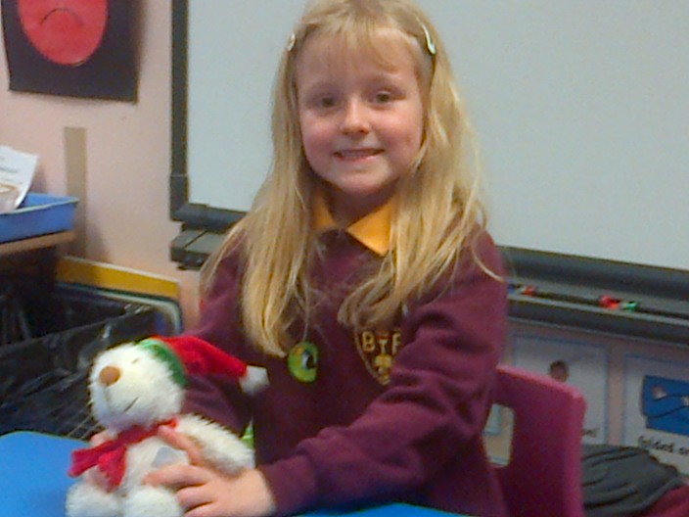

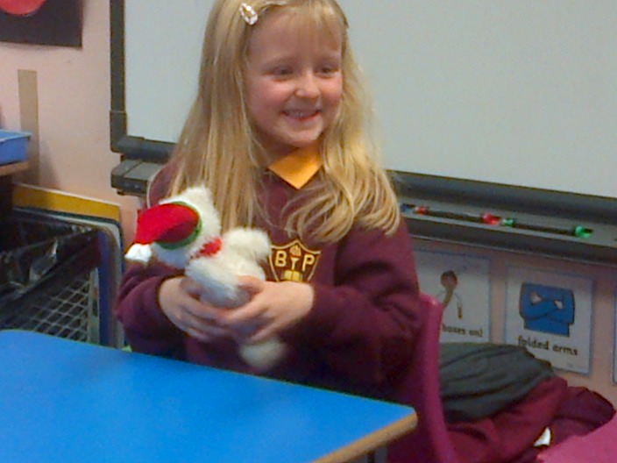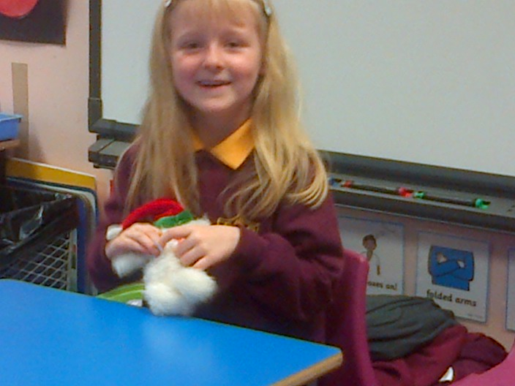

Brooke brought in her magic unicorn which she has had for a long time, since she was a baby. She has looked after it very well even though it has had plenty of outings!

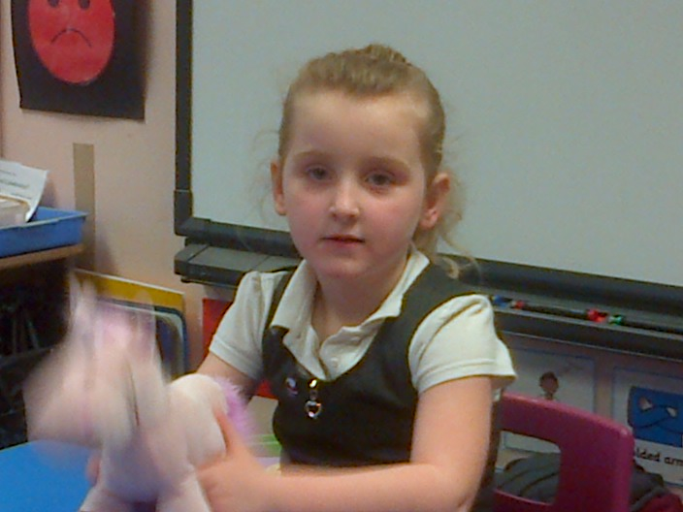

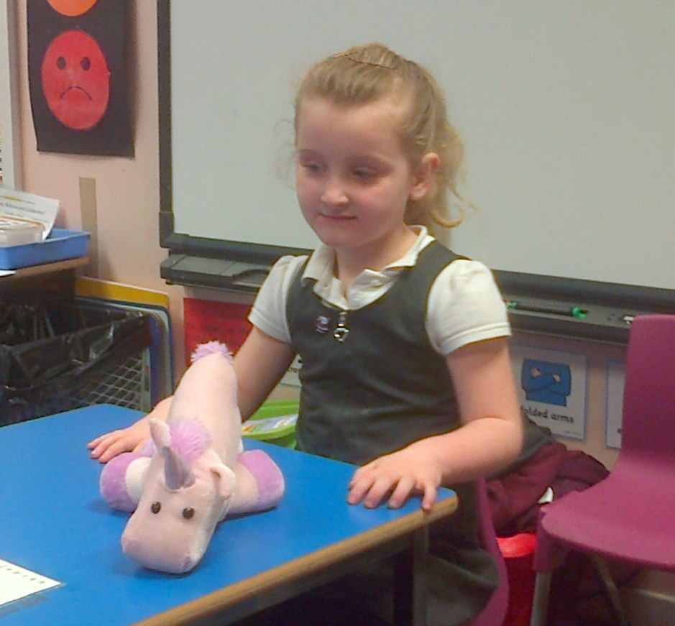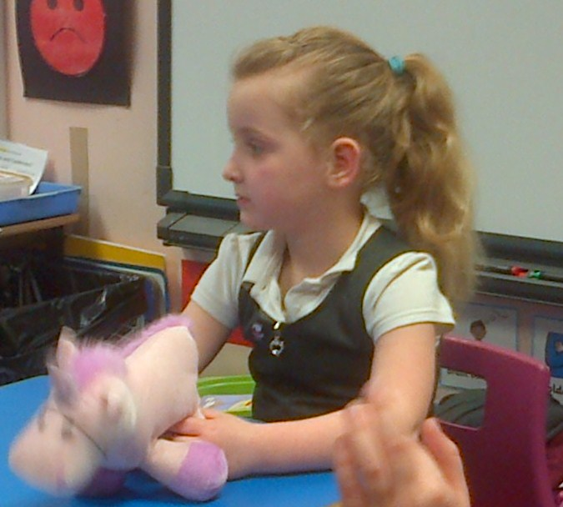

Ammie-Leigh described her mystery toy very well without making it too easy for us to guess what her toy could be. Although it looks very similar to “Postman Pat’s black and white cat” it’s no relation as it was bought in a very hot place when Ammie-Leigh was on holiday in Spain.
