P2bg – week beginning 08.9.14

We worked on the “sk” sound in Phonics this week. We used gel packs and painted pasta shells to help us learn.
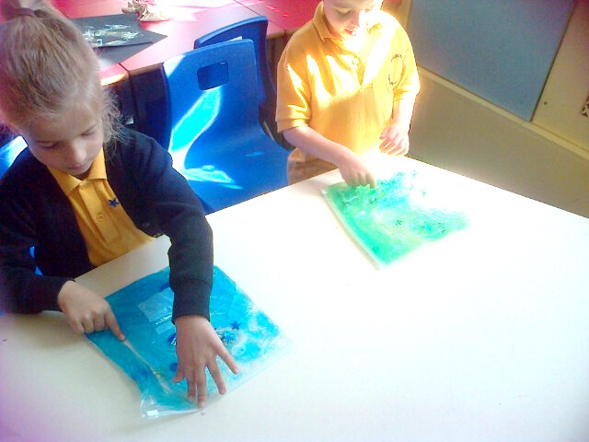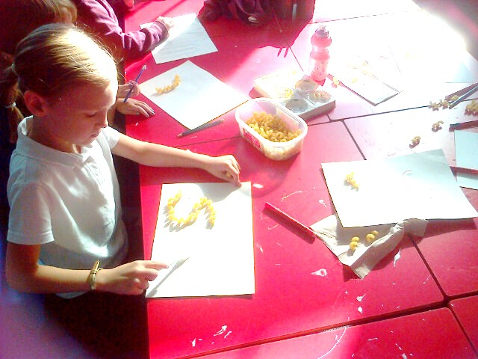
We learned how to spell words like “skill” and “skunk”.
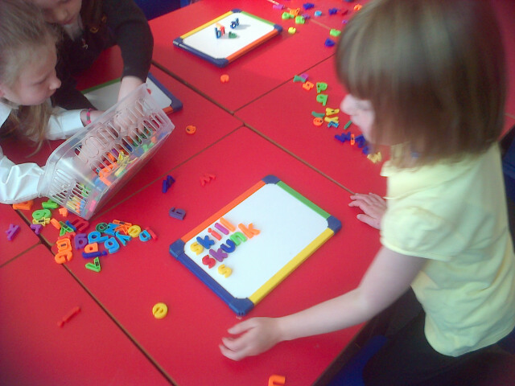

In science we focussed on the sense of taste. We investigated the appearance and texture of a pineapple and watermelon before tasting it.
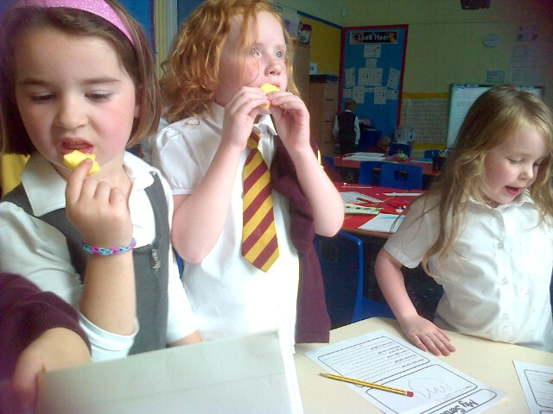
We recorded our observations; the pineapple smelt “fruity and fresh” and the outer skin of the watermelon felt “cold and smooth”.
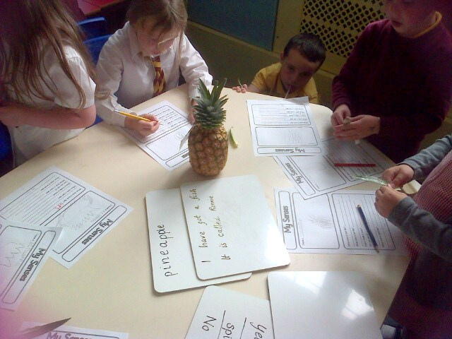
It was also quite heavy to lift.
