BBC Bitesize is available by searching online or through BBC iPlayer.
Literacy and Social subjects | SPELLING  'Z' sound z zz s se Green - lazily zoology wasn't flashcards realising whizzed quizmaster visualisation puzzlement synthesize  Qu sound Green - quietness quilting equalled questioning quotation quickest equipment quadrilateral queued quartered  1.Write clues for your words and make a wordsearch from them. 2.Write a story set 100 years in the future with your spelling words. 3.When reading search for words with these sounds. 4.Look at the spelling grid on school website,practice words. | Newsround and Home News  Watch Newsround then write a summary of what you thought was the most interesting part of the news and why.  If you were broadcasting a home news program from your home today what 3 'stories ' from your household could you include?( remember the cute animal one at the end!)  You could pretend to be a presenter and make your own Home Newsround  https://www.bbc.co.uk/newsround/news/watch_newsround | Career Capers  Interview members of your household about the different jobs they have done. Write a list of the different jobs and a paragraph about the one you are most interested in .  Research here for more information ad career pathways.  https://www.bbc.co.uk/bitesize/articles/zdqnxyc  Careers A to Z: Find your perfect job | Take part in Garden Dragon Watch  https://www.arc-trust.org/news/garden-dragon-watch-is-now-live  Become a garden herpetologist (person who studies amphibians or reptiles). Take time outside exploring your own garden to find out whether amphibians and reptiles live on your patch. Describe and record what you find and if you want send results into the survey.  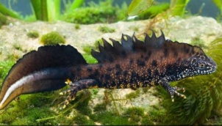 | Where in the World?  We're all limited where we can go for our summer holidays this year - but we can dream and plan for other times !  Write about 3 of your dream your holiday destinations - if you could go anywhere in the world , where would you go? What would you do.?  https://earth.google.com/web/
Shape | Shapes in nature  How many different shapes can you spot in your garden?  Take some photos and name the shape - 2D and 3d  Can you find something; circular, rectangular, square, spherical, cuboid, | Tangrams - create a multitude of different pictures using these 7 shapes . google tangrams for ideas | Types of triangles video and quiz  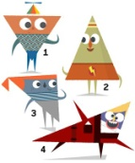https://www.bbc.co.uk/bitesize/topics/zvmxsbk/articles/zggsfrd  Look for triangles in your home. | Symmetry - Draw a picture or take a photo that shows symmetry. There are many examples of symmetry in nature.  https://www.bbc.co.uk/bitesize/topics/zrhp34j/articles/z8t72p3 | How to identify polygons  Polygons are 2D shapes with straight sides. Make a list of all the polygons you can name.  https://www.bbc.co.uk/bitesize/topics/zvmxsbk/articles/z98n4qt - take the polygon quiz
Health and Wellbeing | Garden Assault Course  Build yourself and other family members a garden assault course. Write the insructions to share then time yourselves going around it.  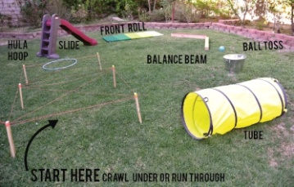  Try to beat your personal best time. | Symmetrical Super Sandwich  Make a symmetrical open sandwich. Collect all your favourite fillings ( remember our Warburton's sandwich making)  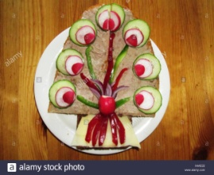 | Outdoor Art  Create a symmetrical incredible beast using natural materials found outside - Name your beast.  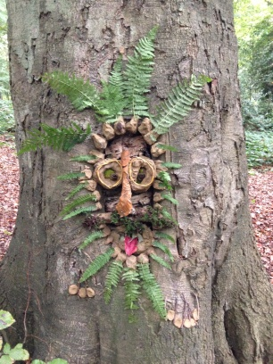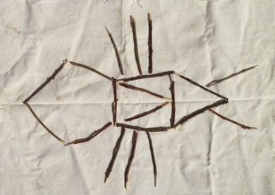 | Relaxing Read  Find a relaxing place outdoors, or an unusual place to read a book. Ask someone to take a photo of you in your reading spot.  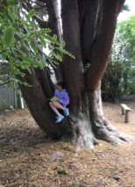 | What lives in a tree ?  Select a tree and find out what lives there. How many different animals use the tree habitat? How many different plants and fungi.  Look here for ideas and to do a quiz  http://treetoolsforschools.org.uk/activitymenu/?cat=minibeasts  select the' What Lives in Tree' activity.

