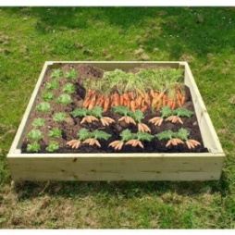

Grass

Vegetable patch

Paving slabs

Fruit tree

Flowers

Shed

Decking

Bark

Bird table

Bench

Six 1mx 1m raised bed
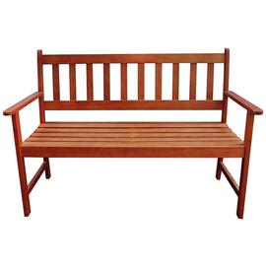of 2
Bench 2 seater 122cm

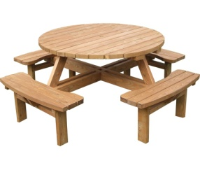 round table seats 8
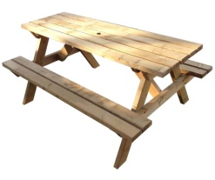

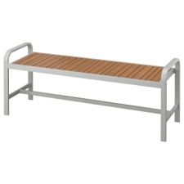
bench 136cm
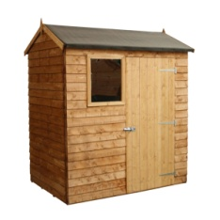shed 1.8m x 1.2m

