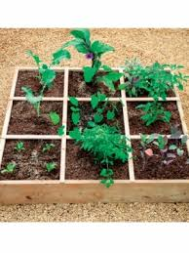
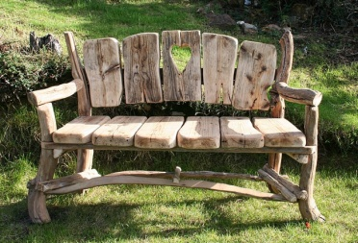
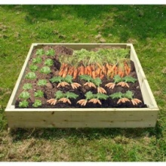
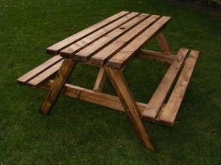
Strathyre Community Garden Project Design Competition

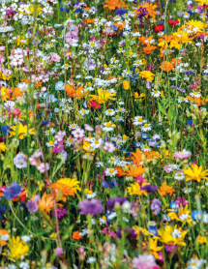
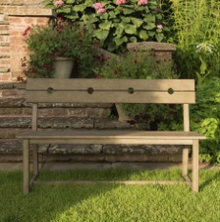
Make a sketch diagram (and Class 2, a scale plan) for our new Strathyre Community Garden. This will be a garden for all the community so in your design think about all the different people who will be using it and what they would like to use it for.
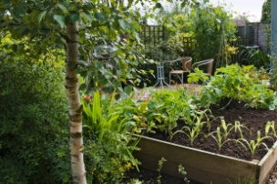
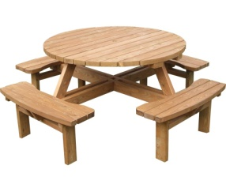
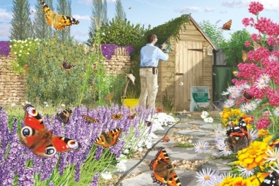
We already have 6 raised beds (1mx1m squares). In your layout plan as well as thinking about where they will go you can think what would grow in the 6 beds. What vegetables? What flowers? You also will need to fit in a shed to your design so we have somewhere to keep our garden tools and also add somewhere to sit. The entrance and main paths will need to be wide enough for a wheelchair so our garden will be accessible to all. The garden will be about 4mx5m rectangular shape. Use the accompanying sheets to help you with your design. Label your design to give more details.
