BBC Bitesize is available by searching online or through BBC iPlayer.
Literacy and Social subjects | SPELLING  m, mm, mb Blue Group - mammoth summerhouse hammering stammering plumber numbed thumbnails grammar crumbly  long /e/ ee, ea Blue Group - overeating seaside teacher cheerfully goalkeeper greengrocer beachwear hearing 1.Write clues for your words and make a wordsearch from them. 2.Write a story set in lockdown with your spelling words. 3.When reading search for words with these sounds. 4.Look at the spelling grid on school website,practice words. | Write a lockdown letter  Everyone loves to get a a handwritten letter. Write a letter to a relative or friend  https://literacytrust.org.uk/family-zone/mydearnewfriend/  Write a short lockdown letter your pet might write to you if it could write during Lockdown - how is their life different at the moment ? What do you think they'd ike to say?- see examle https://www.digsfordogs.uk/a-lockdown-letter-from-your-dog/   | Reading and Comprehension  The Desperate Journey  Read Chapter 4 part 1 ThGreat City p66-78 .answer questions ( in your home pack)  The moment I knew  Do you know what career you might like to do like to do when you're older or what subjects most inspire you? Write 2 paragraphs on 2 things you're passionate about and enjoy doing - could you make a career from them?  Find out about when these famous people knew what they wanted to do.  https://www.bbc.co.uk/bitesize/articles/zhxt92p  https://www.bbc.co.uk/bitesize/articles/zdqnxyc Careeres a-z - find your perfect job | Writers Craft - Write an imaginative story  Write a story where the main charaters are the wildlife in your garden .  For inspiration you could listen to Michael Morpurgos'  'A Song of Gladness' . His story has lots of great description to create pictures in your mind .  https://www.bbc.co.uk/bitesize/articles/z7f7xyc? 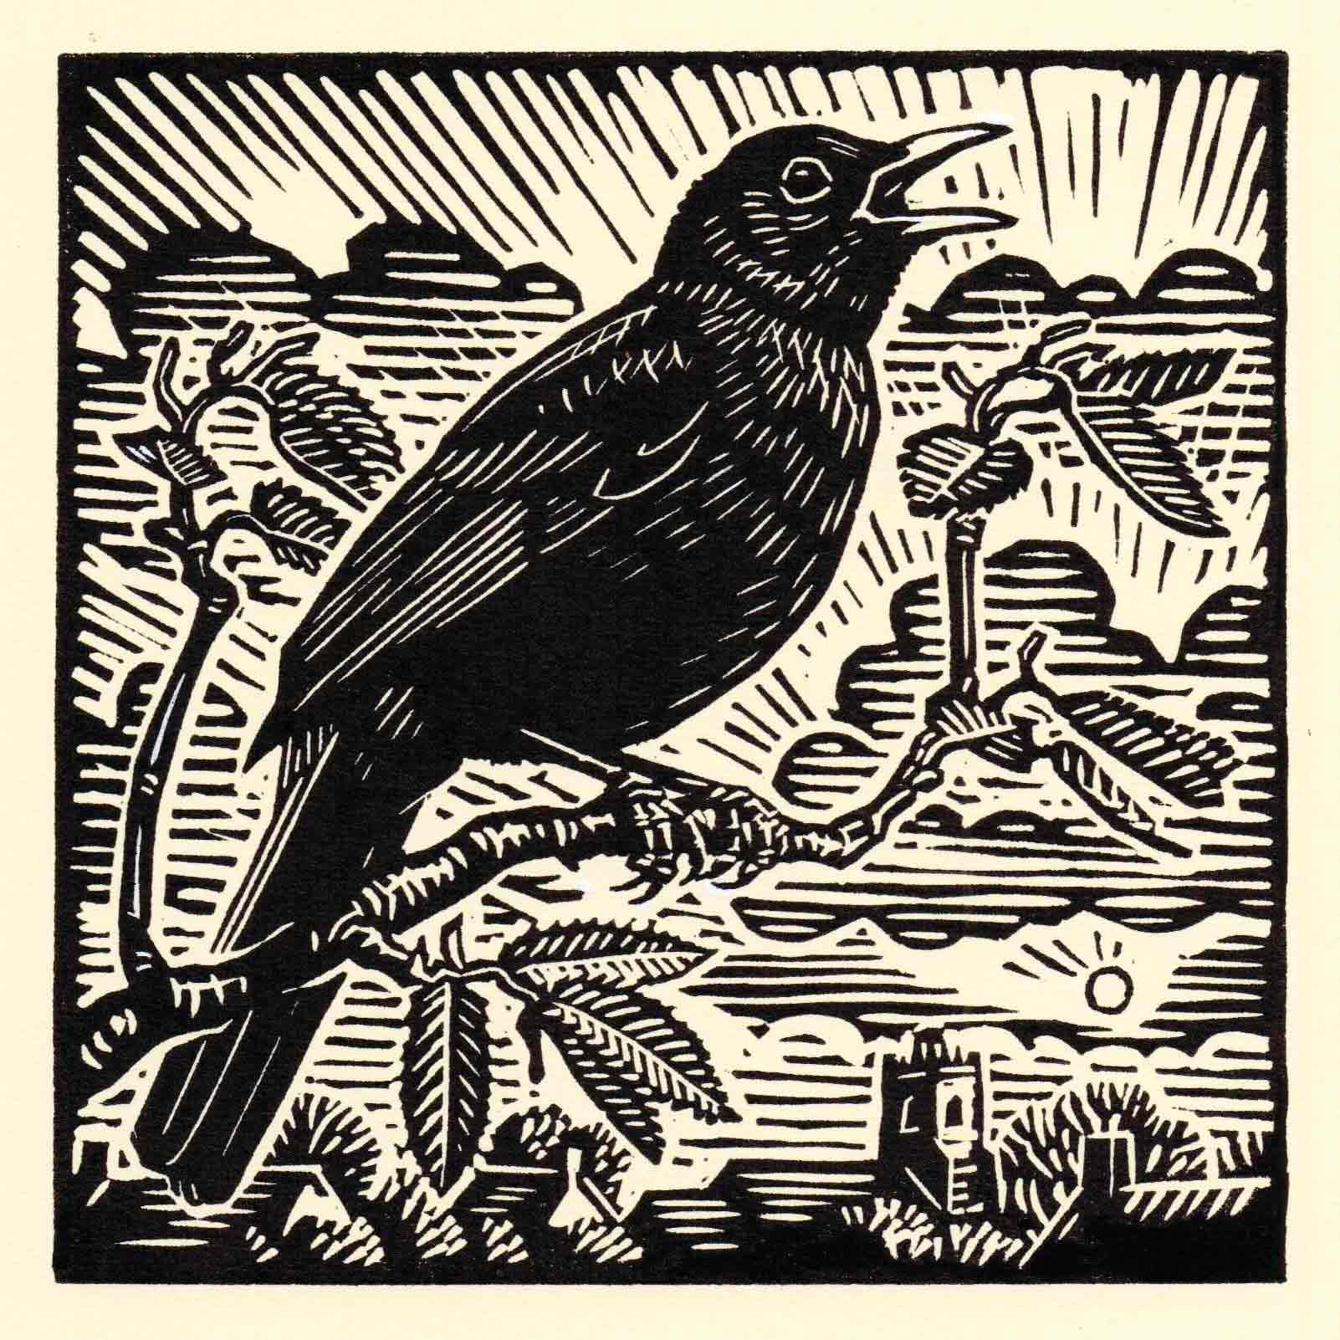 | Collective nouns A collective noun is used to describe a group or collection of things as a whole Examples ; Flock - a group of sheep, Pride - a group of lionss Murmuration - a goup of starlings ( watch video) https://www.bbc.co.uk/newsround/29975553  Here are some examples of common collective nouns - beside them write what they are groups of .Find more if you can . - Animals: flock, herd, pod, swarm.gaggle, pack, litter, school, colony , parliament, caravan, zeal https://www.bbc.co.uk/bitesize/articles/zm2bhbk quiz time!
Area and Perimeter | House floorplan challenge  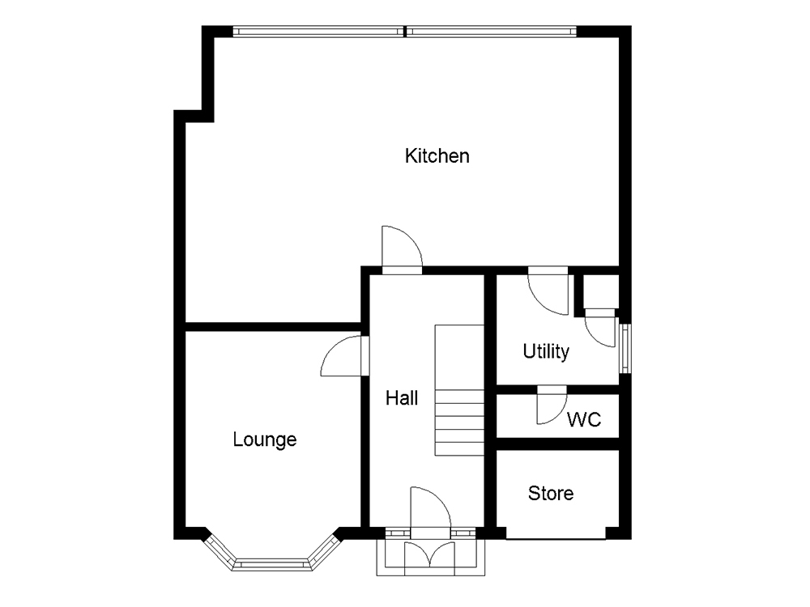  Make a floor plan of your house. If you could add another room to your house what would it be? | Fun park design and scale drawing  Scale 1cm - 1m  Imagine a Funpark was goingto be made in your village .Design and draw a sketch drawing of a funpark with at least 4 rides , 2 places to eat, 1 shop,toilet, ticket booth picnic area. Where would it be located? Do you think all the local people would like it? Why? Why not? | Area Builder Game  Work on your area and perimeter understanding with this game https://phet.colorado.edu/sims/html/area-builder/latest/area-builder_en.htmll  Work on rapid recall of Times Tables Toparks maths Hit the Button Times Tables and Numberbonds https://www.topmarks.co.uk/maths-games/hit-the-button | Community Garden Design  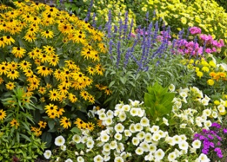  Make a sketch diagram and a sketch plan for our new Strathyre Community Garden - a garden for all the community so in your design think about all the different people who will be using it. The garden will be about 4mx5m rectangular shape. We already have 6 raised beds (1mx1m squares). Fit a shed into your design and a place to sit. | Treasure Hunt X marks the spot.  Make a map of your garden  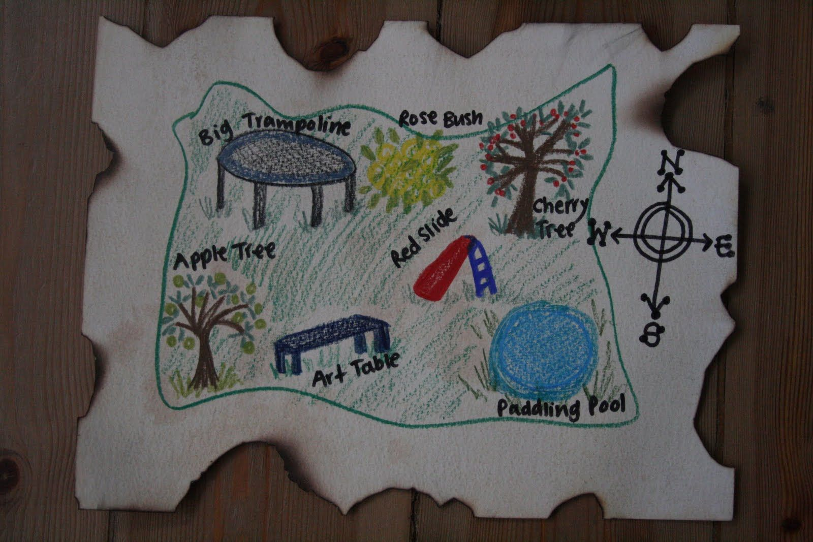  Hide a piece of paper saying treasure - or some 'real' treasure somewhere in your garden - mark on your map with an x where it is - see if people can find it.  b) give directions in from house door how to find it - 2 steps forward turn right 5 steps forward etc
Health and Wellbeing | Get your body moving  How many times ? - Ball skills - personal bests  1)thow a ball in the air and catch without dropping it  2)Bounce a ball against a wall and catch it  3)Keep aaball in the air using feet , knees , head - keepy uppy  4)Throw and catch a ball to another without touching ground  5) Bounce and catch a ball  6) Bounce and catch a ball to another  Remember to record your personal bests and try to improve them day on day. | Forest Bathing  This Japanese practice is a process of relaxation; known in Japan as shinrin yoku. The simple method of being calm amongst trees, observing nature around you whilst breathing deeply can help both adults and children de-stress and boost health and wellbeing in a natural way.  https://www.forestryengland.uk/blog/forest-bathing  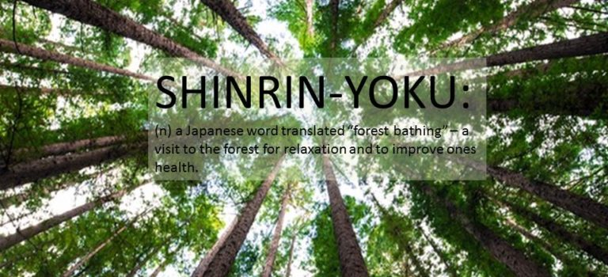 | Oudoord Art  Make a human skleton out of natural materials you find outside. Make it as close to a real skeleton as you can - you could label these bones  Skull, collar bone, elbow, wrist , ribs, pelvis, thigh bone, ankle, spine  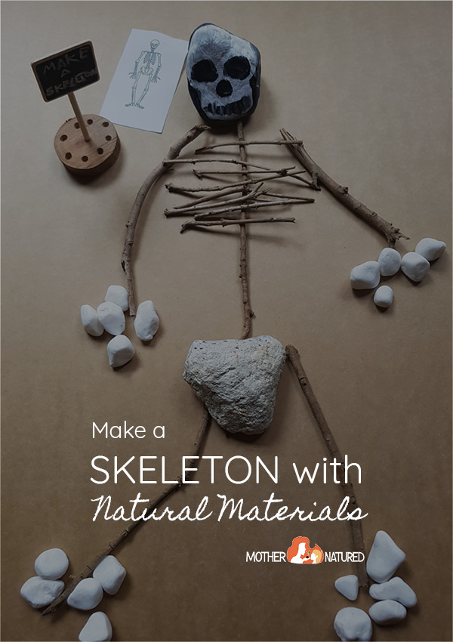  If you enjoyed this create the skeleton of another animal. | Photo Challenge - What is that?  Close up quiz - take close up photos of 5 things from an unusual angle . See if those in your household can guess what they are.  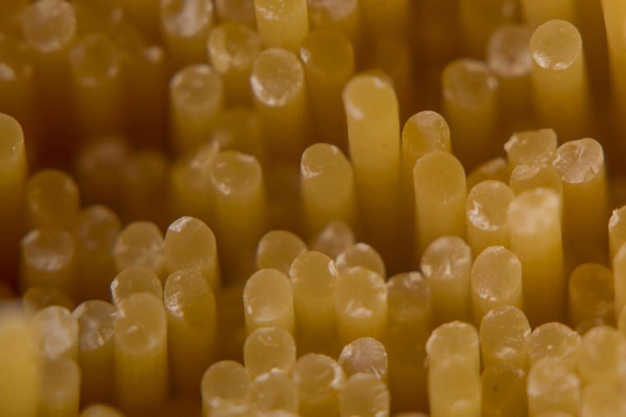 For example this is Spaghetti    What do you think this is? | Doodle Art    Have a relaxing time doing some doodling - draw around your hand as above and fll in with doodle patterns of your choice

