Step 1:
Take a picture of yourself reacting as if you had seen one of the Hairy Maclairy dogs somewhere!

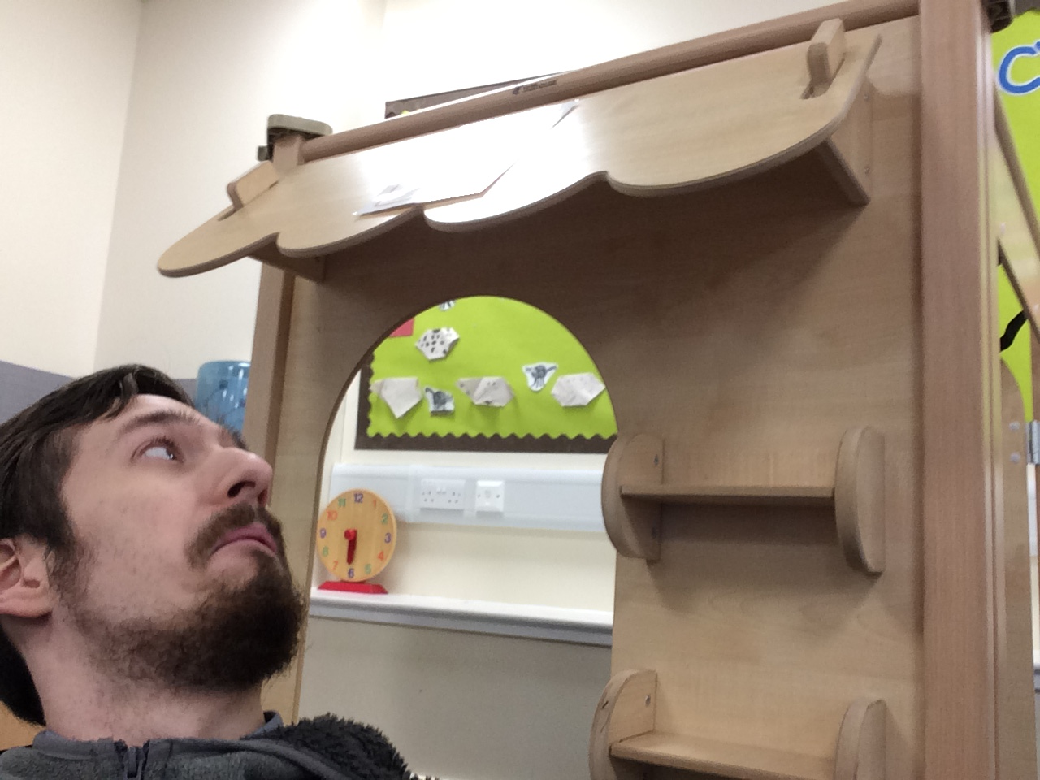

Step 2:
Google pictures of the hairy maclairy dogs: (Hairy Maclairy, Schnitzel von Krumm, Hercules Morse, Bottomley Potts, Muffin Maclay, Scarface Claw) and choose some you would like to use.
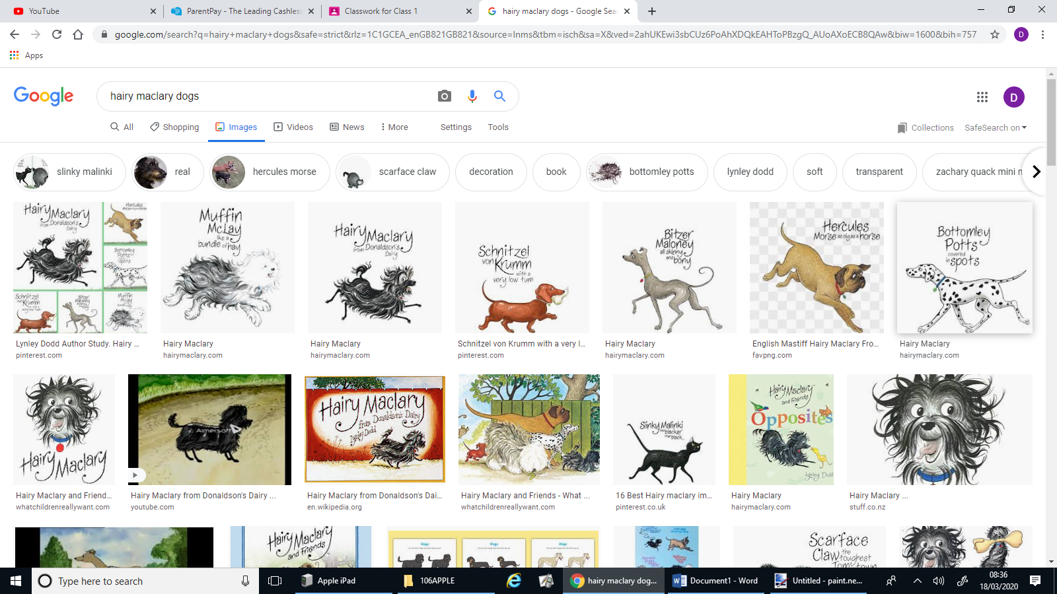
Step 3:
Find your reaction picture by connecting your tablet/camera to the computer and using the explorer folder button to see where it is saved.
Once on paint.net, go to file (top left), open. Find your picture and double click it.

Step 4:
Use the green + button in the bottom right to add a new layer.
Copy and paste your Hairy Maclary animals onto the picture.
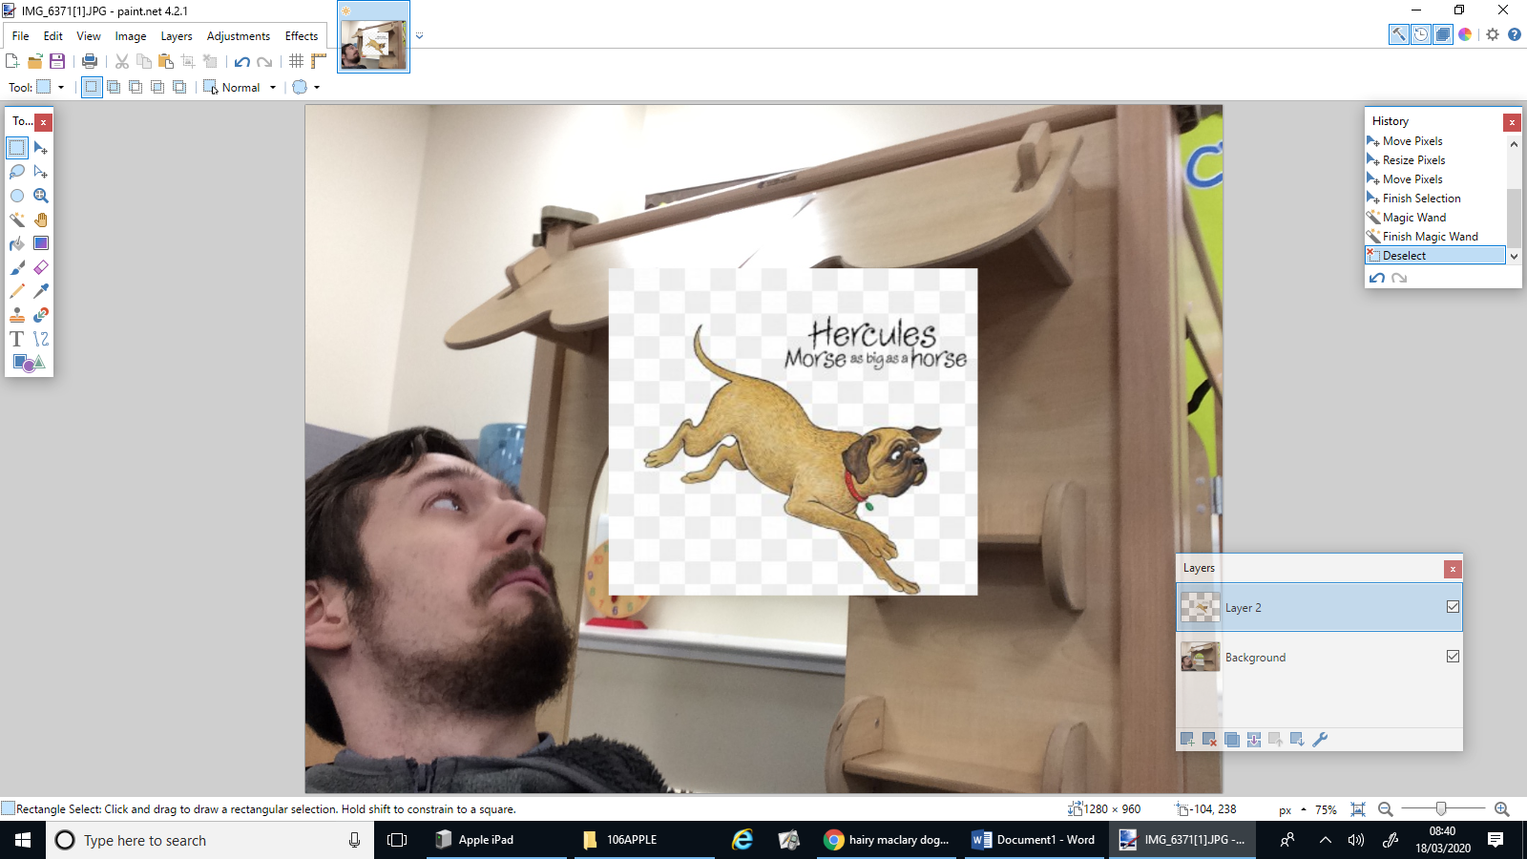
Step 5:
Use the rubber or magic wand to get rid of the background.
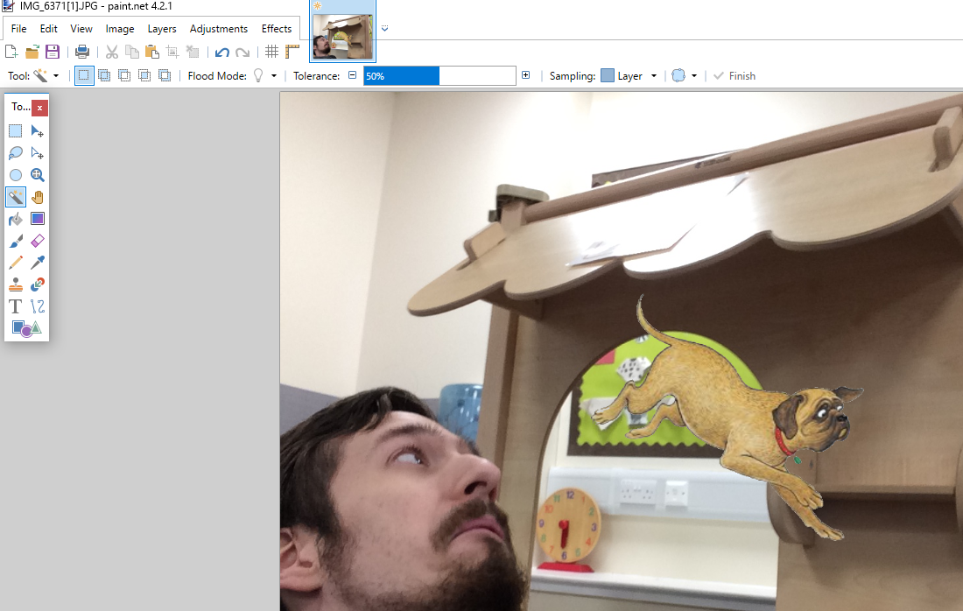

Step 6:
If you want to flip the image around, click on Layers, then ‘Flip Horizontal’
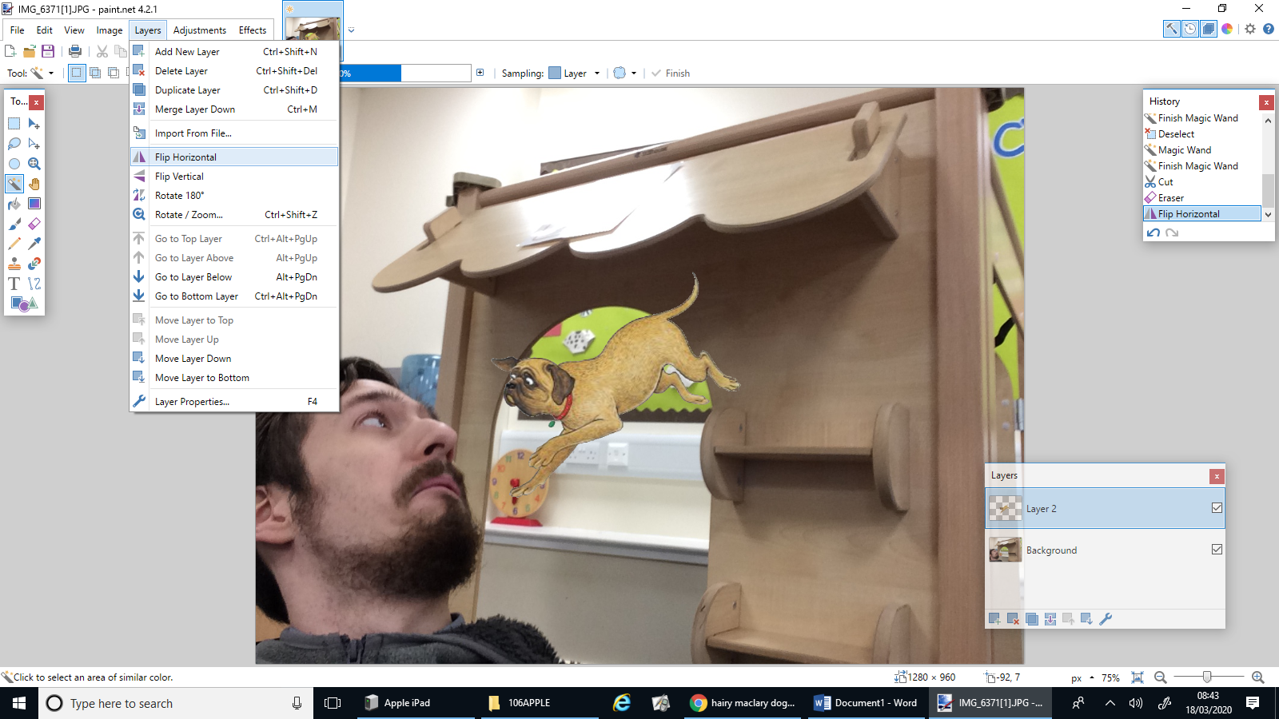

Step 7:
Change the size of your dog by clicking the rectangle tool and dragging your mouse over your dog.
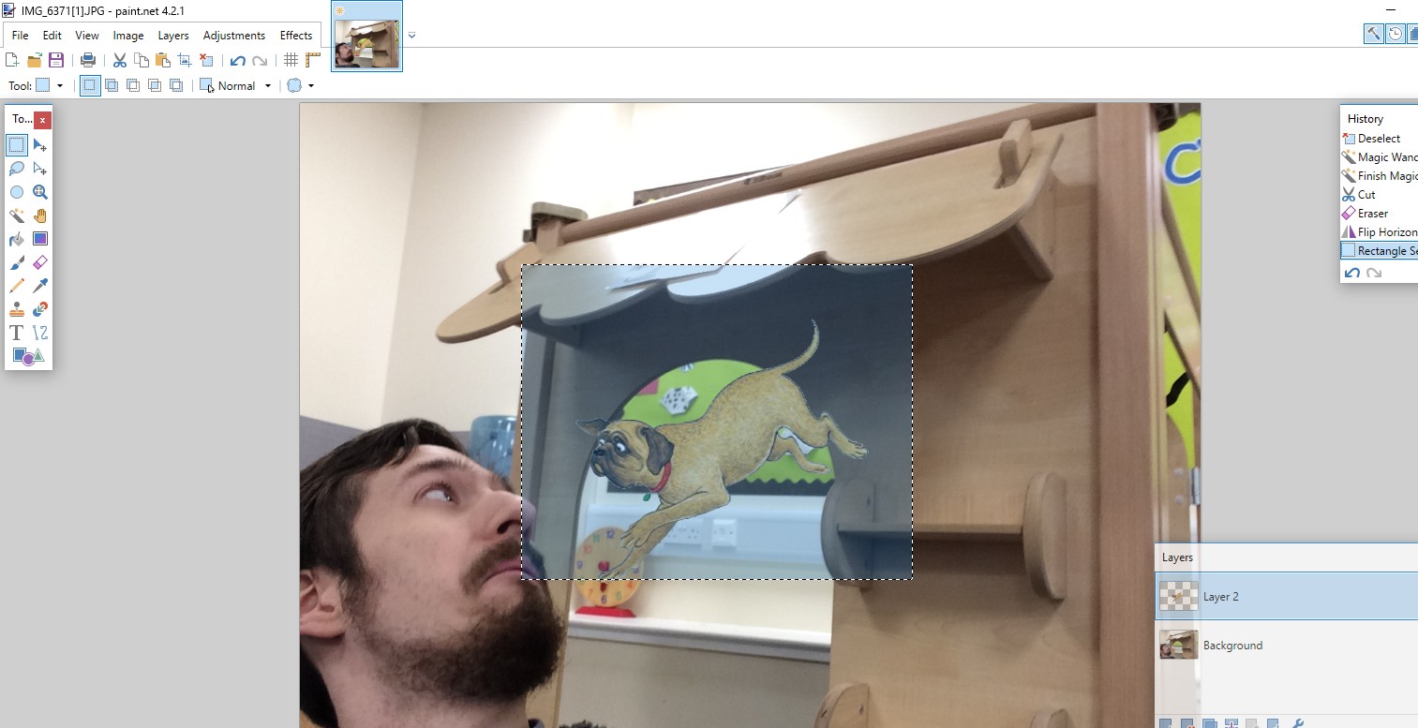
Then change it’s size by clicking the blue arrow button and dragging the corners of your picture.
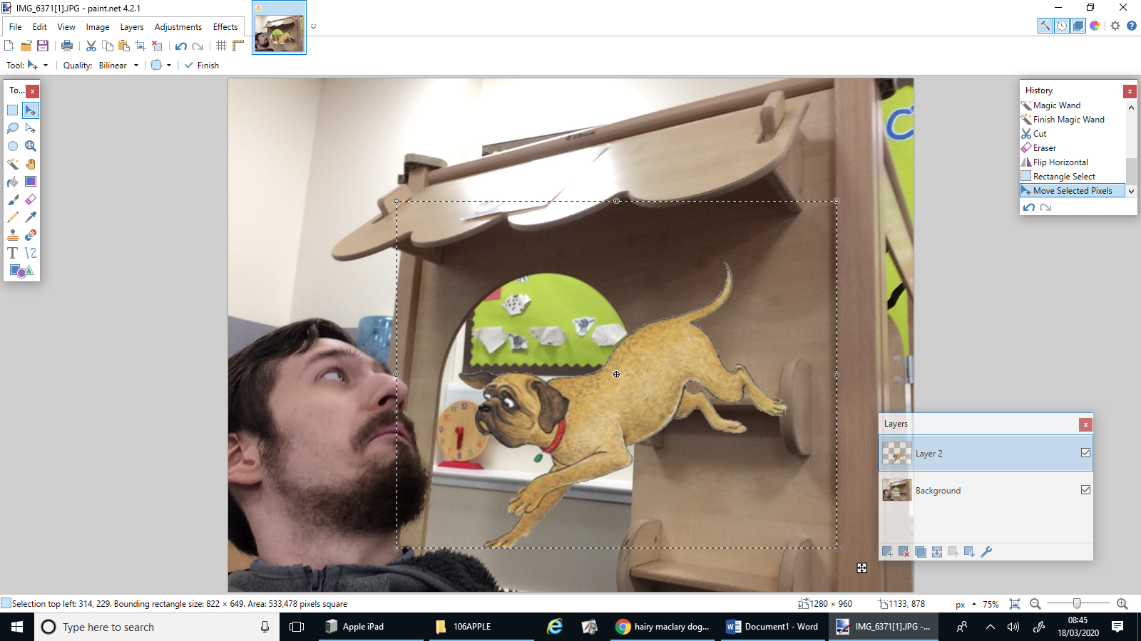

Step 8:
Use the rubber to rub out parts of your dog that you want covered.
I will rub out his back so it looks like he is coming out of the hole here.
Make sure you are rubbing out on the correct layer that your dog is on!
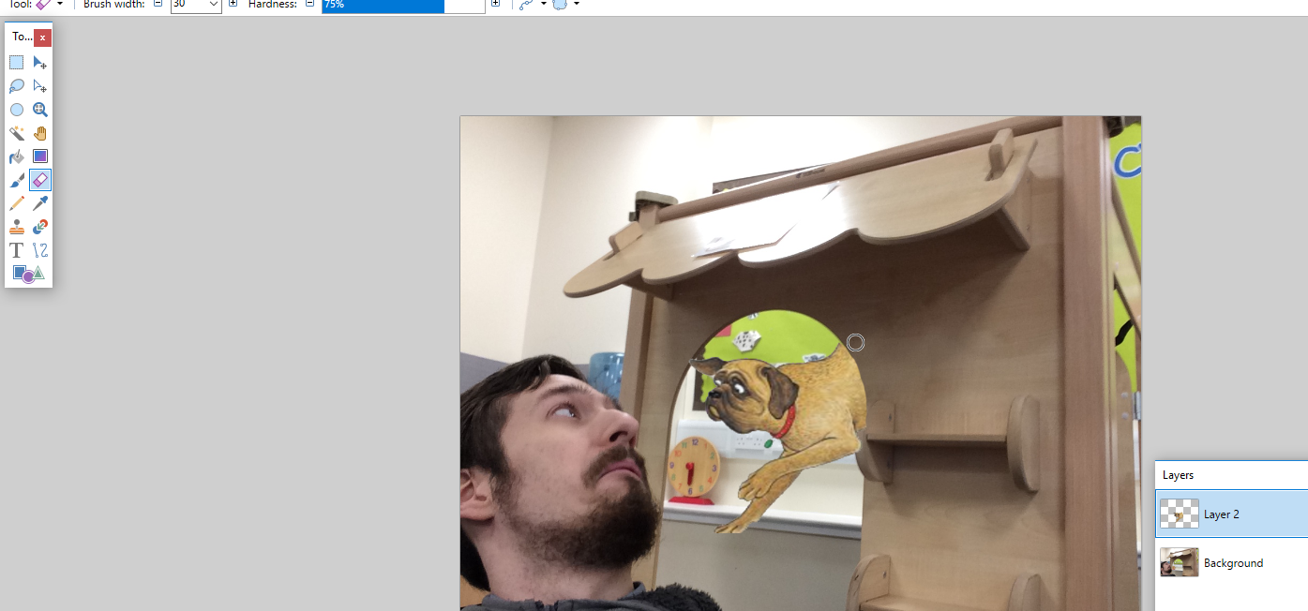

Step 9:
Finally, add a title to your story by using the T button and typing.
You can change the colour using the colour wheel at the bottom.
You can change the size and style in the top menus.
