Google Classroom Guide

- Open your internet browser on a computer/tablet. On google, type in ‘google classroom’ and click the selection that says ‘classroom.google.com’

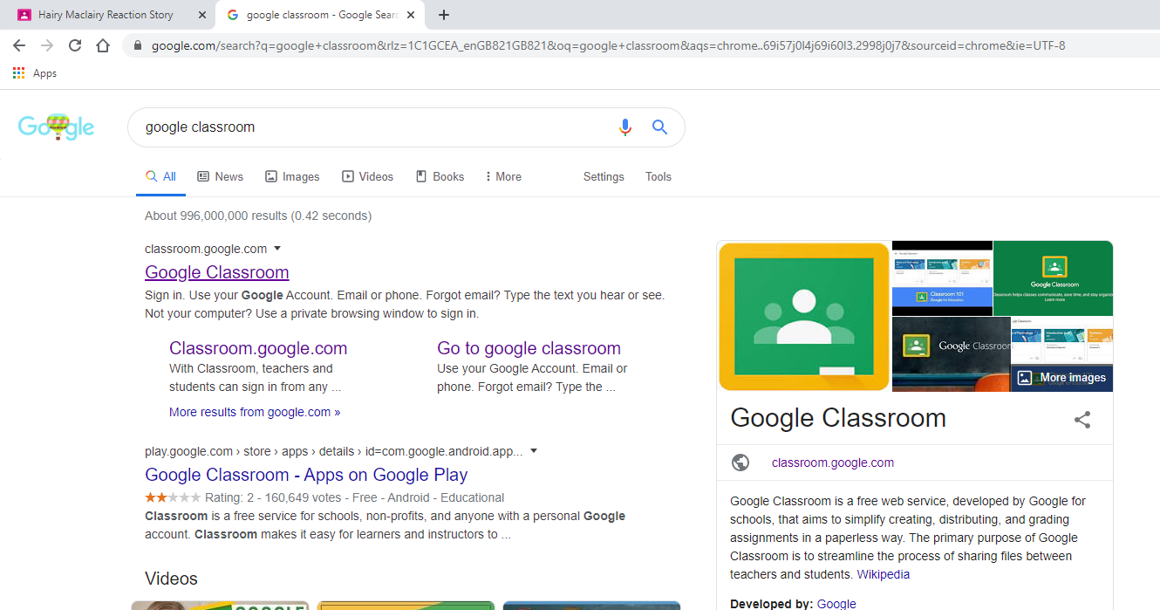

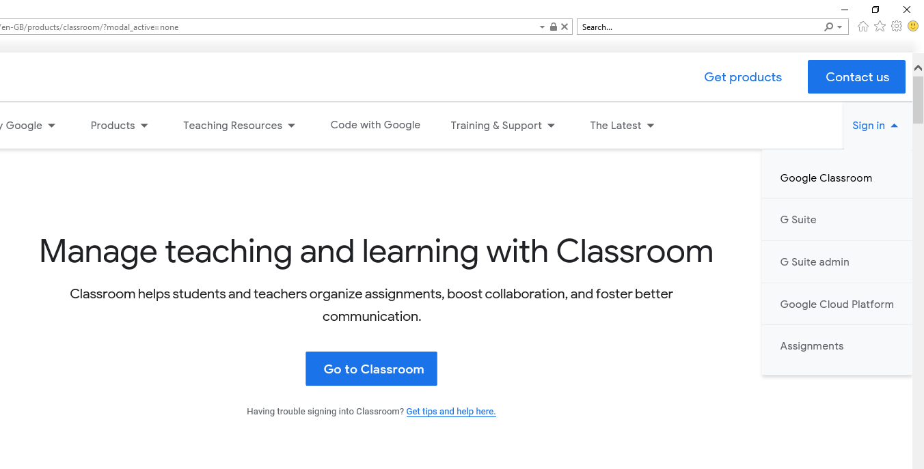
- Once on the website, click ‘sign in’ and ‘google classroom’ on the right hand side

- Sign in using the details on your login card. They should be your child’s surname, first name initial, 50, and be @stirlingschools.net. They should each have a unique password.
- Click on the class that your child is part of

- Press the ‘classwork’ button at the top of the screen

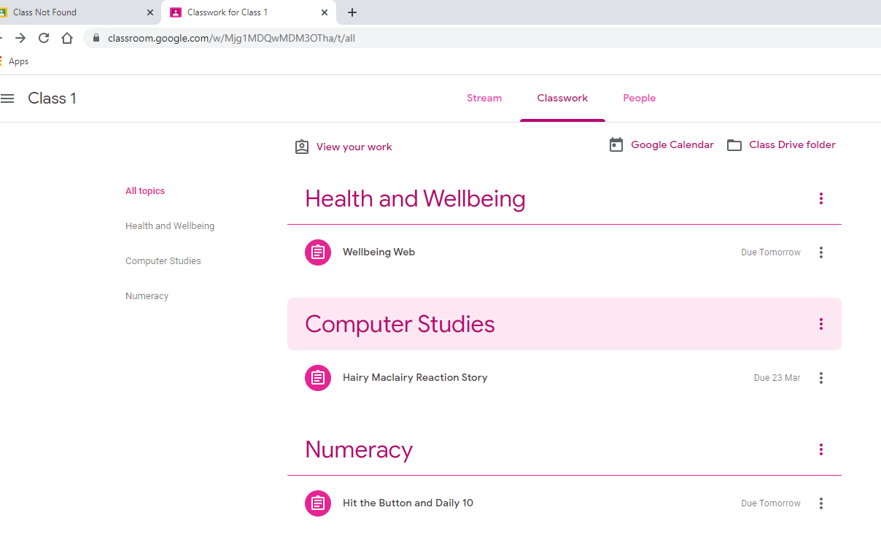
- A list of subjects will be displayed. You can use the due dates to check when lessons are due in and click them to find out more information.
- When you click on a lesson, click the ‘view assignment’ button to get more information about it. Materials and templates will be displayed here too.
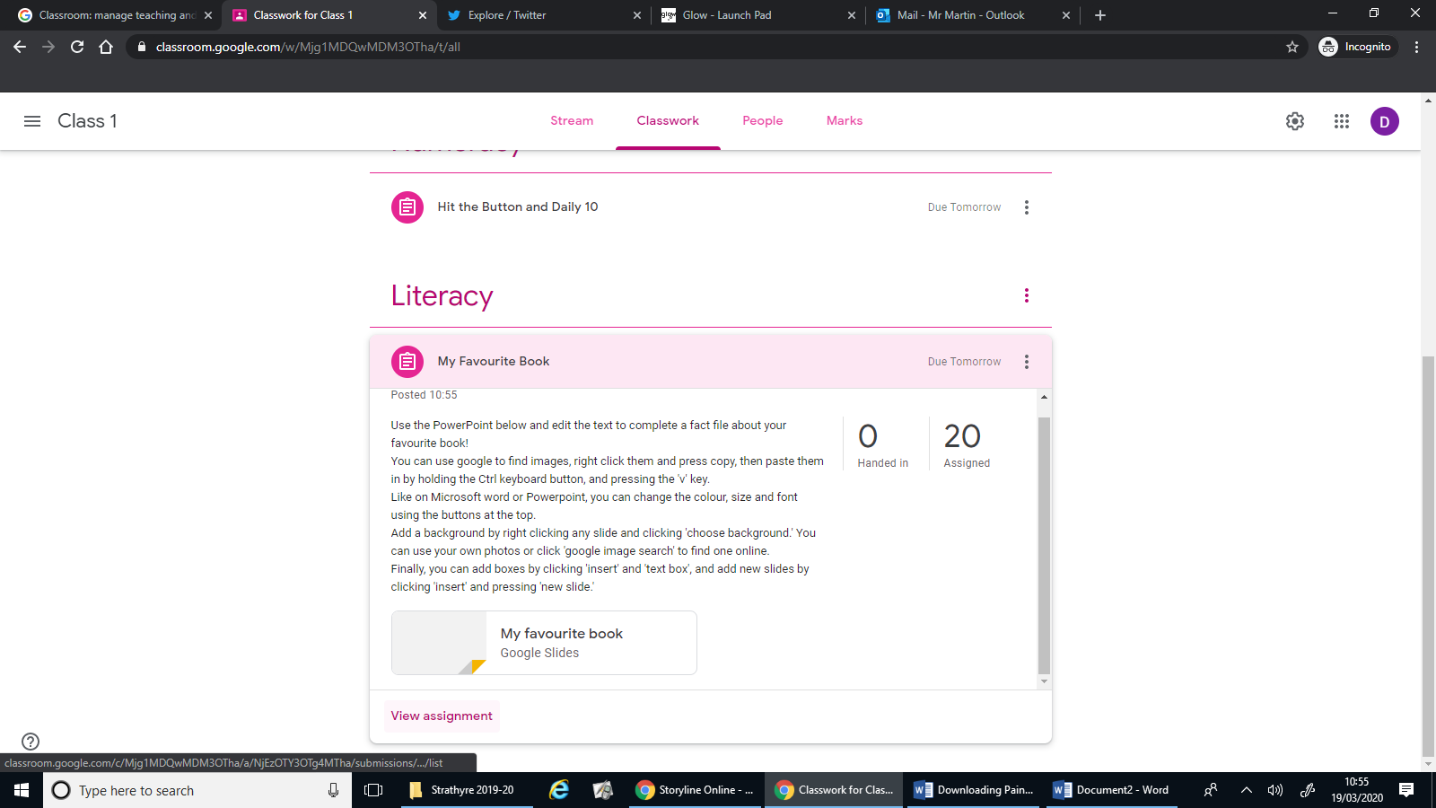

- On this screen you can read the instructions for the assignment. Any materials or templates you need to type onto or edit will be on the right. Click them to open them up and begin working. (Additional reference materials that might help will be displayed on the left).
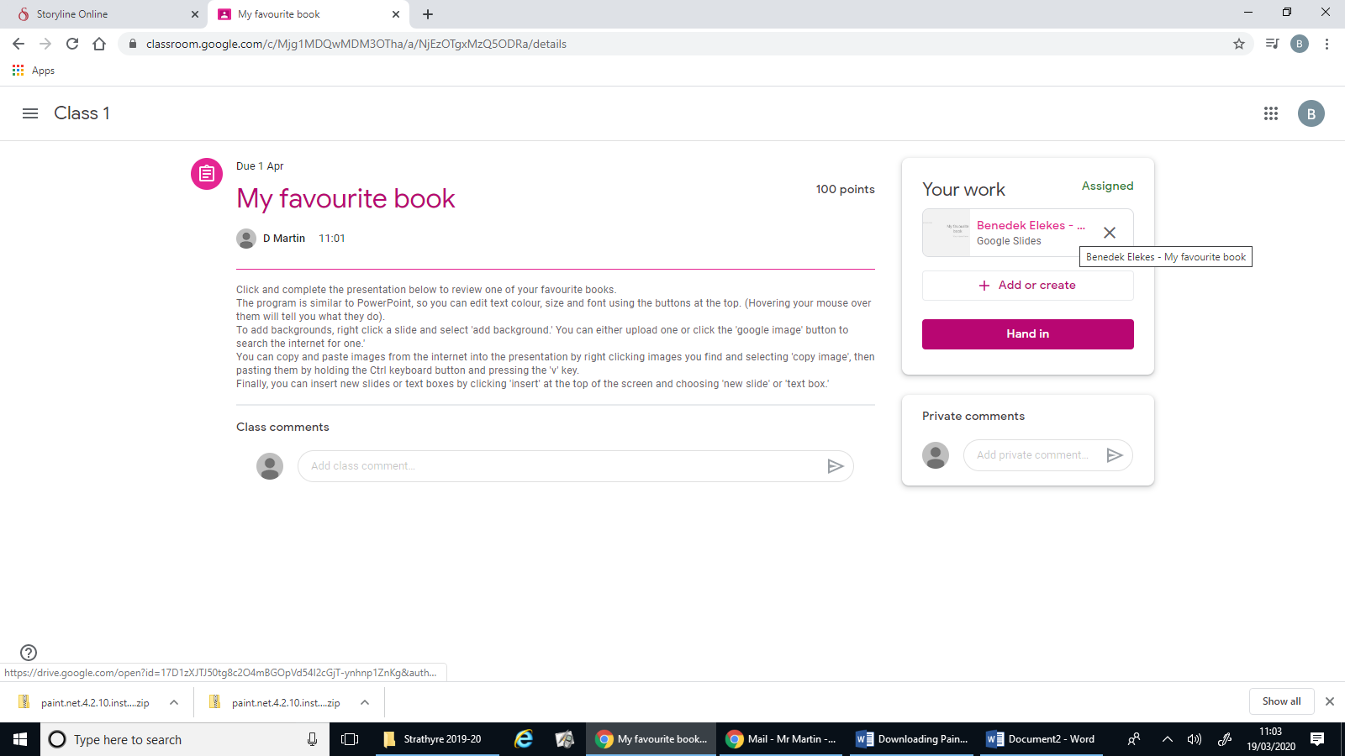
When the assignment is finished, click the ‘hand in’ button.
- If you want to upload your own files of work (for example, photographs of sums you completed on pen and paper rather than on the computer), or you would rather use another program you are more comfortable with like Microsoft Word, that is absolutely fine! Press the ‘Add or create’ button. Then, press ‘File’ to upload these instead.
Finally click ‘select files from device’ and then choose what you would like to submit.
Then press ‘hand in’ as above.
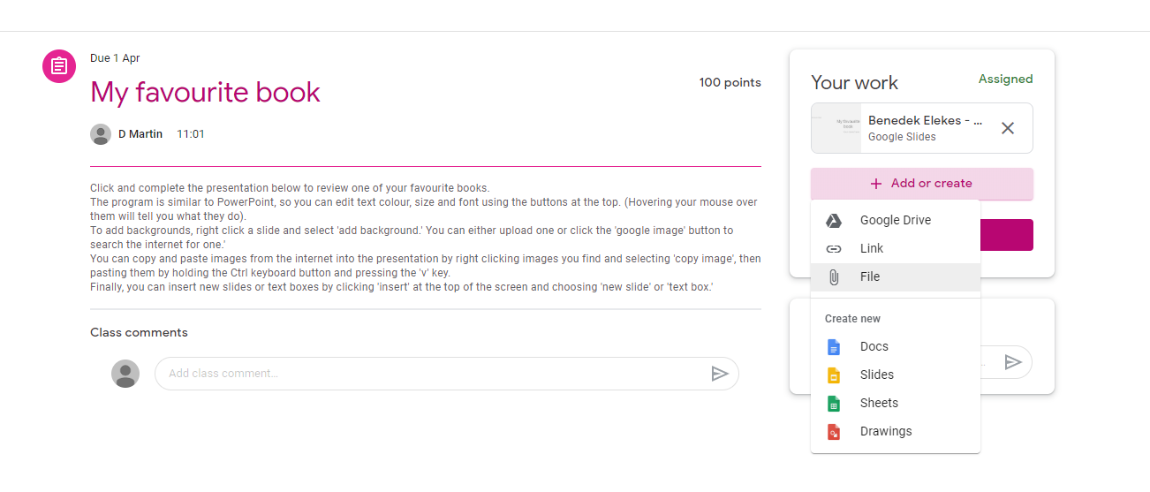

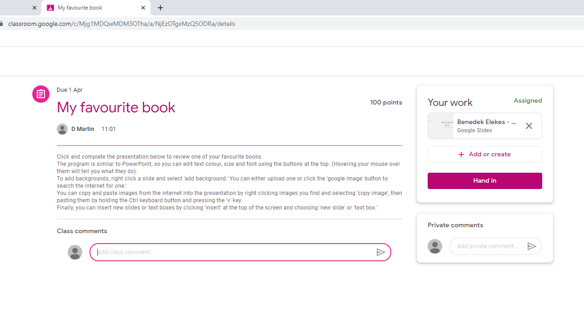
- Any issues, please email the class teacher or type your question in the class or private comments. Class comments can be seen by all, private can only be seen by the teacher. Be aware that the teacher will monitor and delete class comments as necessary.
- Check back whenever you can to complete new lessons from the ‘Classwork’ main screen.
We aim to upload regular Literacy, Numeracy and extra lesson (covering another subject) whenever possible, from after the date of the Easter break finishing, if not sooner. We understand that changes in routine and work mean they cannot all be completed daily, so feel free to complete them when best suits your situation.

Work which is submitted will be returned online by the teacher with comments so pupils can still look at their work feedback.

We will do our best to support the pupils’ learning through these lessons and be as available as we can be to help anyone having issues or wanting support.

