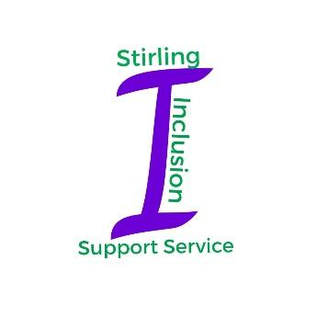

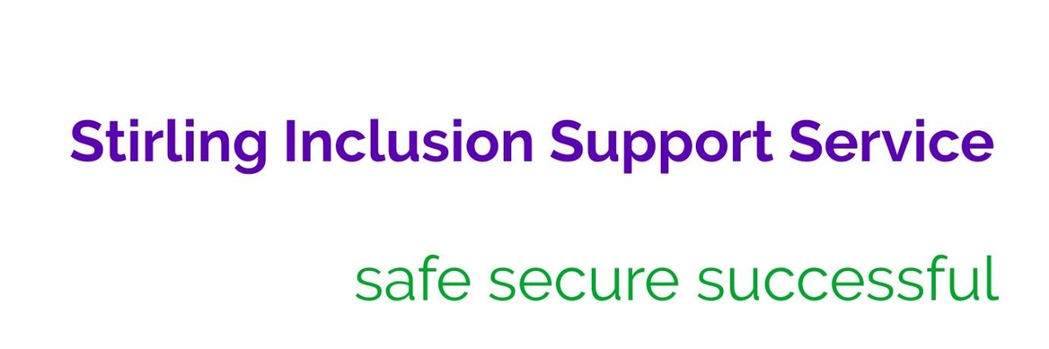

**Service Profile**

The Service works with children/young people who experience social, emotional and behavioural needs and trauma related barriers to learning. By adopting a relational approach underpinned by the Neuro Sequential Model in Education and the six nurture principles, the Service aims to reduce the attainment gap between the most and least disadvantaged children/YP. Equality of opportunity aims to overcome potential barriers through targeted, experiential learning programmes.

**Vision for Learners**

We have high aspirations for every child and young person and deliver an individualised curriculum which provides opportunities for success. We believe that each learner can be supported to be the best they can be, in a trauma informed educational environment that promotes positive relationships, mutual respect and understanding. We strive to provide a safe, secure environment to meet each learner where they are developmentally. We work closely with families, carers and partners to enable all of our children/YP to become aspirational and develop the skills required to achieve success.

**Our values are:** ̵ positive ethos

**̵** positive relationships and partnerships

**̵** mutual respect

**̵** flexibility

**̵** lifelong learning which is enjoyable, relevant and individualised

**We aim to: ̵** ensure a warm, welcoming ethos where everyone is equally valued

**̵** develop a resilient community underpinned by positive relationships

**̵** provide a relevant, enjoyable and appropriate curriculum to meet individualised need

**̵** build the skills needed for future learning, life and work

The Service improves outcomes for children/YP by offering support, capacity building, training, targeted planning and direct work for some, and the provision of off-site placements for the small number of children/YP with the highest level of need. Small group education is offered in Millhall Base for 10 primary aged children and in Chartershall Base for 18 secondary aged young people.

The multi-disciplinary staff team consists of 9.8 Teachers, 2 Admin staff, 10 Support for Learning Assistants (SLAs), 9 Inclusion Support Workers (ISWs) and 3 Sports Inclusion Support Workers (ISWs). The team is led by the Head Teacher, 4 Principal Teachers and the Inclusion Support Worker Team Leader.

**Trauma Informed Approach**

The service is becoming increasingly well known for its work in Trauma Informed Practice. As a result we were invited to participate and contribute to a national Equity and Care Experienced Child and Young People webinar with Education Scotland in June 2021.

**The Standards and Quality report 2020-21 should be seen in context of the COVID-19 global pandemic.**

This has been an exceptional school session as a result of the pandemic. The curriculum and working practices of SISS have had to radically change to meet the new needs presented by our children/YP, their families, our staff group and schools. While we have had no cases of COVID within the service, throughout the year there has been considerable disruption due to staff and pupils being tested or self isolating having been in contact with others who had tested positive.

It is clear that school closures in session 2019 - 2020 as a result of the Pandemic, had a significant detrimental effect on the wellbeing of our children/YP and their families. It was therefore considered important to continue provision for our vulnerable pupils in the event of further school closures.

Strenuous efforts were made to ensure access to learning for all pupils. In September, pupils were provided with chromebooks and all staff were given laptops and received in-house training to deliver on-line learning.

Pupils began to use chromebooks in class and were given training on how to access learning remotely.

In order to provide a COVID safe environment, prior to the start of session, robust risk assessments were developed and considerable adaptations to the work of SISS were made. Two distinct staff bubbles were created with MIllhall and Chartershall becoming separate cohorts.

Adaptations were made to the environment with most of the furniture, equipment and all of the soft furnishings removed from both bases. Class sizes were reduced, limiting numbers in spaces. Children/YP were timetabled to stay in one space throughout the day including breaks and lunchtimes. The curriculum was adapted with the removal of all activities outwith the base and all mainstream inclusion ceased. All PE and sports sessions began to take place outside.

The staff workbase moved to the school hall and the ISW team was disaggregated, some joined the Millhall bubble, some in Chartershall and some were home based.

At the start of the session, the advice from the Council was that outreach work should not take place. By October, we had developed guidance where we could re-establish work with schools while observing strict COVID Risk Assessments.

Our outreach teacher continued to support schools virtually and three ISWs worked with individual children in one school each day with a maximum of two schools in a week. The ISW team delivered groupwork programmes, both in person and virtually throughout the session.

In addition, face to face staff training continued to be delivered to mainstream schools throughout the pandemic to provide the support required.

When schools closed for a second time in January 2021 during the second national lockdown, we consulted with our parents who were asked if they wanted their child/YP to learn remotely or to continue to attend school. 90% of pupils continued to attend school while the others learned remotely and were visited at least twice a week during this period.

The Service met with HMIe in February 2021 as part of Education Scotland’s review of Scottish Education response to the COVID pandemic.

In addition, following the Service visit by HMIe in February 2020 as part of the National Thematic Inspection on Family Learning, a further meeting took place with HMIe and the work of the Service was then featured as an area of good practice with a case study in the subsequent report on Family Learning.

We have worked even more closely with our families since the pandemic began and as a result our relationships have strengthened further. Following consultation it was clear our parents/carers were overwhelmingly appreciative of the work being done by the Service.

**Feedback from Parents/Carers**

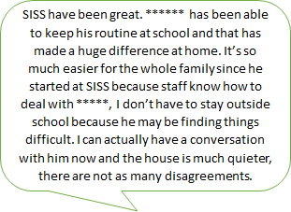

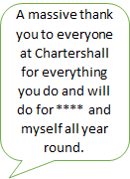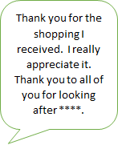

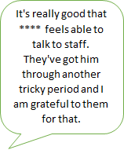

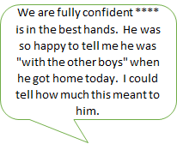

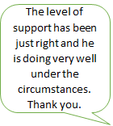

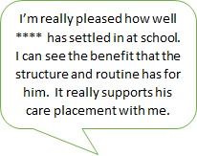

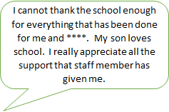

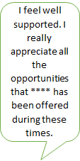

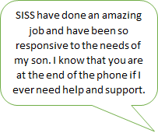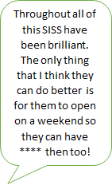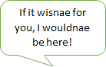

**Profile of pupils**

|  |  |
| --- | --- |
|  | In session 2019-2020, 60% of children/YP attending SISS bases live in SIMD deciles 1 – 2, while 80% live in SIMD deciles 1 – 4.  This session, 75% of SISS pupils live in Deciles 1 – 2 while the other 25% all live in deciles 3 and 4. Currently we have no pupils who live in Deciles 5 to 10. |

|  |  |
| --- | --- |
| This demonstrates a significant shift in demographic in that more pupils are living in areas of deprivation. This is because of the large number of new pupils as well as 2 pupils moving house.  In the SISS Millhall group, 50% of the children are new to the service this year while in the Chartershall group, 25% of pupils are new to service this year. With essentially a new pupil group this session, it is not possible to compare pupil attainment from previous years. Our data demonstrates an increase in most indicators this year providing further evidence of the changing demographic.    **More children/YP are:**   * care experienced ( rise of 6%) * on a Compulsory Supervision Order (rise of 26%) * accommodated (rise of 10%) * 19% in kinship care * previously on the Child Protection register, (rise of 15%) * 3 currently on the Child Protection register |  |

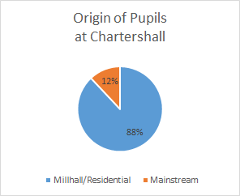

The pupil demographic in Chartershall base shows that 12% came directly from mainstream school while the remaining 88% came via SEBN provisions, either Millhall or residential schools. All of the current S4 group previously attended Millhall, 1 went on to mainstream secondary, 2 came straight to Chartershall while 4 went on to residential schools. Our current senior phase group were previously together in MIllhall when there was a high level of violence and dysregulation. Being together as a group again proved to be challenging for them.

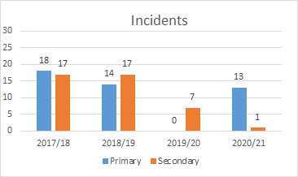

Since the first Lockdown there has been an increase in violent incidents in primary. We believe this is due to the impact of COVID. However there has been an 86% reduction in violent incidents in secondary. The 1 incident in secondary relates to a concern that a pupil was being radicalised on the internet.

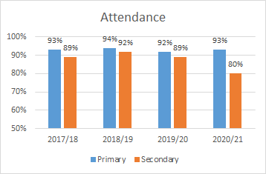

While attendance in Millhall is up 1%, there has been a significant decrease of 9% in Chartershall attendance. This would appear to coincide with the period in the Spring term when mainstream schools were closed due to the pandemic and the majority of mainstream secondary pupils were learning at home.

**There have been no exclusions in SISS in the last 4 years.**

**We believe our trauma informed practice has led to improved learning outcomes across our bases. 87.5% of young people have improved executive functioning scores this session which indicates a greater ability to reason.**

**Curriculum**

The curriculum offered by both bases had to be altered significantly to meet COVID mitigations as experiential learning was not possible, nor could our Primary pupils be included in their mainstream schools as before. Senior Phase pupils could not attendance college or access work placements. However in both Bases a wider range of curricular areas was offered.

**Attainment**

Given the changing needs of SISS children/YP, along with the complexity of their home circumstances, the curriculum offered must be responsive to the needs of each individual. Our children/YP’s dysregulated behaviour means that obtaining baseline assessments when transitioning to SISS can be problematic. Baseline assessments were undertaken for all new learners but due to COVID, we were unable to reassess Primary reading and spelling chronological ages to demonstrate learner progress using this measure.

**Primary Data**

There is an expectation that all SISS Primary children have contact with their mainstream schools. Due to COVID and the need to maintain social bubbles, this has taken place virtually via Google Classroom, video and email contact. The P7 leaver from Millhall has benefitted from enhanced transition to his mainstream high school. This has included face to face visits and learning opportunities as well as virtual contact.

|  |  |  |  |
| --- | --- | --- | --- |
|  |  | |  |
|  | |  | |
|  | |  | |

**Curriculum for Excellence – Broad General Education Levels**

|  |  |
| --- | --- |
|  | Our only P7’s reading and writing results demonstrate that the pupil is achieving the same scores as the middle 50% of learners in his mainstream school and nationally. While in numeracy he has recorded scores higher than his peers in mainstream and within the top 20% nationally.    One primary pupil moved up a level in numeracy. Prior to placement, due to her dysregulation, she had no experience of numeracy assessments and had been unable to access a class learning environment. |

**Senior Phase**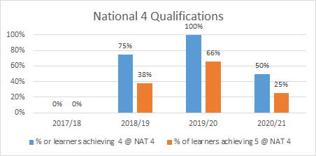

All of our 7 Senior Phase learners have experienced interrupted learning:

* 4 returned from residential schools
* 2 are accommodated
* 1 is on the CP register
* 1 has a learning disability

This has had a significant impact on attainment this session.

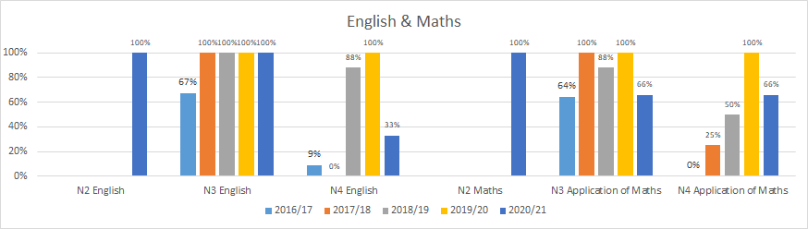

**While fewer National 4 qualifications have been achieved this year, there has been greater breadth in the curriculum as more areas have been covered.**

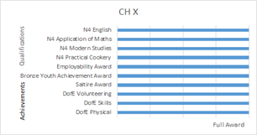 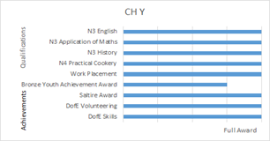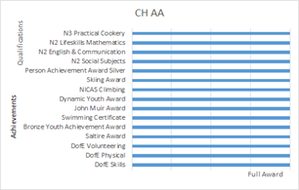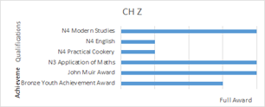

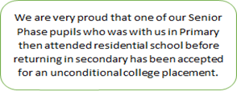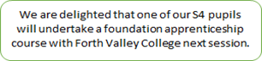

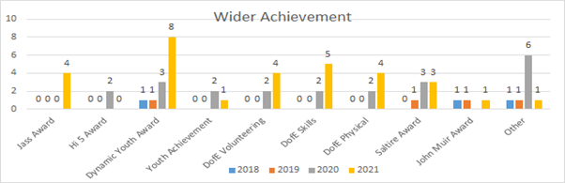

|  |  |
| --- | --- |
| **School Priority 1 - 20/21**  **SISS staff team will consolidate and apply their knowledge of trauma informed practice and adopt a flexible response within the context of COVID-19** | |
| National Improvement Framework Priority   * *Improvement in children and young people’s health and wellbeing* | HGIOS4 Quality Indicators  *2.4 – Personalised Support*  *2.6 - Transitions*  *3.2 – Raising Attainment & Achievement* |
| Key drivers for improvement   * *Teacher professionalism* * *Parental engagement* * *Assessment of children’s progress* | Integrated Children’s Services Plan Outcomes   * *The attainment gap relating to poverty, additional support needs and looked after children and young people is reduced.* * *All children thrive as a result of nurturing relationships and stable environments in their own school and community.* * *Children, young people and their families are respected as equal partners in decision making and planning.* * *Children’s and young people are mentally and emotionally healthy.* |
| **Progress**  As part of our trauma informed approach, SISS Bases remained open for all children/YP across the session, including during the second National Lockdown from January until April. Our main focus has been the ongoing development of trauma informed practice. The Service is part of the Authority Strategy Group on the implementation of NME. All staff continued to participate in training in Trauma Informed Practice using Dr Bruce Perry’s Neurosequential Model in Education (NME). This included:   * recognising that transitioning to school could prove challenging, a summer holiday programme of two activities per week for 4 weeks was offered * working collaboratively with a range of Services to support children/YP in their re-engagement with school, including joint assessments, joint visits, co-delivery of programmes, etc * from August until December pupils were transported to and from school by SISS staff volunteers with an aim of reducing anxiety and supporting attendance * NME training led by the 2 Service NME practitioners. Including repetition of core concepts, the concept of layering of trauma informed practice and knowledge and the interweaving of NME with other key approaches, including MAPA and Nurture * NME Induction training programme developed and delivered to new SISS staff * staff development in trauma informed approaches along with consultations for individual staff to support their work took place * regular re-visiting of NME minimaps led to bespoke regulation profiles and informed Form 4 targets with dosing and proactive regulation strategies built into every programme * NME approaches were included in planning for children/YP receiving outreach support. NME core concepts were embedded in individual pupil plans * almost all staff participating in Mental Health First Aid training * Seasons for Growth COVID workshops were delivered to base pupils * Service HT, along with 2 NME practitioners are members of the Authority NME Strategy and Implementation group   **Despite the impact of COVID this session, we have continued to develop our understanding and practice of how we assess and meet individual need, continuing to place an emphasis on individual Health & Wellbeing:**   * individualised experiential learning was planned, while minimising the risk of COVID * all base children received support from Inclusion Support Workers * all staff are now included in termly minimap updates for all children/YP in line with planning dates * creation and appointment of Health & Wellbeing Project Lead * sports ISW sessions were offered to every child/YP * a new gym was created * Family Work has continued to offer targeted support. The work has included: * supporting one parent through homelessness * support for parents who were self-isolating x 4, including essential food shopping * virtual coffee mornings were held x 5, attended by 8 parents * digital support x 5 parents to use TEAMS to support attendance at meetings and Google classrooms to support learning * Health & Wellbeing pamper packs were provided to all parents/carers * 40 Christmas Eve boxes were provided for all pupils and their siblings * Christmas gifts were provided for all children/ YP to give to parents/carers * supported 2 homeless families including purchasing clothing and providing donations of clothes and supporting housing applications * liaison with local charities to provide food parcels x 10 for 12 families * delivery of donated takeaways to 6 families x 3 * supported one young person to visit his carer in hospital x 5 | |
| **Impact**  This work has continued via collegiate sessions and in whole staff meetings as well as participation in NME assessments and in planning to meet individual needs of pupils. Bespoke training packages in trauma-informed practice have been delivered to new members of staff. The training is evidenced in the methodology and practice of all staff. Minimaps are used in conjunction with Boxall assessments in Individual Forward Plans. (Classrooms, resourced as trauma informed environments, have had to be re-designed in line with COVID mitigations).  It is difficult to demonstrate an increase in the identified measurements because of the impact of COVID,  however we believe that as a result of our our Trauma Informed approach we have seen:   * improved attendance in MIllhall, 100% of Millhall pupils attended the Base during the Lockdown * one Millhall pupil accrued 17 HSIR reports prior to joining SISS from August to November, since joining Millhall there have been no further incidents of violence * while there has been an increase in dysregulation and non-reportable incidents, the percentage of HSIR reports have deceased in the second half of the session in Millhall * 86% reduction in violent incidents in Chartershall base * 3% increase in attendance in Chartershall Base from August to December 2020 compared to 2019 * staff report pupils are cooperating and staying in their rooms as required by COVID mitigations * one young person stated that the Seasons for Growth intervention helped him to make sense of his experience during lockdown. Another stated that the intervention had helped him share details of historical traumatic experiences for the first time * 87.5% young people have improved executive functioning scores this session which indicates a greater ability to reason * 71% of senior phase pupils achieved national qualifications * 86% achieved at least one wider achievement award * staff report that NME assessment and strategies have had a direct/positive impact on their practice and that they now plan according to pupils emotional age as opposed to chronological age * quality assurance demonstrates that Minimaps, Boxall and Form 4 targets are now integrated and incorporated directly into planning * staff report that the collaboration of relevant staff, along with the support of Service NME practitioners, has led to improved support for children/YP. The main improvement identified was the inclusion of focused regulation activities * 4 x schools commented on how helpful they found NME strategies, planned/modelled by SISS * within self evaluation, staff commented on a sense of pride in NME developments and the positive impact for children/YP * CLPL delivery in schools has received positive feedback from both primary and secondary colleagues - trainers have linked NME with other areas, e.g. CPI MAPA, to good effect and across contexts, e.g. in a secondary ASD base (see page 15) * one school has created a therapeutic environment for their pupil based on NME approaches as advised by SISS * the therapeutic approach was delivered by SISS was been praised by another local authority whose pupil attends our Base | |
| **Next Steps**   * maintain and consolidate staff expertise in Trauma Informed Practice * provide further support and strategies on NME for parents * develop increased resilience in child/YP, parent and staff group | |

|  |  |
| --- | --- |
| **School Priority 2 - 20/21**  **Further develop the suite of Baseline Assessments and Monitoring and Tracking procedures to support all areas of the curriculum** | |
| National Improvement Framework Priority   * *Improvement in attainment, particularly in literacy and numeracy* | HGIOS4 Quality Indicators  *2.2 - Curriculum*  *2.3 - Learning teaching and assessment*  *3.2 - Raising attainment and achievement* |
| Key drivers for improvement   * *Assessment of children’s progress* * *School improvement* * *Performance information School leadership* | Integrated Children’s Services Plan Outcomes   * *The attainment gap relating to poverty, additional support needs and looked after children and young people is reduced.* * *All children thrive as a result of nurturing relationships and stable environments in their own school and community.* * *Children, young people and their families are respected as equal partners in decision making and planning.* * *Children and young people are mentally and emotionally healthy.* |
| **Progress**  **Taking this priority forward led to:**   * training for all teachers on the suite of Assessments and Monitoring and Tracking procedures, including Boxall and NME minimaps to further embedded the process * assessment procedures have being updated to embed NME practice within planning * Individual Forward Plan process was developed and used by all staff to ensure plans for each pupil are within one document * improved collaborative working between staff on Individual Forward Plans * DYW statements being identified in IFPs at secondary level * distributed leadership with teachers leading on knowledge and understanding of baseline assessments during collegiate development and training sessions * development of procedures to monitor key milestones for progression across all areas of the curriculum * termly data conversations between PTs and teachers to moderate evidence * development of Attainment Tracker process giving an overview of progress of all children/YP * implementation of a new process for evidence gathering, saved electronically and linked to key planning documents and quality assurance * mini-maps are used to assess progress in Health and Wellbeing and inform Regulatory Activity Plans * Boxall online being used to support outreach pupil assessments * a greater focus on outdoor learning to support engagement and access to the curriculum. | |
| **Impact**  Staff have worked together on significant aspects of learning. Training of baseline assessments has been delivered collegiately in order to embed the practice. A new tracker has been created to monitor baseline assessments and the BGE curriculum. The results of the baseline assessments inform planning and next steps in programme delivery. New Key Milestone for Progression documents have been created and used in order to effectively track the learning of the BGE cohort and staff report increased confidence in moderation.  Despite a disrupted year as a result of COVID, and an increase in dysregulation as demonstrated by the increase in incidents in Millhall, attainment of most pupils across the Service has increased.  **Broad General**  One child who joined Millhall in March as a non-reader has already gained 4 months in his reading score while another child has moved up a level in Maths.  The spelling age of BGE pupils in Chartershall has increased by an average of 8.8 months in six months.   |  |  |  |  |  |  | | --- | --- | --- | --- | --- | --- | |  | **Pupil a** | **Pupil b** | **Pupil c** | **Pupil d** | **Pupil e** | | **Gain** | **9 m** | **10 m** | **6 m** | **7 m** | **12 m** | | |
| **Senior Phase**  While baselines were lower this year individual pupils have made good progress In Senior Phase. Four out of five pupils were returners from residential schools. One learner has a diagnosed learning disability and one recently returned following a 10 month external placement. 50% of these pupils achieved 5 Nat 4s or above.  There has been a 25% increase in the number of wider achievement awards gained.   * all pupils have an Individual Forward Plan which covers all areas of the curriculum * planning has been streamlined with all staff working on the same pupil document * all teachers report satisfaction regarding accessibility of pupil planning via Shared Drive * Individual Forward Plans are formulated using robust assessment information, plans for all areas of the curriculum are now included in one document. Pupil plans are now truly individualised and belong to the child rather than a series of individual teacher plans. This has improved coherence in pupil planning * all staff now use the same approach to monitoring and tracking across service using the IFP process * staff report increased confidence in assessing pupil progress and learning. The Attainment Tracker and data conversations provide evidence of progress and attainment, supporting planning of next steps in learning * staff reported greater confidence using regulation profiles to support children/YP * staff are more confident managing dysregulated behaviour - there have been fewer HSIRs from Chartershall Base * most staff reported that participating in NME assessments led to a wider understanding of the needs of child/YP and what they can do to meet those needs * staff report greater pupil engagement in learning and enjoyment in activities | |
| **Next Steps**   * continue to refine and embed the IFP process and the assessment, monitoring and tracking process * to develop opportunities to capture learner voice, including within learning conversations * individual Health & Wellbeing targets to be included in all areas of a child/YP curriculum | |

|  |  |
| --- | --- |
| **School Priority 3**  **To embed Digital technology and skills in the life of the Service/school and to increase opportunities for Blended Learning** | |
| National Improvement Framework Priority   * *Improvement in attainment, particularly in literacy and numeracy.* * *Closing the attainment gap between the most and least disadvantaged children* * *Improvement in employability skills and sustained, positive destinations.* | HGIOS4 Quality Indicators  *2.2 Curriculum*  *2.3 Learning teaching and assessment*  *3.1 Improving/ensuring wellbeing, equality and inclusion*  *3.2 Raising attainment and achievement*  *3.3 Increasing creativity and employability* |
| Key drivers for improvement   * *Parental engagement* * *School improvement* | Integrated Children’s Services Plan Outcomes   * *The attainment gap relating to poverty, additional support needs and looked after children and young people is reduced* * *All children thrive as a result of nurturing relationships and stable environments in their own school and community* * *Children, young people and their families are respected as equal partners in decision making and planning* * *Children’s and young people are mentally and emotionally healthy* |
| **Progress**  The Service made rapid progress in terms of digital developments. This included:   * conducting a skills audit to gather staff views regarding Google Shared Drive * all school files being moved from staff share to Google Shared Drive * a training programme, based on a skills audit, was provided for all staff, including GDPR, safeguarding and security and individual training was provided for less confident staff * support and signposting being provided to enable staff to learn independently, along with regular updates regarding developments * Google Meet becoming the platform for staff meetings * all children/YP being provided with Chromebooks and support * all staff being given I.T. devices   support for families with connectivity issues and to access meetings remotely   * blended learning being provided for children/YP unable to attend bases due to COVID * sharing the learning events and other school celebrations being offered online for children/YP to showcase achievements and ensure parents/carers felt included in the school community * group work programmes being delivered to schools remotely | |
| **Impact**  The introduction and use of Google Shared Drive has been welcomed and valued by the whole staff team as it supports remote working where necessary. Teachers reported how highly they value the ability to work remotely and to access files and planning formats from different locations. Using Google Meet has facilitated staff team meetings more easily, especially across the three bases during COVID conditions.  Moving all of our documents from ‘Staff Share’ on the school server to Google Shared Drive has:   * allowed staff to work collaboratively on live documents * given staff remote access to all pupil information, assessment and reports, including the Individual Forward Plan * led to greater efficiency in work; Outreach teacher stated that virtual meetings have enabled her to support more schools on a daily basis * enabled flexible working and overcome limitations caused by COVID * facilitated effective communication between staff, e.g. sharing session plans, contact notes * eased organisation of meetings, including whole team, base meetings, individual meetings, TACs/Staged Intervention meetings and Inservice days * led to staff reporting increased confidence in using IT, leading to a positive impact on health and wellbeing * resulted in staff reporting that they find it easier to monitor progress of learners, leading to improvement in planning * allowed evidence folders to be developed digitally and accessed remotely * improved pupil planning by using Google docs to share live documents with mainstream colleagues | |
| **Impact on children/YP & families:**   * outreach staff have reported that delivering programmes virtually has resulted in more proactive interactions with class teachers, (3 programmes) * developing use of Google Meet made it easier for 25 families to access meetings virtually * 4 Senior Phase learners participated in college courses using Google meet * staff reported that the new approaches and updated IT equipment has resulted in more effective communication with children/YP and families * 1 primary pupil has been supported in the transition to mainstream high school using Google Classroom * mainstream contact for children/YP was facilitated by virtual opportunities * the development facilitated remote learning and blended learning opportunities * 3 sharing the learning events were held remotely * 5 virtual coffee mornings were held, attended by 8 parents * 2 outreach children/YP were supported virtually * 4 schools benefited from remote delivery of resilient kids - evaluations * 15 children/YP benefitted from remote and/or blended learning * virtual group work programmes (See priority 4) | |
| **Next Steps**   * develop a Digital Skills curriculum and embed the use of digital skills across the curriculum * continue to provide training and support for families including family learning events * gain Digital Schools Award | |

|  |  |
| --- | --- |
| **School Priority 4**  **To develop the offer of support to schools for children who have experienced trauma and adopt a flexible response within the context of COVID-19, including virtual training for staff** | |
| National Improvement Framework Priority   * *Improvement in children and young people’s health and wellbeing* | HGIOS4 Quality Indicators  *2.4 Personalised support*  *2.6 Transitions*  *3.1 Improving/ensuring wellbeing, equality and inclusion* |
| Key drivers for improvement   * *Parental engagement* * *School improvement* | Integrated Children’s Services Plan Outcomes   * *The attainment gap relating to poverty, additional support needs and looked after children and young people is reduced* * *All children thrive as a result of nurturing relationships and stable environments in their own school and community* * *Children, young people and their families are respected as equal partners in decision making and planning* * *Children’s and young people are mentally and emotionally healthy* |
| **Progress**  The support provided for schools this year has differed from previous years because of COVID mitigations and the need to minimise staff in schools. Much of the work has been done virtually. We have targeted direct support where there is greatest need, identified via corporate incident forms. We did this by supporting school leadership teams with advice and training, supported teachers with planning and strategies for pupils, offered groupwork programmes and supported a smaller number of children intensively, face to face.  **Work has included:**  **Strategic work with the Authority**   * SISS audits Health & Safety Corporate Incident Forms for Education on behalf of the ASN & Wellbeing team and lead monthly liaison with professional associations. HTs are called to ask if they wish support and staff who have been assaulted receive an email to acknowledge their involvement in incidents. * SISS delivered staff development programmes to schools across the Authority, including MAPA, NME, Resilient Kids, Seasons for Growth Reconnector and Refresher training * SISS developed Risk Assessments for the Authority and supported schools to devise their own establishment Risk Assessments and individual child/YP Risk Assessments   **Support to Schools**   * the Support Request Guidance to schools was revised to ease access to support * support to schools included: * support & advice and virtual attendance at TACs for 47 children across 25 schools * MAPA staff development for 62 staff across 5 schools, delivered virtually or in person * pupil assessment through Boxall online for 23 children/YP * support & advice for pupil programmes, including ongoing development of Personal Relationship Plans (PRPs) for 47 children across 25 schools   + individual Risk Assessments re dysregulated behaviour and COVID risks x 2 schools * ISWs facilitated Person Centred Planning sessions x 2 pupils   **Direct support for children/Young People**   * children identified via the CIF audit received direct support from the ISW team * as a result of COVID mitagations fewer pupils received direct support from the ISW team * ISW planning became more focused using the new IFP * guidance was developed to allow staff to work face to face with children/YP within COVID mitigations * ISW staff team were disaggregated between 2 SISS bubbles, with the third cohort homeworking to facilitate work with mainstream schools * the 3 home based ISWs were allocated to specific schools with the greatest level of need * ISW sessions were outdoors as far as possible * when working within schools, ISWs offered individual support and groupwork programmes, with both virtual and in person delivery * outreach staff continued to support transitions from mainstream school to SISS offsite bases as required | |
| **Impact**  **Strategic work with Authority**  All schools identified by the corporate incident form audit as experiencing violence towards staff, were offered support by SISS. All MAPA training delivered this session was to schools identified via the audit.. Training was delivered in 3 primary schools, 1 Secondary ASD unit and in 1 secondary ASN team. In total, 75 staff across 5 schools participated in the training  Following MAPA training, incidences of violence reduced in those schools:   |  |  |  |  |  |  | | --- | --- | --- | --- | --- | --- | |  | School A | School B | School C | School D | School E | | No. Corp Incident Forms before MAPA training | 13 | 14 | 19 | 16 | 1 | | No. Corp Incident Forms after MAPA training | 1 | 2 | 0 | 0 | 0 |   Feedback on this process has been positive with fewer staff complaints being made to professional associations.  As part of the Authority NME Implementation Group, SISS staff have created and delivered training to 184 staff in 7 schools  **Support to Schools**  SISS has taken a flexible needs led approach to supporting schools throughout the pandemic.   * via the new process, the number of Support Requests from primary schools is similar to last session, although there was a reduction in requests from secondary schools. * 32 requests were made, 26 were agreed * the new referral process provides easier access to support for schools as requests are processed immediately rather than monthly * 5 requests were made by telephone * the outreach teacher provided individualised consultation and support to a total of 47 children from 25 schools * the outreach teacher has completed 7 observations in schools for 6 children, as part of support and advice around assessment * the outreach teacher has coordinated 21 Boxall online assessments for primary children and 2 for secondary young people, informing development of individualised planning * staff led 2 problem solving sessions on how to apply MAPA approaches in their context * 1 Person Centered Planning meeting was used to support a whole school * Resilient Kids Staff Training was delivered virtually to Early Years staff in the Wallace Learning Community. This enabled nursery staff to deliver the Resilient Kids to School programme to children transitioning to Primary 1 * Seasons for Growth practitioner refresher sessions were delivered to 9 teachers from Primary, Secondary and ASN * the Seasons for Growth Reconnecter event attended by 12 staff   **Direct support with children/Young People**  **This support led to a significant reduction in violent incidents in the schools the children attended**  As a result of COVID mitigations and the need to maintain bubbles in school fewer children received support from the ISW team, those who did received more intensive support than would have been provided previously.   |  |  |  |  |  | | --- | --- | --- | --- | --- | |  | **Child 1** | **Child 2** | **Child 3** | **Child 4** | | No. Corp Incident Forms before ISW support | 22 | 16 | 16 | 3 | | No. Corp Incident Forms after ISW support | 1 | 0 | 0 | 0 |  * all children identified to the service via Corporate Incident Forms (CIFs) demonstrated a significant reduction of incidents following SISS intervention * through outreach consultation and support, Positive Behaviour Plans now include trauma informed regulatory practices * ISWs have supported 8 children/YP as part of their transitions to SISS offsite bases * ISWs have provided 433 face to face sessions to 12 individual children in 7 primary schools * ISWs delivered 16 Resilient Kids Groups to 399 children, in 7 primary schools, 3 of which were delivered virtually * 2 Person Centred Planning meetings were facilitated for mainstream pupils | |
| **Next steps**   * Return to increased direct supports in schools, with consideration given to blended learning * Expand programme offer to schools, including proactive strategies within PRP * Continue to support schools with regulatory activities within pupil planning | |

**and finally some last words from our children and young people about the last year………..**

