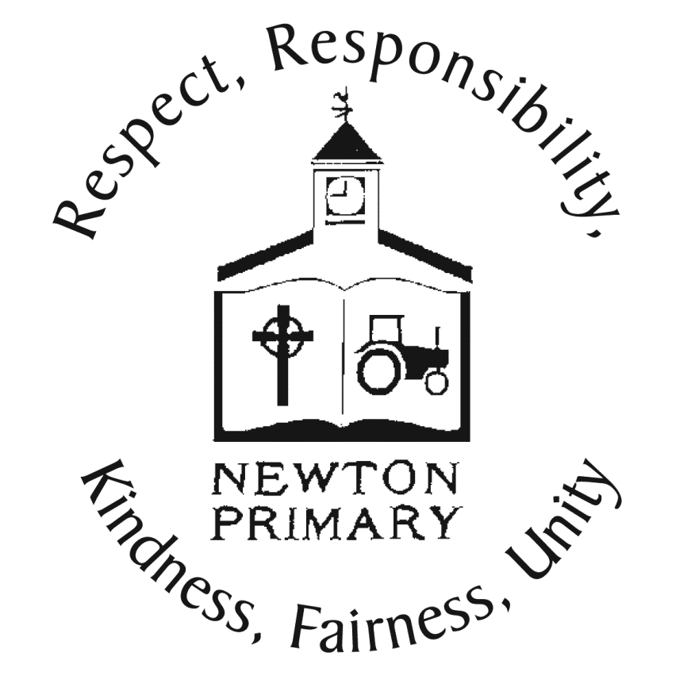

**Newton Primary School and Nursery**

**Stirling Council**

2021-2022

**Newton Primary School Improvement Plan**

**Self-Evaluation for Self-Improvement** is at the heart of our practice in Newton. We continue to develop our practice in making robust use of evidence as a basis for judgements regarding the impact of our work on our learners by considering

* **How are we doing?**
* **How do we know?**
* **What are we going to do now?**

We do this by

* **Looking inwards** to analyse our work
* **Looking outwards** to find out more about what is working well for others locally and nationally
* **Looking forwards** to gauge what continuous improvement might look like in the longer term.

**What is our vision for the school?**

Our vision has been developed in consultation with our whole school community and puts our children at the centre:

‘To provide a happy, caring, achieving and inclusive school community where children are motivated to **play, learn, and grow together** to develop their potential and be ambitious to achieve success in all aspects of their life’.

**‘Play, Learn and Grow Together at Newton’**

**Which values underpin our work?**

Our starting point for learning is a positive school ethos and a climate of respect and trust based upon our shared values of **Respect, Responsibility, Kindness, Fairness and Unity** as agreed by our whole school community in session 2020-2021**.**

**What do we aim to achieve for our learners in Newton?**

**N**ewton PS aims to……

**E**quip our children with transferable skills which will support them in becoming responsible resilient, lifelong learners who respect diversity and fairness.

**W**ork closely with parents, families, professionals, and the wider community to support enriching experiences and outcomes for all **T**each and facilitate learning about our local, national, and global issues and communities to promote sustainability and respect for diversity  **0**ffer high quality and engaging teaching and learning experiences that are motivating, challenging, relevant and meet the needs of all learners

**N**urture positive relationships and a supportive learning environment to ensure everyone feels valued and achievements are celebrated.

**P**repare learners with skills to develop their potential, have high standards and ambitions to achieve success in all aspects of their lif

**S**upport each other to ensure a safe, happy and successful school

**What is the context of our school?**

Our modern purpose-built school is situated to the north east of Dunblane. The school is non-denominational and opened in August 1996. The school provides attractive, bright and pleasant accommodation for over 450 children, has fifteen classrooms and communal open areas, a large refurbished library space and music room, a fully equipped gym, production kitchen and dining hall. Outdoors, there is an extensive asphalt play area, with Trim Trail, an outdoor classroom and a large fenced playing field. Both the nursery and school enjoy their own gardens where we plant for wildlife, and also grow our own vegetables and fruit trees. We make use of the immediate environment and local woods for outdoor learning.

Within the school building we also have a very welcoming nursery class. Our nursery offers a bright and attractive large playroom as well as an extensive garden for outdoor play. We provide morning and afternoon sessions as well as extended day provision for children. The provision has capacity for 32 children at any one time aged 3-5 years, and from August will be open from 8am-6pm 46 weeks per year.

We have close working relationships within the local community with Active Stirling, Dunblane Development Trust, the Dunblane Centre, Dunblane Library, Dunblane Museum, Dunblane Cathedral, Tesco Dunblane, Dementia Friendly Dunblane, Dunblane Memory Cafe and the local Co-op.

Our current school roll is 389 not including our nursery learners.

Most recently published SIMD information identifies that 74% of our families live in deciles 9 or 10 with a further 23% in Deciles 7 and 8, with only 2% of our pupils living in deciles 4 and 5 and no pupils living in deciles 1-3 or decile 6.

The school has a positive and inclusive ethos with a strong emphasis on building children’s confidence and celebrating success. Children, parents and staff identify strongly and are proud to be associated with our school. We have high and attainable expectations for all children in our care. We aspire to become a learning community capable of continuous improvement, ensuring we provide the highest quality learning and teaching experiences for all our children. Opportunities for leadership are offered to children, staff, parents and carers. We continue to find new ways to involve and serve our wider and global community.

**What are we planning to do 2021-2022?**

**Who did we consult?**

We have agreed the areas for improvement within our establishment through consultation with parents through our Newton Families Together, Parent Council and through parental questionnaires. Due to COVID-19 restrictions on visitors to our school we have not been able to offer opportunities for parents to share their voice through in school events such as class family learning events, through curriculum evenings, voting for change at parents evenings etc. We would normally consult with pupils through our Leading and Learning pupil groups which every child is a member of, however again throughout this year we have consulted with children mostly by using Google Classroom jamboards. We consult with staff through self evaluation, Termly Reflection Meetings and Curriculum Impact Meetins, Meeting Learner’s Needs Meetings and in Forward Planning Professional Dialogue Discussions as well as agreed priorities within the Dunblane Learning Community.

**Our Response to the COVID-19 Global Pandemic**

Newton Primary School reopened on 12th August 2020 in line with government advice as part of the nationwide response to the Covid-19 pandemic. Guidance and protocols were shared with parents, staff and pupils as part of this response. Risk Assessments are in place and updated when appropriate in line with guidance. These are available in all classrooms, on our school website and at the reception area of our school. Our Newton Families Together Parent Council work closely with our school to support decisions and priorities. Each class has parent representative to support this and all parents are welcome to be part of this group. We have met throughout the pandemic to keep our Parent Council updated.

Enhanced hygiene guidance and measures were put in place which include:

* Hand sanitisers available at entry/exit points of the school and at all classroom entry/exit points
* Children and staff are be expected to wash hands at each entry and exit from the classroom and at all transitions.
* Handwashing facilities are available for hand washing in every classroom.
* Tissue bins were provided in every classroom and children were advised to use tissues to cover your mouth and nose when they cough or sneeze, and after coughing surfaces were cleaned.
* PPE is available in every classroom, including wipes, gloves, aprons, facemasks, sanitizer, soap, blue roll and paper towels, tissues.
* All adults wear face coverings

Enhanced cleaning was introduced and included:

* All unnecessary furniture has been removed from classrooms and resources available support effective cleaning. All desks and work/rest areas will be kept clear to allow for easy cleaning/disinfecting.
* A day time cleaner was employed from 11.30-2.30 every day to clean touch points, toilets and surfaces
* Doors are wedged open (other than fire doors), where appropriate, to reduce touchpoints.
* Unnecessary resource sharing is avoided
* Children were given their own individual stationery pack when they come into school to avoid sharing of stationery and other equipment.

Physical distancing was introduced for all adult and measures included

* Following signage around the building to support distancing measures.
* Ensuring there is one person in the main foyer at any one time.
* Asking parents/carers not to congregate in areas such as the playground.
* Marked out areas in every classroom to ensure 2m ‘teaching space.’

We have outbreak management controls in place including:

* Anyone with symptoms of covid-19 should not attend school or will be asked to return home.
* PPE is available for use if isolation is required for an individual.
* We have an identified Isolation Room.

Throughout this year in particular, effective communication with parents and families, and with children has been very important and includes:

* We continue to communicate through parentmail
* All information uploaded to our school website.
* A weekly note is shared with parents with updated information about our school response to Covid-19 as well as sharing other information in relation to the children’s learning.
* A termly newsletter is also shared.
* Class teachers update Google Classroom daily/weekly as appropriate and home learning is set using this method.

Since August 2020 we have offered a flexible start to the school day from 9.00-9.30 to allow parents to physically distance. Our school has been split into class bubbles and year groups only come together at break and lunch times in zoned areas within the playground where they play on a weekly rota. Breaks and lunches have been separated with an early break for our younger learners and a later one for our older P4-7 learners. This is the same at lunchtime. This also allows reduced staff numbers in the staffroom during these times. Children eat lunch in their classrooms to avoid crowds in the dining hall and a reduced menu has been served since August 2020 with no hot lunches being available.

In December 2020 all schools were again closed to pupils and we moved again to remote learning. Children who had two parents who were key workers, or were considered to be vulnerable learners were able to attend school supported by Learning Assistants. During this time all P5-7 children were given a school chromebook and staff were provided with laptops. This allowed staff to be much more visible during remote learning, offering class and group daily Google Meets, direct teaching as well as uploading and sharing daily class tasks and daily tasks for all.

During remote learning we surveyed parents and families and invited them to share their views. We had 152 responses and 97.4% parents shared that their children accessed remote learning daily with the remaining 2.6% sharing they engaged with remote learning some days. Parents were invited to share what difficulties they were having with remote learning, what else Newton PS could do to support children’s learning at home and an opportunity to further comment.

*‘I think the google meets have been the highlight and a real boost. Keeping up with their classmates is so important. Also the work being given out daily has been better, easier to organise, being a working at home parent and also for my child to organise the learning time they do each day. Well done team Newton!’*

*‘I have been very impressed with the remote learning provided, especially the live engagement with the children. I think this is key to maintaining the relationships in the class with their teacher and their peers’*

*‘Support and delivery of learning has been brilliant. My child is so much more engaged as he knows that his teacher will be expecting to see his work and she has given some lovely feedback. He looks forward to the Google Meets. His teacher’s hard work has not gone unnoticed. Thank you’.*

All children across the school did a wellbeing web when they returned to support the teaching and support staff to have a good understanding of children’s experiences during lockdown. Staff were then able to take appropriate action to support children’s learning and achievement on return.

* **School Improvement Priority 1**: Improvement in attainment, particularly in literacy and numeracy (Literacy, STEM, Assessment of Children’s Progress)
* **School Improvement Priority 2**: Improvement in employability skills and sustained, positive school-leaver destinations for all young people
* **School Improvement Priority 3:** Ensuring wellbeing, equalities and inclusion (Staff wellbeing and Diversity)

**School Improvement Priority 1**: Improvement in attainment, particularly in literacy and numeracy (Literacy, STEM, Assessment of Children’s Progress)

|  |  |  |  |
| --- | --- | --- | --- |
| **National Improvement Framework Priorities** | **HGIOS 4 & HGIOELC Quality Indicators** | **Children’s Services Plan Outcomes** | **Regional Improvement Collaborative Priorities** |
| * Improvement in attainment, particularly in literacy and numeracy. * Closing the attainment gap between the most and least disadvantaged children. * Improvement in children and young people’s health and wellbeing. * Improvement in employability skills and sustained, positive destinations.   **Key drivers of improvement**   * School Leadership * Teacher professionalism * Parental engagement * Assessment of children’s progress * School improvement# * Performance information | 1.1 Self-evaluation for self-improvement  1.2 Leadership for learning  1.3 Leadership of change  1.4 Leadership and management of staff/ practitioners  1.5 Management of resources to promote equity  2.1 Safeguarding and child protection  2.2 Curriculum  2.3 Learning teaching and assessment  2.4 Personalised support  2.5 Family learning  2.6 Transitions  2.7 Partnerships  3.1 Improving/ ensuring wellbeing, equality and inclusion | Improving mental health and emotional wellbeing  Tackling child poverty  Improving outcomes for children with care experience  Improving outcomes for children with disabilities  Improving outcomes for children in need of protection | Improve attainment in literacy and numeracy for all children and young people  Close the attainment gap between the most and least disadvantaged children and young people for numeracy and literacy  Improve the health and wellbeing of children and young people  Improve curriculum developments and learning and teaching to support empolyability skills and sustained positive destinations. |

|  |  |  |
| --- | --- | --- |
| **Improvement Priority 1: Improvement in Attainment, particularly Literacy and Numeracy**  **High Level Actions** | **Impact** | **Measurement (what and when)** |
| **Literacy and Languages**   * To strive towards our Gold Accreditation for Developing our Reading Culture by involving parents/carers/wider community * Update and refresh resources to support further development and teaching of literacy at First and Second Level through a relevant and current programme/resource * Focus on raising attainment in writing. * Review and refresh Newton’s writing policy and guidance for staff * Based on the refreshed policy, share with parents how writing is taught at Newton and our programmes are designed, organised and structured. * communicate guidance on how parents can best support their child at home. | * Children will continue to embed a love of reading (with a resulting impact on wider literacy skills) * Improvement in literacy standards, reading and writing attainment and motivation in reading and writing for all * All children will have access to high quality literature and literacy resources * Parents will feel confident about how to best support their child with reading at home | * Analysis of attainment and achievement data * Analysis of Scottish Book Trust Reading Schools Accreditation data * Continued identification of children requiring targeted support and interventions in place, measured and evaluated. Particularly those children who have not achieved First Level by the end of P4 * Children’s enjoyment of reading and writing * Quality Assurance and Self Evaluation * Parent, pupil and staff consultations throughout the process of creating the Writing Policy and Parent Guidance |
| **Science, Technology, Engineering, Maths**   * To implement challenge boxes for able learners across all stages by researching and purchasing resources supported by Scottish Maths week small grants fund * Further develop challenges to extend interest and learning in STEM through play and learning to promote curiosity, creativity and interest. * Extending and supporting observation, and analysing children’s play to progress learning throughout the whole school * Further develop Stay Play and Learn sessions across the year at key points as far as is possible when restrictions lift. | * Children working beyond expected levels withing Numeracy and Mathematics will be appropriately challenged Children will be more confident in mental agility and numeracy skills * Improvement in STEM skills * To develop a deep understanding of the kinds of pedagogical approaches including play and digital learning to engage learners * All staff will have engaged with ‘Play’ framework and consider how children will have opportunities to play to promote learning * All pupils will have rich outdoor learning experiences | * Analysis of attainment and achievement data * Children’s interest and engagement * Children’s views through consultation and consideration of personalisation and choice * Tracking and Monitoring for children working beyond expected Levels * Quality Assurance and Self Evaluation |
| By using Education Scotland’s ‘Assessment within BGE 2020/21 (Update)’ document and learning from Tommy Lennox (Education Scotland) create a school Assessment Framework to support staff, children and families to have a clear understanding of:   * How children are assessed at Newton Primary School * What assessment approaches are used to allow children and young people to demonstrate knowledge and understanding, skills, attributes and capabilities in different contexts across the curriculum and within the 4 contexts for learning * The clear purpose of assessment for all including children and families. E.g.diagnostic information as opposed to monitoring understanding, knowledge and skills. * Shared expectations for standards to be achieved * robust arrangements for moderation across stages and the curriculum. * The importance that children and young people are fully involved in the assessment of learning, giving them an active voice and role in decision making and setting of next steps. * How parents can support learning at home through curriculum guides, sharing learning leaflets, etc   Clear guidance for online Learning Journals and trial use to allow for feedback, changes and improvements | * Staff will feel supported to re-engage with how they will approach assessment as part of their planning for learning and teaching * assessment will inform decision making about priorities with a focus on equity * shared expectations and standards support the moderation cycle * Parents will have clear knowledge of how children are assessed, the purpose of assessment and where children are in terms of progress and achievement * Children will have a clear understanding of what they need to do to improve, and their next steps * Through online journals parents and children will engage in dialogue about their learning and progression | * Teacher observations * Pupil/teacher/ parental dialogue * Parental and pupil engagement with online journals * Parental Feedback on reporting * Parentla Feedback on understanding of how children are assessed. |

**School Improvement Priority 2**: Improvement in employability skills and sustained, positive school-leaver destinations for all young people

|  |  |  |  |
| --- | --- | --- | --- |
| **National Improvement Framework Priorities** | **HGIOS 4 & HGIOELC Quality Indicators** | **Integrated Children’s Services Plan Outcomes** | **Regional Improvement Collaborative Priorities** |
| * Improvement in attainment, particularly in literacy and numeracy. * Closing the attainment gap between the most and least disadvantaged children. * Improvement in children and young people’s health and wellbeing. * Improvement in employability skills and sustained, positive destinations.   **Key drivers of improvement**   * School leadership * Teacher professionalism * Parental engagement * Assessment of children’s progress * School improvement * Performance information | 1.1 Self-evaluation for self-improvement  1.2 Leadership for learning  1.3 Leadership of change  1.4 Leadership and management of staff/ practitioners  1.5 Management of resources to promote equity  2.1 Safeguarding and child protection  2.2 Curriculum  2.3 Learning teaching and assessment  2.4 Personalised support  2.5 Family learning  2.6 Transitions  2.7 Partnerships  3.1 Improving/ ensuring wellbeing, equality and inclusion | Improving mental health and emotional wellbeing  Tackling child poverty  Improving outcomes for children with care experience  Improving outcomes for children with disabilities  Improving outcomes for children in need of protection | Improve attainment in literacy and numeracy for all children and young people  Close the attainment gap between the most and least disadvantaged children and young people for numeracy and literacy  Improve the health and wellbeing of children and young people  Improve curriculum developments and learning and teaching to support empolyability skills and sustained positive destinations. |

|  |  |  |
| --- | --- | --- |
| **Improvement Priority 2: Digital Literacy**  **High Level Actions** | **Impact** | **Measurement (Evidence - what and when)** |
| * continue to build on digital learning and work implemented through the Digital Schools Award * embed a digital culture within our school and to ensure responsibility and online safety * embed digital pedagogy into practice particularly for children in Second Level and further develop digital skills in literacy and numeracy for children at Early and First Level * Explore materials, websites and apps to support digital learning for children who are not achieving levels as expected * Based on our newly created digital policy, share with parents how our digital culture at Newton is designed, organised and structured. * Newton PS to have a bigger digital profile through twitter/school website/and other appropriate digital platforms. * All classes to have digital learning journals * Audit staff skills and use feedback to inform CLPL next session. * Digital SIP group to lead training in response to need | * For all pupils to be confident at using online platforms to engage with Learning * All teaching and support staff will be confident with the digital learning approaches used at Newton Primary * Digital Learning will be embedded across the curriculum * Improvement in motivation to use digital devices to raise standards in all curricular areas. * Children will participate in fun, engaging activities through digital platforms * Children will develop good digital habits, * All children will have access to high quality learning and teaching through digital learning * Parents will feel confident about how to best support their child to use digital devices at home for learning and ensure online safety and protection * Parents and children can share learning through online journals | * Observation of engagement with digital learning opportunities * through CLPL to support learning and teaching staff will gain confidence.gv share learning through reflection and evaluation will * Children’s enjoyment and engagement of using digital platforms and devices will increase * Digital resilience through use of online platforms and the importance of online safety is understood. |

**School Improvement Priority 3:** Ensuring wellbeing, equalities and inclusion (Staff wellbeing and Diversity)

|  |  |  |  |
| --- | --- | --- | --- |
| **National Improvement Framework Priorities** | **HGIOS 4 & HGIOELC Quality Indicators** | **Integrated Children’s Services Plan Outcomes** | **Regional Improvement Collaborative Priorities** |
| * Improvement in attainment, particularly in literacy and numeracy. * Closing the attainment gap between the most and least disadvantaged children. * Improvement in children and young people’s health and wellbeing. * Improvement in employability skills and sustained, positive destinations.   **Key drivers of improvement**   * School leadership * Teacher professionalism * Parental engagement * Assessment of children’s progress * School improvement * Performance information | 1.1 Self-evaluation for self-improvement  1.2 Leadership for learning  1.3 Leadership of change  1.4 Leadership and management of staff/ practitioners  1.5 Management of resources to promote equity  2.1 Safeguarding and child protection  2.2 Curriculum  2.3 Learning teaching and assessment  2.4 Personalised support  2.5 Family learning  2.6 Transitions  2.7 Partnerships  3.1 Improving/ ensuring wellbeing, equality and inclusion | Improving mental health and emotional wellbeing  Tackling child poverty  Improving outcomes for children with care experience  Improving outcomes for children with disabilities  Improving outcomes for children in need of protection | Improve attainment in literacy and numeracy for all children and young people  Close the attainment gap between the most and least disadvantaged children and young people for numeracy and literacy  Improve the health and wellbeing of children and young people  Improve curriculum developments and learning and teaching to support empolyability skills and sustained positive destinations. |

|  |  |  |
| --- | --- | --- |
| **Improvement Priority 3: Ensuring Wellbeing, Equalities and Inclusion**  **High Level Actions** | **Impact** | **Measurement (what and when)** |
| **Staff Wellbeing**  Focus on Staff Health and Wellbeing as we emerge from Global Pandemic   * Linked closely to our ‘Nurturing Newton’ Creating a Climage for Learning Policy, create an area to focus on staff wellbeing and how the importance of the Nurture Principles and Relationships are at the heart not only in supporting our children but in looking after our own wellbeing and self care * CLPL workshop with Claire Lavelle, from ‘The Hive of Wellbeing’ to ensure staff understand their health and wellbeing is a priority * To ensure that all staff have access to professional reading/ workshops/CLPL to support the benefits of wellbeing e.g. Gavin Oates ‘Life will see you now’ ‘Tree of Knowledge’ workshop for staff.   **Diversity**   * Continued focus on diversity at school and learning community level to include racism through CLPL from ‘The Black Curriculum’ * Now that staff are equipped and more confident in teaching diversity related contexts, more direct work with learners and families * Audit resources and planning so diversity is considered at planning stages * Further explore wider diversity topics aside from gender * Strengthen DYW links with consideration given to gender balance and equality | * All staff will feel confident implementing the ‘Nurturing Newton’ guidance, underpinned by the Six Principles of Nurture * The individual needs of all pupils will be met and supported * Staff’s professional development and learning will be continuous to support improved outcomes for learners * increased understanding and celebration of diversity within our learning community * Increased staff confidence when approaching or addressing diversity and the * Increased awareness, interest and discussion around current issues in the media e.g. Black Lives Matter movement, * The need to be proactive in our approaches | * baseline survey to determine how staff are feeling as we emerge from the pandemic * Evaluation of ‘Hive of Wellbeing’ CLPL offered * Staff will be encouraged to engage in a professional reading group which will encourage discussion and opportunities to take on a test of change * staff feedback and discussion before and after CLPL * Feedback from learners and families |