Technical Tips and Guidance for Families
Printing and Editing Worksheets/Documents
Class teachers are providing a range of learning materials for children to access and we recognise that some families have been experiencing some formatting issues of documents, trouble with editing online and the feeling of excessive printing burdens and costs. We do not want to add any additional pressures to families in the current circumstances and hope the tips and guidance below will help.
Printing Worksheets/Learning Activities
We would like to reiterate that families do not need to print worksheets and learning activities off to complete at home. We understand that some families like or prefer to do this but there is no pressure or expectation from the school or class teachers that this is the case.
Templates are provided as a guide and children can simply record their answers or complete tasks on their blank digital jotter or on blank/lined paper at home. Families are not expected to recreate or draw out worksheets by hand.
If families are printing documents, colour backgrounds can be removed and black and white/grayscale options can be selected to minimise use of ink and reduce printing costs.
Using SnapType to complete worksheets or tasks on an iPad, tablet or mobile device.
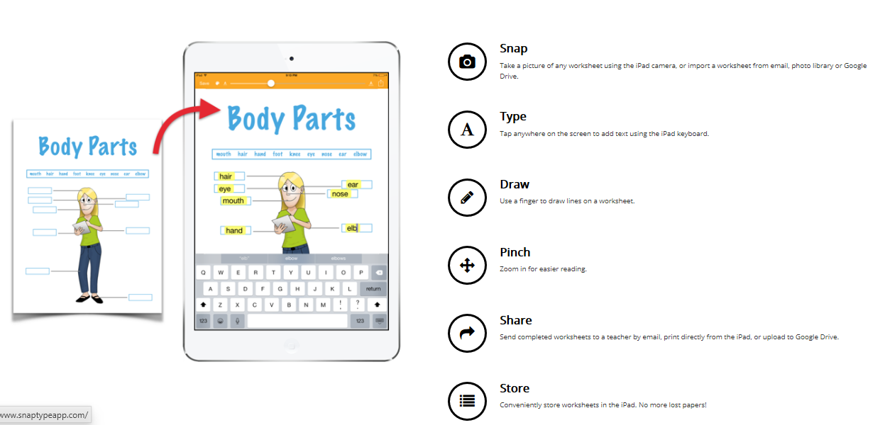
For families who don’t have a printer, want to reduce printing or are finding it difficult to complete set tasks on an iPad or tablet then you might find the SnapType App helpful. SnapType is a simple and alternative way to complete any school worksheet. This can be downloaded on the App Store or Google Play to complete tasks easily at home and avoid printing! The free version allows children to type and the pro version (£4.99) allows children to draw or write. www.snaptypeapp.com.
Using a split screen to view two the digital jotter and learning task/worksheet on screen at once
The split screen function can be used (see video below) to help children have a worksheet or task template up on the screen along with their digital jotter at the same time. This prevents children from having to jump between screens and they can record answers in the digital jotter quickly and easily. This function is also useful to save printing worksheets or tasks. The key combo is Alt and [ or Alt and ] on a Chromebook only.
Using the Split Screen Function
Formatting/Editing Documents
Class teachers are working hard to provide a range of different materials to engage and motivate children and are learning new ways of ensuring material is editable and easy to complete. Google Docs is being used increasingly to set tasks and our Tech Team have found workarounds for helping to make PDFs editable. Some class teachers are trialling set assignments and the use of Google Forms. Not one size fits all for a learning task but class teachers will offer editable documents wherever possible.
Reporting broken links or formatting issues with worksheets or learning tasks
Any materials or worksheets/documents that have been shared by class teacher have been tried and tested on the device they are working from. Our class teachers can’t test things on a range of different devices and can only fix issues that are reported to them. Children are quick to share with their class teachers on their Google Classrooms if a document isn’t working or format is showing different on a specific device and our teachers are responding as best they can. Please encourage your child to do this or for younger parents can let class teachers know via the Google Classroom stream.
Technical Support
If you require any technical support with any elements of using Google Classroom or resetting of account passwords please contact us via email at newtontechsupport@stirlingschools.net. If your child is attending school, please make sure they know their passwords or write them down for them.

