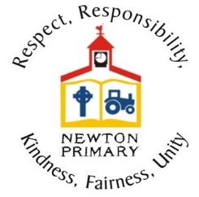

Please read the information below carefully to help us with the smooth delivery of remote learning and for any troubleshooting issues that you may encounter. If your child is accessing Google Classroom independently please read this information through with them.
How should I/my child share completed learning tasks with the class teacher?
Wherever possible, learning tasks should be shared with the class teacher within the Digital Home Learning Jotter. This can be found for your child under the ‘Classwork Tab’ within your child’s Google Classroom. Worksheets provided can be easily highlighted using the cursor key, copied and pasted into the Digital Jotter to complete keeping everything in one place.
Please do not SHARE a task through Google Drive unless the teacher has specified this. If tasks are being completed on paper an image can be uploaded quickly into the jotter using a tablet, phone or Chromebook device. This way everything is together in the same place and it is more manageable for teachers to navigate work for all children when viewing and providing feedback.
Some tasks will be created as ‘assignments’ specifically to the children and these can be ‘handed in’ once complete and do not need to be recorded in the Digital Home Learning Jotter.
Accessing the digital jotter for the first time and sharing home learning tutorial
Where in the Digital Jotter should learning tasks be added?
It is helpful if learning tasks are always added at the top of the digital jotter to allow for ease of access to completed tasks - particularly during this remote learning period where the jotters are being used more frequently. We would advise the children always upload tasks after the cover page. Please see tutorial below (from 1 minute 35 seconds).
Using the digital jotter weekly and viewing feedback tutorial
How do I/does my child read and receive feedback left by the class teacher?
Feedback will be given for learning tasks throughout the day/week by class teachers, where appropriate. It is helpful for class teachers if children can acknowledge comments by clicking the ‘tick’ next to the comment so class teachers can see that the comments have been received. The start of the tutorial below demonstrates this and also shows how to make comments back should children wish.
Using the digital jotter and viewing/receiving feedback
I/my child can’t edit the PDF document that the class teacher has shared, how should they complete this?
Where possible, class teachers are sharing editable tasks for children to complete, however this is not always possible when working across different platforms. Children do not always need to complete answers to tasks on the specific worksheets provided and we recognise that this does have printing cost implications.
Children should record answers in their Digital Jotter where possible. Some PDFs can be opened using Google Docs. Click on the PDF file and at the top of the page select ‘Open With’ and choose ‘Google Docs’ this will allow the document to be edited. This doesn’t work for all PDFs but will work for some. This can then be copied and pasted into the Digital Jotter.
Some children prefer to complete tasks on paper and answers can be written out and uploaded as an image to the digital jotter (see below).
How can I/my child upload images from a tablet/mobile device to the Digital Home Learning Jotter?
Using a mobile phone or tablet to take images of work completed is a quick and easy way to share learning with the class teacher. In order to make this process easier it is important that you have downloaded the Google Docs app to the device as well as Google Classroom.
- Open Google Classroom on the device and access the Digital Home Learning jotter. You will need to click on the Google Doc link to open the document. At this point it is view only.
- Click on the small square with an arrow inside (top right corner). This will then take you into Google Docs where you can edit the jotter.
- Click on the pencil (bottom right corner). This will allow you to edit e.g. type, add images, tables, comments, links etc.
- To insert an image - you should see a number of icons along the top bar of the screen. Click on the + icon to add an image. This will then be automatically saved in the jotter.
What should I/my child do if we have a question about a learning task, Google Meet or recording?
All information required for each day’s learning will be provided in the daily overview provided by the class teacher. This will include the timing of live sessions or if recorded sessions are available. Families are encouraged to read all information carefully before asking questions as all information required should be available within the guidance provided.
If you or your child do have questions, please post this on the daily task post or the thread that the class teacher has created for comments on that day. This allows for easier and quicker access for class teachers to view and respond to comments.
How can I access the live Google Meet sessions?
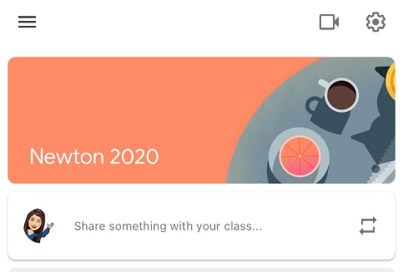
All live Google Meet sessions can be accessed via the link along the top bar of the Google Classroom. This link will always be available and will only ‘go live’ when the class teacher starts the meeting. If you try to join and it is not yet working, it is likely that the class teacher hasn’t joined yet.
If accessing a live Google Meet from a mobile/tablet device, the link for the meeting will not be visible but to access you should click on the small video icon at the top or bottom of the screen.
Can my child join a Google Meet using an account out with Stirling Council Education?
Your child must be logged into their own Google Classroom with their stirlingschools.net login in order to access a Google Meet. If your child is not granted access to join a Google Meet this is because the link is trying to access using another account logged in on the device. Please login with your child’s account and try again.
My child missed the live Google Meet session, where can I find the recording?
The timings of live Google Meet sessions will not always suit all families. Where appropriate, Google Meets will be recorded and stored so that these can be accessed at a time of your choosing.
Recordings can be accessed under the ‘Classwork’ tab. You will find these either under the day’s remote learning that they were recorded or under the topic ‘Google Meet Recordings’.
My/my child’s device is asking for a Class Code to access Google Classroom, where can I find this?
All children are allocated to Google Classrooms and therefore do not require a Class Code to gain access. If the device being used is logged in with the stirlingschools.net account direct access to Google Classroom will be available.
G-Suite will not let you access a Google Classroom if you are signed into a device with another account. You will need to log out of that account first. If you click on the Google account icon at the top right of the screen on a Google webpage, then on Sign out you can then login in with a different account. Alternatively, if you press CTRL + Shift + N in Chrome browser you can use an Incognito window to login into another google account at the same time but this will not save the details each time.
Using Features of Google Meet
Please see some short video clips to help with accessing and using features of Google Meet.
Google Meet – viewing multiple screens at one time during a meet (this allows children to see all of their peers on the screen at one time).
Google Meet – include yourself on a tile within Google Meet (this allows children to see themselves on the larger tiles along with everyone else).
Technical Support
If you require any technical support with any elements of using Google Classroom or resetting of account passwords please contact us via email at newtontechsupport@stirlingschools.net. If your child is attending school, please make sure they know their passwords or write them down for them.

