Newton Primary School
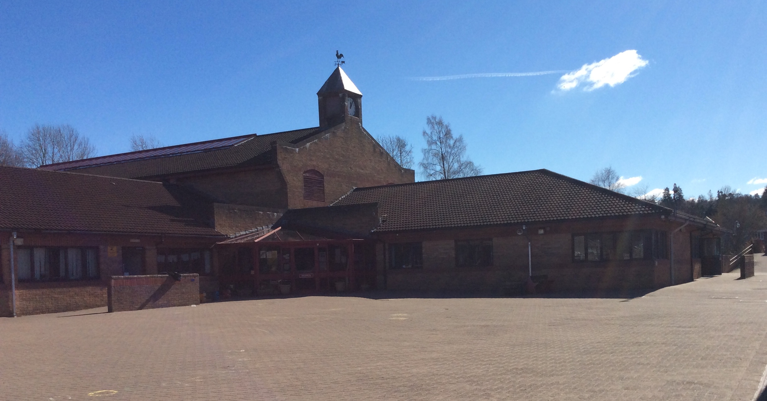
  - Transition Information 2020
Dates for your Diary
Week beginning 18.5.20 – Look out for our ‘P1 Transition Hub’ appearing on our School Website. This will be where we share lots of information that you will require for your child starting school. There will also be some videos posted over the coming weeks for your child to see so please check this regularly.
Week beginning 25.5.20 – A link to a Google form will be posted on the nursery Facebook page and the P1 Transition Hub. This will allow you and your child to ask any questions you may want about transition.
Week beginning 1.6.20 - Look out for a virtual tour of our school and playground on the P1 Transition Hub! Please also keep an eye on your post box for a delivery from your P6 Buddies!
My New School – Activity pack will be emailed out for your child with lots of activities and ideas for discussion around starting school.
Week beginning 8.6.20 – P 1 Transition Information Week. This week would have been the P1 transition afternoon. All information that would usually be delivered in person this afternoon, will be posted on the P1 Transition Hub page on the website.
Buddy Question Time! – Your P6 buddies will answer your questions about school
You will also receive an email this week letting you know who your child’s Primary 1 teacher will be.
P1 Meet your Teacher. Check the P1 Transition Hub for a video message from your new teacher, and an ‘All about Me’ task so you can tell your teacher all about the things you like!
Week beginning 22.6.20 – Keep an eye out for a little delivery from your new P1 teacher!

Welcome to Newton Primary School
We arre delighted to welcome all our new entrants and their families to Newton Primary School. Starting a new school is exciting, but we realise it can also be an anxious time for parents and children. At Newton Primary we aim to support a smooth transition in order to ensure your child settles happily and quickly with us.
We understand that Transition this year will look very different to it has in previous years due to the current COVID-19 picture. We are working within guidance from the Scottish Government and Stirling Council, and as such, things may change at short notice. Our aim is to give you and your child as much information as possible to allow them to prepare for their start in P1. As part of your child’s transition to Newton Primary School we have arranged several virtual activities and events to help you and your child get to know us better. Please be assured that if you have any questions or concerns, we will be happy to speak with you to support any individual needs.
Kindest Regards,
Lyndsey-Anne Brown
Depute Headteacher
Newtonp1transtion@stirlingschools.net

