Newton Primary School, Closure Contingency Learning Plan, Primary 7 Learning Grid 4: 18th May – 29th May 2020
‘A Voyage of Discovery’ - Country Study
This term our Context for Learning is a country study: ‘A Voyage of Discovery’. This is an opportunity to explore different countries and cultures around the world.
Over the following period of time these activities offer your child the opportunity to enhance and practise the skills they have been developing in class as well an opportunity to undertake a variety of differing tasks of their choosing. They also give you an idea of the type of things you can work on further with your child should they complete all the tasks on this sheet. There are also relevant and appropriate web sites and apps which may be of help.
Times provided are estimates only, as children will work at their own speed. Green tasks are recommended tasks to prioritise if you wish.
Timeline (Write/Make)  (Appox. 1 hour task)  Research and create a timeline of significant events for the country you have been studying. Please include between 5-10 events. You may wish to create this by hand or use the following:  https://templates.office.com/en-gb/history-timeline-tm16411244  https://www.free-powerpoint-templates-design.com/line-belt-history-powerpoint-diagram/  Extension:  (45 minute task)  Create a fact file of a significant person from your country of study and write about the long-term impact this person has had. | Aerial Landscape Art (Make)  (open ended)  Using Google Maps, explore the satellite images of different sections of your country of study:  https://www.google.co.uk/maps/  Create a piece of aerial landscape art for a particular area of the country. Type ‘aerial landscape art’ into Google images to look at lots of examples. You can complete in a medium of your choice. E.g. oil pastels, paint, pencils, pens, crayons etc.  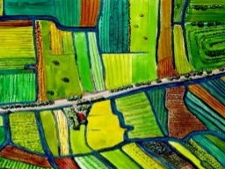  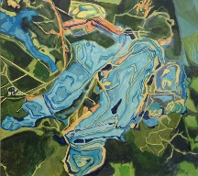  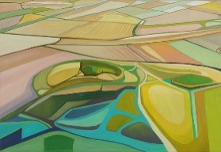 | Food and Drink (Do/Make)  (tasks of varying length)  Complete one of the following:  - Create a Venn diagram to compare and contrast food from Scotland and your country of study.  https://www.bbc.co.uk/bitesize/clips/zhckq6f  - Find out what foods are grown in your country of study and label them on a map. Show which foods you have tried and which you would like to try. Identify the foods that are not grown in Scotland and explain why.  - Create a menu of traditional food from your chosen country.  - Plan and prepare a traditional dish from your country of study to be shared with your family.
Modern Languages (Say/Do)  (Approx. 30 minute task)  Continue to focus on developing your French vocabulary by completing some of the following lessons and games:  https://www.topmarks.co.uk/Search.aspx?q=French  You may also want to learn another language of your choice. There are loads of websites to support you including Duolingo and BBC Languages.  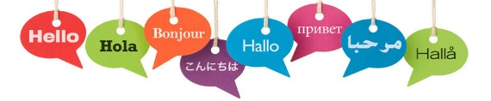 | Writing (Write)  (Approx.1 hour task)  Complete one of the following:  - Share some questions you would like to ask someone from your country of study and compose a letter.  https://www.bbc.co.uk/teach/skillswise/writing-a-letter/zbc8vk7  - Write a postcard from the point of view of someone visiting your country of study.  https://www.bbc.co.uk/bitesize/topics/z2yycdm/articles/zgfhcj6 | Tourist Guide (Write/Say/Make/Do)  (Approx.1 hour and 30 minutes+ task)  Complete one of the following:  - Design and create a tourist brochure or leaflet to encourage people to visit your chosen country.  - Role play as the presenter of a travel program, presenting from your country of study. Write prompt cards to help you with your role-play of a travel show presenter.
RME: Parable – The Prodigal Son (Say/Make/Do)  (open ended)  Read the story of the Prodigal Son in Luke 15 v 11-22 (or look it up online). Then watch this Lego version https://www.youtube.com/watch?v=dPt-XJM9daM  Can you make your own Lego version of this parable? You could either record it and upload it to Google Classroom or perform it for your family. | Music (Make/Do)  Approx. (45 minute task)  Listen to a piece of music from the country you have been studying. What style of music is it? What instruments are playing in the music?  Using this music as inspiration, compose a tune that you feel symbolises your chosen country. | Outdoor Classroom Day: Playful Nature (Do)  (open ended)  As a school, we were planning on celebrating Outdoor Classroom Day on Thursday 21st May so would love to still mark the day with you learning outside where possible. See how many of the following activities you can complete:  https://outdoorclassroomday.com/resources/lesson-ideas/
Literacy & Languages: Reflective Reading  (Approx.30 minutes per task)  LI: to develop Reflective Reading skills through film  See ‘The BFG’ Film Trailer Task Map uploaded to Google Classroom. Watch the trailer and complete at least two of the suggested activities. | Literacy & Languages: Writing  (Approx. 30 minutes per task x 4)  LI: to use a wide range of sophisticated vocabulary, connectives, openers and punctuation  Please see the VCOP Grid and resources uploaded onto Google Classroom. Try to complete at least one activity from each row over the next two weeks. | Literacy & Languages: Talking and Listening  (varying length depending on podcast chosen)  LI: to listen for information  Select a podcast of your choice from:  https://www.bbc.co.uk/podcasts?q=children  Consider the following questions as you listen:  What are the key messages?  How does what you are listening to relate to you and your life?  Does the podcast link to anything you have read or watched recently?
Numeracy & Mathematics: Patterns and Sequences  LI: to understand, continue and describe number sequences (including square numbers, triangle numbers and the Fibonacci Sequence)  Watch the following on number sequences: https://www.bbc.co.uk/bitesize/topics/z69k7ty/articles/zyd4rdm and then complete the Sumdog challenge: www.sumdog.com  (Approx.20 minute task)  Complete the Square Numbers and Triangle Numbers task sheet on Google Classroom. You might like to watch the following for some extra revision: https://www.bbc.co.uk/bitesize/topics/zm982hv/articles/z7rk8xs  (Approx.20 minute task)  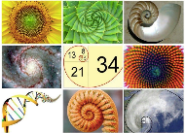  Have a look at the Power Point about the Fibonacci Sequence on Google Classroom. Try to create your own artwork using the Fibonacci sequence! Remember to tweet your artwork to @NewtonPrimary01 for everyone to see!  Approx. (1 hour task) | Numeracy & Mathematics: Measure  LI(1): to find the area of composite shapes  LI(2): to understand and use scale accurately  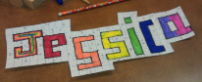  Using a ruler, draw out your name in bubble letters. Calculate the area of your name using Area = Length x Breadth. (Approx.20 minute task)  Watch, read and practise the following on scale drawings: https://www.bbc.co.uk/bitesize/articles/zntkd6f  (Approx.10 minute task)  Create a scale model or drawing of a famous landmark from a country you have been researching. You will need to gather the measurements of the real landmark before deciding on an appropriate scale e.g. 1cm: 10m.  (1 hour task – depending on chosen model/drawing)  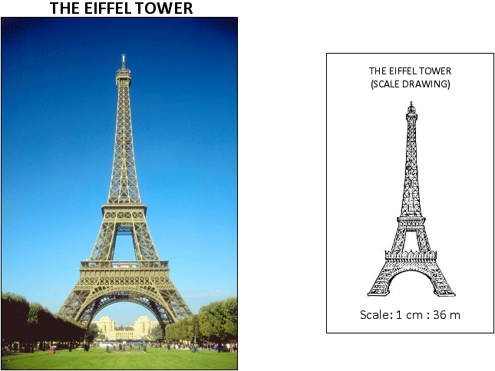 | Numeracy & Mathematics: Negative Numbers  (Approx.10 minutes per task)  LI: to add and subtract negative numbers  Use the thermometers to read the scales and work out the difference between the temperatures.  https://www.topmarks.co.uk/Flash.aspx?f=Temperaturev2  Using the Power Point on Google Classroom, play ‘Who Wants to be a Millionaire? – Negative Numbers’. Can you make it to the £1,000,000 question?  Make your way around the maze using your knowledge of BODMAS and negative numbers! How many levels can you complete? https://www.transum.org/software/Fun_Maths/Maze/BidMaze.asp?Level=2
HWB: RSHP  (open ended)  LI: to explore how humans reproduce  Your parents have been emailed resources to help support your learning in this area. We really encourage you to engage in conversations with an adult you trust about RSHP and to ask any questions you have.  Please follow the link below for an important reminder about the underwear rule:  https://www.nspcc.org.uk/globalassets/documents/advice-and-info/underwear-rule-children-guide-english.pdf | HWB: Fitness  (Approx.20 minute task – including warm up and cool down x 3)  LI: to improve our fitness and stamina  Please see the PE Circuit Recording Sheet uploaded onto Google Classroom. Find a safe space outside or inside and complete each of the fitness exercises for 1 minute. Repeat these 3 (or more) times each week and challenge yourself to get a new personal best (PB) each time. If you have a printer you can print out the recording sheet, if not you can keep a record on a piece of paper.  Please remember to do a proper warm up and cool down so that you do not pull any muscles! | HWB: Taking Care of Your Wellbeing  (4 minute video – tasks of varying length)  LI: to make sense of our feelings and develop skills for taking care of our wellbeing during the coronavirus outbreak.  It’s completely OK to experience a wide range of emotions at the moment. Our lives are so different to what we are used to and not being able to see friends and family can be really hard.  Please explore the ‘Information for Young People’ section which gives lots of good advice.  https://blogs.glowscotland.org.uk/glowblogs/stirlingeps/information-for-young-people/

Suggested web sites and apps:
LITERACY:  Nessy Spelling - https://www.nessy.com/uk/  Newsround - https://www.bbc.co.uk/newsround/news/watch_newsround  BBC Bitesize - https://www.bbc.co.uk/bitesize/subjects/z8rdtfr | NUMERACY:  Sumdog - https://www.sumdog.com/user/sign_in  Top Marks - https://www.topmarks.co.uk/  Daily Rigour - https://www.cdmasterworks.co.uk/the-daily-rigour/  Nrich Maths - https://nrich.maths.org/primary
Primary Homework Help - http://www.primaryhomeworkhelp.co.uk/

